Table of Contents

UNITED STATES

SECURITIES AND EXCHANGE COMMISSION
Washington, D.C. 20549

SCHEDULE 14A

Proxy Statement Pursuant to Section 14(a) of the

Securities Exchange Act of 1934 (Amendment No. )

☑ Filed by the Registrant ☐ Filed by a party other than the Registrant

CHECK THE APPROPRIATE BOX:
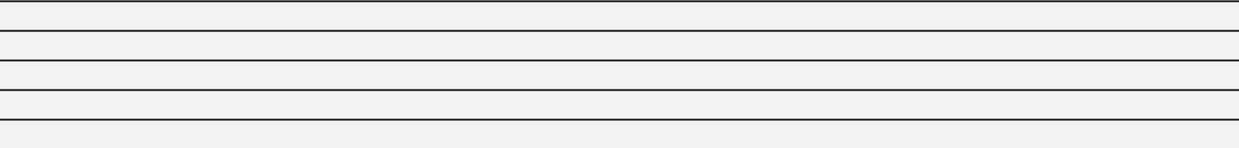
- Preliminary Proxy Statement

- Confidential, for Use of the Commission Only (as permitted by Rule 14a-6(e)(2))

- Definitive Proxy Statement

- Definitive Additional Materials

- Soliciting Material under §240.14a-12


Occidental Petroleum Corporation

(Name of Registrant as Specified In Its Charter)

(Name of Person(s) Filing Proxy Statement, if other than the Registrant)

PAYMENT OF FILING FEE (CHECK ALL BOXES THAT APPLY):
- No fee required

- Fee paid previously with preliminary materials

- Fee computed on table in exhibit required by Item 25(b) per Exchange Act Rules 14a-6(i)(1) and 0-11

Table of Contents


Table of Contents


OUR VISION | OUR VALUES
We will lead the industry by reaching for | LEAD WITH PASSION
the impossible, then achieving it. | OUTPERFORM EXPECTATIONS
We do this by having the right assets in the | OUTPERFORM EXPECTATIONS
hands of remarkable people driven by a passion | DELIVER RESULTS RESPONSIBLY
to outperform. | UNLEASH OPPORTUNITIES
 | COMMIT TO GOOD

ZERO IN™ ON VALUE

COMPLEMENTARY | SHAREHOLDER | STRENGTHENING | PATHWAY TO
BUSINESSES | RETURNS | FINANCIAL PROFILE | NET ZERO
► Oil & Gas | ► Sustainable & | ► Partial Preferred | ► Direct Air Capture
► OxyChem | Growing Common | Equity Redemption | ► CO2 Sequestration
► Midstream & | Dividend | ► Opportunistic Debt | ► Core Business
Marketing, | ► Share Repurchases | Reduction | Enhancement
including | ► Equity | ► Investment Grade
Low Carbon | Appreciation | Ambition
Ventures | Through Enterprise
 | Value Rebalancing

Table of Contents


2022 HIGHLIGHTS

FINANCIAL

Record free cash flow |  | Record net income attributable | Retired | Completed
before working capital of |  | to common shareholders of | more than | $3 billion
$13.6 billion¹ |  | $12.5 billion | $10.5 billion | $3 billion
 |  | $12.5 billion | $10.5 billion | share repurchase
 |  |  | of debt | program
OPERATIONAL

Proved reserves increased by

~300 MMboe

to ~3,800

MMboe²

Record

operational milestones

in U.S. Onshore, Gulf of Mexico and International oil & gas

Record

Delaware Basin well productivity

Record

OxyChem

pre-tax

earnings

HEALTH, SAFETY AND ENVIRONMENTAL Board approved Occidental’s

updated HSE and Sustainability Principles

Commenced construction of Occidental’s

first Direct Air Capture plant

U.S. oil & gas operations achieved Zero Routine Flaring

in advance of the World Bank’s 2030 initiative

Secured

over 400 square miles

of land and pore space

for Gulf Coast sequestration hubs

- For a reconciliation to the most comparable GAAP financial measure of operating cash flow from continuing operations, see Annex A.
- Million barrels of oil equivalent.

Table of Contents

Strategy to Achieve Net Zero

Occidental is actively implementing multiple pathways to net zero to advance the goals of the Paris Agreement. Our strategy employs four key elements to achieve net-zero emissions in our operations and energy use before 2035 and no later than 2040, and in our total carbon inventory including the use of our products before 2050.
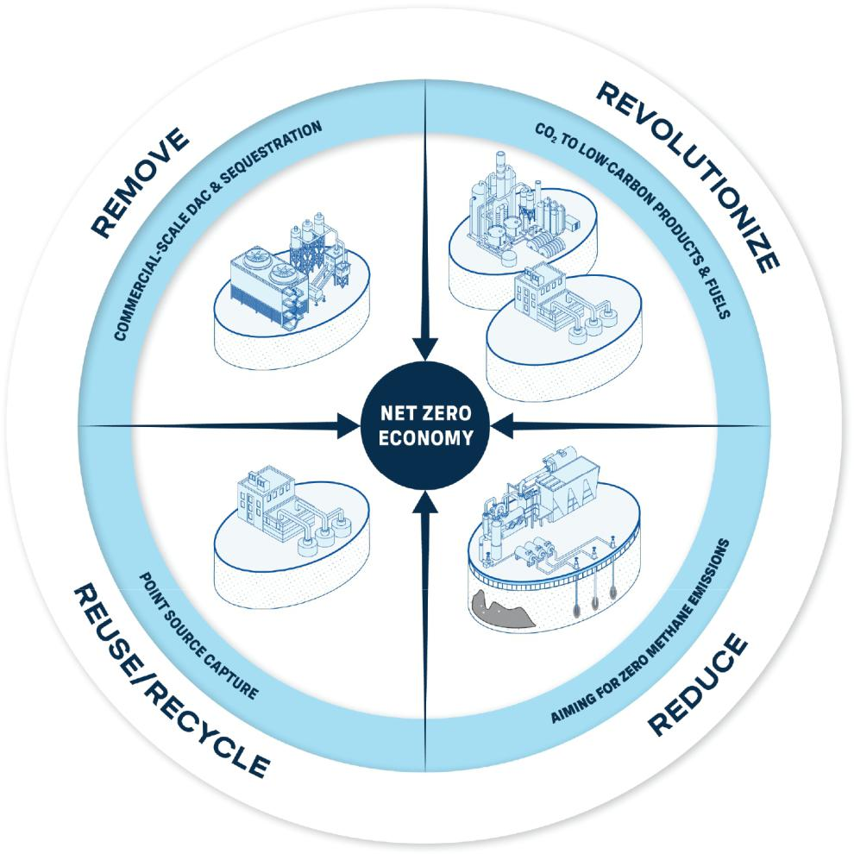

REVOLUTIONIZE | Revolutionize carbon management by applying our 50+ years of leadership in CO₂ separation, transportation, use, recycling and storage to
 | invest in and deploy leading-edge technologies and promote collaboration with industry, government and non-governmental organizations,
 | using an integrated approach that benefits Oxy’s stakeholders and the world
REDUCE | Reduce emissions across our operations through employee-driven innovation and excellence and state-of-the-art, cost-effective
 | technologies
REUSE/RECYCLE | Reuse and recycle CO₂ with technologies and partnerships that use captured CO₂ to enhance existing products and produce new low-
 | carbon or zero-emissions products
REMOVE | Remove existing CO₂ from the atmosphere in significant amounts for beneficial use and safe, secure sequestration by developing, proving
 | and deploying innovative capture technologies and market mechanisms at commercial scale to further the goals of the Paris Agreement

Table of Contents

Message from the Board of Directors

Dear Shareholders,

We cordially invite you to attend Occidental’s 2023 Annual Meeting of Shareholders (2023 Annual Meeting). The meeting will be held via live webcast on Friday, May 5, 2023 at 9:00 a.m. Central Time. A meeting agenda and details follow, as well as voting instructions. You will be able to participate in the 2023 Annual Meeting online at www.virtualshareholdermeeting.com/OXY2023 and may submit questions and vote your shares electronically (other than shares held through our employee benefit plans, which must be voted prior to the meeting). The attached Notice of the 2023 Annual Meeting of Shareholders and proxy statement provide details on how to join the meeting and the business we plan to conduct.

NAVIGATING CHANGE

Before we review the successes Occidental achieved and the challenges the company overcame last year, we would like to take a moment to remember Steve Chazen, our former Independent Chairman, who sadly passed away in September 2022. Among his many professional accomplishments, Steve served as the President and CEO of Occidental from May 2011 to April 2016 and was a member of the Board from May 2010 to May 2017. He returned to our Board in March 2020 as the company faced a difficult macroeconomic environment at the onset of the COVID-19 pandemic. He possessed a brilliant mind and financial astuteness that guided our discussions, and a dry sense of humor that is missed in the boardroom.

The Board is also appreciative of Jack Moore, who was elected to succeed Steve as Independent Chairman. Jack previously served as Independent Vice Chairman of the Board from September 2019 to September 2022 and as a member of our Board since 2016, preceded by a long and successful career in the energy industry. Under his leadership, we have continued our strong performance.

In January 2023, the Board elected Claire O’Neill as a director. Through her prior experience as a Member of the UK Parliament, Minister for Energy and Clean Growth in the UK government, and other roles focused on sustainability and energy transition matters, we believe Claire will bring valuable expertise to our Board as Occidental continues to advance the sustainability of our businesses with complementary low-carbon initiatives along the company’s pathway to net zero. The Board also elected Ken Robinson as a director in February 2023. Ken brings over 40 years of experience in global finance and accounting, enterprise risk, ethics and compliance across several industries. Going forward, the Board will remain committed to ongoing and thoughtful refreshment to maintain an appropriate balance of tenure, backgrounds and skills on the Board.

CAPITALIZING ON OPERATIONAL SUCCESSES AND DRIVING FINANCIAL PERFORMANCE

Occidental’s workforce performed at an exceptional level in 2022. Our employees successfully adapted to the lingering impacts of the COVID-19 pandemic, supply chain issues, inflationary pressures and the implementation of multiple permitting and other regulatory initiatives as the company returned to increased activity levels. Occidental’s Permian, Rockies, Gulf of Mexico and International oil and gas teams set new operational and productivity records last year, and OxyChem delivered record pre-tax earnings. These operational successes in part drove strong financial results for the year, which positioned us to repay more than $10.5 billion of debt in 2022 and to complete our previous $3 billion share repurchase program. With a stronger balance sheet, Occidental plans to focus on a sustainable and growing dividend for shareholders supported by an active repurchase program and continued rebalancing of the company’s enterprise value in favor of common shareholders.

LEVERAGING CARBON MANAGEMENT AND MAJOR PROJECTS EXPERTISE

Occidental continues to actively pursue its net-zero pathway for the company’s total carbon inventory of Scope 1, 2 and 3 emissions. Since we announced the net-zero plan in 2020, the company has taken important steps toward achieving the ambitious interim targets and goals it has set. For example, Occidental’s U.S. operations achieved zero routine flaring in 2022, eight years ahead of the World Bank’s 2030 target. In September 2022, Occidental began construction of its first large-scale direct air capture (DAC) plant in Ector County, Texas. We are excited to oversee the company’s net-zero strategy and low-carbon initiatives, which leverage Occidental’s 50+ years of carbon management experience with expertise in major energy infrastructure projects, and to be a part of the innovation occurring every day at the company. We are also encouraged by the passage of the Inflation Reduction Act in the U.S., which contains several enhancements to the 45Q tax credit that will incentivize the development of carbon capture projects.

LISTENING TO SHAREHOLDER FEEDBACK

Occidental proactively engaged with shareholders collectively representing a majority of shares outstanding, with independent director participation in many of these discussions. Feedback from these engagements has informed our viewpoints and decisions. We will remain committed to regular and transparent engagement with shareholders and other stakeholders. We value your views and would like to hear from you. If you would like to write to the Board, you may address your correspondence to the Board of Directors, in care of the Corporate Secretary, Occidental Petroleum Corporation, 5 Greenway Plaza, Suite 110, Houston, Texas 77046.

Thank you for your continued support of Occidental. We are grateful to serve on your behalf.

Sincerely,

On Behalf of Your Board,
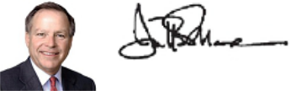

JACK B. MOORE

Chairman of the Board
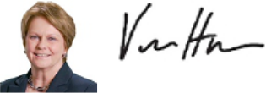

VICKI HOLLUB

President and Chief Executive Officer

2023 PROXY STATEMENT
1

Table of Contents

Notice of Annual Meeting of Shareholders

You are cordially invited to attend Occidental’s 2023 Annual Meeting of Shareholders (2023 Annual Meeting), to be held at 9:00 a.m. Central Time on Friday, May 5, 2023, via live webcast at www.virtualshareholdermeeting.com/OXY2023.

DATE AND TIME | LOCATION | RECORD DATE
Friday, May 5, 2023 at | Live webcast: | Each shareholder of record as of the close of
9:00 a.m. Central Time | www.virtualshareholdermeeting.com/OXY2023 | business on March 10, 2023 (the record date) is
 |  | entitled to receive notice of, attend and vote at the
 |  | meeting.




ITEMS OF BUSINESS

At the meeting, our shareholders will be asked to act on the following matters and consider any other matters as may properly come before the meeting:

PROPOSAL |  | BOARD RECOMMENDATION | MORE INFORMATION
1. | Elect the ten directors named in the proxy statement to serve until the 2024 Annual Meeting | FOR | Page 14
2. | Approve the frequency of future advisory votes to approve named executive officer compensation, on an | ONE YEAR | Page 35
 | advisory basis | ONE YEAR | Page 35
3. | Approve, on an advisory basis, named executive officer compensation | FOR | Page 36
4. | Ratify the selection of KPMG as Occidental’s independent auditor | FOR | Page 79
5. | Act on a shareholder proposal requesting an Independent Board Chairman Policy, if properly presented | AGAINST | Page 81

Notice and Attendance

A Notice of Internet Availability (NOIA) or proxy card is being mailed beginning on March 23, 2023 to each shareholder of record as of the record date. Shareholders of record as of the record date will be able to attend the 2023 Annual Meeting via live webcast, view the list of our shareholders of record, vote and submit questions during the meeting by visiting www.virtualshareholdermeeting.com/OXY2023. To participate in the Annual Meeting, shareholders of record must enter the 16-digit control number that appears on their proxy card. If shareholders hold their shares in street name and their voting instruction form indicates that they may vote those shares through the http://www.proxyvote.com website, then they may join the 2023 Annual Meeting with the 16-digit access code indicated on that voting instruction form. Otherwise, shareholders who hold their shares in street name should contact their bank, broker or other nominee (preferably at least five days before the 2023 Annual Meeting) and obtain a “legal proxy” in order to be able to join the 2023 Annual Meeting. Please see “Questions and Answers about the Annual Meeting and Voting” beginning on page 86 for additional information.

HOW TO VOTE

Your vote is extremely important. Regardless of whether or not you plan to attend the 2023 Annual Meeting, we encourage you to vote using any of the methods listed below.

This will ensure that your shares are represented and will save Occidental additional expenses of soliciting proxies.

INTERNET | CALL
Online using your smartphone or | By telephone call to the toll-free
computer at the website listed on the | number listed on your proxy card or
NOIA, proxy card or voting instruction | voting instruction form
form

If you have any questions or require any assistance in voting your shares, please contact Alliance Advisors, Occidental’s proxy solicitor, toll-free at 844-885-0175 or by email at oxy@allianceadvisors.com.


MAIL
Completing, signing and returning your proxy card or voting instruction form in the postage-paid envelope provided

By Order of the Board,
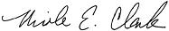

VIRTUAL MEETING
If you plan to participate in the 2023 Annual Meeting via the live webcast, you may vote online during the meeting using your smartphone or computer

NICOLE E. CLARK
Vice President, Deputy General Counsel and Corporate Secretary
March 23, 2023

2

Table of Contents

Table of Contents

Message from the Board of Directors |  | 1
Notice of Annual Meeting of Shareholders |  | 2
Proxy Statement Summary |  | 4
Environmental and Sustainability |  | 12
Human Capital Resources |  | 13
PROPOSAL 1 |  | 14
ELECTION OF DIRECTORS |  | 14
Director Nominations |  | 14
About the Director Nominees |  | 15
Summary of the Board’s Director Nominee Core Competencies |  | 21
and Composition Highlights
Corporate Governance |  | 23
Corporate Governance Highlights |  | 23
Board Evaluation Process |  | 24
Director Selection and Recruitment |  | 24
Board of Directors and its Committees |  | 25
Director Engagement |  | 28
Shareholder Engagement |  | 31
Communications with Directors |  | 32
Other Governance Matters |  | 32
Non-Employee Director Compensation |  | 33
Director Compensation Program |  | 33
Director Compensation Table |  | 34
PROPOSAL 2 |  | 35
ADVISORY VOTE ON THE FREQUENCY OF FUTURE |  | 35
ADVISORY VOTES TO APPROVE EXECUTIVE
COMPENSATION

Executive Compensation Tables |  |  | 61
 | Summary Compensation |  | 61
 | Grants of Plan-Based Awards |  | 63
 | Outstanding Equity Awards |  | 65
 | Stock Vested in 2022 |  | 68
 | Nonqualified Deferred Compensation |  | 68
 | Executive Severance and Change in Control |  | 69
 | Potential Payments upon Termination or Change in Control |  | 71
 | Payments to Former Officer |  | 74
Pay Ratio |  |  | 75
Pay vs. Performance |  |  | 76
 | Financial Performance Measures |  | 77
 | Analysis of the Information Presented in the Pay versus |  | 78
 | Performance Table
 | PROPOSAL 4 |  | 79
RATIFICATION OF SELECTION OF KPMG AS OCCIDENTAL’S |  |  | 79
INDEPENDENT AUDITOR
 | Audit Related Matters |  | 79
 | Ratification of Selection of Independent Auditor |  | 80
 | Report of the Audit Committee |  | 80
 | PROPOSAL 5 |  | 81
SHAREHOLDER PROPOSAL REQUESTING AN INDEPENDENT |  |  | 81
BOARD CHAIRMAN POLICY
 | The Board of Directors’ Statement in Opposition |  | 82
Security Ownership |  |  | 84
 | Certain Beneficial Owners and Management |  | 84

PROPOSAL 3 |  | 36
ADVISORY VOTE TO APPROVE NAMED EXECUTIVE |  | 36
OFFICER COMPENSATION
Compensation Discussion and Analysis |  | 37
Executive Summary |  | 38
Objectives of the Executive Compensation Program |  | 40
Governance Features of the Executive Compensation Program |  | 41
Overview of the 2022 Executive Compensation Program |  | 42
Compensation Program Emphasizes Performance |  | 43
Say-on-Pay Vote |  | 43
Participants in the Executive Compensation Decision-Making |  | 44
Process
Elements of the 2022 Compensation Program |  | 46
Other Compensation and Benefits |  | 50
Individual Compensation Considerations |  | 52
Additional Compensation Policies and Practices |  | 59
Risk Assessment of Compensation Policies and Practices |  | 60
Compensation Committee Report |  | 60

Questions and Answers about the Annual Meeting and Voting | 86
General Information | 89
Information Available Online | 89
Important Notice Regarding the Availability of Proxy Materials for | 89
the Shareholder Meeting to Be Held on May 5, 2023
Voting Instructions and Information | 88
Shareholder Proposals for the 2024 Annual Meeting | 91
Director Nominations for the 2024 Annual Meeting | 91
Forward-Looking Statements | 93
ANNEX A: Reconciliations to GAAP | 94

2023 PROXY STATEMENT
3

Table of Contents

Proxy Statement Summary

This section highlights certain important information presented in this proxy statement and is intended to assist you in evaluating the matters to be voted on at the meeting. We encourage you to read the proxy statement in its entirety before you cast your vote. For more information regarding Occidental’s 2022 performance, please review Occidental’s Annual Report on Form 10-K for the fiscal year ended December 31, 2022 (the Annual Report).

Agenda Items and Voting Recommendations


Proposal

1


Election of Directors

The Governance Committee recommended to the Board, and the Board approved, the nomination of the 10 persons whose biographies appear on pages 15-20 to serve for a one-year term ending at the 2024 Annual Meeting, but in any event, until his or her successor is elected and qualified, unless ended earlier due to his or her death, resignation, disqualification or removal from office.


The Board of Directors recommends a vote “FOR” each of the director nominees.

See page 14

Proposal

2


Advisory Vote on the Frequency of Future Advisory Votes to Approve Named Executive Officer (NEO) Compensation

In accordance with the Dodd-Frank Wall Street Reform and Consumer Protection Act, shareholders are being asked to vote, on an advisory basis, whether future advisory votes on NEO compensation should occur every one, two or three years. Valuing shareholder feedback, the Board recommends that future advisory votes on NEO compensation continue to occur every one year.


The Board of Directors recommends a vote of “ONE YEAR” for this proposal.

See page 35

Proposal

3


Advisory Vote to Approve NEO Compensation

The executive compensation program for the NEOs includes many best-practice features that are intended to enhance the alignment of compensation with the interests of Occidental’s shareholders. The executive compensation program is described in the Compensation Discussion and Analysis (CD&A) section beginning on page 37 of this proxy statement.

The Board of Directors recommends a vote “FOR” this proposal.

See page 36

Proposal

4

 | Ratification of Selection of KPMG as Occidental’s Independent Auditor
 |  | The Board of
 | The Audit Committee of the Board of Directors of Occidental has selected KPMG LLP as independent auditor to audit the consolidated | The Board of
 | financial statements of Occidental and its subsidiaries for the year ending December 31, 2023. As a matter of good corporate | Directors
 | governance, the Board submits the selection of the independent auditor to our shareholders for ratification. | recommends a
 |  | vote “FOR”
 |  | this proposal.
 |  | See page 79



Shareholder Proposal Requesting an Independent Board Chairman Policy

Proposal Occidental expects this shareholder proposal to be introduced at the 2023 Annual Meeting. The Board of Directors disclaims any

- changes, are presented in the form received from the shareholder proponent. The shareholder proposal is required to be voted on at the 2023 Annual Meeting only if it is properly presented. Because Occidental’s amended and restated By-laws currently require an Independent Chairman of the Board, the Board believes this proposal is unnecessary, misdirected and not warranted for adoption at Occidental and recommends a vote “AGAINST” this proposal.responsibilityforthecontentoftheproposalandforthestatements made in support thereof, which, except for minor formatting

The Board of Directors recommends a vote

“AGAINST” this proposal, if properly presented.

See page 81

4

Table of Contents

Proxy Statement Summary

Director Nominees and Composition Highlights

The Board seeks to achieve a diverse and broadly inclusive membership. Our Board’s director nominees bring varying perspectives to the boardroom by virtue of their diverse backgrounds and experiences, qualifications, skills, genders, ethnicities and tenures on the Board. To better convey the well-roundedness of our Board’s director nominees, we have included a skills matrix on page 21 that identifies the core competencies of each of our Board’s director nominees that contributed to his or her nomination to the Board.





JACK B. MOORE | VICKY A. BAILEY | ANDREW GOULD | CARLOS M. GUTIERREZ
Former President and Chief Executive | Former Assistant Secretary, | Former Chairman and | Co-Founder, Executive Chairman and CEO,
Officer, Cameron International | Domestic Policy and International Affairs, | Chief Executive Officer, Schlumberger | EmPath, Inc.
INDEPENDENT | U.S. Department of Energy | DIRECTOR SINCE: | DIRECTOR SINCE:
CHAIRMAN SINCE: | President, Anderson Stratton | 2020 | 2009
2022 | International, LLC | COMMITTEE MEMBERSHIP: | COMMITTEE MEMBERSHIP:
DIRECTOR SINCE: | DIRECTOR SINCE: | COMMITTEE MEMBERSHIP: | COMMITTEE MEMBERSHIP:
2016 | 2022
COMMITTEE MEMBERSHIP: | COMMITTEE MEMBERSHIP:





VICKI HOLLUB | WILLIAM R. KLESSE | CLAIRE O’NEILL | AVEDICK B. POLADIAN
President and Chief Executive Officer, | Former Chief Executive Officer and | Former Member of Parliament and | Former Executive Vice President and Chief
Occidental | Chairman of the Board, Valero Energy | Minister for Energy and Clean Growth | Operating Officer, Lowe Enterprises
DIRECTOR SINCE: | DIRECTOR SINCE: | (UK Govt) | DIRECTOR SINCE:
DIRECTOR SINCE: | DIRECTOR SINCE: | DIRECTOR SINCE: | DIRECTOR SINCE:
2015 | 2013 | DIRECTOR SINCE: | 2008
 | COMMITTEE MEMBERSHIP: | 2023 | COMMITTEE MEMBERSHIP:
 | COMMITTEE MEMBERSHIP: | COMMITTEE MEMBERSHIP: | COMMITTEE MEMBERSHIP:

 |  | BOARD COMMITTEES:
 |  | Audit
 |  | Corporate Governance and Nominating
KEN ROBINSON | ROBERT M. SHEARER | Environmental, Health and Safety
Former Senior Vice President of Audit | Former Managing Director, BlackRock
and Controls, Exelon Corporation | Advisors, LLC
DIRECTOR SINCE: | DIRECTOR SINCE: | Executive Compensation
2023 | 2019 | Sustainability and Shareholder Engagement
 | COMMITTEE MEMBERSHIP:
 |  | Chair | Member
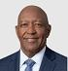


2023 PROXY STATEMENT
5

Table of Contents

Proxy Statement Summary

INDEPENDENCE

Occidental’s governance policies require that independent directors comprise at least two-thirds of the members of the Board (a policy that exceeds New York Stock Exchange (NYSE) requirements). The Board has affirmatively determined that each of our Board’s director nominees, other than Ms. Hollub, is independent.
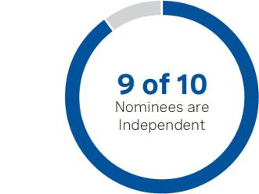

TENURE

The average tenure of our Board’s director nominees is approximately 6.0 years, which we believe reflects a balance of company experience and new perspectives.
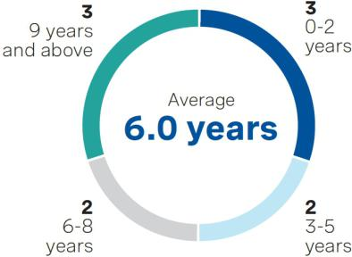

DIVERSITY

The Board recognizes the importance of having a diverse and broadly inclusive membership. As part of its commitment to diversity and Board refreshment, the Board recently elected Ms. O’Neill and Mr. Robinson as directors.
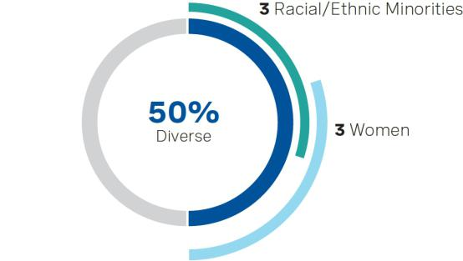

Corporate Governance Highlights


RELATING TO THE BOARD

- Independent Chairman of the Board

- Annual elections of the entire Board by a majority of votes cast (for uncontested elections)

- Mandatory resignation if a majority vote is not received (for uncontested elections)

- Demonstrated commitment to Board refreshment

- Tenure policy that seeks to maintain an average tenure of 10 years or less for non-employee directors

- Board committees composed entirely of independent directors

- Meaningful director stock ownership guidelines (6x annual cash retainer) with holding requirement

- Annual evaluations of the Board, each committee and individual directors

- One meeting dedicated to strategy discussions every year with an expanded management group, in addition to ongoing strategy oversight


RELATING TO SHAREHOLDER RIGHTS

  - Ability of shareholders to call a special meeting at a 15% threshold

  - Ability of shareholders to propose an action by written consent at a 15% threshold

  - Shareholder right to proxy access (3% for 3 years, up to 20% of the Board)⁽¹⁾
  - Confidential Voting Policy

  - Nominating Policy to consider properly submitted shareholder-recommended director nominees

  - No supermajority voting requirements

  - Active independent director participation in and oversight of the shareholder engagement program

- For more information, see "Corporate Governance - Director Selection and Recruitment - Proxy Access for Shareholder Nominated Director Candidates" on page 25.

6

Table of Contents

Proxy Statement Summary

Shareholder Engagement

Occidental is committed to regular and transparent communication and engagement with its shareholders and other stakeholders.


In 2022, we engaged with shareholders representing approximately
4x
our outstanding shares*

- Based on average shares outstanding in 2022. Includes each shareholder engagement, except engagements with direct board representation or common equity ownership of over 15% where engagement was counted once.

HOW WE ENGAGED WITH OUR SHAREHOLDERS:

- We proactively engage with our largest shareholders throughout the year, including broad-based engagements in the fall/winter to discuss environmental, social and governance (ESG) matters and in advance of the annual meeting to discuss agenda items and any other topics of interest.

- We regularly conduct roadshows targeting engagement with specific investors and participate in industry conferences to engage with a broad group of investors.

- We also engage with investors through virtual and in-person meetings, phone calls and emails.

- We regularly report our shareholders’ views to the Board and respond to feedback.

- Independent directors participated in many of our engagement meetings.

- The Board’s Sustainability and Shareholder Engagement Committee oversees our shareholder engagement program and provides an avenue for shareholder feedback to be communicated directly to the Board.

TOPICS DISCUSSED

WITH OUR
SHAREHOLDERS:

- Shareholder return framework and cash flow priorities

- Actions to strengthen the company’s balance sheet, including debt reduction and potential for preferred equity redemption

- Capital spending and activity levels

- Oil & gas inventory and operational differentiation

- Oxy Low Carbon Ventures (OLCV) updates

- Our pathway to achieve net-zero emissions in our operations and energy use (Scope 1 and 2) before 2040 and in our value chain, including the use of our products (Scope 3), with an ambition to do so before 2050

- Climate, sustainability and human capital matters

- Board composition and refreshment

- Board oversight of the company’s strategy

- Board oversight of risk

- Design and structure of our executive compensation program

2023 PROXY STATEMENT
7

Table of Contents

Proxy Statement Summary

Meaningful Dialogue with Shareholders on Climate and Sustainability Matters. Occidental uses engagement with shareholders, as well as other stakeholders, to have meaningful dialogue on ESG matters, including climate and sustainability. During our recent series of off-season engagements in the fall/winter, we continued to discuss climate and sustainability matters, including Occidental’s net-zero pathway and significant milestones on that pathway thus far, with a majority of the shareholders participating. We also regularly engage with stakeholders, such as Climate Action 100+, an investor-led initiative that includes many of our largest shareholders, on our net-zero strategy, sustainability practices and reporting and other climate-related matters. These conversations give us a better understanding of shareholder and stakeholder interests and have helped shape our greenhouse gas (GHG) emissions reductions and net-zero targets and enhance Occidental’s climate-related disclosure. For example, guided by shareholder input, Occidental expanded our discussion of our net-zero strategy, climate-related policy positions, advocacy and engagement, alignment with recommendations of the Task Force on Climate-related Financial Disclosures, and the independent limited assurance verification process with respect to our GHG emissions estimates, among other topics, in our 2022 Climate Report.

During the 2022 proxy season, we engaged with shareholders regarding the proposal Follow This submitted on behalf of Benta B.V. requesting that Occidental set and publish quantitative targets covering the short-, medium- and long-term GHG emissions of the company’s operations and the use of our energy products (Scope 1, 2 and 3) that are aligned with the Paris Agreement. We discussed our belief that Occidental had already set and disclosed quantitative short-, medium- and long-term goals for Occidental’s Scope 1, 2 and 3 emissions that are aligned with the goals of the Paris Agreement. We also detailed how our medium-term Scope 1, 2 and 3 target reflects a trajectory toward our long-term net-zero goals consistent with the ramp up of the commercialization of carbon capture, utilization and storage (CCUS) and DAC technologies assumed in a range of external scenarios (including the International Energy Agency (IEA) Net-Zero Emissions scenario). Through our conversations, we learned that shareholders were generally supportive of Occidental’s net-zero strategy and the targets and goals along its pathway. Follow This’s proposal was not adopted by the shareholders, receiving less than 17% of the votes cast. We continued our engagement with Follow This in September 2022 and continue to actively engage with shareholders regarding our decarbonization strategy and performance.

Occidental is committed to being a part of the climate solution and, in conjunction with our ongoing engagement with shareholders and other stakeholders, will continue to develop and implement policies and practices to reduce GHG emissions. We were the first U.S.-based global oil and gas company to include Scope 3 emissions within the scope of our net-zero goals. Occidental also achieved zero routine flaring during 2022 across Occidental’s U.S. oil and gas operations, eight years ahead of the World Bank’s 2030 target, and began construction on Occidental’s first DAC facility, which is the first commercial-scale DAC plant in the Permian Basin.

2022 Business Performance Highlights

Overview

Occidental’s principal businesses consist of three segments: oil and gas, chemical and midstream and marketing. The oil and gas segment explores for, develops and produces oil (including condensate), natural gas liquids (NGL) and natural gas. The chemical segment (OxyChem) primarily manufactures and markets basic

chemicals and vinyls. The midstream and marketing segment purchases, markets, gathers, processes, transports and stores oil, NGL, natural gas, CO² and power. It also optimizes its transportation and storage capacity, and invests in entities that conduct similar activities, such as Western Midstream Partners, L.P. Within the midstream and marketing segment, the OLCV business seeks to leverage Occidental’s legacy of carbon management expertise to develop CCUS projects, including the commercialization of DAC technology, and invests in other low-carbon technologies intended to reduce GHG emissions from its operations and strategically partner with other industries to help reduce their emissions.

We conduct operations internationally, with assets primarily in the United States, the Middle East and North Africa. We are one of the largest oil producers in the U.S., including a leading producer in the Permian and DJ basins, and offshore Gulf of Mexico. We are regarded as a premier partner in Oman, the United Arab Emirates and Algeria.

8

Table of Contents

Proxy Statement Summary

2022 Performance Highlights

For information regarding the relationship between our performance highlights and the executive compensation program, please see “Compensation Discussion and Analysis,” beginning on page 37.

Strategic


- Completed Front-End Engineering and Design (FEED) and commenced construction of the company’s first DAC facility, which is expected to be commercially operational in 2025

- Started pre-FEED activities for Occidental’s second DAC plant

- Secured over 400 square miles of pore space and land for Gulf Coast sequestration hubs

- Filed permit applications for multiple Class VI sequestration wells

 Operational

- Set record Delaware Basin well productivity with average 30-day initial production of more than 3,000 barrels of oil equivalent per day (Boed) for the 191 wells online in 2022

- Permian production grew by 90 thousand Boed

- Ended 2022 with proved reserves of approximately 3.8 billion barrels of oil equivalent (Boe), reflecting an increase of approximately 0.3 billion Boe over year-end 2021

- Gulf of Mexico tie-back execution drove multiple production milestones

- OxyChem generated record pre-tax earnings of $2.5 billion

 Financial

- Generated operating cash flow from continuing operations of $16.8 billion and record free cash flow before working capital of $13.6 billion⁽¹⁾

- Achieved record net income attributable to common stockholders of $12.5 billion and Return on Capital Employed (ROCE)⁽²⁾ of 28%
- Retired over $10.5 billion of debt and eliminated more than $400 million per annum of interest and finance expenses

- Completed $3 billion share repurchase program

 HSE and Sustainability

- Achieved zero routine flaring during 2022 across U.S. Oil & Gas operations, eight years ahead of the World Bank’s 2030 target; significantly reduced methane emissions

- Original signatory to the “Aiming for Zero Methane Emissions” pledge; continued active participation in the Oil and Gas Climate Initiative, Methane Guiding Principles, Ipieca and Oil and Gas Methane Partnership 2.0

- Updated the company’s HSE and Sustainability Principles, with Board approval

- Received several Responsible Care® and Facility Safety Awards from the American Chemistry Council and a Better Practice Award from the U.S. Department of Energy

Executive Compensation Program Summary

The Compensation Committee strives to maintain a compensation program that will attract, retain and motivate outstanding executives by providing incentives to reward them for superior performance that supports Occidental’s long-term strategic objectives, across the commodity price cycle, and is competitive with industry practices.

The primary elements of executive compensation are “direct compensation” and consist of base salary, an annual cash incentive award and long-term incentive awards. Direct compensation is heavily weighted toward long-term incentive awards. In 2022, Ms. Hollub’s target direct compensation consisted of: long-term incentive awards conditioned on Occidental’s three-year TSR and CROCE performance (37.50%); time-vesting RSU awards (18.75%); and NQSOs (18.75%) (terms defined below).

- Free cash flow is a non-GAAP financial measure. See Annex A for a reconciliation to GAAP.

- ROCE is a non-GAAP financial measure. See Annex A for a reconciliation to GAAP.

2023 PROXY STATEMENT
9

Table of Contents

Proxy Statement Summary

Allocation of Direct Compensation Elements in 2022

A substantial majority of named executive officer (NEO) compensation is dependent on performance. 90% of Ms. Hollub’s (and an average of 84% of the other NEOs’) target direct compensation opportunity is variable, or at risk. The ultimate value of at-risk compensation is dependent on company performance outcomes, the result of the Compensation Committee’s assessment of each individual’s performance and Occidental’s stock price performance.
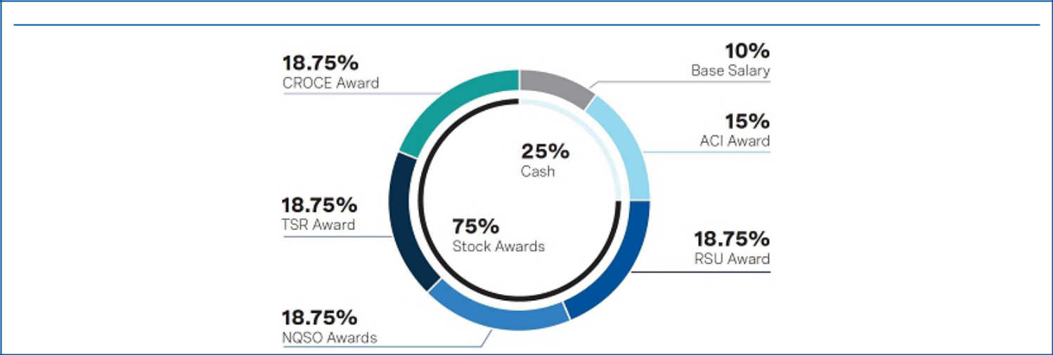

CEO TARGET DIRECT COMPENSATION MIX⁽¹⁾ — 90% VARIABLE/AT RISK

- Target direct compensation is composed of base salary, target annual cash incentive award opportunity and the target value of long-term incentive awards.

Significant Portion of ACI Award Tied to Sustainability

Based on shareholder feedback, the Compensation Committee maintained the sustainability metric weighting for the company performance portion of the ACI Award at 30% to continue advancing the company’s net-zero strategy and incentivize executives to address Occidental’s Scope 1, 2 and 3 emissions in the short-term by including targets focused on emissions reduction efforts and carbon ventures and reduction projects. For more information, see "Compensation Discussion and Analysis - Elements of the 2022 Compensation Program - Annual Cash Incentive" beginning on page 46.

Emissions Reduction Efforts
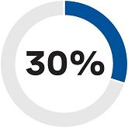
(Scope 1 and 2)

Reduce operating emissions

- Deploy the Emissions Technology program and Find It/Fix It operational emissions program to international locations

- Deploy at least 4 emissions reduction projects in the Permian Basin

- Achieve a 15% reduction in routine flaring from our 2020 baseline

Carbon Ventures and Reduction

Projects (Scope 3)

Advance carbon management platform

- Approval to commence, and commencement of, construction on first DAC plant (DAC 1)

- Enter into at least 1 carbon capture, transport or sequestration joint venture

- Enter into at least 3 low-carbon product development transactions

- Identify and coordinate external validation of the company’s carbon accounting process, including validation of GHG emissions at one or more operating sites

10

Table of Contents

Proxy Statement Summary

Highlights of Executive Compensation Program Policies and Practices

The 2022 executive compensation program for the NEOs includes many best-practice features that are intended to enhance the alignment of compensation with the interests of Occidental’s shareholders.


WHAT WE DO

Pay for Performance. A substantial majority of NEO compensation is performance-based. The Compensation Committee reviews the metrics underlying the long-term incentive award program and annual cash incentive (ACI) awards annually to evaluate their continued alignment with Occidental’s business priorities.

Act on Shareholder Feedback. Shareholder feedback influences the executive compensation program and contributed to the Compensation Committee’s decisions to maintain the weighting of sustainability metrics at 30% for the company performance portion of the ACI award opportunity. The favorable response from shareholders informed the Compensation Committee’s decision to maintain the sustainability metric’s weighting for the 2023 ACI award. Shareholder feedback also prompted us to enhance our disclosure to provide more information about the company’s performance against the metric targets approved in February 2022 for the 2022 ACI award.

Clawback in the Event of Misconduct. The Compensation Committee has the authority to claw back ACI awards and long-term incentive awards for violations of Occidental’s Code of Business Conduct and related policies. The Compensation Committee also intends to adopt a clawback policy consistent with the requirements of new Exchange Act Rule 10D-1 upon or prior to the effectiveness of applicable NYSE listing standards.

Emphasize Stock Ownership. Cash Return on Capital Employed (CROCE) and Total Shareholder Return (TSR) awards are payable in shares of common stock and the net shares received for each vested Restricted Stock Unit (RSU) award are subject to a two-year holding period. In addition, the named executive officers (as well as other officers) are subject to meaningful stock ownership guidelines, ranging from two to six times the officer’s annual base salary, and a holding requirement until such guidelines are met.

Monitor Compensation Program for Risk. The executive compensation program includes multiple features that are intended to appropriately mitigate excessive risk-taking. The Compensation Committee conducts an annual assessment of our executive compensation program to identify and minimize, as appropriate, any compensation arrangements that may encourage excessive risk-taking.

Use Double-Trigger Equity Vesting for Equity Awards. Pursuant to the Amended and Restated 2015 Long-Term Incentive Plan (2015 LTIP), equity awards vest in the event of a change in control only if there is also a qualifying termination of employment.

Use Relative and Absolute Performance Measures for Equity Awards. Performance equity is earned based on both relative shareholder returns and absolute financial returns, with TSR awards capped if Occidental’s absolute TSR is negative.


WHAT WE DON’T DO

No Dividend Equivalents on Unvested Performance Awards. Dividends and dividend equivalent rights are subject to the same performance goals as the underlying award and will not be paid until the performance award has vested and becomes earned (except in the case of certain retention awards).

No Hedging or Derivative Transactions. Occidental’s directors, executive officers and all other employees are not permitted to engage in transactions designed to hedge or offset the market value of Occidental’s equity securities.

No Golden Parachute Payments. Our golden parachute policy provides that, subject to certain exceptions, Occidental will not grant golden parachute benefits (as defined in the policy) to any executive officer which exceed 2.99 times his or her salary plus ACI award without shareholder approval.

No Repricing of Stock Options. Other than in connection with a corporate transaction involving Occidental, Occidental does not permit the repricing of stock options or stock appreciation rights without shareholder approval.

2023 PROXY STATEMENT
11

Table of Contents

Environmental and Sustainability

Pathway to Net Zero

In 2020, Occidental was the first U.S. oil and natural gas producer to establish net-zero emissions goals for our operations and products (Scopes 1, 2, and 3) aligned with the goals of the Paris Agreement. Our pathway to net zero combines continuous operational upgrades and improvements that lower emissions associated with our oil, gas and chemicals production coupled with industrial-scale carbon management solutions. Ultimately, Occidental is bringing together people, resources, innovative technology and our 50+ year legacy of carbon management to accelerate our pathway to net zero, as well as helping others do the same.

Net-zero emissions in our operations and energy use (Scope 1 and 2) before 2040, with an ambition to achieve before 2035

Net-zero for our total emissions inventory including product use (Scope 1, 2 and 3) with an ambition to achieve before 2050

Total carbon impact through carbon removal and storage technology and development past 2050

Scope 1: Direct reported emissions from our operations. Scope 2: Indirect reported emissions from the generation by others of power, heat and steam we consume. Scope 3: Other indirect reported emissions (not included in Scope 2) that occur in the value chain of the reporting company, including upstream and downstream emissions.

Occidental has established a range of interim targets that address the company’s Scope 1, 2 and 3 emissions, applying the short- (up to 2025), medium- (2026-2035) and long-term (2036-2050) time frames adopted by Climate Action 100+, to bolster Occidental’s net-zero strategy. These ambitious targets have been carefully set by management, with oversight from the Board, to maximize the efficient use of Occidental’s infrastructure and advance its field development plans and reflect insights from scenario modelling and assessments. Given the ramp-up of the commercialization of CCUS and DAC technology necessary, among other things, to achieve the challenging net-zero goals set by Occidental over the next three decades and beyond, we believe that Occidental’s net-zero pathway is non-linear and have discussed the same with shareholders in our engagement calls and meetings.


2022 SIGNIFICANT ACHIEVEMENTS

- Achieved Zero Routine Flaring during 2022 across U.S. oil and gas operations, eight years ahead of the World Bank’s 2030 target.

- Completed FEED and began construction of Occidental’s first commercial-scale DAC plant in the Permian Basin.

- Commenced pre-FEED activities for the company’s second DAC facility.

- Secured more than 400 square miles of pore space and land for Gulf Coast sequestration hubs.

- Received agency approval of closed-loop gas capture to mitigate non-routine flaring in the Permian Basin.

- Removed or converted over 3,100 gas-driven pneumatic control devices in our U.S. onshore operations in 2022, including over 76% of the remaining high-bleed and over 13% of the intermittent-bleed pneumatics.

- Filed permit applications for multiple Class VI sequestration wells.

- Original signatory to the Oil and Gas Climate Initiative’s “Aiming for Zero Methane Emissions” pledge.

Four Pillars of Sustainability

Occidental’s sustainability reporting and strategy align with the World Economic Forum’s (WEF) four pillars of Stakeholder Capitalism: (1) principles of governance, (2) planet, (3) people and (4) prosperity. Each pillar represents a key focus area as the company continues to implement and enhance sustainable business practices and programs. Occidental was the first U.S. oil and gas company to endorse WEF’s Stakeholder Capitalism Metrics, a global ESG framework that promotes transparency with investor and stakeholder engagement.

Reporting on Performance. Occidental’s Climate Report, CDP Climate Change Report, CDP Water Security Report and Annual ESG Performance Indicators summary table with information regarding our environmental, health, safety and social performance are among the documents available for download on Occidental’s website. Our disclosure leverages sustainability reporting frameworks and standards supported by investors and other stakeholders, including the recommendations of the TCFD, the disclosure standards set by the Sustainability Accounting Standards Board (SASB) and the Ipieca Sustainability Reporting Guidance.

For more information about our company’s net-zero pathway and other climate-related sustainability initiatives, visit www.oxy.com/Sustainability and see our 2022 Climate Report, available online at https://www.oxy.com/globalassets/documents/publications/oxy-climate-report-2022.pdf.

12

Table of Contents

Human Capital Resources

Occidental recognizes that a motivated, well-trained and diverse workforce is a strong competitive advantage and, as a result, has invested in employee engagement, training and development programs and tools to attract and retain diverse talent.

Health, Safety and Well-Being

The health and safety of Occidental’s workforce and communities is a top priority for Occidental. In November 2022, the Board approved updates to the company’s longstanding Health, Safety and Environmental Principles (as revised, the HSE and Sustainability Principles) that management recommended based on engagement with shareholders, employees and other stakeholders. Occidental endeavors to apply these principles to improve workplace and contractor safety, prevent and mitigate incidents and safeguard people and the environment in the communities where it operates.

Occidental strives to give employees the tools and resources they need to succeed both professionally and personally. To that end, Occidental offers, and regularly evaluates, its comprehensive health, welfare and retirement and savings benefits plans, professional memberships and work/life balance benefits. It also provides programs to enhance and support employees’ overall well-being, including their physical, mental, social and financial health. In 2022, Occidental increased its focus on mental health and holistic wellness through manager training and employee programs and events.

Diversity, Inclusion and Belonging (DIB)

Senior management, with the support of the Board, strives to foster a culture where employees’ differences are appreciated, celebrated and encouraged. To promote awareness, governance and oversight of the company’s DIB strategy and program, Occidental established the DIB Advisory Board and the DIB Ambassador Committee in 2021. The DIB Advisory Board, which is chaired by Occidental’s President and CEO and includes members of senior leadership, oversees the execution of Occidental’s integrated DIB strategy and its alignment with the company’s mission, vision and strategic objectives. The DIB Advisory Board also helps institutionalize DIB policies for recruitment, retention and development, among other things. The DIB Ambassador Committee, which is chaired by Occidental’s Vice President of Diversity and Inclusion, consists of a diverse group of employee representatives from all business segments, domestic and international. This committee leads company-wide initiatives to raise DIB awareness through educational resources and programs.

In 2022, to more efficiently and effectively recruit diverse talent, the company’s Human Resources (HR) department began implementing artificial intelligence powered talent platforms to source diverse talent, technical expertise and hard-to-find skills.

Employee Outreach and Engagement

Quarterly Executive Virtual Conversations. To enhance senior leadership’s engagement with employees, Occidental hosts Quarterly Executive Virtual Conversations (QEVCs), which provide employees the opportunity to hear directly from senior leadership regarding financial and operational updates and submit questions for management to answer. During the August 2022 QEVC, Occidental’s Vice President of Diversity and Inclusion presented an update on the company’s DIB strategy and initiatives. Occidental’s employee outreach and engagement extends beyond QEVCs to newsletters, focus groups and employee resource groups (ERGs), among other channels and tools.

Employee Resource Groups. In October 2022, as part of Occidental’s integrated DIB strategy, the HR department launched eight new ERGs to supplement our longstanding Early Career Network and Women of Oxy Network. An ERG is a group of employees who actively engage in communicating or gathering around a central purpose, mission, background or activity. ERGs can help advance inclusion and a sense of belonging of employees with a common set of interests and/or goals. The mission and goals of ERGs are fully aligned with Occidental’s expectation to be an employer, partner and neighbor of choice. Each ERG is inclusive of all employees—everyone can benefit from and participate in an ERG, either as a member or an ally. Our ERGs are as follows:

► | Allyship | ► | Out (LGBT+) Network | ► | Hispanic Network
► | Black Employee Network | ► | Veterans Network | ► | Mental Health Matters
► | Early Career Network | ► Women of Oxy Network |  | ► | Mosaic (Multicultural) Network

- FRIEND (Friends, Relatives and Individuals Empowering Neurodiversity)

Workforce Diversity Data

In response to shareholder feedback, we disclosed the workforce diversity data from the Consolidated EEO-1 Report that Occidental submitted in 2022 to the U.S. Equal Employment Opportunity Commission for the 2021 fiscal year. We encourage you to review the report, available online at https://www.oxy.com/globalassets/documents/ sustainability/oxy-eeo1-consolidated-2021.pdf.

2023 PROXY STATEMENT
13

Table of Contents


_{Proposal} ELECTION OF DIRECTORS

THE BOARD OF

DIRECTORS
RECOMMENDS
A VOTE “FOR” EACH
OF THE DIRECTOR
NOMINEES.

Director Nominations

The Board is committed to recruiting and nominating directors for election who will collectively provide the Board with the necessary diversity of skills, backgrounds and experiences to meet Occidental’s ongoing needs and support oversight of our business strategy and priorities. In recommending candidates for election to the Board, the Corporate Governance and Nominating Committee (the Governance Committee) evaluates a candidate’s character; judgment; skill set and experience in light of Occidental’s current and future needs and strategic priorities; independence; other time commitments, including other public and private company board memberships; and any other factors that the Governance Committee deems relevant. In addition, in determining whether to recommend incumbent directors for reelection to the Board, the Governance Committee also reviews and considers tenure; the director’s board and committee meeting attendance; the level of support that the director’s nomination received at the most recent annual shareholders’ meeting (if applicable); and the well-roundedness of the Board as a whole.

The Board is committed to ongoing and thoughtful refreshment of its membership and strives to maintain an appropriate balance of tenure, backgrounds and skills on the Board. The Board believes that this ongoing refreshment, which has resulted in three new directors since early 2022, further aligns Board composition with the needs of Occidental as our businesses evolve over time and encourages regular consideration of fresh viewpoints and perspectives. The Board also believes that, over time, directors develop an enhanced understanding of Occidental and an ability to work effectively as a group. Accordingly, the Board aims to have directors with a mix of tenures represented. In addition, the Board and the Governance Committee actively consider diversity in their recruitment and nominations of director candidates, and the effectiveness of these efforts is actively assessed during regular reviews of the Board’s composition.

The Board appreciates the value of diversity of backgrounds and experiences among its membership and shares investors’ goals for racial, ethnic and gender diversity on boards. Accordingly, the Board has been actively seeking additional members to enhance the diverse viewpoints and expertise represented on the Board and to increase the Board’s racial, ethnic and gender diversity. The Board elected Vicky A. Bailey as a director in March 2022. She possesses significant experience in the energy sector, both public and private. In January 2023, the Board added Claire O’Neil to the Board. With more than 16 years of experience in consulting, finance and clean energy growth strategy as well as climate policy, we believe she will provide valuable insight for our low-carbon initiatives. Most recently, in February 2023, Ken Robinson joined the Board. He brings over 40 years of experience in global finance and accounting, enterprise risk, ethics and compliance across several industries.

In February 2023, the Governance Committee recommended to the Board, and the Board approved, the nomination of the ten persons whose biographies appear below to serve for a one-year term ending at the 2024 Annual Meeting, but in any event, until his or her successor is elected and qualified, unless ended earlier due to his or her death, resignation, disqualification or removal from office.

If you submit a validly executed proxy card but do not specify how you want to vote your shares with respect to the election of directors, then your shares will be voted “FOR” the nominees proposed by our Board and named in this proxy statement, in line with our Board’s recommendation. The Board has no reason to believe that any of the Board’s nominees would be unable or unwilling to serve as a director if elected. However, should any of our Board’s nominees be unable or unwilling to stand for election at the time of the 2023 Annual Meeting, proxies may be voted for a substitute nominee selected by the Board, or the Board may reduce the number of directors.

14

Table of Contents

Proposal 1: Election of Directors

Pursuant to Occidental’s By-laws, in an uncontested election, the affirmative vote of a majority of votes cast with respect to each director nominee will be required for the nominee to be elected, meaning that the number of votes cast “FOR” a director must exceed the number of votes cast “AGAINST” that director. Your broker will not vote your shares on this proposal unless you give voting instructions, and abstentions and broker non-votes have no effect on the vote. Any nominee for director who does not receive a greater number of votes “FOR” his or her election than votes “AGAINST” in an uncontested election must tender his or her resignation. Unless accepted earlier by the Board, such resignation will become effective on October 31 of the year of the election.

About the Director Nominees

All of the nominees are currently directors of Occidental who were elected by shareholders at the 2022 Annual Meeting, except for Ms. O’Neill, who was appointed to the Board in January 2023, and Mr. Robinson, who was appointed to the Board in February 2023.

Biographical information with respect to each of our Board’s director nominees, together with a list of the core competencies that contributed to the determination that such person should serve as a director, is presented below. An overview of the core competencies of each of our Board’s director nominees is featured in a skills matrix on page 21.


JACK B. MOORE
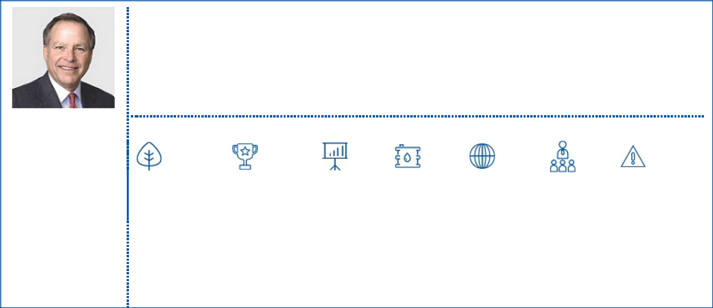

Director Qualifications

Mr. Moore most recently served as President and Chief Executive Officer of Cameron International Corporation from April 2008 to October 2015 and served as Chairman of the Board of Cameron from May 2011 until it was acquired by Schlumberger in 2016. Mr. Moore served as Cameron’s President and Chief Operating Officer from January 2007 to April 2008. Mr. Moore joined Cameron in 1999 and, prior to that, held various management positions at Baker Hughes, where he was employed for over 20 years. Mr. Moore is a partner at Genesis Investments. He currently serves on the University of Houston System Board of Regents and actively serves in leadership positions with the American Heart Association. Mr. Moore is a graduate of the University of Houston with a B.B.A. degree and attended the Advanced Management Program at Harvard Business School.

Before his election as our Independent Chairman in 2022, Mr. Moore served as Independent Vice Chairman from September 2019 until his election as Independent Chairman.

INDEPENDENT

Age: 69
Chairman Since: 2022
Director Since: 2016
Board Committees:
Compensation (Chair); Governance

Current Public Company Directorships:
KBR Inc.
ProPetro Holding Corp.

Former Public Company Directorships
(within the last 5 years):
Rowan Companies plc

Core Competencies

Environmental, | Executive | Financial | Industry | International | Public | Risk
Health, | Compensation | Reporting/ | Background | Experience | Company | Management
Safety & |  | Accounting |  |  | Executive
Sustainability |  | Experience |  |  | Experience

2023 PROXY STATEMENT
15

Table of Contents

Proposal 1: Election of Directors

VICKY A. BAILEY
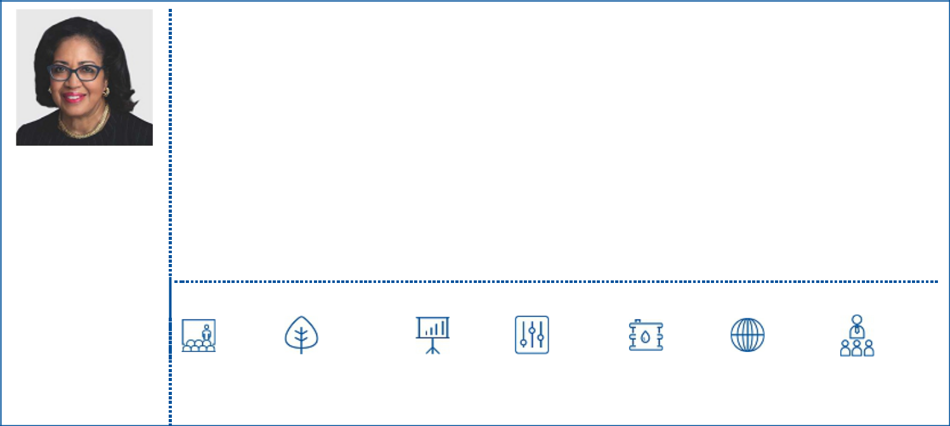

INDEPENDENT

Age: 70
Director Since: 2022
Board Committees:
Governance; Sustainability

Current Public Company Directorships:
Cheniere Energy, Inc.
Equitrans Midstream
Corporation
PNM Resources, Inc.

Former Public Company Directorships
(within the last 5 years):
EQT Corporation

Director Qualifications

Ms. Bailey has been President of Anderson Stratton International, LLC. (ASI), a strategic consulting and government relations entity, since November 2005 and is a former equity partner of BHMM Energy Services, LLC (2006-2013), a certified minority-owned energy facility management company contracted to manage the Central Energy Plant at the Indianapolis Airport Midfield Terminal Complex. Before being President of ASI, Ms. Bailey was a partner with Bennett Johnston & Associates, LLC, a public relations firm in Washington, D.C. (2004-2006). Ms. Bailey served as Assistant Secretary, U.S. Department of Energy for both Domestic Policy and International Affairs from 2001 to 2004. In the aftermath of September 11th, she was co-chair of several bilateral international energy working groups with the goal of implementing our national energy policy and strengthening our relationships with other nations to foster energy security. Also, in this role, she served as Vice Chair and the U.S. representative to the IEA, working with all energy-producing nations. Notably the International Energy Forum (IEF) was established in Riyadh, Saudi Arabia during her time as Assistant Secretary. Domestically, Ms. Bailey oversaw the development and implementation of energy policy in the areas of clean coal technologies, nuclear power, crude oil production, natural gas development and LNG production. Previously, she was the President of PSI Energy, Inc., Indiana’s largest electric utility and a subsidiary of Cinergy Corp. (now Duke Energy). From 1993 to 2000, she was appointed as a Commissioner, Federal Energy Regulatory Commission (FERC), and from 1986 to 1993, she served as a Commissioner, Indiana Utility Regulatory Commission (IURC). Ms. Bailey was a trustee of the North American Electric Reliability Corporation (NERC) from 2010 to 2013, the not-for-profit international regulatory authority whose mission is to assure the effective and efficient reduction of risks to the reliability and security of the transmission grid. In addition to her public company board service, Ms. Bailey serves as a director of Battelle Memorial Institute, a private nonprofit applied science, technology and research organization that has a management role at several of the U.S. national laboratories. Her other not-for-profit board service include Executive Chair, United States Energy Association (USEA), a trustee of The Conference Board (TCB), Resources for the Future (RFF), member National Petroleum Council, American Association of Blacks in Energy (AABE), National Academies Board on Energy and Environmental Systems and the Girl Scout Council of the Nation’s Capital. Ms. Bailey has a Bachelor of Science in Industrial Management from the Krannert School of Management at Purdue University and completed the Advanced Management Program at the Wharton School of the University of Pennsylvania.

Core Competencies

Corporate | Environmental, | Financial | Government, | Industry | International | Public
Governance | Health, | Reporting/ | Legal & | Background | Experience | Company
 | Safety & | Accounting | Regulatory |  |  | Executive
 | Sustainability | Experience |  |  |  | Experience

16

Table of Contents

Proposal 1: Election of Directors

ANDREW GOULD
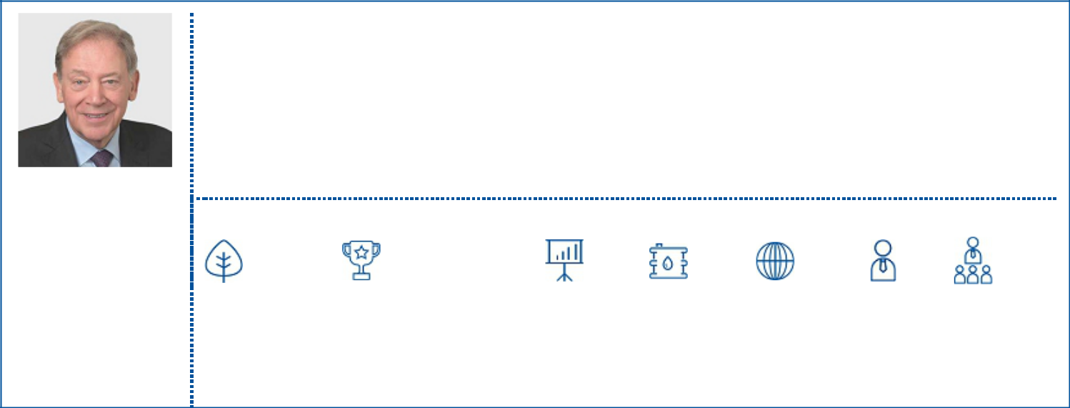

INDEPENDENT

Age: 76
Director Since: 2020
Board Committees:
Sustainability (Chair);
Audit; Environmental,
Health and Safety

Former Public

Company Directorships
(within the last 5 years):
BG Group
McDermott
International, Ltd
Saudi Aramco


Director Qualifications

Mr. Gould is the former Chairman and Chief Executive Officer of Schlumberger Limited (Schlumberger), a leading oilfield services company, and served in that capacity from 2003 to 2011. Mr. Gould began his career at Schlumberger in 1975 in its Internal Audit department, based in Paris. In addition to his career at Schlumberger, Mr. Gould served as non-Executive Chairman of BG Group, a multinational oil and gas company, from 2012 until its sale to Royal Dutch Shell in 2016 and served as interim Executive Chairman in 2014. Mr. Gould served on the United Kingdom Prime Minister’s Council for Science and Technology from 2004 to 2007. He was Vice-Chairman Technology for the United States National Petroleum Councils’ 2007 report “Facing the Hard Truths about Energy” and was awarded the Charles F. Rand Memorial Gold Medal by the Society of Petroleum Engineers in 2014. He is currently a partner of CSL Capital Management, a private equity firm that specializes in energy services, Chairman of BJ Energy Services, a private pressure pumping business, Chairman of Kayrros Advisory Board, an advanced data analytics company, and Chairman of the International Advisory Board at Boston Consulting Group Center for Energy Impact. Mr. Gould is a member of the U.S. National Petroleum Council. Mr. Gould has an undergraduate degree in Economic History from Cardiff University and qualified as a Chartered Accountant with the Institute of Chartered Accountants in England and Wales.

Core Competencies

Environmental, | Executive | Finance/ | Financial | Industry | International | Investor | Public
Health, | Compensation | Capital | Reporting/ | Background | Experience | Relations | Company
Safety & |  | Markets | Accounting |  |  |  | Executive
Sustainability |  |  | Experience |  |  |  | Experience

CARLOS M. GUTIERREZ
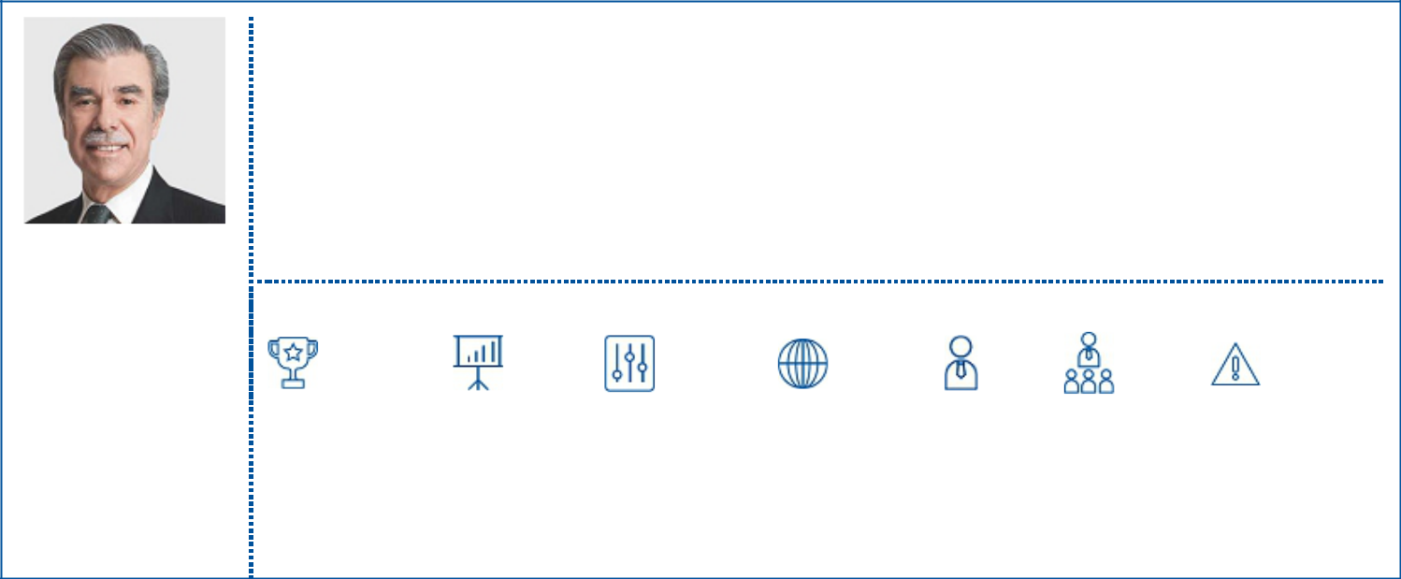

INDEPENDENT

Age: 69
Director Since: 2009
Board Committees:
Audit; Governance; Sustainability

Current Public Company Directorships:

Exelon Corporation MetLife, Inc.

Former Public Company Directorships
(within the last 5 years):
Time Warner Inc.

2023 PROXY STATEMENT

Director Qualifications

Secretary Gutierrez is Co-Founder, Executive Chairman and CEO of EmPath, Inc., a skills intelligence software technology company. Previously, Secretary Gutierrez was Co-Chair of Albright Stonebridge Group, a commercial diplomacy and strategic advisory firm, from April 2013 to July 2020. He joined Albright Stonebridge from Citigroup Inc. where he was Vice Chairman of the Institutional Clients Group and a member of the Senior Strategic Advisory Group at Citigroup Inc. from 2011 to February 2013. Prior to joining Citigroup, Secretary Gutierrez was with communications and public affairs consulting firm APCO Worldwide Inc., where he was Chairman of the Global Political Strategies division in 2010. He served as U.S. Secretary of Commerce from February 2005 to January 2009, where he worked with foreign government and business leaders to advance economic relationships and enhance trade. Prior to his government service, Secretary Gutierrez was with Kellogg Company, a global manufacturer and marketer of well-known food brands, for nearly 30 years. After assignments in Latin America, Canada, Asia, and the United States, he became President and Chief Executive Officer in 1999 and Chairman of the Board in 2000, positions he held until 2005. Secretary Gutierrez currently serves as an external director on the U.S. Board of PwC, a private professional services firm. He is a member of the Human Freedom Advisory Council at the George W. Bush Institute, the Bo’ao Forum for Asia and the Tent Partnership for Refugees Advisory Council. He is also a cofounder of The Dream. US, a scholarship fund for undocumented students.

Core Competencies

Executive | Financial | Government, | International | Investor | Public | Risk
Compensation | Reporting/ | Legal & | Experience | Relations | Company | Management
 | Accounting | Regulatory |  |  | Executive
 | Experience |  |  |  | Experience

17

Table of Contents

Proposal 1: Election of Directors


VICKI HOLLUB
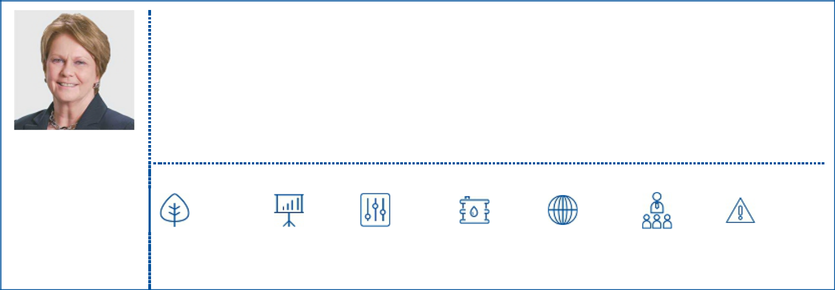

PRESIDENT AND CHIEF

EXECUTIVE OFFICER
Age: 63
Director Since: 2015

Current Public Company Directorships:

Lockheed Martin


Director Qualifications

Ms. Hollub became President and Chief Executive Officer of Occidental Petroleum Corporation in April 2016. She has been a member of Occidental’s Board of Directors since 2015. During her 40-year career with Occidental, Ms. Hollub has held a variety of management and technical positions with responsibilities on three continents, including roles in the United States, Russia, Venezuela and Ecuador. Most recently, she served as Occidental’s President and Chief Operating Officer, overseeing the company’s oil and gas, chemical and midstream operations. Ms. Hollub previously was Senior Executive Vice President, Occidental Petroleum, and President, Oxy Oil and Gas, where she was responsible for operations in the U.S., the Middle East and Latin America. Prior to that, she held a variety of leadership positions, including Executive Vice President, Occidental, and President, Oxy Oil and Gas, Americas; Vice President, Occidental, and Executive Vice President, U.S. Operations, Oxy Oil and Gas; Executive Vice President, California Operations; and President and General Manager of the company’s Permian Basin operations. Ms. Hollub started her career at Cities Service, which was acquired by Occidental. Ms. Hollub serves on the boards of Lockheed Martin and the American Petroleum Institute. She is the chair of the World Economic Forum’s Oil and Gas Community and a member of the Oil and Gas Climate Initiative. A graduate of the University of Alabama, Ms. Hollub holds a Bachelor of Science in Mineral Engineering. She was inducted into the University of Alabama College of Engineering 2016 class of Distinguished Engineering Fellows.

Core Competencies

Environmental, | Financial | Government, | Industry | International | Public | Risk
Health, | Reporting/ | Legal & | Background | Experience | Company | Management
Safety & | Accounting | Regulatory |  |  | Executive
Sustainability | Experience |  |  |  | Experience

WILLIAM R. KLESSE
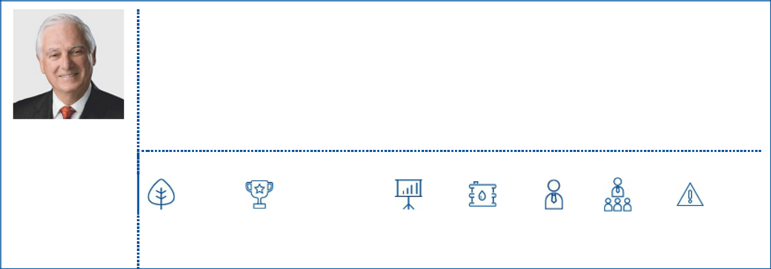

INDEPENDENT

Age: 76
Director Since: 2013
Board Committees:
Environmental, Health and Safety (Chair); Compensation

Former Public Company Directorships:
(within the last 5 years):
MEG Energy

Director Qualifications

Mr. Klesse is the former Chief Executive Officer and former Chairman of the Board of Valero Energy Corporation (Valero), an international manufacturer and marketer of transportation fuels, other petrochemical products and power. He joined the Valero board as Vice Chairman in 2005 and served as Chairman of the Board from 2007 until his retirement in December 2014. From 2006 to May 2014, he served as Chief Executive Officer of Valero and served as President from 2008 to 2013. From 2003 to 2005, Mr. Klesse was Valero’s Executive Vice President and Chief Operating Officer. Prior to that, he served as Executive Vice President of Refining and Commercial Operations following Valero’s 2001 acquisition of Ultramar Diamond Shamrock Corporation, where he had been Executive Vice President of the company’s refining operations. Mr. Klesse began his 45-plus year career in the energy industry at Diamond Shamrock Corporation, which merged with Ultramar Corporation in 1996. Mr. Klesse is a trustee of the University of Dayton, Texas Biomedical Research Institute and United Way of San Antonio and Bexar County and serves on the Advisory Board of the San Antonio Food Bank and the UTSA Engineering Advisory Council at the Margie and Bill Klesse College of Engineering and Integrated Design. He also serves on the boards of The Briscoe Western Art Museum and Christus Santa Rosa Foundation. Mr. Klesse holds a bachelor’s degree in Chemical Engineering from the University of Dayton and a Master of Business Administration with an emphasis in Finance from West Texas A&M University.

Core Competencies

Environmental, | Executive | Finance/ | Financial | Industry | Investor | Public | Risk
Health, | Compensation | Capital | Reporting/ | Background | Relations | Company | Management
Safety & |  | Markets | Accounting |  |  | Executive
Sustainability |  |  | Experience |  |  | Experience

18

Table of Contents

Proposal 1: Election of Directors

CLAIRE O’NEILL


Director Qualifications

Ms. O’Neill served as the Managing Director for Climate and Energy at the World Business Council for Sustainable Development (WBCSD) from August 2020 until December 2021. Prior to that, Ms. O’Neill served as COP26 President-Designate from July 2019 until February 2020. Before leading the UK’s successful bid to host COP 26, Ms. O’Neill served as a UK Member of Parliament for Devizes from 2010 until 2019, where she was a Government Whip and Minister for Rail before being appointed as Minister of State for Energy and Clean Growth. Ms. O’Neill currently serves as Co-Chair of the Global Imperatives Advisory Board for the WBCSD, an Executive Board Director and Chair of the International Advisory Council for Climate Impact X and a co-founder and co-chair of the Responsible Energy Forum, among other senior advisory roles regarding climate and sustainability matters. From March 2022 to January 2023, Ms. O’Neill served as an Executive Board Director and Audit Committee member of Scottish Power. Ms. O’Neill has a Bachelor of Arts in Geography from Brasenose College at Oxford University and a Master of Business Administration from Harvard Business School.

INDEPENDENT |  | Core Competencies
Age: 58
Director Since: 2023
Board Committees:
Governance; Sustainability |  | Environmental, | Finance/ | Financial | Government, | Industry | International
 |  | Health, | Capital | Reporting/ | Legal & | Background | Experience
 |  | Safety & | Markets | Accounting | Regulatory
 |  | Sustainability |  | Experience


AVEDICK B. POLADIAN
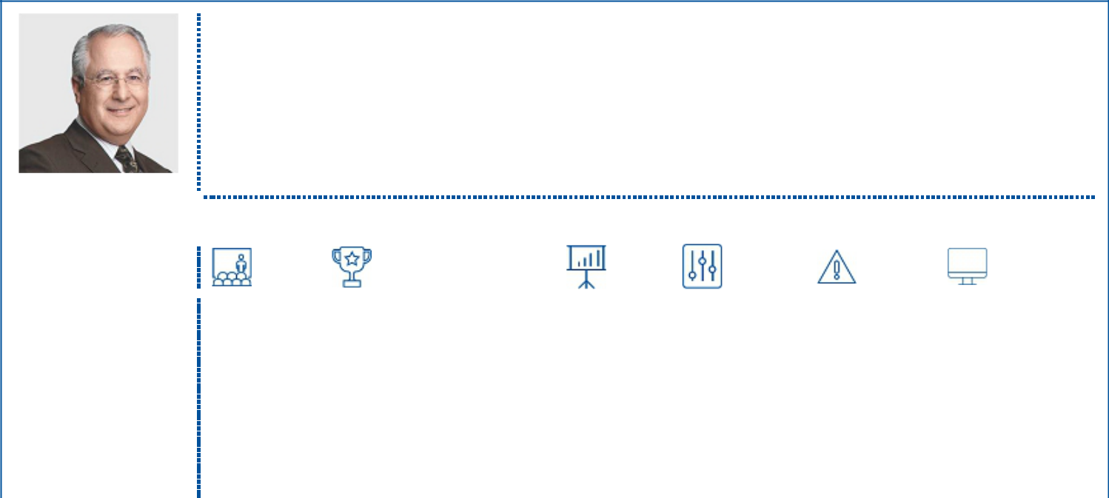

Director Qualifications

Mr. Poladian is currently a director and the former Executive Vice President and Chief Operating Officer (2002-2016) of Lowe Enterprises, Inc., a privately-held diversified national real estate company active in commercial, residential and hospitality property investment, management and development. During his tenure as Chief Operating Officer, Mr. Poladian oversaw human resources, risk management, construction, finance and legal functions across the firm. Mr. Poladian was with Arthur Andersen from 1974 to 2002, admitted to Partner in 1984, Managing Partner, Pacific Southwest in 1989, and is a certified public accountant (inactive). He is a past member of the Young Presidents Organization, the California Society of CPAs and the American Institute of CPAs. Mr. Poladian was appointed to the California State Board of Accountancy and served in the position for nine years. He is a Director Emeritus of the YMCA of Metropolitan Los Angeles, a member of the Board of Advisors of the USC Price School of Public Policy, a member of the Board of Advisors of the Ronald Reagan UCLA Medical Center and a former Trustee of Loyola Marymount University. Mr. Poladian holds a bachelor’s degree in Accounting from Loyola Marymount University.

INDEPENDENT
Age: 71 |  | Core Competencies
Director Since: 2008
Board Committees:
Governance (Chair); Audit;
Compensation
Current Public Company |  | Corporate | Executive | Finance/ | Financial | Government, | Risk | Technology/
Directorships: |  | Governance | Compensation | Capital | Reporting/ | Legal & | Management | Cyber Security
Public Storage |  |  |  | Markets | Accounting | Regulatory
Western Asset |  |  |  |  | Experience
Management Company
Funds
Former Public Company
Directorships
(within the last 5 years):
California Resources
Corporation
2023 PROXY STATEMENT
19

Table of Contents

Proposal 1: Election of Directors

KEN ROBINSON
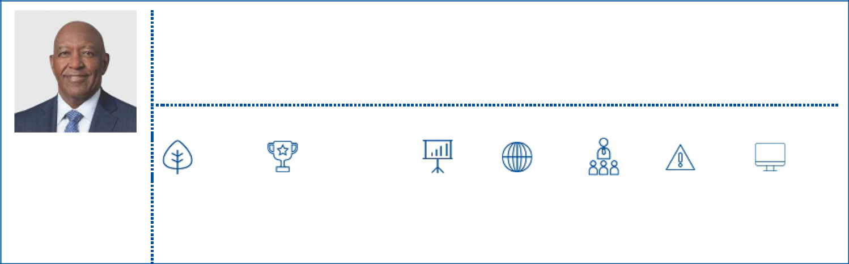

INDEPENDENT

Age: 68
Director Since: 2023

Current Public Company Directorships:

Abercrombie & Fitch Co. Paylocity Holding Corporation


Director Qualifications

Mr. Robinson served as the Senior Vice President of Audit and Controls at Exelon Corporation from 2016 to 2020. Before Exelon, Mr. Robinson held several senior leadership positions during his nearly 40-year career at The Procter & Gamble Company, including Vice President, Global Diversity & Inclusion; Global Risk and Compliance Leader; Chief Audit Executive; and Vice President, Finance. Mr. Robinson currently serves on the boards of directors of Abercrombie & Fitch Co., Paylocity Holding Corporation and Morgan Stanley U.S. Banks. He also serves as a Trustee of the International Financial Reporting Standards Foundation and is board chair of the National Underground Railroad Freedom Center Museum. Mr. Robinson has a Bachelor of Science from Mississippi State University and a Master of Business Administration from the University of Memphis.

Core Competencies

Environmental, | Executive | Finance/ | Financial | International | Public | Risk | Technology/
Health, | Compensation | Capital | Reporting/ | Experience | Company | Management | Cyber
Safety & |  | Markets | Accounting |  | Executive |  | Security
Sustainability |  |  | Experience |  | Experience

ROBERT M. SHEARER
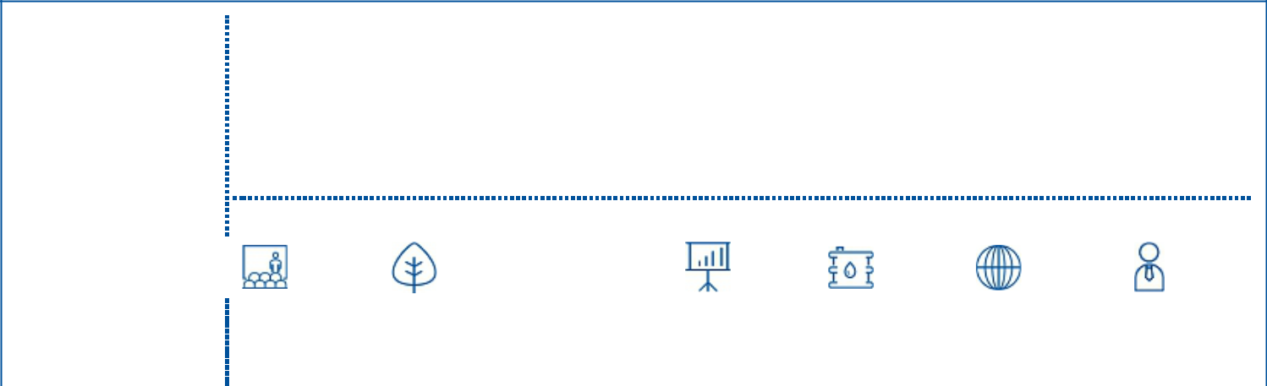

Director Qualifications

Mr. Shearer retired in 2017 as a managing director of BlackRock Advisors, LLC, where he also served as co-head of BlackRock’s Equity Dividend team and was a member of the Fundamental Equity Platform within BlackRock’s Portfolio Management Group. Mr. Shearer was also the portfolio manager for both the BlackRock Equity Dividend Fund and Natural Resources Trust, which grew from $500 million to over $50 billion under his leadership. Prior to that, Mr. Shearer managed the Merrill Lynch World Natural Resources Portfolio for Merrill Lynch Investment Managers, which merged with BlackRock in 2006. Mr. Shearer has also held senior leadership roles at David L. Babson & Company, Concert Capital Management and Fiduciary Trust Company International. As a senior research officer for Citicorp Investment Management, he focused on the oil industry, including exploration and production, pipelines and oilfield services. Mr. Shearer holds an undergraduate degree in Economics from the University of Wisconsin, as well as a Master of International Management from the Thunderbird School of Global Management and a Master of Business Administration from the University of Wisconsin. He is a Chartered Financial Analyst.

INDEPENDENT | Core Competencies
Age: 67
Director Since: 2019
Board Committees:
Audit (Chair);
Environmental, Health and | Corporate | Environmental, | Finance/ | Financial | Industry | International | Investor
Safety; Sustainability | Governance | Health, | Capital | Reporting/ | Background | Experience | Relations
 |  | Safety & | Markets | Accounting
 |  | Sustainability |  | Experience
20

Table of Contents

Proposal 1: Election of Directors

Summary of the Board’s Director Nominee Core Competencies and Composition Highlights

The following chart summarizes the competencies that the Board considers valuable to effective oversight of Occidental and illustrates how our Board’s director nominees individually and collectively represent these key competencies. The lack of an indicator for a particular item does not mean that the director does not possess that qualification, skill or experience as we look to each director to be knowledgeable in these areas; rather, the indicator represents that the item is a core competency that contributed to his or her nomination to the Board.

Corporate Governance |  | ● |  |  |  |  |  | ● |  | ●
contributes to the Board’s understanding of best practices in corporate governance matters |  | ● |  |  |  |  |  | ● |  | ●
Environmental, Health, Safety & Sustainability | ● | ● | ● |  | ● | ● | ● |  | ● | ●
contributes to the Board’s oversight and understanding of EHS and sustainability issues and their relationship to the | ● | ● | ● |  | ● | ● | ● |  | ● | ●
company’s business and strategy
Executive Compensation | ● |  | ● | ● |  | ● |  | ● | ●
contributes to the Board’s ability to attract, motivate and retain executive talent and to align compensation programs | ● |  | ● | ● |  | ● |  | ● | ●
with shareholder interests
Finance/Capital Markets |  |  | ● |  |  | ● | ● | ● | ● | ●
valuable in evaluating Occidental’s capital structure, capital allocation and financial strategy (dividends/stock |  |  | ●
repurchases/financing)
Financial Reporting/Accounting Experience | ● | ● | ● | ● | ● | ● | ● | ● | ● | ●
critical to the oversight of the company’s financial statements and financial reports
Government, Legal & Regulatory |  | ● |  | ● | ● |  | ● | ●
contributes to the Board’s ability to navigate regulatory dynamics and understand complex legal matters and public |  | ● |  | ● | ● |  | ● | ●
policy issues
Industry Background | ● | ● | ● |  | ● | ● | ● |  |  | ●
contributes to a deeper understanding of our business strategy, operations, key performance indicators and | ● | ● | ● |  | ● | ● | ● |  |  | ●
competitive environment
International Experience | ● | ● | ● | ● | ● |  | ● |  | ● | ●
critical to cultivating and sustaining business and governmental relationships internationally and providing oversight |  |  |  |  |  |  | ● |  | ● | ●
of our multinational operations
Investor Relations |  |  | ● | ● |  | ● |  |  |  | ●
contributes to the Board’s understanding of shareholder concerns and perceptions |  |  | ● | ● |  | ● |  |  |  | ●
Public Company Executive Experience |  | ● | ● | ● | ● | ● |  |  | ●
contributes to the Board’s understanding of operations and business strategy and demonstrates leadership | ● |  |  |  |  |  |  |  | ●
ability
Risk Management | ● |  |  | ● | ● | ● |  | ● | ●
contributes to the identification, assessment and prioritization of significant risks facing the company | ● |  |  | ● | ● | ● |  | ● | ●
Technology/Cyber Security |  |  |  |  |  |  |  | ● | ●
contributes to the Board’s understanding of information technology and cyber risks |  |  |  |  |  |  |  | ● | ●




2023 PROXY STATEMENT
21

Table of Contents

Proposal 1: Election of Directors

INDEPENDENCE

Occidental’s governance policies require that independent directors comprise at least two-thirds of the members of the Board (a policy that exceeds (NYSE) requirements). The Board has affirmatively determined that each of our Board’s director nominees, other than Ms. Hollub, is independent.
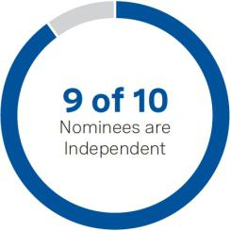

TENURE

The average tenure of our Board’s director nominees is approximately 6.0 years, which we believe reflects a balance of company experience and new perspectives.
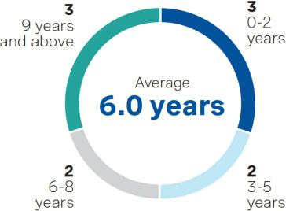

DIVERSITY

The Board recognizes the importance of having a diverse and broadly
inclusive membership. As part of its commitment to diversity and Board
refreshment, the Board recently elected Ms. O’Neill and Mr. Robinson as

directors.


22

Table of Contents

Corporate Governance

Occidental’s corporate governance policies (the Corporate Governance Policies) establish Occidental’s governance framework. The Corporate Governance Policies address the structure and operation of the Board, including matters related to director independence; tenure; outside board memberships; the role of the Board’s Independent Chairman; director stock ownership; and Board, Committee and individual director performance evaluations. In addition to the Corporate Governance Policies, the Board has established other stand-alone governance policies, including a policy on shareholder rights plans, a confidential voting policy and an independent compensation consultant policy. Occidental’s governance policies are reviewed and updated periodically, in light of changing regulations, evolving best practices and shareholder feedback. The Corporate Governance Policies and other governance policies are available on our website at www.oxy.com/investors/governance.

Occidental’s corporate governance practices generally align with the Investor Stewardship Group’s Corporate Governance Framework for U.S. Listed Companies.

Corporate Governance Highlights


RELATING TO THE BOARD

Independent Chairman of the Board

Annual elections of the entire Board by a majority of votes cast (for uncontested elections)

Mandatory resignation if a majority vote is not received (for uncontested elections)

Demonstrated commitment to Board refreshment

Tenure policy that seeks to maintain an average tenure of 10 years or less for non-employee directors

Board committees composed entirely of independent directors

Meaningful director stock ownership guidelines (6x annual cash retainer)

with holding requirement

Annual evaluations of the Board, each committee and individual directors

One meeting dedicated to strategy discussions every year with an expanded management group, in addition to ongoing strategy oversight

RELATING TO SHAREHOLDER RIGHTS


Ability of shareholders to call a special meeting at a 15% threshold

Ability of shareholders to propose an action by written consent at a 15% threshold

Shareholder right to proxy access (3% for 3 years, up to 20% of the Board)⁽¹⁾
Confidential Voting Policy

Nominating Policy to consider properly submitted shareholder-recommended director nominees

No supermajority voting requirements

Active independent director participation in and oversight of the shareholder engagement program

- For more information, see "Corporate Governance - Director Selection and Recruitment - Proxy Access for Shareholder Nominated Director Candidates" on page 25.

2023 PROXY STATEMENT
23

Table of Contents

Corporate Governance

Board Evaluation Process

Led by the Governance Committee, the Board conducts a robust annual evaluation of its performance and the performance of each of the Board’s committees and the individual directors. The Governance Committee believes that board evaluations are a critical tool in assessing the composition and effectiveness of the Board, its committees and its members and present an opportunity to identify areas of strength and areas capable of improvement. The annual Board evaluation includes an assessment of, among other things, whether the Board and its committees have the necessary diversity of skills, backgrounds and experiences to meet Occidental’s needs. The evaluation process also includes ongoing discussion and feedback from directors throughout the year regarding the Board and its committees’ effectiveness. The Governance Committee annually considers the format of its evaluation processes, which, in recent years, have intentionally included different formats, such as questionnaires, individual director interviews and the use of a third-party facilitator. The 2022 Board evaluation process is summarized below.

DETERMINE THE PROCESS | In 2022, the Governance Committee recommended, and the Board approved, Board evaluations through the use of:
 | (i) written questionnaires, (ii) a skills matrix and (iii) individual director interviews. This process was intended to
 | encourage feedback from directors to promote productive discussions.
CONDUCT EVALUATIONS | The Board and committee questionnaires solicited feedback related to committee and board effectiveness and
 | performance; agenda topics and materials; skills; leadership; and, at the Board level, matters related to strategy. The
 | questionnaires also included open-ended questions that prompted each director to reflect and comment on his or her
 | own individual performance and contributions to the Board. The Chair of the Governance Committee interviewed
 | each director to discuss his or her questionnaire responses and to solicit additional feedback.
ANALYZE THE RESULTS | In late 2022, the aggregated results of each questionnaire and feedback from the director interviews was reviewed
 | and discussed at a meeting of the Governance Committee. Each committee reviewed its individual results, and the
 | Chair of the Governance Committee led the Board in a discussion of the overall findings at a meeting of the full
 | Board.
TAKE RESPONSIVE ACTION | As part of its analysis of the evaluation results, the Board and management determined appropriate responsive
 | actions to be implemented over the next year that are intended to address areas that were identified as capable of
 | improvement. For example, at the Board level, this process provided valuable insight for Board succession planning
 | and preferred director candidate qualifications. At the committee level, for the Sustainability and Shareholder
 | Engagement Committee as one example, in response to feedback regarding meeting materials, enhancements have
 | been made to pre-read meeting materials and management presentations to allow for more robust discussion relative
 | to the time spent on presentations at committee meetings.

Director Selection and Recruitment

Pursuant to the Board’s Nominating Policy, the Governance Committee considers director candidates recommended by shareholders as discussed further on page

- In recent years, the Board has identified director candidates through the use of independent search firms, third-party recommendations and the recommendations of directors and executive officers. For a discussion of the factors that the Governance Committee considers in recommending candidates for election to the Board, see “Proposal 1: Election of Directors – Director Nominations” on page 14.

24

Table of Contents

Corporate Governance

Proxy Access for Shareholder-Nominated Director Candidates

Occidental’s By-laws permit a group of up to 20 shareholders, collectively owning 3% or more of Occidental’s outstanding common stock continuously for at least three years, to nominate and have included in Occidental’s proxy materials, director nominees constituting up to 20% of the Board, but not less than two directors, provided that the shareholder(s) and the nominee(s) meet the requirements of Occidental’s By-laws. For more information on proxy access and other procedures to recommend candidates to the Board, see “Director Nominations for the 2024 Annual Meeting” beginning on page 91.


3% _{for} 3 2 _{or} 20%


shares years nominees of the number of directors

Any shareholder or group of up to 20 shareholders maintaining continuous qualifying ownership of at least 3% of our outstanding shares for at least 3 years

Can nominate, and have included in our proxy materials, director nominees constituting the greater of 2 nominees or 20% (rounded down) of the Board

Nominating shareholder(s) and the nominee(s) must also meet the eligibility requirements described in Occidental’s By-laws.

Board of Directors and its Committees

Occidental is governed by its Board, which is led by an independent Chairman, and its five committees, composed entirely of independent directors. The structure of the Board and the responsibilities of its committees are described in more detail below.

Director Independence

Occidental’s governance policies require that independent directors comprise at least two-thirds of the members of the Board (a policy that exceeds NYSE requirements). The Board has affirmatively determined that each of our Board’s director nominees, other than Ms. Hollub, is independent. The Board also determined that Margarita Paláu-Hernández, who served as a director until the 2022 Annual Meeting, and Gary Hu and Andrew N. Langham, who served as directors until March 2022, each qualified as independent during his or her service on the Board.

Independent Board Leadership Structure

Occidental’s By-laws provide for the Board to annually elect one of its independent directors to be Chairman of the Board.

Mr. Moore has served as the Independent Chairman of the Board since September 2022. The Chairman of the Board presides at Board meetings and meetings of shareholders and his/her responsibilities include, among other things:


- Call meetings of the independent directors and chair executive sessions of the Board at which no members of management are present;

- Approve the agendas for Board and committee meetings;

- Propose a schedule of Board meetings and the information to be provided by management for Board consideration;

- Recommend the retention of consultants who report directly to the Board;

- Assist in assuring compliance with the Corporate Governance Policies and recommend revisions to the policies;

- Evaluate, along with the members of the Compensation Committee and the other independent directors, the performance of the Chief Executive Officer;

- Consult with other Board members as to recommendations on the membership and chairpersons of the Board committees and discuss recommendations with the Governance Committee;

- Communicate to the CEO the views of the independent directors and the Board committees with respect to objectives set for management by the Board; and

- Serve as a liaison between the Board and Occidental’s shareholders.

2023 PROXY STATEMENT
25

Table of Contents

Corporate Governance

Occidental’s By-laws provide that the Board may also elect a Vice Chairman from among the independent directors to perform the duties of the Chairman in the absence or disability of the Chairman. Prior to Mr. Moore’s appointment as Independent Chairman, he served as the Independent Vice Chairman of the Board since September 2019, which allowed for a more seamless transition into his role as Chairman.

Board Committees

The committees of the Board are composed entirely of independent directors. The primary responsibilities of the committees are described below. From time to time, the Board of Directors delegates additional duties to the committees.


AUDIT COMMITTEE

MEMBERS:

Robert M. Shearer (Chair)

Andrew Gould

Carlos M. Gutierrez

Avedick B. Poladian

MEETINGS IN 2022: 4

The Audit Committee members are independent and the Board has determined that each Audit Committee member is an “audit committee financial expert” within the meaning of the SEC’s regulations.

The Audit Committee Report with respect to Occidental’s financial statements is on page 80.

PRIMARY RESPONSIBILITIES:


- Engage and evaluate the independent auditor

- Discuss the scope and results of the audit with the independent auditor and matters required to be discussed by the Public Company Accounting Oversight Board (PCAOB)

- Oversee financial reporting and accounting principles and controls and the internal audit function

- Review internal audit reports and responsive actions by management

- Review matters relating to financial risk

- Evaluate the independent auditor’s qualifications, performance and independence

- Oversee matters relating to Occidental’s Code of Business Conduct

- Assist the Board in monitoring the integrity of Occidental’s financial statements and Occidental’s compliance with legal and regulatory requirements with respect to financial matters

ENVIRONMENTAL, HEALTH AND SAFETY COMMITTEE


MEMBERS

William R. Klesse (Chair)

Andrew Gould

Robert M. Shearer

MEETINGS IN 2022: 4*

PRIMARY RESPONSIBILITIES:

- Review and discuss with management the status of environmental, health and safety issues, including compliance with applicable laws and regulations

- Review and discuss the results of internal compliance reviews and remediation projects

- Review and discuss with management Occidental’s environmental, health and safety performance and related initiatives

- Does not include a joint meeting of the EH&S and S&SE Committees to discuss the company’s GHG emissions and associated reporting.

26

Table of Contents

Corporate Governance

CORPORATE GOVERNANCE AND NOMINATING COMMITTEE


MEMBERS:

Avedick B. Poladian (Chair)

Vicky A. Bailey

Carlos M. Gutierrez

Jack B. Moore

Claire O’Neill

MEETINGS IN 2022: 3

It is the policy of the Governance Committee to consider nominees to the Board recommended by Occidental’s shareholders. See pages 91-92 for information regarding how to recommend nominees to the Board.

PRIMARY RESPONSIBILITIES:

- Recommend candidates for election to the Board

- Review and interpret Occidental’s Corporate Governance Policies and consider other governance issues

- Review and approve related party transactions

- Oversee the evaluation of the Board, its committees and the individual directors

- Evaluate and make recommendations to the Board regarding the compensation and benefits of non-employee directors

EXECUTIVE COMPENSATION COMMITTEE


MEMBERS:

Jack B. Moore (Chair)

William R. Klesse

Avedick B. Poladian

MEETINGS IN 2022: 4

The Compensation Committee’s report on executive compensation is on page 60.

PRIMARY RESPONSIBILITIES:

- Review the performance of the CEO and determine CEO compensation based on this evaluation

- Review and approve the compensation of all other executive officers

- Oversee the assessment of risks related to Occidental’s compensation policies and programs

- Administer Occidental’s equity-based incentive compensation plans and periodically review the performance of the plans

SUSTAINABILITY AND SHAREHOLDER ENGAGEMENT COMMITTEE


MEMBERS:

Andrew Gould (Chair)

Vicky A. Bailey

Carlos M. Gutierrez

Claire O’Neill

Robert M. Shearer

MEETINGS IN 2022: 3*

PRIMARY RESPONSIBILITIES:

- Review and oversee Occidental’s external reporting on ESG and sustainability matters, including climate-related risks and opportunities

- Review and oversee the company’s social responsibility programs, policies and practices, including the Human Rights Policy, and oversee associated external reporting

- Oversee Occidental’s shareholder engagement program

- Review and monitor climate-related public policy trends and related regulatory matters

- Review shareholder proposals related to matters overseen by the committee

- Oversee Occidental’s Political Contributions and Lobbying Policy and review Occidental’s political activities and expenditures

- Oversee the Charitable Contributions and Matching Gift Program

- Does not include a joint meeting of the EH&S and S&SE Committees to discuss the company’s GHG emissions and associated reporting.

2023 PROXY STATEMENT
27

Table of Contents

Corporate Governance

Director Engagement

Director Education and Orientation

Directors are provided with continuing education, including business-specific learning opportunities through site visits and briefing sessions led by internal experts or third parties on topics that are relevant to Occidental. For example, Board and committee briefings on climate risks and opportunities in 2022 included updates from the OLCV team and other members of management on Occidental’s net-zero strategy (including DAC 1 progress), its GHG emissions and associated reporting as well as pertinent legislative and regulatory updates (including the impact of the Inflation Reduction Act and other legislation on Occidental and its low-carbon initiatives). In January 2023 at a special meeting, the full Board received an update on DAC 1, including costs and inflation, materials and related supply chain matters, technology and scale-up and financing options. Directors are also encouraged to attend additional continuing education programs designed to enhance the performance and competencies of individual directors and the Board.

Each new director is provided with extensive onboarding materials and information covering director responsibilities, corporate governance practices and policies, business strategies, leadership structure, and long-term plans concerning Occidental in order to enable the director to perform the duties of a director. Orientation also includes individualized meetings with senior management and other appropriate individuals. Participation in regular Board and committee meetings also provides new directors with a strong foundation for understanding Occidental’s businesses, connects directors with members of management, and accelerates their effectiveness. Directors have access to additional orientation and educational opportunities as they accept new or additional responsibilities on the Board or its committees.

Director Attendance

The Board of Directors held eight meetings in 2022, one of which was principally devoted to a strategic review session and two of which were special meetings. Each of the directors attended at least 75% of the aggregate number of meetings of the Board and of the Board committees on which he or she served and which were held during the period that each director served. All of the directors then serving on the Board attended the 2022 Annual Meeting of Shareholders. Attendance at the Annual Meeting of Shareholders is expected of directors as if it were a regular meeting of the Board.

Executive Sessions of the Independent Directors

The independent directors regularly meet in executive sessions at which no members of management are present. The independent directors held four executive sessions in 2022. The Board’s Independent Chairman chaired the executive sessions.

Risk Oversight

Risk oversight occurs at both the Board and committee level. The Board is responsible for overseeing Occidental’s policies and procedures with respect to risk management, and it has empowered its committees with oversight of specific, material risks tailored to each committee’s area of focus. Each of the Board’s committees is integral to the control and compliance aspects of risk oversight by the Board. Each committee meets regularly with management to review, as appropriate, compliance with existing policies and procedures and to discuss changes or improvements that may be required or desirable. The frequency of committee meetings is intended to allow each committee adequate time for in-depth review and discussion of matters associated with its areas of responsibility. Each committee regularly reports to the Board regarding the committee’s discussion of issues and findings, as well as to make recommendations regarding appropriate changes or improvements.

28

Table of Contents

Corporate Governance


BOARD OVERSIGHT

As part of its overall responsibility for overseeing Occidental’s policies and procedures with respect to risk management, the Board has empowered its committees with oversight responsibility for the risks and matters described below, which are tailored to each committee’s area of focus.

AUDIT

- Assists the Board in monitoring the company’s financial statements, compliance with legal and regulatory requirements, the qualifications and independence of the independent auditor, the independent auditor’s performance, and Occidental’s internal audit function

- Oversees information technology security programs, including cyber security
- Oversees Occidental’s Enterprise Risk Management (ERM) program and Code of Business Conduct compliance program

COMMITTEES

CORPORATE GOVERNANCE AND NOMINATING
- Oversees the Corporate Governance Policies, Board composition and refreshment, Board committee leadership and membership and Board, committee and individual director performance evaluations

- Administers the company’s Related Party Transactions Policy

ENVIRONMENTAL, HEALTH AND SAFETY
- Oversees compliance with applicable environmental, health and safety laws and regulations

- Oversees the company’s Operational Management System, including results of internal compliance reviews

- Oversees remediation projects

EXECUTIVE COMPENSATION

- Oversees the risk assessment related to the company’s compensation policies and programs applicable to executive officers and other employees, including the determination of whether any such policies and programs encourage unnecessary or excessive risk taking

SUSTAINABILITY AND SHAREHOLDER ENGAGEMENT

- Oversees the external reporting on ESG and sustainability matters, including climate-related risks and opportunities

- Oversees the company’s social responsibility programs, policies and practices, including the Human Rights Policy

- Oversees Occidental’s Political Contributions and Lobbying Policy and Charitable Contributions and Matching Gift Program

- Oversees the shareholder engagement program


ROLE OF MANAGEMENT

Senior leadership, including the ERM Council (a group of senior executives responsible for governance and oversight of the ERM program), manages risk. Occidental maintains internal processes and controls to facilitate risk identification and management. As part of Occidental’s governance and risk management processes, senior management regularly reports to the Board on financial, operational, human capital, cyber security, environmental, health, safety and sustainability matters.

2023 PROXY STATEMENT
29

Table of Contents

Corporate Governance

OVERSIGHT OF CYBER SECURITY

The Board recognizes the importance of monitoring cyber risk. At the management level, the company has a dedicated Chief Information Officer (CIO) who, along with his team, is responsible for the Information Technology (IT) organization and the strategy and deployment of IT across Occidental’s worldwide oil and gas, midstream, chemicals and corporate operations. The CIO briefs the Audit Committee on a quarterly basis on the cyber security program, events and the state of cyber security. Beginning in 2022 at the then-Chairman’s request, the Board also annually reviews the company’s cyber security program. In July 2022, the CIO briefed the full Board on the cyber warfare landscape, Occidental’s cyber risk management strategy and cyber security framework and external scoring and statistics, among other things. A representative from Secureworks also presented to the Board on its independent National Institute of Standards and Technology (NIST) Cybersecurity Framework (CSF) maturity assessment of Occidental’s cyber security posture and program.

In addition to the above, Occidental’s cyber security practices are reviewed as part of our standard general IT controls. Industrial Control Systems (ICS) Cybersecurity has also been incorporated into Occidental’s ERM program.

OVERSIGHT OF HUMAN CAPITAL AND CULTURE

The Board understands the importance of attracting, retaining and motivating top talent at all levels within the company, and that Occidental’s commitment to diversity, inclusion and belonging (DIB) is a key part of doing so. At the management level, the company has a dedicated Vice President of Diversity and Inclusion who, along with her team, is responsible for providing strategic diversity and inclusion expertise and support to business leaders and executives. The DIB Advisory Board, which is chaired by Occidental’s President and CEO and includes members of senior leadership, provides DIB governance and oversight to ensure that Occidental’s integrated DIB strategy is executed and aligns with the company’s mission, vision and strategic objectives. The DIB Ambassador Committee, which is chaired by Occidental’s Vice President of Diversity and Inclusion, consists of a diverse group of employee representatives from all business segments, domestic and international. The full Board discusses senior management succession planning at least annually. Most recently, in February 2023, the Vice President of HR Strategy and Services presented to the Sustainability and Shareholder Engagement Committee on the company’s HR strategy priorities for 2023 and reviewed employee diversity statistics.

OVERSIGHT OF HSE & SUSTAINABILITY

The Board oversees environmental, health, safety and sustainability matters, including those with respect to climate change, as an integral part of its oversight of Occidental’s strategy and key risks. These matters are inherent to the company’s strategic plans and, accordingly, are incorporated into regular Board meetings as well as the Board’s annual in-depth strategic review session.

In addition, the Board’s committee structure is designed to provide the Board and its committees with the appropriate oversight of relevant environmental, health and safety matters. The Environmental, Health and Safety Committee oversees and reviews the status of environmental, health and safety issues, including compliance with applicable laws and regulations. It also reviews results of internal compliance reviews and remediation projects, among other things.

The Board’s committee structure is also designed to provide the Board and its committees with the appropriate oversight of relevant sustainability matters. The Sustainability and Shareholder Engagement Committee provides close oversight of key sustainability and social responsibility issues, including shareholder proposals related to such matters. It reviews and monitors climate-related public policy trends and related regulatory matters and oversees Occidental’s social responsibility programs, policies and practices, including the Human Rights Policy. It also oversees Occidental’s external reporting on ESG and sustainability matters, including climate-related risks and opportunities. These two committees held a joint meeting in 2022 to discuss Occidental’s GHG emissions and associated reporting. Also, upon the recommendation of both committees, the Board approved updates to the company’s longstanding Health, Safety and Environmental Principles (as revised, the HSE and Sustainability Principles) that management recommended based on engagement with shareholders, employees and other stakeholders. Both committees report to the full Board on their respective activities and findings.

30

Table of Contents

Corporate Governance

Strategy Oversight

The Board and its committees provide strategic guidance to management and oversight of Occidental’s business strategy throughout the year. This includes a dedicated discussion of significant risks, opportunities and strategies at the Board’s annual strategic planning meeting, which allows for an in-depth annual assessment of the key risks and opportunities facing Occidental. In particular, while Occidental’s low-carbon ventures and carbon management platform is a topic that is a focus for the full Board throughout the year, it has also been a key topic of our annual strategic planning meeting in recent years. The strategic planning meeting also affords the Board the opportunity to meet with expanded members of management, including internal subject-matter experts. At the 2022 strategic planning meeting, the Board focused particularly on the company’s assets and enabling technologies, as well as associated challenges and opportunities. In addition, various elements of strategy are discussed at every Board meeting, as well as at many meetings of the Board’s committees.

Shareholder Engagement

Occidental is committed to regular and transparent communication and engagement with its shareholders and other stakeholders.


In 2022, we engaged with shareholders representing approximately
4x
our outstanding shares*

- Based on average shares outstanding in 2022. Includes each shareholder engagement, except engagements with direct board representation or common equity ownership of over 15% where engagement was counted once.

HOW WE ENGAGED WITH OUR SHAREHOLDERS:

- We proactively engage with our largest shareholders throughout the year, including broad-based engagements in the fall/winter to discuss ESG matters and in advance of the annual meeting to discuss agenda items and any other topics of interest.

- We regularly conduct roadshows targeting engagement with specific investors and participate in industry conferences to engage with a broad group of investors.

- We also engage with investors through virtual and in-person meetings, phone calls and emails.

- We regularly report our shareholders’ views to the Board and respond to feedback.

- Independent directors participated in many of our engagement meetings.

- The Board’s Sustainability and Shareholder Engagement Committee oversees our shareholder engagement program and provides an avenue for shareholder feedback to be communicated directly to the Board.

TOPICS DISCUSSED

WITH OUR
SHAREHOLDERS:

- Shareholder return framework and cash flow priorities

- Actions to strengthen the company’s balance sheet, including debt reduction and potential for preferred equity redemption

- Capital spending and activity levels

- Oil & gas inventory and operational differentiation

- OLCV updates

- Our net-zero pathway to achieve net-zero emissions in our operations and energy use (Scope 1 and 2) before 2040 and in our value chain, including the use of our products (Scope 3), with an ambition to do so before 2050

- Climate, human capital and sustainability matters

- Board composition and refreshment

- Board oversight of the company’s strategy

- Board oversight of risk

- Design and structure of our executive compensation program

2023 PROXY STATEMENT
31

Table of Contents

Corporate Governance

Communications with Directors

Shareholders and other interested parties may communicate with any director by sending a letter to the director’s attention in care of Occidental’s Corporate Secretary, Occidental Petroleum Corporation, 5 Greenway Plaza, Suite 110, Houston, Texas 77046. The Corporate Secretary opens, logs and forwards all such correspondence (other than advertisements or other solicitations) to directors unless a director has requested that the Corporate Secretary forward correspondence unopened.

Other Governance Matters

Related Party Transactions

Pursuant to Occidental’s Conflict of Interest Policy and Code of Business Conduct, each director and executive officer has an obligation to avoid any activity, agreement, business investment or interest, or other situation that could be construed either as divergent from or in competition with Occidental’s interest or as an interference with such person’s primary duty to serve Occidental, unless prior written approval has been granted by the Audit Committee. All potential conflicts of interest must be reported to a designated compliance officer. A summary of the Conflict of Interest Policy is included in Occidental’s Code of Business Conduct which can be found at www.oxy.com/investors/governance.

Pursuant to Occidental’s written policy on related party transactions, the Governance Committee reviews relationships and transactions in which Occidental and its directors, executive officers or their immediate family members participate if the amount involved exceeds $ 120,000. To help identify related party transactions, each director and executive officer completes an annual questionnaire that requires disclosure of any transaction between Occidental and the director or executive officer or any of his or her affiliates or immediate family members. Additionally, the accounting department reviews Occidental’s financial records for payments made to, or received from, related parties and the entities with which the related parties are affiliated, and reports any identified transactions to the legal department. The Governance Committee reviews and approves, ratifies or rejects identified related party transactions. In approving, ratifying or rejecting a related party transaction, the Governance Committee considers such information as it deems appropriate to determine whether the transaction is on reasonable and competitive terms and is fair to Occidental and its shareholders.

32

Table of Contents

Non-Employee Director Compensation

The Governance Committee periodically reviews non-employee director compensation and makes recommendations regarding changes to the program to the Board. The Governance Committee last reviewed non-employee director compensation in May 2021 with the assistance of Meridian as its independent compensation consultant. Meridian performed a robust review of Occidental’s non-employee director compensation program, which included a detailed comparison of Occidental’s non-employee director compensation program and practices against those of Occidental’s peer companies (as defined on page 45) and against a broader comparator group of the largest 200 companies in the S&P 500. After careful consideration and discussion, the Governance Committee determined to partially restore non-employee director compensation to an amount approximately 11% less than 2019 levels.

The Governance Committee believes the program is competitive and aligned with market practices and therefore decided not to make changes to the program for the 2022-2023 term.

Director Compensation Program

The non-employee directors receive a combination of cash, in the form of an annual retainer payable on a monthly basis, and stock-based compensation. Occidental does not provide option awards, non-equity incentive awards or retirement plans for non-employee directors. The Independent Chairman of the Board, the Independent Vice Chairman of the Board (if any) and the committee chairs receive additional compensation for their service due to the increased responsibilities that accompany these positions. Ms. Hollub does not receive any compensation for her service as a director.

The following table describes the components of the non-employee director compensation program for the 2022-2023 term:

Compensation Element |  | Term Amount
Annual Cash Retainer | $ | 110,000 for non-employee directors
 | $ | 140,000 for Chairman of the Board
Annual Equity Award | $ | 200,000 for non-employee directors
 | $ | 250,000 for Vice Chairman of the Board
 | $ | 310,000 for Chairman of the Board
Board or Committee Meeting Fees |  | None
Committee Chair Additional Annual Equity Award | $ | 25,000 for each committee

Annual Equity Award

The Board believes that director and shareholder interests should be aligned over the long term. In furtherance of this objective, the majority of non-employee director compensation is equity-based compensation. Directors may elect to receive their annual equity award in shares of common stock or in deferred common stock units.

Common Stock Award. Pursuant to the terms of the award, the director receives shares of common stock that are fully vested at grant but subject to transfer restrictions. 50% of the shares may not be sold or transferred until the third anniversary of the grant date, and the remaining 50% may not be sold or transferred until the date of the director’s separation from service; provided, however, that all of the shares become transferable in the event of certain change in control events or the director’s separation from service.

Deferred Common Stock Unit Award. Pursuant to the terms of the award, the director receives deferred stock units that are fully vested at grant but subject to transfer restrictions. Each deferred stock unit is equivalent to one share of common stock and payable in shares of common stock upon the satisfaction of the deferral period. 50% of the deferred stock units are payable upon the third anniversary of the grant date, and the remaining 50% are payable on the date of the director’s separation from service; provided, however, that all of the deferred stock units are payable in the event of certain change in control events or the director’s separation from service.

2023 PROXY STATEMENT
33

Table of Contents

Non-Employee Director Compensation

All Other Compensation

Directors are eligible to participate in the Occidental Petroleum Corporation Matching Gift Program, which matches contributions made by employees and directors to educational institutions and organizations, as well as arts and cultural organizations. The limit for such matching contributions is $10,000. Occidental also reimburses non-employee directors for expenses related to their Board service, including hotel, airfare, ground transportation and meals.

Stock Ownership Guidelines

Each non-employee director is expected to beneficially own a number of shares of common stock or deferred stock units of Occidental having a market price equal to at least six times the annual cash retainer for non-employee directors within five years of his or her election to the Board. A director who does not meet the minimum ownership guideline may not sell any shares of Occidental common stock until he or she meets the ownership guideline and would continue to meet the ownership guideline following any such sale. As of March 1, 2023, each of our non-employee directors was in compliance with these guidelines.

Director Compensation Table

The table below summarizes the total compensation for each of the non-employee directors in 2022.

COMPENSATION OF DIRECTORS

 | Fees Earned or |  |  | Stock | All Other
Name | Paid in Cash |  | Awards⁽¹⁾ |  | Compensation⁽²⁾ |  |  | Total
Vicky A. Bailey | $ | 82,500 | $ | 233,401 | $ | — | $ | 315,901
Stephen I. Chazen⁽³⁾ | $ | 105,000 | $ | 310,022 | $ | — | $ | 415,022
Andrew F. Gould | $ | 110,000 | $ | 225,055 | $ | — | $ | 335,055
Carlos M. Gutierrez | $ | 110,000 | $ | 200,010 | $ | — | $ | 310,010
Gary Hu⁽⁴⁾ | $ | 27,500 | $ | — | $ | — | $ | 27,500
William R. Klesse | $ | 110,000 | $ | 225,055 | $ | — | $ | 335,055
Andrew N. Langham⁽⁴⁾ | $ | 27,500 | $ | — | $ | — | $ | 27,500
Jack B. Moore⁽⁵⁾ | $ | 117,500 | $ | 305,033 | $ | — | $ | 422,533
Margarita Paláu-Hernández⁽⁴⁾ | $ | 45,833 | $ | — | $ | — | $ | 45,833
Avedick B. Poladian | $ | 110,000 | $ | 225,055 | $ | 2,500 | $ | 337,555
Robert M. Shearer | $ | 110,000 | $ | 225,055 | $ | — | $ | 335,055

- Equity awards are granted to each non-employee director on the first business day following the annual meeting. Prior to the grant date, directors are given the option to receive their annual equity awards as shares of common stock or as deferred stock units, as described above. In 2022, all non-employee directors elected to receive shares of common stock. The grant date fair value reported in the table is calculated by multiplying the number of shares of common stock granted by a price per share of $57.84, the closing price of Occidental’s common stock on the NYSE on May 9, 2022. The dollar amount shown for Ms. Bailey includes a pro-rated equity award upon election to the Board reflecting a price per share of $59.84, the closing price of Occidental’s common stock on the NYSE on March 23, 2022. The dollar amount shown for Mr. Moore includes a pro-rated equity award in connection with his election as Independent Chairman reflecting a price per share of $71.10, the closing price of Occidental’s common stock on the NYSE on November 2, 2022. These grants are made in whole shares, with fractional share amounts rounded up to the nearest whole share. For information regarding the total number of restricted shares and deferred stock units held by each director, see the Beneficial Ownership of Directors and Executive Officers table on page 85.

- A matching contribution in the amount of $2,500 was made on behalf of Mr. Poladian pursuant to Occidental’s Matching Gift Program.

- Mr. Chazen passed away on September 22, 2022.

- Messrs. Hu and Langham resigned from the Board effective as of March 4, 2022, and Ms. Paláu-Hernández did not stand for re-election at the 2022 Annual Meeting.

- Mr. Moore was elected as Independent Chairman of the Board effective as of September 26, 2022. Prior to his appointment as Independent Chairman, he served as Independent Vice Chairman of the Board.

34

Table of Contents


ADVISORY VOTE ON

THE FREQUENCY OF

FUTURE ADVISORY

Proposal VOTES TO APPROVE

EXECUTIVE

COMPENSATION

THE BOARD OF DIRECTORS RECOMMENDS THAT YOU VOTE “ONE YEAR” FOR THE ADVISORY VOTE ON THE FREQUENCY OF FUTURE ADVISORY VOTES TO APPROVE EXECUTIVE COMPENSATION.

In accordance with the Dodd-Frank Wall Street Reform and Consumer Protection Act, shareholders are being asked to cast a vote on the frequency of future advisory votes concerning the approval of the compensation of Occidental’s named executive officers. Shareholders may indicate whether they prefer an advisory vote to approve executive compensation every one, two or three years, or may abstain. Abstentions have the same effect as votes cast AGAINST each of the frequency options of the proposal. After careful consideration of the frequency alternatives, the Board believes that a one-year frequency for conducting an advisory vote on executive compensation remains appropriate for Occidental and its shareholders at this time. Our shareholders previously supported a one-year frequency for this shareholder advisory vote at the 2017 Annual Meeting of Shareholders.

The frequency alternative that receives the majority of the shares of common stock represented at the 2023 Annual Meeting and entitled to vote on this proposal will be considered the frequency selected by shareholders. If none of the alternatives receives a majority vote, the frequency receiving the highest number of votes will be considered the frequency selected by shareholders. However, because this vote is advisory and not binding on the Board, the Board may decide that it is in the best interests of our shareholders to hold an advisory vote to approve executive compensation more or less frequently than the option approved by our shareholders.

2023 PROXY STATEMENT
35

Table of Contents


ADVISORY VOTE TO
APPROVE NAMED
^{Proposal} EXECUTIVE OFFICER COMPENSATION

THE BOARD RECOMMENDS THAT YOU VOTE “FOR” THE ADVISORY VOTE TO APPROVE NAMED EXECUTIVE OFFICER COMPENSATION.

Occidental is submitting this proposal to its shareholders for an advisory vote to approve the compensation of its named executive officers as disclosed in this proxy statement pursuant to Section 14A of the Exchange Act. At our 2017 annual meeting, the shareholders approved, on an advisory basis, a frequency of every year for casting advisory votes to approve named executive officer compensation; and in accordance with the Dodd-Frank Wall Street Reform and Consumer Protection Act, we are asking shareholders to cast a say-on-frequency vote this year. See page 35 for information regarding Proposal 2 (Advisory Vote on the Frequency of Future Advisory Votes to Approve Executive Compensation).

The executive compensation program for the named executive officers includes many best-practice features that are intended to enhance the alignment of compensation with the interests of Occidental’s shareholders. The executive compensation program is described in the Compensation Discussion and Analysis (CD&A) section beginning on page 37 of this proxy statement.

The Compensation Committee strives to maintain a compensation program that will attract, retain and motivate outstanding executives by providing incentives to reward them for strong performance that supports Occidental’s long-term strategic objectives and is competitive with industry practices. The executive compensation program is intended to:


- Align with shareholder interests;

- Preserve performance accountability across the commodity price cycle;

- Build and encourage long-term share ownership;

- Provide a consistent retention incentive;

- Be straightforward and transparent for the benefit of executives and shareholders;

- Match or exceed prevailing governance standards for performance-based compensation;

- Use relative and absolute performance measures for equity awards; and

- Respond to shareholder feedback.

The Board recommends that shareholders support the following resolution for the reasons described in the CD&A:

RESOLVED, that the shareholders approve, on an advisory basis, the compensation of Occidental’s named executive officers for 2022, as set forth in the CD&A, Summary Compensation Table and the other tables and narrative disclosures regarding named executive officer compensation set forth in this proxy statement.

A majority of the shares of common stock present in person or by proxy at the 2023 Annual Meeting and entitled to vote on this proposal must vote “FOR” the proposal to approve it. Your broker may not vote your shares on this proposal unless you give voting instructions. Abstentions have the same effect as votes cast “AGAINST” the proposal. Broker non-votes have no effect on the vote. As in past years, your vote will not directly affect or otherwise limit or enhance any existing compensation or award arrangement of any of our named executive officers, but the outcome of this advisory say-on-pay vote will be taken into account by the Compensation Committee in making future compensation decisions.

36

Table of Contents

Compensation Discussion and Analysis

This Compensation Discussion and Analysis (CD&A) describes the material elements, objectives and principles of Occidental’s 2022 executive compensation program for its named executive officers (NEOs), recent compensation decisions and the factors the Compensation Committee considered in making those decisions. The following officers are our NEOs for 2022:

Name | Position
Vicki Hollub | President and Chief Executive Officer
Robert L. Peterson | Senior Vice President and Chief Financial Officer
Peter J. Bennett | Vice President and President, U.S. Onshore Resources and Carbon Management, Commercial Development
Kenneth Dillon | Senior Vice President and President, International Oil and Gas Operations
Richard A. Jackson | Senior Vice President and President, U.S. Onshore Resources and Carbon Management, Operations
Marcia E. Backus⁽¹⁾ | Former Senior Vice President, General Counsel and Chief Compliance Officer


- Ms. Backus ceased being an executive officer as of October 3, 2022, stepped down from her role as Senior Vice President, General Counsel and Chief Compliance Officer of Occidental effective as of December 31, 2022 and terminated employment effective as of March 1, 2023. Ms. Backus has agreed to provide transition services to Occidental on a consulting basis through June 30, 2024.

Table of Contents

Executive Summary | 38 | 2022 Long-Term Incentive Award Mix at Grant Date | 49
Objectives of the Executive Compensation Program | 40 | Other Compensation and Benefits | 50
Governance Features of the Executive Compensation Program | 41 | Qualified Defined Contribution Plans | 50
Overview of the 2022 Executive Compensation Program | 42 | Nonqualified Deferred Compensation Plans | 51
Compensation Program Emphasizes Performance | 43 | Other Personal Benefits | 51
Say-on-Pay Vote | 43 | Individual Compensation Considerations | 52
Participants in the Executive Compensation Decision-Making | 44 | Additional Compensation Policies and Practices | 59
Process |  | Stock Ownership Guidelines | 59
Elements of the 2022 Compensation Program | 46 | Equity Grant Practices | 59
Salary | 46 | Potential Recoupment of Compensation Due to Misconduct | 59
Annual Cash Incentive | 46 | Potential Recoupment of Compensation Due to Misconduct | 59
Annual Cash Incentive | 46 | Risk Assessment of Compensation Policies and Practices | 60
Long-Term Incentive Award Program | 48 | Risk Assessment of Compensation Policies and Practices | 60
Long-Term Incentive Award Program | 48 | Compensation Committee Report | 60

2023 PROXY STATEMENT
37

Table of Contents

Compensation Discussion and Analysis

Executive Summary

In 2022, Occidental’s operations returned to increased activity levels, which required a renewed focus on safety and the environment as well as strong leadership from the company’s senior executives. Occidental’s employees demonstrated flexibility and persistence as the company successfully navigated the lingering impacts of the COVID-19 pandemic, market volatility, inflationary pressures and supply chain issues, among other things.

The company’s Permian, Rockies, Gulf of Mexico and International oil and gas teams set new operational and productivity records, and OxyChem delivered record earnings. This strong operational performance in part drove the company’s financial success, including delivering approximately 119% in total shareholder return. During this same period, Occidental’s performance peer group delivered approximately 54% in total shareholder return and the S&P 500 index delivered an approximate -18% in total shareholder return. These operational and financial achievements helped to enable Occidental to repay over $10.5 billion of debt in 2022 and to complete our previous $3 billion share repurchase program.
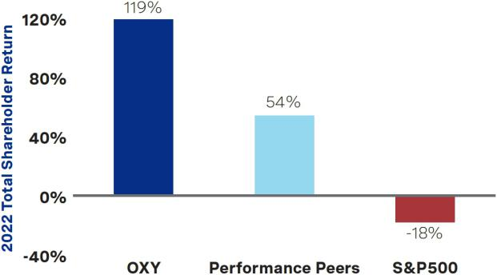

Pay-for-Performance Driven

Occidental remains committed to the pay-for-performance philosophy that underpins our compensation program, incentivizing our executive team to focus on strategic business objectives that, when met, will continue to create shareholder value. To achieve this, a substantial portion of NEO compensation is performance-based, and as a result, Occidental’s performance significantly impacts the realizable values of the NEOs’ compensation awards.

For 2022, the Compensation Committee established an appropriate mix of short-term and long-term incentive compensation, resulting in significant at-risk pay for Ms. Hollub at 90% and the other NEOs at an average of 84%. The company also retained the same award vehicles and allocation proportions, which track our stock price and business performance. The Compensation Committee will continue to thoughtfully oversee the effectiveness of Occidental’s executive compensation structure to ensure CEO and executive compensation is strongly aligned with company performance and shareholder experience.

CEO TARGET COMPENSATION AVERAGE OTHER NEO TARGET COMPENSATION
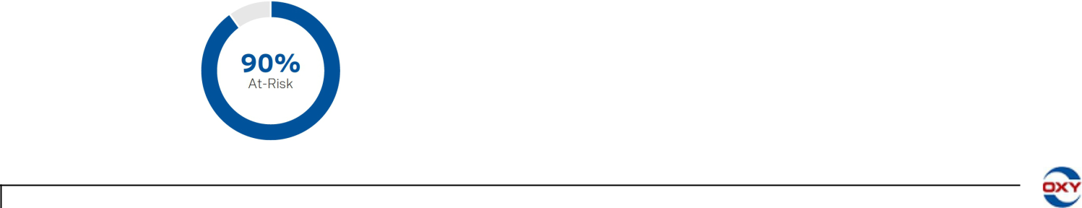

38

Table of Contents

Compensation Discussion and Analysis

Responsiveness to Shareholder Feedback

Our board and management are committed to continually engaging our shareholders and soliciting their perspectives and input on compensation, governance and other matters of interest (e.g., operational, energy transition and human capital). Throughout 2022 and the beginning of 2023, consistent with prior years, a broad array of Occidental management participated in these discussions, with active independent director participation either directly or through oversight of the shareholder engagement program.

Based on our conversations with shareholders and the support of approximately 97% of the total votes cast in our 2021 and 2022 advisory votes to approve NEO compensation (each, a Say-on-Pay vote), we believe that shareholders generally endorse the current executive compensation program, including the use of sustainability metrics in the annual cash incentive (ACI) award program, and recognize that it is functioning as intended. While recognizing that competitive pay is necessary to attract and retain top executive talent, in response to shareholder feedback, the Compensation Committee maintained (i) a high level of at-risk pay, coupled with the continued use of returns-focused metrics, to support the compensation program’s strong pay-for-performance philosophy as discussed above and (ii) the weighting of sustainability metrics for the company performance portion of the ACI award at 30% to remain closely aligned with the company’s net-zero strategy. The Compensation Committee will continue to engage with shareholders on the design of the executive compensation program and work to promote alignment of executive officer pay with shareholder interests.

Looking ahead to 2023, given Occidental’s commitment to be a part of the climate solution and the importance of the energy transition to shareholders, the Compensation Committee decided to continue to maintain the weighting of sustainability metrics at 30% for the ACI award. The Compensation Committee also determined to remove non-qualified stock options (NQSOs) as part of the long-term incentive (LTI) award program because they were intended to be a temporary component of the program design, and the Compensation Committee believes they have served their purpose. With that change, the Compensation Committee determined to increase the performance-based portion of the LTI award program to 60%.
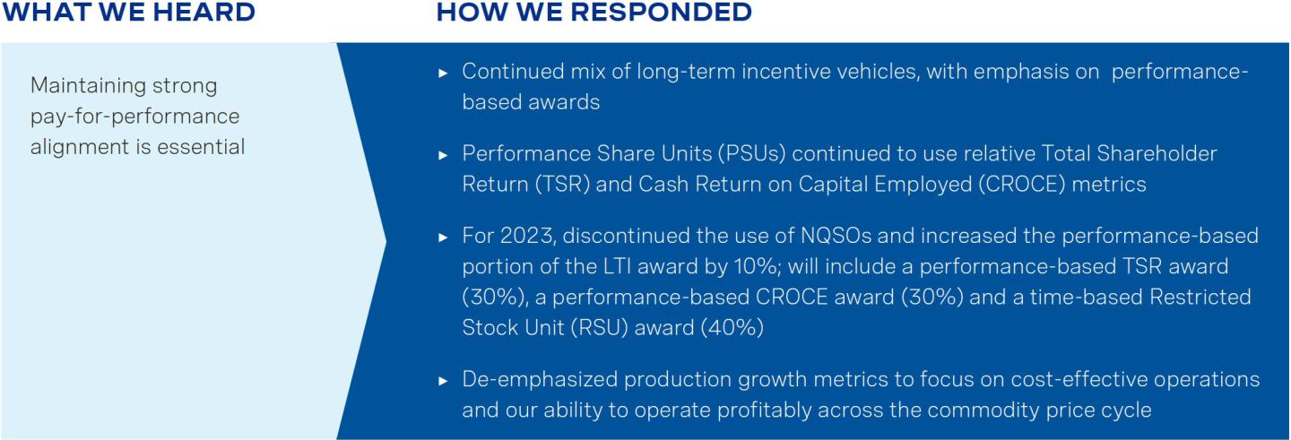

2023 PROXY STATEMENT
39

Table of Contents

Compensation Discussion and Analysis
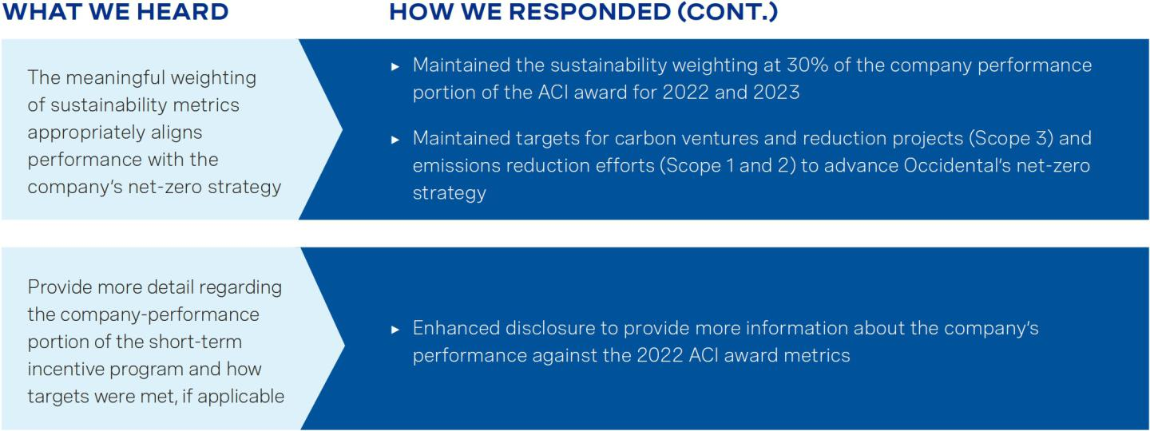

Objectives of the Executive Compensation Program

The Compensation Committee strives to maintain a compensation program that will attract, retain and motivate outstanding executives by providing incentives to reward them for strong performance that supports Occidental’s long-term strategic objectives and is competitive with industry practices. The executive compensation program is intended to:

- Align with shareholder interests;

- Preserve performance accountability across the commodity price cycle;

- Build and encourage long-term share ownership;

- Provide a consistent retention incentive;

- Be straightforward and transparent for the benefit of executives and shareholders;

- Match or exceed prevailing governance standards for performance-based compensation;

- Use relative and absolute performance measures for equity awards; and

- Respond to shareholder feedback.

40

Table of Contents

Compensation Discussion and Analysis

Governance Features of the Executive Compensation Program

The 2022 executive compensation program for the NEOs includes many best-practice features that are intended to enhance the alignment of compensation with the interests of Occidental’s shareholders.


WHAT WE DO

Pay for Performance. A substantial majority of NEO compensation is performance-based. The Compensation Committee reviews the metrics underlying the long-term incentive award program and ACI awards annually to evaluate their continued alignment with Occidental’s business priorities.

Act on Shareholder Feedback. Shareholder feedback influences the executive compensation program and contributed to the Compensation Committee’s decisions to maintain the weighting of sustainability metrics at 30% for the company performance portion of the ACI award opportunity. The favorable response from shareholders informed the Compensation Committee’s decision to maintain the sustainability metric’s weighting for the 2023 ACI award. Shareholder feedback also prompted us to enhance our disclosure to provide more information about the company’s performance against the 2022 ACI award metrics.

Clawback in the Event of Misconduct. The Compensation Committee has the authority to claw back ACI awards and long-term incentive awards for violations of Occidental’s Code of Business Conduct and related policies. The Compensation Committee also intends to adopt a clawback policy consistent with the requirements of new Exchange Act Rule 10D-1 upon or prior to the effectiveness of applicable NYSE listing standards.

Emphasize Stock Ownership. CROCE and TSR awards are payable in shares of common stock, and the net shares received for each vested RSU award are subject to a two-year holding period. In addition, the NEOs (as well as other officers) are subject to meaningful stock ownership guidelines, ranging from two to six times the officer’s annual base salary, and a holding requirement until such guidelines are met.

Monitor Compensation Program for Risk. The executive compensation program includes multiple features that are intended to appropriately mitigate excessive risk-taking. The Compensation Committee conducts an annual assessment of our executive compensation program to identify and minimize, as appropriate, any compensation arrangements that may encourage excessive risk-taking.

Use Double-Trigger Equity Vesting for Equity Awards. Pursuant to the Amended and Restated 2015 Long-Term Incentive Plan (2015 LTIP), equity awards vest in the event of a change in control only if there is also a qualifying termination of employment.

Use Relative and Absolute Performance Measures for Equity Awards. Performance equity is earned based on both relative shareholder returns and absolute financial returns, with TSR awards capped if Occidental’s absolute TSR is negative.


WHAT WE DON’T DO

No Dividend Equivalents on Unvested Performance Awards. Dividends and dividend equivalent rights are subject to the same performance goals as the underlying award and will not be paid until the performance award has vested and becomes earned (except in the case of certain retention awards).

No Hedging or Derivative Transactions. Occidental’s directors, executive officers and all other employees are not permitted to engage in transactions designed to hedge or offset the market value of Occidental’s equity securities.

No Golden Parachute Payments. Our golden parachute policy provides that, subject to certain exceptions, Occidental will not grant golden parachute benefits (as defined in the policy) to any executive officer which exceed 2.99 times his or her salary plus ACI award without shareholder approval.

No Repricing of Stock Options. Other than in connection with a corporate transaction involving Occidental, Occidental does not permit the repricing of stock options or stock appreciation rights without shareholder approval.

2023 PROXY STATEMENT
41

Table of Contents

Compensation Discussion and Analysis

Overview of the 2022 Executive Compensation Program

 |  | Form of | How Target Values
Element | Purpose | Payout | are Determined | 2022 Determinations
Base | Provide a competitive | Cash | The Compensation Committee | In 2022, Ms. Hollub’s base salary was increased by
Salary | level of fixed |  | reviews base salaries annually | $300,000 to $1,300,000 to continue the salary
 | compensation. |  | and as circumstances warrant. | restoration process to pre-COVID levels; each of Mr.
 |  |  | The Compensation Committee | Peterson’s and Mr. Jackson’s base salaries were
 |  |  | reviews compensation surveys, | increased by $60,000 to $710,000; Mr. Bennett’s
 |  |  | publicly available peer company | and Mr. Dillon’s base salaries were increased by
 |  |  | data, internal pay equity, | $35,000 to $610,000 and $710,000, respectively;
 |  |  | individual responsibilities and | and Ms. Backus’ base salary was increased by
 |  |  | performance assessments with | $20,000 to $750,000.
 |  |  | the intent to attract and retain | Salary decisions are described in more detail under
 |  |  | highly talented executives. | Salary decisions are described in more detail under
 |  |  |  | “Individual Compensation Considerations” beginning
 |  |  |  | on page 52.


Annual Cash

Incentive

Motivate executives to Cash

achieve superior
performance over a one-
year period.

The Compensation Committee annually reviews the objectives, metrics and targets underlying the ACI award, and their relative weightings, with an aim to incentivize the NEOs to excel in areas that are aligned with Occidental’s business objectives.



The 2022 ACI award is based 80% on corporate performance and 20% on individual performance and contribution for Ms. Hollub and 60% on corporate performance and 40% on individual performance and contribution for all other NEOs. The corporate performance portion is based on Occidental’s total spend per barrel and sustainability performance.

The ACI is described in more detail under “Elements of the 2022 Executive Compensation Program – Annual Cash Incentive” beginning on page 46. The amount ultimately earned under the ACI award for each NEO is discussed under “Individual Compensation Considerations” beginning on page 52.

PSU | Incentivize executives to |  | Stock
Awards | sustain long-term
 | performance.
RSU Awards | Provide a retention |  | Stock
 | incentive that promotes
 | sustained stock
 | ownership and alignment
 | with stock price
 | performance.
NQSOs | Reinforce the importance |  | Stock
 | of stock price
 | appreciation.

The Compensation Committee annually reviews and determines a target long-term incentive award package for each NEO based on a review of compensation surveys, publicly available peer company data, the executive’s prior-year award value (as applicable), retention considerations, the balance of short-and long-term pay and internal pay equity.

The majority of the long-term incentive award package for each NEO is performance-based. The Compensation Committee annually considers the performance criteria for PSU awards in light

of Occidental’s ongoing business objectives.

Similar to 2021, the Compensation Committee continued using TSR and CROCE as the performance criteria for the PSU awards. The TSR award is an objective, external measure of Occidental’s effectiveness in translating our results into shareholder returns. The CROCE award incentivizes a high level of executive focus on capital efficiency and prudent capital allocation. The RSU award, which is subject to a two-year post-vesting holding period, aligns with Occidental’s absolute stock price performance and provides retention value. Lastly, the NQSOs generate high-level alignment with shareholders and reinforce the importance of price appreciation. Long-term incentive awards are weighted: 50% PSU (25% TSR and 25% CROCE); 25% RSU and 25% NQSOs.

The long-term incentive award program is described in more detail under “Elements of the 2022 Executive Compensation Program – Long-Term Incentive Award Program” beginning on page 48. The target value of the long-term incentive award package of each NEO is described under “Individual Compensation Considerations” beginning on page 52.

42

Table of Contents

Compensation Discussion and Analysis

Compensation Program Emphasizes Performance

A substantial majority of NEO compensation is dependent on performance.

90% of Ms. Hollub’s (and an average of 84% of the other NEOs’) 2022 target direct compensation opportunity is variable, or at risk. The ultimate value of at-risk compensation is dependent on company performance outcomes, the result of the Compensation Committee’s assessment of each individual’s performance and Occidental’s stock price performance.
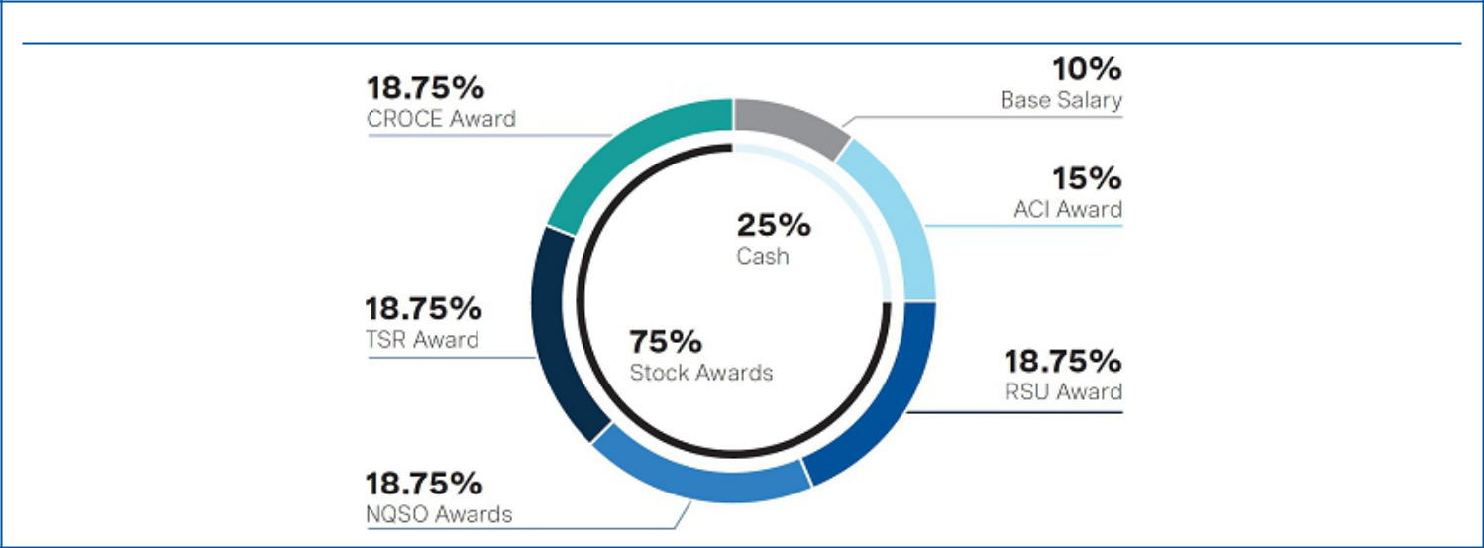

CEO TARGET DIRECT COMPENSATION MIX⁽¹⁾ - 90% VARIABLE/AT RISK

- Target direct compensation is composed of base salary, target ACI award opportunity, and the target value of long-term incentive awards.

Say-on-Pay Vote

At the 2021 and 2022 Annual Meetings, Occidental’s Say-on-Pay vote received support from approximately 97% of the total votes cast. The Compensation Committee views these results as an endorsement by shareholders of the design of the company’s current executive compensation program. Through shareholder engagement, we received positive feedback from stakeholders on increasing the weighting of sustainability metrics for the company performance portion of the 2021 ACI award, maintaining that weighting for the company performance portion of the 2022 ACI award, and setting associated short-term targets aligned with the Paris Agreement to address emissions reduction efforts (Scope 1 and 2 emissions) and carbon ventures and reduction projects (Scope 3 emissions). Management has also received support from shareholders and other stakeholders for having a significant portion of CEO and other NEO compensation be variable, or at risk.

2023 PROXY STATEMENT

At our 2021 and 2022 Annual Meetings, shareholders showed strong support for our executive compensation program with 97% of the votes cast at each meeting approving our advisory resolution.
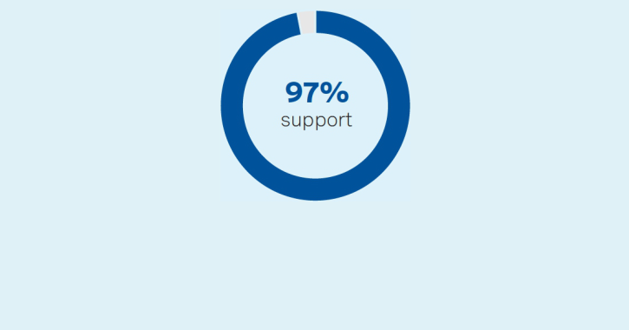

43

Table of Contents

Compensation Discussion and Analysis

Participants in the Executive Compensation Decision-Making Process

Role of the Independent Compensation Committee. The Compensation Committee, composed of independent members of the Board, is responsible for annually reviewing and approving all aspects of the Chief Executive Officer’s compensation, as well as annually reviewing and approving the compensation of all other NEOs. In performing these duties, the Compensation Committee obtains input, advice and information from senior management, members of Occidental’s Human Resources team and an independent compensation consultant, as further described below, throughout the year. The Compensation Committee also considers the views expressed by Occidental’s investors and shareholder advisory groups in making executive compensation decisions. The Compensation Committee uses publicly available data regarding the executive compensation practices of its compensation peer group (as defined below) as an additional tool but does not benchmark executive compensation to a specific percentile within the peer group.




JACK B. MOORE | WILLIAM | AVEDICK
Chair | R. KLESSE | B. POLADIAN

Role of Senior Management. Ms. Hollub, as Chief Executive Officer, makes recommendations to the Compensation Committee regarding the compensation package for each of the other NEOs. Ms. Hollub and the Vice President of Human Resources are present for a portion of each of the Compensation Committee meetings, but no senior executive is present when decisions regarding his or her compensation are discussed and determined. Only the Compensation Committee sets Ms. Hollub’s compensation package. Senior members of the Human Resources team and other members of senior management interact with the compensation consultant as necessary and prepare materials for each Compensation Committee meeting to assist the Compensation Committee in its consideration and administration of executive compensation programs, plans and policies.

Role of the Independent Compensation Consultant. In 2022, the Compensation Committee engaged Meridian Compensation Partners, LLC (Meridian) as its compensation consultant to provide advice on various executive compensation matters. Meridian has served as the Compensation Committee’s compensation consultant since 2016. The Compensation Committee reviewed the independence of Meridian under SEC rules, the NYSE Listed Company Manual standards and Occidental’s Independent Compensation Consultant Policy and found Meridian to be independent and without conflicts of interest. Occidental also participates in and reviews compensation surveys conducted by compensation consultants, including Meridian, in order to better understand external compensation practices, including with respect to executive compensation.

Role of Shareholders. Occidental maintains an ongoing dialogue with its shareholders. Members of Occidental’s senior management team and, on a case-by-case basis, one or more of Occidental’s independent directors, engage with shareholders through virtual and in-person meetings and phone calls. Input from these meetings regarding Occidental’s executive compensation policies and practices is taken into account by the Compensation Committee in making future compensation decisions. In 2022, for example, shareholder support played an important role in the Compensation Committee’s decision to maintain the sustainability metric of the company performance portion of the ACI award at 30% and continue to set targets for the sustainability metric to incentivize executives to enhance emissions reduction efforts (Scope 1 and 2 emissions) and promote carbon ventures and reduction projects (Scope 3 emissions). The Compensation Committee believes that this structure provides for a stronger link between potential bonus payout and the advancement of the company’s net-zero strategy. Based on shareholder feedback, the Compensation Committee also determined to maintain the mix of long-term incentive awards in 2022, which continues to emphasize our pay-for-performance philosophy. The Compensation Committee also supported enhancing Occidental’s CD&A disclosure to provide more information about the company’s performance against the 2022 ACI award metrics in response to feedback from shareholders during the company’s recent off-season engagement.

Role of Peer Company Information. In order to evaluate how Occidental’s executive compensation program compares within the oil and gas industry, particularly with respect to award types, compensation mix, performance metrics and reported levels of compensation, the Compensation Committee reviews the executive compensation practices, programs and policies of a “compensation peer group,” as identified below. The Compensation Committee also reviews and considers oil and gas industry

44

Table of Contents

Compensation Discussion and Analysis

compensation surveys and related materials. This information is used only as a reference and not to establish compensation benchmarks, as Occidental does not benchmark executive compensation to a specific percentile within the compensation peer group. The Compensation Committee also maintains a “performance peer group” within the oil and gas industry, and the value of the TSR awards is dependent on Occidental’s three-year TSR performance as compared to the three-year TSR performance of the companies within the applicable performance peer group. The Compensation Committee regularly reviews these peer groups to ensure that they have reasonably similar business strategies, represent a mix of integrated and independent oil and gas companies and generally compete against Occidental for investor dollars and/or executive talent. A review of this nature prompted the Compensation Committee, for 2021, to revise the compensation peer group and add the S&P 500 Index as a performance peer. In updating the compensation peer group, the Compensation Committee faced the persistent challenge of finding current independent peers of comparable size in a shrinking pool of peer companies. It expanded its review to include companies representative of different oil industry sectors to include upstream, downstream and integrated companies and considered, among other things, enterprise value and companies with which Occidental competes for talent. As noted above, Occidental does not benchmark executive compensation to a specific percentile within the compensation peer group and did not seek direct alignment with pay levels or practices at peer companies when making the determination to update the compensation peer group. After careful review and deliberation, and in consultation with Meridian, the Compensation Committee determined to maintain the same compensation and performance peer groups for 2022.

 |  |  |  | Enterprise Value
 |  | Compensation Peers | Performance Peers | at 12/31/22
Company | Stock Ticker | (2022) | (2022 TSR) | ($ in billions)⁽¹⁾
BP p.l.c. | BP | ● | ● | $122.1
Chevron Corporation | CVX | ● | ● | $356.2
ConocoPhillips | COP | ● | ● | $153.6
EOG Resources, Inc. | EOG | ● | ● | $ 76.1
ExxonMobil Corporation | XOM | ● | ● | $476.2
Hess Corporation | HES | ● |  | $ | 50.8
Marathon Petroleum Corporation | MPC | ● |  | $ | 78.8
Occidental Petroleum Corporation | OXY |  |  | $ | 87.3
Phillips 66 | PSX | ● |  | $ | 69.5
Pioneer Natural Resources Company | PXD | ● |  | $ 58.0
Shell plc | SHEL | ● | ● | $207.5
TotalEnergies SE (formerly Total SE) | TTE |  | ● | $175.9
Valero Energy Corporation | VLO | ● |  | $ | 58.3
S&P 500 Index | — |  | ● | $ | —

- Source: S&P Capital IQ.

The chart below shows Occidental’s percentile rank versus its 2022 compensation peers for enterprise value and assets as of December 31, 2022. Occidental fell within the middle of its compensation peers for enterprise value (55th percentile) and assets (36th percentile).
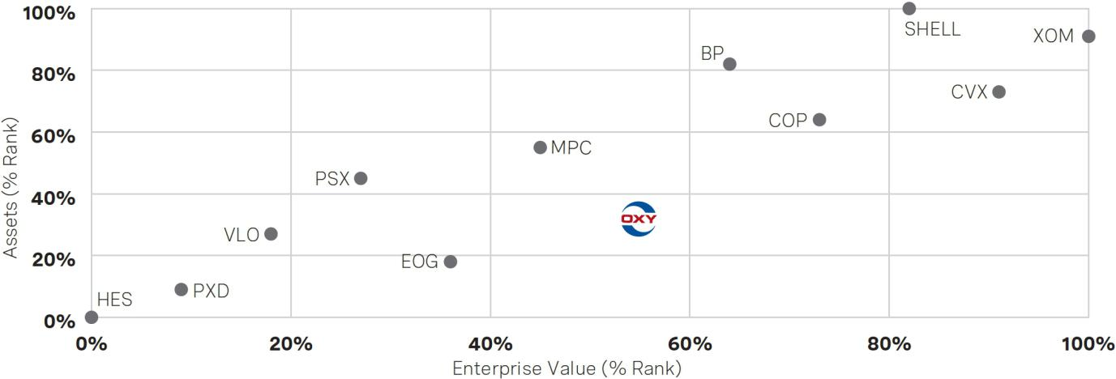

2023 PROXY STATEMENT
45

Table of Contents

Compensation Discussion and Analysis

Elements of the 2022 Compensation Program

Salary

The Compensation Committee believes that base salary should reward executives on a market-competitive basis for consistent performance of job requirements and the achievement of short-term goals. Salaries are reviewed by the Compensation Committee annually and as circumstances warrant. In determining base salary levels, the Compensation Committee reviews compensation surveys, publicly available peer company data, internal pay equity, individual responsibilities and performance assessments.

In connection with its annual review, base salaries for executive officers (other than the CEO) were modestly increased in 2022, ranging from 3-9%, for Occidental to remain competitive in attracting and retaining top executive talent. Mr. Peterson and Mr. Jackson each received a $60,000 increase to their respective base salaries. Mr. Dillon and Mr. Bennett each received a $35,000 increase to their respective base salaries and Ms. Backus’ base salary was increased by $20,000 (which increase was approved prior to her announcement of her intent to retire). The Compensation Committee determined that these changes were appropriate in light of each executives’ respective performance and scope of responsibilities.

The Compensation Committee also decided to increase Ms. Hollub’s salary by $300,000 to $1,300,000, which the Compensation Committee believed was warranted in light of Ms. Hollub’s 2021 performance assessment and also because her salary had not been restored to pre-COVID levels. Even with this increase, Ms. Hollub’s 2022 base salary remained slightly below the salary approved by the Compensation Committee for Ms. Hollub as part of the company’s 2019 compensation program.

Base salary represented, on average, approximately 12% of the 2022 compensation packages of the NEOs, based on compensation as reported in the Summary Compensation Table on page 61. For additional information regarding salary decisions for the NEOs in 2022, see “Individual Compensation Considerations” beginning on page 52.

Annual Cash Incentive

The ACI award is intended to motivate executives to achieve superior company and individual performance over a one-year period. In the first quarter of each plan year, the Compensation Committee approves individual target award amounts for each executive officer based on a review of compensation surveys, publicly available peer company data, the executive’s prior-year award value, retention considerations, the balance of short- and long-term pay and internal pay equity. Potential payouts under the ACI award range from 0% to 200% of the target award amount, based on actual company and individual performance. The amounts earned by each NEO under the ACI award for 2022, which were paid in the first quarter of 2023, are reflected in the “Non-Equity Incentive Plan Compensation” column of the Summary Compensation Table on page 61, as further described below.

Setting the Annual Cash Incentive. The Compensation Committee annually reviews all facets of the ACI award, with an aim to incentivize the NEOs to excel in areas that are aligned with Occidental’s business objectives. In February 2022, the Compensation Committee approved metrics related to the company’s total spend per barrel (which encompasses the company’s strategic, operational and financial performance) and sustainability goals. For the company performance portion of the ACI award, the Compensation Committee maintained the sustainability metric weighting at 30% to continue advancing the company’s net-zero strategy and incentivize executives to address Occidental’s Scope 1, 2 and 3 emissions in the short-term by including targets focused on emissions reduction efforts and carbon ventures and reduction projects. The Compensation Committee set target performance goals that it believed were rigorous based on Occidental’s detailed capital program and business plan, projections from the strategic planning team and business unit heads, prior-year results and third-party forecasts relating to future market conditions and other external market factors.

Weighting the Metrics. The Compensation Committee determined that company performance metrics would comprise 80% of Ms. Hollub’s target ACI award, and 60% for the other NEOs, with the remainder of the ACI award opportunity linked to an assessment of the performance of the individual executive. The Compensation Committee determined to weight a larger portion of Ms. Hollub’s ACI award opportunity toward key company performance metrics because, as Chief Executive Officer, her leadership directly affects all aspects of the company’s performance.

46

Table of Contents

Compensation Discussion and Analysis

2022 Annual Cash Incentive Award

COMPANY PERFORMANCE PORTION
 |  |  |  |  |  |  |  |  | Result
 |  |  | Potential |  |  |  |  |  | as of
 |  |  | Payout |  | Performance |  |  |  | December | Weighted
 | Weight |  | Range |  | Metric |  | Target Performance |  | 31, 2022 | Score
 | Total Spend per Barrel
 |  |  | 0% - 140% |  | Total Spend |  | $23.25 |  | $22.94⁽²⁾ | 95%
 |  |  | 0% - 140% |  | per Barrel⁽¹⁾ |  |  |  | $22.94⁽²⁾ | 95%
 | Sustainability
 |  |  |  |  |  |  | Reduce operating emissions
 |  |  |  |  | Emissions |  | ► | Deploy the Emissions Technology program and Find It/Fix It operational
 |  |  |  |  | Reduction |  | ► |  | Above
 |  |  |  |  |  |  |  | emissions program to international locations | Above
 |  |  |  |  | Efforts |  |  | emissions program to international locations | Above | 25%
 |  |  |  |  |  |  |  |  | Target⁽³⁾ | 25%
 |  |  |  |  | (Scope 1 |  | ► | Deploy at least 4 emissions reduction projects in the Permian Basin | Target⁽³⁾
 |  |  |  |  | and 2) |  | ► | Achieve a 15% reduction in routine flaring from our 2020 baseline
 |  |  | 0% - 60%
 |  |  | 0% - 60% |  |  |  | Advance carbon management platform
 |  |  | KEY
 |  |  | CORPORATE |  | Carbon |  | ► Approval to commence, and commencement of, construction on first DAC plant
 |  |  | OBJECTIVES |  |  |  |  | (DAC 1)
 |  |  |  |  | Ventures and |  |  | (DAC 1) | Above
 |  |  |  |  |  |  | ► | Enter into at least 1 carbon capture, transport or sequestration joint venture | Above
 |  |  |  |  | Reduction |  | ► |  | Above | 30%
 |  |  |  |  |  |  | ► |  | Target⁽⁴⁾ | 30%
 |  |  |  |  | Projects |  | ► | Enter into at least 3 low-carbon product development transactions | Target⁽⁴⁾
 |  |  |  |  | (Scope 3) |  | ►
 |  |  |  |  |  |  | ► | Identify and coordinate external validation of the company’s carbon accounting
 |  |  |  |  |  |  |  | process, including validation of GHG emissions at one or more operating sites
INITIAL COMPANY PERFORMANCE PORTION TOTAL: |  |  |  |  |  |  |  |  |  | 150%
COMMITTEE ADJUSTMENT FOR KEY STRATEGIC ACCOMPLISHMENTS:
Record net income, operating cash flow and free cash flow for the 2022 fiscal year (FY22)
CROCE of approximately 36% and a return on capital employed (ROCE) of approximately 28% for FY22
Repayment of over $10.5 billion in debt principal |  |  |  |  |  |  |  |  |  | 20%
$3 billion in share repurchases as part of the company’s shareholder return framework
Top-performing stock in S&P 500 index; approximately 119% total shareholder return
TOTAL COMPANY PERFORMANCE PORTION PAYOUT: |  |  |  |  |  |  |  |  |  | 170%
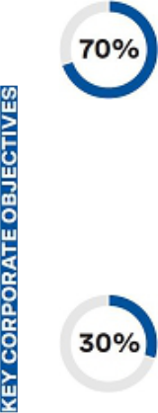

- “Total Spend per Barrel” (TSPB) applies to continuing operations and equals the sum of SG&A, OPEX and CAPEX, divided by MMboe. For purposes of this review, “SG&A” or “selling, general and administrative expenses” means total SG&A and other operating and non-operating expenses for the company, prior to any accrual for the 2022 ACI award; “OPEX” or “operating expenses” means total upstream oil and gas lease operating expenses; “CAPEX” or “capital expenditures” means total capital investment for the company; and “MMboe” means total million “Boe,” or barrels of oil equivalent, produced in the year.

- The Compensation Committee determined that it was appropriate to exercise discretion to adjust TSPB performance from $24.62 to $22.94 to reflect the negative impacts of (1) inflation on lease operating expenses and capital projects, (2) rising commodity prices on production sharing contracts and (3) Winter Storms Elliott and Landon on production.

- The Compensation Committee decided that the target metrics for emissions reduction efforts were met above target, with the rationale summarized below for each target:

  - Employees implemented the Emissions Technology program and Find It/Fix It operational emissions program in the company’s Oman operations primarily through periodic satellite surveillance beginning in the first half of 2022, which accelerated detection of emissions sources and, where warranted, repair of equipment. Management and employees also collaborated extensively with operators of outside-operated international joint ventures (e.g., Dolphin and Al Hosn) on the implementation of emissions reduction technologies and practices and to share learnings from such programs.

  - Occidental deployed several emission reduction projects in the Permian Basin in 2022, including: (1) retrofitting or removing from our inventory 169 high-bleed pneumatic control devices in the Permian Basin, or over 76% of those devices we operated at the beginning of 2022; (2) replacing four low-pressure flares with Vapor Recovery Units or Vapor Combustion Units and enhancing reliability of tank emissions control with backup units for critical facilities; (3) tying an authorized gas vent in an enhanced oil recovery plant into a closed piping system that delivers the gas to a nearby plant where it is consumed as fuel; (4) reducing non-routine flaring through the installation of additional gas takeaway optionality and temporary gas storage

2023 PROXY STATEMENT
47

Table of Contents

Compensation Discussion and Analysis

wells to better manage gas during downstream plant or pipeline outages; and (5) completing 15 production facility consolidation projects to minimize the company’s surface infrastructure footprint and decommission existing emitting equipment (e.g., tanks, compressors and pneumatic devices) at the sites that were tied into the consolidated facilities.

  - Occidental achieved a 44% reduction in routine flaring in 2022 from our 2020 baseline. Occidental also succeeded in achieving zero routine flaring in its U.S. operations in 2022.

- The Compensation Committee also determined that the target metrics for carbon ventures reduction projects were met above target, with the rationale summarized below for each target:

  - For DAC 1, Occidental completed front-end engineering and design (FEED) in June 2022, received approval to commence construction and commenced construction with site and road preparation activities in September 2022.

  - Certain Occidental subsidiaries secured more than 400 square miles of pore space and land in multiple locations along the Gulf Coast. Senior management estimates that this pore space has the capacity to store up to 6 billion metric tons of carbon dioxide (CO2) that could accommodate up to 50 DAC plants in addition to point source emissions projects.

  - Occidental, through its subsidiaries, entered into three offtake agreements for carbon removal credits (i.e., with Airbus, SK Trading International and the Houston Texans) and invested in carbon product utilization technologies (e.g., Carbon Upcycling (cement) and Cemvita (sustainable aviation fuel)).

  - ERM Certification and Verification Services, Inc. issued an Independent Assurance Statement in October 2022 reporting its limited assurance verification process of the company’s Scope 1, Scope 2 and Scope 3 (Categories 9, 10 and 11) emissions, total GHG emissions and methane emissions individually and by business segment for 2021 and total GHG emissions individually and by business segment for 2020 and 2019 as disclosed on Occidental’s website at https://www.oxy.com/globalassets/documents/sustainability/ERMCVS-assurance-statement-Oxy.pdf. Trinity Consultants also completed its review of 2019 through 2021 GHG emissions estimates for Occidental’s Gulf of Mexico operations in September 2022.

Annual Cash Incentive Award – Individual Performance Portion. The individual performance portion of the ACI award (20% of the target ACI award for Ms. Hollub and 40% for the other NEOs) links compensation directly to the performance of the executive. In evaluating Ms. Hollub’s performance, the Compensation Committee principally considered the following performance goals:

- Maintain focus on Occidental’s commitment to safety, health, the environment, sustainability, diversity, governance, social responsibility and the highest standards of ethical conduct and continue to foster a collaborative culture;

- Balance capital allocation, total spend and asset divestitures to optimize cash flow generation to further reduce debt; and

- Focus on optimizing the long-term return on invested capital by investing strategically within Occidental’s portfolio of assets, with an emphasis on life cycle development costs, including finding and development costs and long-term operating costs.

For a detailed discussion of the Compensation Committee’s considerations with respect to each NEO’s individual performance, please see “Individual Compensation Considerations” beginning on page 52.

Long-Term Incentive Award Program

The majority of NEO compensation is determined by Occidental’s long-term performance. In 2022, similar to 2020 and 2021, the long-term incentive award program included a performance-based TSR award (25%), a performance-based CROCE award (25%), a time-based RSU award (25%) and a time-based NQSO award (25%), each of which is payable solely in shares of common stock. The long-term incentive awards are intended to motivate and incentivize executives to achieve results (including stock price performance) that are consistent with Occidental’s strategic business objectives. The Compensation Committee believes that long-term compensation should represent the largest portion of each NEO’s total compensation package and that the levels of payout ultimately achieved should reflect Occidental’s performance, both relative to peer company performance and on an absolute basis. During the process of determining the NEOs’ long-term incentive compensation packages for 2022, the Compensation Committee evaluated many factors, including:

- Alignment of executive officer pay to achieving long-term growth in shareholder value;

- Linkage of any above-target payouts to superior performance and absolute returns;

- Shareholder feedback regarding long-term compensation metrics;

- Competitiveness with the compensation programs of peer companies;

- Impact of commodity prices on Occidental’s stock price and financial performance; and

- Allocation of total compensation between long-term and short-term components.

2022 Long-Term Incentive Award Program. The 2022 long-term incentive program consisted of two PSU awards (one based on Occidental’s relative TSR and the other based on absolute CROCE performance), a time-based RSU award and a time-based NQSO award as indicated below. Forfeiture and change in control provisions applicable to the awards are discussed in more detail in the Potential Payments upon Termination or Change in Control table and the accompanying footnotes, beginning on page 71.

48

Table of Contents

Compensation Discussion and Analysis

2022 Long-Term Incentive Award Mix at Grant Date
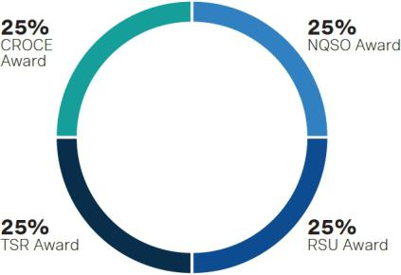

Total Shareholder Return (TSR) Award. The Compensation Committee believes that the comparison of Occidental’s three-year TSR to peer companies’ returns over the same period is an objective external measure of Occidental’s effectiveness in translating its results into shareholder returns. TSR is the change in price of a share of common stock plus reinvested dividends, over a specified period of time, and is an indicator of management’s achievement of long-term growth in shareholder value. Payout of the TSR award is based on Occidental’s three-year TSR as compared to the three-year TSR of the performance peers identified on page 45. For the 2022 TSR award, the Compensation Committee retained the S&P 500 index as a performance peer. The TSR award is denominated in PSUs, each of which is equivalent to one share of common stock. The percentage of such number of PSUs that will be payable at the end of the three-year performance period, which began January 1, 2022 and ends December 31, 2024, will depend on Occidental’s relative and absolute TSR performance.

If Occidental’s absolute TSR is negative over the performance period, then, irrespective of Occidental’s ranking within the peer group, the payout of the TSR award is capped at no more than target. A table illustrating the potential payout of the TSR award based on relative and absolute TSR performance is set forth below:

TSR Ranking | % of Target PSUs Earned
#1 | 200%
#2 | 180%
#3-#7 | Linearly interpolated between 25% and 180%
#8 | 25%
#9 | 0%
For payout above 100%, Occidental’s absolute TSR must be positive.

An example of the interpolation calculation if Occidental ranked fourth among its TSR performance peers with respect to the 2022 TSR awards is as follows:

TSR Ranking | Formula Points | Company | Standing |  | % of Target PSUs Earned
#1 |  | AAA | 22.50% | 200%
#2 | B | BBB | 20.00% | 180%
#3 |  | CCC | 17.50%
#4 |  | OXY | 15.00% |  | Linearly interpolated between
#5 |  | DDD | 12.50% |  | Linearly interpolated between
#5 |  | DDD | 12.50% |  | 25% and 180%
#6 |  | EEE | 10.00% |  | 25% and 180%
#7 |  | FFF | 7.50%
#8 | A | GGG | 5.00% | 25%
#9 |  | HHH | 2.50% | 0%

Interpolation Formula = 25% + [(180% - 25%) x ((OXY TSRI – A) / (B – A))]

Interpolation Formula = 25% + [155% x ((15% - 5%) / (20% - 5%))]

Example Interpolation Payout Result = 128.3%

The cap on the TSR award payout if TSR performance over the performance period is negative is intended to reinforce the pay-for-performance nature of the compensation program. The 2022 TSR award comprised 25% of each NEO’s target long-term incentive award opportunity for 2022. Cumulative dividend equivalents will be paid in cash at the end of the three-year performance period and will be paid only on the number of PSUs earned.

2023 PROXY STATEMENT
49

Table of Contents

Compensation Discussion and Analysis

Payout of 2020 TSR Awards. For the 2020 TSR award, which had a performance period that ended on December 31, 2022, Occidental achieved a TSR ranking of 5 (out of 8) and an absolute TSR that was positive as of the end of the performance period. Thus, the Compensation Committee approved a payout result of approximately 122%, after applying the interpolation formula.

Cash Return on Capital Employed (CROCE) Award. The CROCE award is designed to focus executives on the efficient use of capital by promoting discipline in capital allocation decisions. CROCE is a transparent measure of how efficiently Occidental uses its capital and is calculated from Occidental’s audited financial statements with no adjustments for special items. The CROCE award is denominated in PSUs, each of which is equivalent to one share of common stock. The percentage of such number of PSUs that become payable at the end of the applicable three-year performance period depends on Occidental’s absolute CROCE during the performance period. The CROCE award comprised 25% of each NEO’s target long-term incentive award opportunity for 2022. A table illustrating the potential payout of the CROCE award based on CROCE performance is set forth below:

CROCE Performance Targets⁽¹⁾ | % of Target PSUs Earned⁽²⁾
CROCE of ≥ 22% | 200%
CROCE of 20% | 100%
CROCE of 18% | 25%
CROCE < 18% | 0%

- See page 94 for the formula to calculate CROCE.

- Payout percentages for CROCE values between 18% and 22% to be determined using linear interpolation between 25% and 200% of target, with a target payout at a CROCE of 20%.

Payout of 2020 CROCE Awards. For the 2020 CROCE award, which had a performance period that ended on December 31, 2022, Occidental achieved a three-year CROCE of 22.4% as of the end of the performance period compared to a threshold CROCE of 11%, a target CROCE of 13% and a maximum CROCE of 15%. Thus, the Compensation Committee approved a payout result of 200%.

Non-Qualified Stock Option (NQSO) Award. The Compensation Committee determined that including the NQSO award as a component of the 2022 long-term incentive program would reinforce the importance of stock price appreciation and presented an opportunity to generate high-level alignment with shareholders. The NQSO award vests ratably over three years with one-third vesting on each of February 28, 2023, 2024 and 2025, subject to continued employment. The NEOs received 25% of their 2022 long-term incentive award opportunity in the form of NQSOs.

Restricted Stock Unit (RSU) Award. The 2022 RSU award vests ratably over three years with one-third vesting on each of February 28, 2023, 2024 and 2025, subject to continued employment. Each RSU is equivalent to one share of common stock, and payment for a vested RSU award will be made solely in shares of common stock. The shares of stock ultimately received by the NEO pursuant to the RSU award are subject to a two-year post-vesting holding period. Dividend equivalents are accrued and paid out upon vesting. The NEOs received 25% of their 2022 long-term incentive award opportunity in the form of RSUs.

Other Compensation and Benefits

Qualified Defined Contribution Plans

Occidental does not have a defined benefit pension plan that provides NEOs a fixed monthly retirement payment. Instead, all salaried employees on the U.S. dollar payroll, including the NEOs, are eligible to participate in one or more tax-qualified defined contribution plans.

Savings Plan. For 2022, the defined contribution 401(k) savings plan (Savings Plan) permitted employees to save a percentage of their annual salary up to the $305,000 limit set by IRS regulations, and employee pre-tax contributions were limited to $ 20,500. Employees may direct their contributions to a variety of investments. Occidental matches two dollars for every one dollar the employee contributes up to 2% of eligible pay, plus an additional dollar-for-dollar match on the next 3% of eligible pay. The NEOs are fully vested in their account balances under the Savings Plan. The amounts contributed by Occidental to the Savings Plan are included in the “All Other Compensation” column of the Summary Compensation Table on page 61.

50

Table of Contents

Compensation Discussion and Analysis

Retirement Plan. The defined contribution retirement plan (Retirement Plan) is funded annually through a reallocation process from the employee’s Supplemental Retirement Plan II (SRP II) account balance (described below). Because the exact amount that could be contributed to the Retirement Plan without exceeding governmental limits cannot be determined until the end of the year, the reallocation process has been developed to maximize the amount contributed each year to a tax-qualified defined contribution plan. The Retirement Plan is company-funded, and employees may not contribute to the Retirement Plan. The NEOs are fully vested in their account balances under the Retirement Plan. The amounts allocated to the Retirement Plan are included in the SRP II contributions by Occidental in the “All Other Compensation” column of the Summary Compensation Table on page 61.

Nonqualified Deferred Compensation Plans

Occidental maintains two nonqualified deferred compensation plans: (i) the SRP II and (ii) the Modified Deferred Compensation Plan (MDCP). The purpose of the SRP II is to provide eligible employees, including the NEOs, with benefits to compensate them for maximum limits imposed by law on the amount of contributions that may be made to Occidental’s tax-qualified defined contribution plans. The purpose of the MDCP is to provide key management and highly compensated employees the ability to accumulate additional retirement income through deferrals of compensation.

Additional information regarding the terms and conditions of the SRP II and the MDCP is provided in “Nonqualified Deferred Compensation” on pages 68 and 69. Amounts contributed to the SRP II on behalf of the NEOs are included in the “All Other Compensation” column of the Summary Compensation Table on page 61. None of the executive officers made contributions to the MDCP or SRP II in 2022. The contributions, aggregate earnings, withdrawals and aggregate balances for the NEOs in the SRP II and MDCP with respect to 2022 are shown in the Nonqualified Deferred Compensation table on page 69.

Other Personal Benefits

Occidental provides a limited number of other personal benefits for its NEOs, which, in 2022, consisted principally of fees related to financial and tax planning, excess liability insurance, annual physical, personal use of, and spousal accompaniment on, corporate aircraft and club dues which are included in the “All Other Compensation” column of the Summary Compensation Table beginning on page 61.

2023 PROXY STATEMENT
51

Table of Contents

Compensation Discussion and Analysis

Individual Compensation Considerations

In making executive compensation decisions for a given year, the Compensation Committee considers, among other factors, the performance of Occidental and the individual contributions of each NEO. Details regarding the 2022 compensation decisions and performance evaluation of each NEO are presented below.

VICKI HOLLUB | President and Chief Executive Officer


Ms. Hollub is the President and Chief Executive Officer of Occidental. Ms. Hollub is responsible for all operations, the financial management of Occidental, implementing Occidental’s strategy, and assisting the Board with, among other matters, corporate strategy development, executive succession planning and talent development, and executive compensation for all other NEOs.

Tenure. Ms. Hollub joined Occidental over 40 years ago, and before her appointment as Chief Executive Officer in 2016, she held a variety of increasingly significant leadership and technical positions on three continents.

Performance Assessment. In assessing Ms. Hollub’s individual performance for 2022, the Compensation Committee considered her dynamic leadership and significant accomplishments in the areas identified as individual performance goals on page 48. Highlights of the individual performance assessment are set forth below.

- Ms. Hollub optimized long-term return on invested capital by investing strategically within Occidental’s portfolio of assets, while practicing disciplined allocation of capital and controlling life cycle development costs, including development and long-term operating costs.

Achieved record net income attributable to common stockholders of approximately $12.5 billion and free cash flow before working capital of $13.6 billion*; reduced debt by more than $10.5 billion; completed a $3 billion share repurchase program

No. 1 performing stock in S&P 500 for 2022, with approximately 119% in total shareholder returns

Generated a CROCE of approximately 36%* and a ROCE of approximately 28%*

OxyChem generated record earnings before interest and taxes (EBIT) of $2.5 billion in 2022

- Ms. Hollub drove operational excellence by emphasizing advancement in technology, development programs and improved operational efficiencies in drilling and completions.

Under Ms. Hollub’s leadership, drilling teams across Occidental were inspired to deliver record results

- Longest lateral ever drilled by Occidental at over 18,000’ in Midland Basin; entire well drilled in approximately 12 days

- Record Delaware Basin well productivity: average 30-day IP >3,000 Boe/d for the 191 wells online in 2022

- Top two 1st Bone Spring formation IP30s in New Mexico for all operators

- Top six Barnett formation IP30s in Midland Basin for all operators

Ms. Hollub’s focus on developing assets resulted in several production records and improved operational capabilities

- Caesar-Tonga expansion project online in December; completed safely, on budget and ahead of schedule

- Horn Mountain achieved its highest production rate in over 21 years at 65 Mboe/d, boosted by the successful start-up of the Horn Mountain West development, three months ahead of schedule

- Lucius platform reached 150 MMboe of cumulative, gross production in under eight years from first oil, a record for Occidental Gulf of Mexico platforms

- Al Hosn achieved record quarterly net production of 86 Mboe/d

- Ms. Hollub focused on the company’s commitment to safety, health, the environment, sustainability, diversity, governance and social responsibility by investing in resources to help achieve Occidental’s net-zero ambitions, supporting company diversity programs and initiatives, and promoting a collaborative culture that embodies the highest standards of ethical behaviors.

The Board approved updates to the company’s longstanding Health, Safety and Environmental Principles (as revised, the HSE and Sustainability Principles), which Ms. Hollub recommended based on engagement with shareholders, employees and other stakeholders

Advancing Occidental’s low-carbon strategy is a top priority for Ms. Hollub. In 2022, Occidental achieved zero routine flaring of gas across U.S. oil and gas operations and reduced associated emissions. Under her leadership, the OLCV and Major Projects teams began construction of DAC 1 in Ector County, Texas

Certain Occidental subsidiaries secured over 400 square miles of pore space and land in multiple locations along the U.S. Gulf Coast for carbon sequestration; Occidental and certain of its subsidiaries also invested in emerging net-zero and low-carbon technologies, businesses and assets

Ms. Hollub championed the company’s commitment to Diversity, Inclusion, and Belonging (DIB) as the chair of the DIB Advisory Board; with Ms. Hollub’s support, Occidental also launched eight new ERGs in 2022, which bring employees together with a central purpose, mission, background or activity to help advance inclusion and a sense of belonging

Ms. Hollub supported the ongoing conversion of Occidental’s longstanding HSE management system into a more comprehensive operational management system, reinforced the Company’s expectations for HSE performance and expanded programs to support health and well-being, with a focus in 2022 on the mental health of employees and their families

OxyChem received several Responsible Care® and Facility Safety Awards from the American Chemistry Council and a Better Practice Award from the U.S. Department of Energy

52

Table of Contents

Compensation Discussion and Analysis
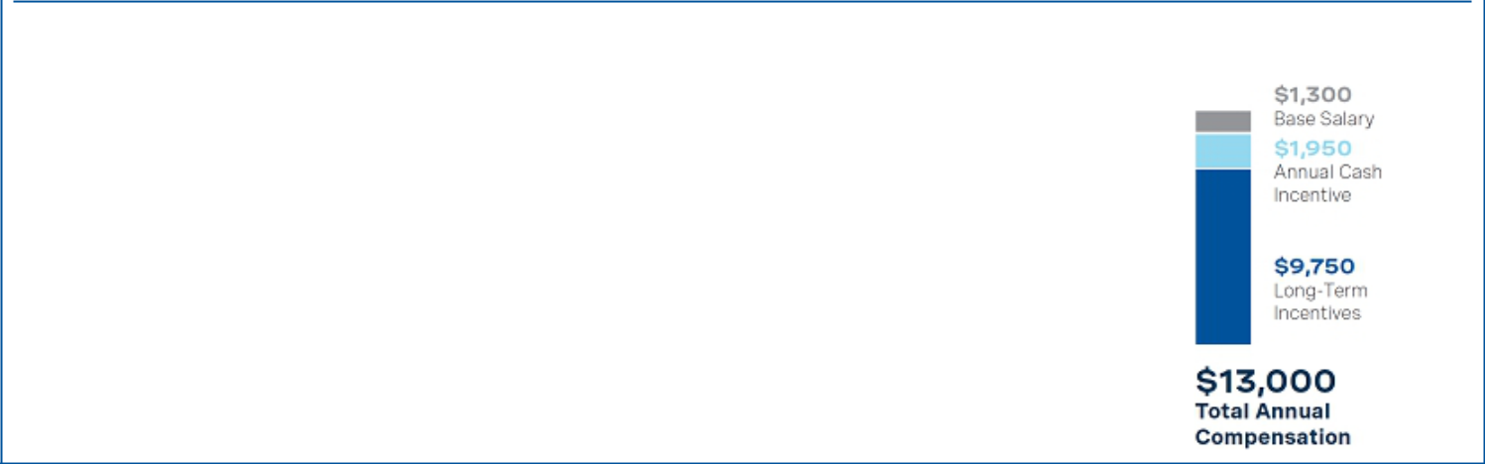

COMPENSATION DECISIONS

Base Salary: Effective February 21, 2022, Ms. Hollub’s salary was further restored by $300,000 to $1,300,000, while still reflecting a slight overall decrease from pre-COVID levels. The Compensation Committee determined this increase was appropriate in light of her 2021 performance and scope of responsibilities.

Annual Cash Incentive: Ms. Hollub’s target ACI award opportunity was set in February 2022 at $1,950,000, a 30% increase from 2021. Based on a review of Ms. Hollub’s individual performance, the Compensation Committee approved an ACI payout of 170% of target, consistent with the 170% payout for the company performance portion.

Long-Term Incentives: The target grant date value of Ms. Hollub’s long-term incentive award package for 2022 was $9,750,000, an approximate 33% increase from 2021, which the Compensation Committee determined was appropriate in light of her 2021 performance and scope of responsibilities. This reflects a partial restoration toward pre-COVID levels. Even with this increase, the target grant date value of Ms. Hollub’s 2022 LTI award package is lower than the LTI award package approved by the Compensation Committee for Ms. Hollub as part of the company’s 2019 compensation program. For information regarding how the Compensation Committee determines individual long-term incentive award amounts, see “Elements of the 2022 Compensation Program – Long-Term Incentive Award Program” beginning on page 48.

The overall increase in Ms. Hollub’s total target compensation for 2022, driven by the further restoration of Ms. Hollub’s base salary to near pre-COVID levels and her increased ACI and long-term incentive award values, was made to enhance the competitiveness of her pay compared to CEO pay in Occidental’s peer compensation group.

2022 TARGET COMPENSATION

($) in Thousands

- Non-GAAP financial measure. A reconciliation to the comparable GAAP financial measure can be found in Annex A.

2023 PROXY STATEMENT
53

Table of Contents

Compensation Discussion and Analysis
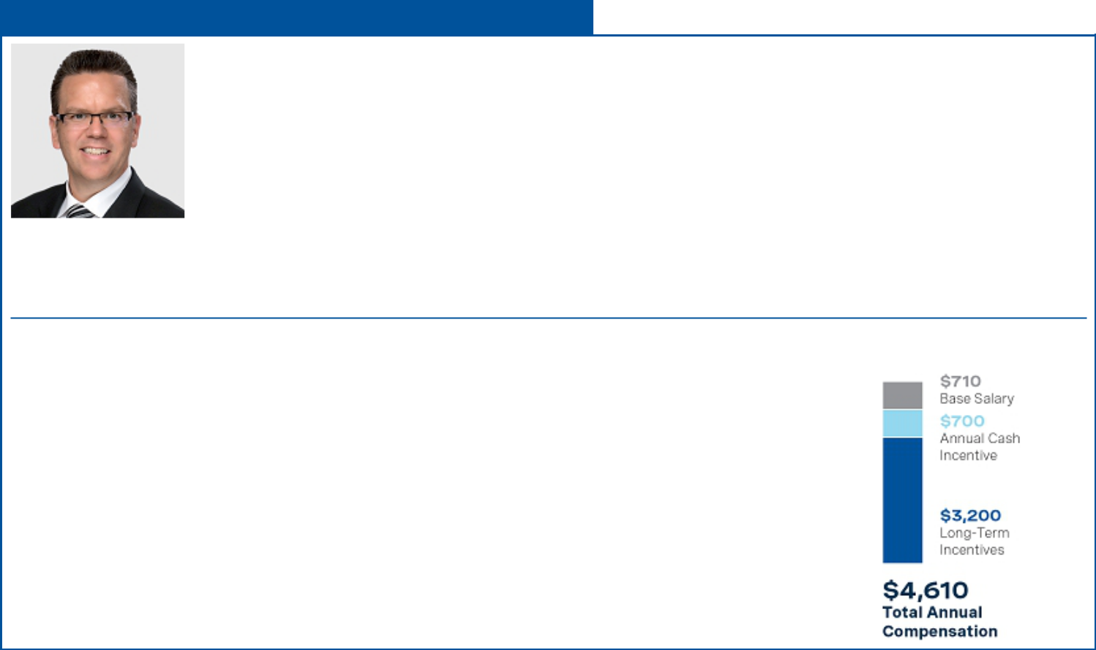

ROBERT L. PETERSON | Senior Vice President and Chief Financial Officer

Mr. Peterson has served as Senior Vice President and Chief Financial Officer since April 2020. Mr. Peterson previously served as Senior Vice President, Permian EOR, Occidental Oil and Gas, from September 2019 to April 2020. Prior to that, Mr. Peterson was Vice President, Permian Strategy, Occidental Oil and Gas, from November 2018 to September 2019, where he was responsible for developing and implementing a joint portfolio, technology and people strategy for the Company’s Permian business and ensuring alignment with Occidental’s Low Carbon Ventures strategy, and was President of OxyChem, the Company’s chemical subsidiary, from August 2014 to September 2017, where he was instrumental in completing its major capital investments and improving the profitability of the business.

Tenure. Mr. Peterson joined Occidental more than 25 years ago and, before his appointment as Senior Vice President and Chief Financial Officer in 2020, has held a variety of increasingly significant leadership positions.

Performance Assessment. In assessing Mr. Peterson’s performance, the Compensation Committee considered his leadership and management of his functional areas of responsibility, as well as his leadership and support for Occidental’s overall strategic goals and performance objectives. Mr. Peterson made meaningful contributions with respect to the oversight and management of the company’s financial strength, including balance sheet improvement, liquidity, credit ratings and

financial controls. Mr. Peterson’s efforts also included optimizing the capital program, constructing a shareholder return framework, and maintaining open engagement with equity and fixed income investors, banks, and the broader financial community. Mr. Peterson’s contributions also included optimizing cash resources, reducing debt by more than $10.5 billion of principal and repurchasing $3 billion of common equity. This work included significantly improving the balance sheet through successful bond tenders, open market repurchases and exercising attractive make-whole provisions to reduce debt, leveling debt maturity concentrations, and retiring interest rate swaps. Mr. Peterson also advanced tax efficiency strategies including a tax benefit of $2.7 billion in connection with a legal entity reorganization.

COMPENSATION DECISIONS 2022 TARGET COMPENSATION

($) in Thousands
Base salary: Effective February 21, 2022, Mr. Peterson’s salary was increased by $60,000 to $710,000, which the Compensation Committee determined was appropriate in light of his 2021 performance and scope of responsibilities.

Annual Cash Incentive: Mr. Peterson’s target ACI award opportunity was set at $700,000, an increase of $50,000 from 2021. Based on a review of Mr. Peterson’s individual performance, the Compensation Committee approved an ACI payout of 170% of target, consistent with the 170% payout for the company performance portion.

Long-Term Incentives: The target grant date value of Mr. Peterson’s long-term incentive award package for 2022 was $3,200,000, a 14.3% increase from 2021, which the Compensation Committee determined was appropriate in light of his 2021 performance and scope of responsibilities. For information regarding how the Compensation Committee determines individual long-term incentive award amounts, see “Elements of the 2022 Compensation Program – Long-Term Incentive Award Program” beginning on page 48.

54

Table of Contents

Compensation Discussion and Analysis
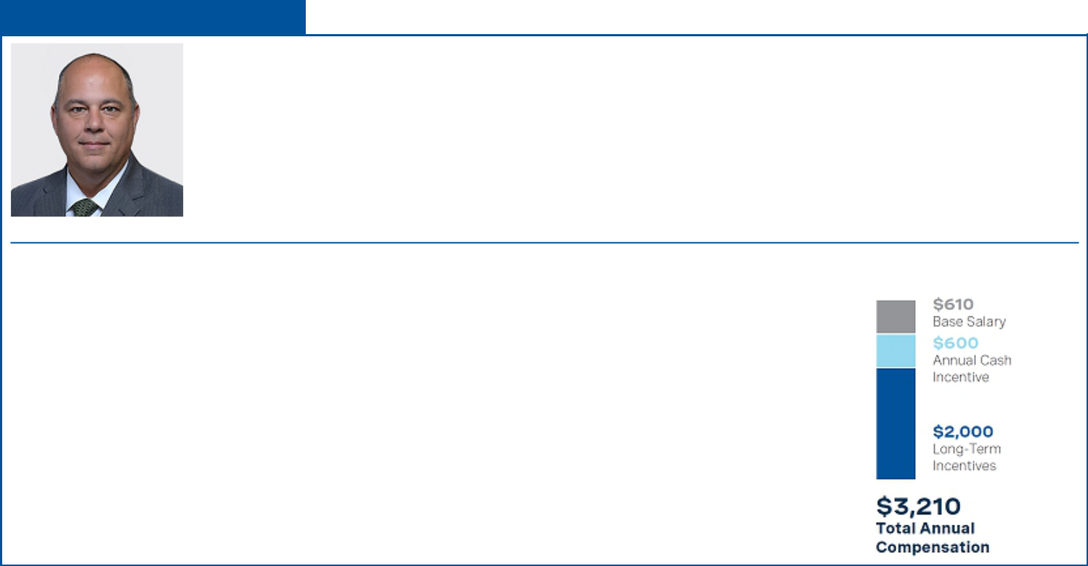

PETER J. BENNETT | Vice President

Mr. Bennett is a Vice President of Occidental and the U.S. Onshore Resources and Carbon Management – President, Commercial Development. In this role, Mr. Bennett is responsible for the strategic direction and capital placement for Occidental’s U.S. Onshore Resources and Carbon Management business. His responsibilities include securing partnerships to enhance the company’s portfolio while accelerating value from resource development.

Tenure. Mr. Bennett joined Occidental more than 18 years ago and, before his appointment as Vice President in 2017, has held a variety of increasingly significant leadership positions.

Performance Assessment. In assessing Mr. Bennett’s performance, the Compensation Committee considered his commercial and portfolio management contributions to increasing the value of Occidental’s oil and gas assets, including the renegotiation and expansion of our joint venture with Ecopetrol in the Permian Basin and the delivery of strong production and cash flow from our investment strategy. The Compensation Committee also considered Mr. Bennett’s contributions for OLCV, including enhancing the value of the company’s carbon portfolio and securing capitalization options and new technical and commercial partnerships to support DAC growth and commercialize multiple US Gulf Coast sequestration hubs. As Chairman of the Board of Western Midstream, LP (WES), Mr. Bennett provides strategic oversight of WES, which generated its highest net income in the partnership’s history in 2022.

COMPENSATION DECISIONS 2022 TARGET COMPENSATION
($) in Thousands
Base salary: Effective February 21, 2022, Mr. Bennett’s salary was increased by $35,000 to $610,000, which the Compensation Committee determined was appropriate in light of his 2021 performance and scope of responsibilities.

Annual Cash Incentive: Mr. Bennett’s target ACI award opportunity was set at $ 600,000, an increase of $25,000 from 2021. Based on a review of Mr. Bennett’s individual performance, the Compensation Committee approved an ACI payout of 170% of target, consistent with the 170% payout for the company performance portion.

Long-Term Incentives: The target grant date value of Mr. Bennett’s long-term incentive award package for 2022 was $2,000,000, an approximate 14% increase from 2021, which the Compensation Committee determined was appropriate in light of his 2021 performance and scope of responsibilities. For information regarding how the Compensation Committee determines individual long-term incentive award amounts, see “Elements of the 2022 Compensation Program – Long-Term Incentive Award Program” beginning on page 48.

2023 PROXY STATEMENT
55

Table of Contents

Compensation Discussion and Analysis
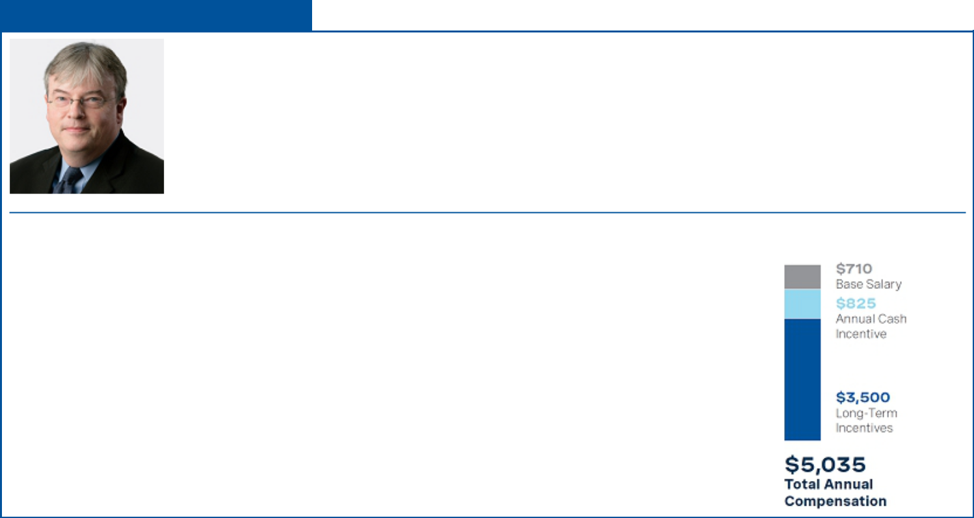

KENNETH DILLON | Senior Vice President

Mr. Dillon is a Senior Vice President of Occidental and the President of International Oil and Gas Operations for Occidental Oil and Gas Corporation, a subsidiary of Occidental. In this role, Mr. Dillon oversees the company’s operations in the Middle East, North Africa, South America and Gulf of Mexico, as well as Major Projects.

Tenure. Mr. Dillon joined Occidental more than 30 years ago and, before his appointment as Senior Vice President in 2016, has held a variety of increasingly significant leadership positions.

Performance Assessment. In assessing Mr. Dillon’s performance, the Compensation Committee considered his contributions to the success of renegotiating and signing long-term extensions of Occidental’s production contracts in Algeria, achieving record production in Block 9 in Oman after 40 years of operations, and record production at Al Hosn in Abu Dhabi following Phase One of the plant expansion. In Occidental’s Gulf of Mexico operations, significant projects at Horn Mountain and Caesar Tonga were brought into production ahead of schedule. In addition, Mr. Dillon’s support for OLCV led to meeting milestones in the development of new technologies at scale.

COMPENSATION DECISIONS 2022 TARGET COMPENSATION

($) in Thousands
Base salary: Effective February 21, 2022, Mr. Dillon’s salary was increased by $35,000 to $710,000, which the Compensation Committee determined was appropriate in light of his 2021 performance and scope of responsibilities.

Annual Cash Incentive: Mr. Dillon’s target ACI award opportunity was set at $825,000, an increase of $25,000 from 2021. Based on a review of Mr. Dillon’s individual performance, the Compensation Committee approved an ACI payout of 170% of target, consistent with the 170% payout for the company performance portion.

Long-Term Incentives: The target grant date value of Mr. Dillon’s long-term incentive award package for 2022 was $3,500,000, an approximate 19% increase from 2021, which the Compensation Committee determined was appropriate in light of his 2021 performance and scope of responsibilities. For information regarding how the Compensation Committee determines individual long-term incentive award amounts, see “Elements of the 2022 Compensation Program – Long-Term Incentive Award Program” beginning on page 48.

56

Table of Contents

Compensation Discussion and Analysis
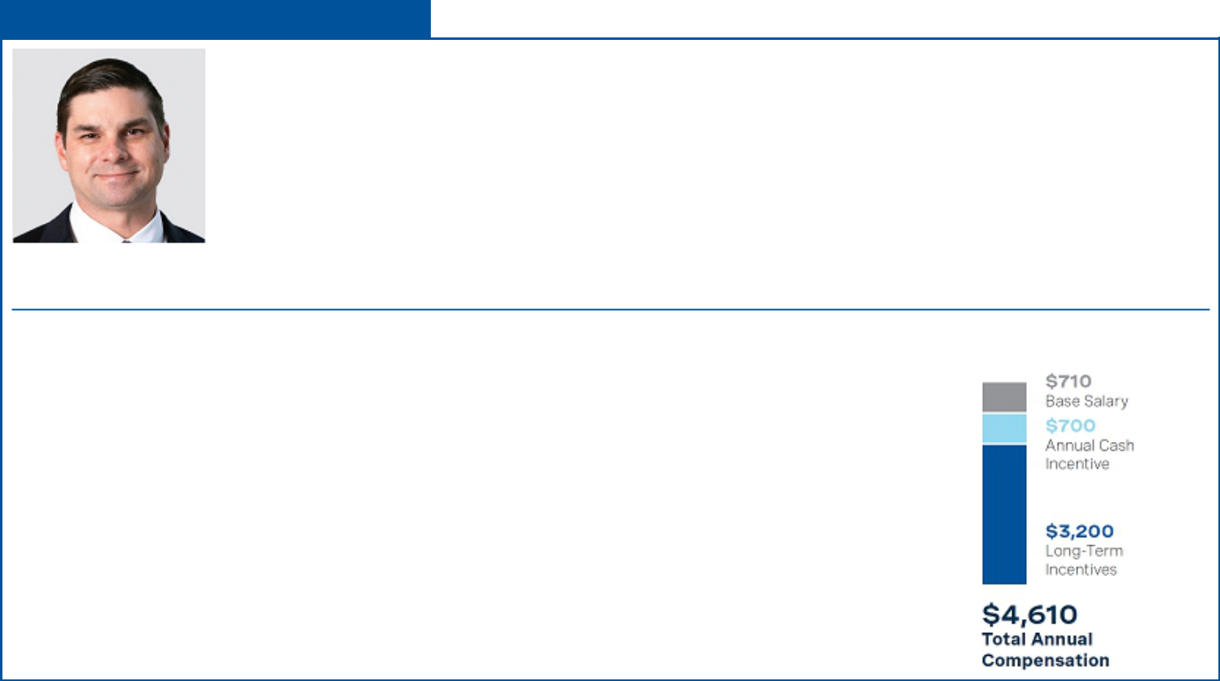

RICHARD A. JACKSON | Senior Vice President

Mr. Jackson is a Senior Vice President of Occidental and the U.S. Onshore Resources and Carbon Management – President, Operations. In this role, Mr. Jackson leads the development and operations of Occidental’s U.S. onshore oil and gas businesses while continuing to advance and integrate the company’s low-carbon technologies and opportunities. His responsibilities include accelerating subsurface innovation, delivering value-added resource development and advancing operational technologies and key low carbon innovations.

Tenure. Mr. Jackson joined Occidental more than 19 years ago and, before his appointment as Senior Vice President in 2020, has held a variety of increasingly significant leadership positions.

Performance Assessment. In assessing Mr. Jackson’s performance, the Compensation Committee considered his contributions to the success of Occidental’s U.S. Onshore Resources (Oil and Gas) and OLCV technical and business progress. U.S. Onshore Oil and Gas business results included continued advancements in safety system and organization, strong production and cash flow delivery driven from significant Permian production growth and cost management while ramping up operational resources. Low-carbon advancements included significant operational emissions reduction through key projects and reaching zero routine flaring across the company’s U.S. onshore operations, completing DAC 1 FEED and beginning initial construction, securing more than 400 square miles of pore

space and land in multiple locations along the Gulf Coast with storage capacity expected to accommodate up to 50 DAC plants in addition to point source emissions projects, accelerating NET Power zero-emission power through support of new technical and commercial partnerships and milestones and carbon market advancement through carbon dioxide removal sales.

COMPENSATION DECISIONS 2022 TARGET COMPENSATION

($) in Thousands
Base salary: Effective February 21, 2022, Mr. Jackson’s salary was increased by $60,000 to $710,000, which the Compensation Committee determined was appropriate in light of his 2021 performance and scope of responsibilities.

Annual Cash Incentive: Mr. Jackson’s target ACI award opportunity was set at $ 700,000, an increase of $50,000 from 2021. Based on a review of Mr. Jackson’s individual performance, the Compensation Committee approved an ACI payout of 170% of target, consistent with the 170% payout for the company performance portion.

Long-Term Incentives: The target grant date value of Mr. Jackson’s long-term incentive award package for 2022 was $3,200,000, a 14.3% increase from 2021, which the Compensation Committee determined was appropriate in light of his 2021 performance and scope of responsibilities. For information regarding how the Compensation Committee determines individual long-term incentive award amounts, see “Elements of the 2022 Compensation Program – Long-Term Incentive Award Program” beginning on page 48.

2023 PROXY STATEMENT
57

Table of Contents

Compensation Discussion and Analysis
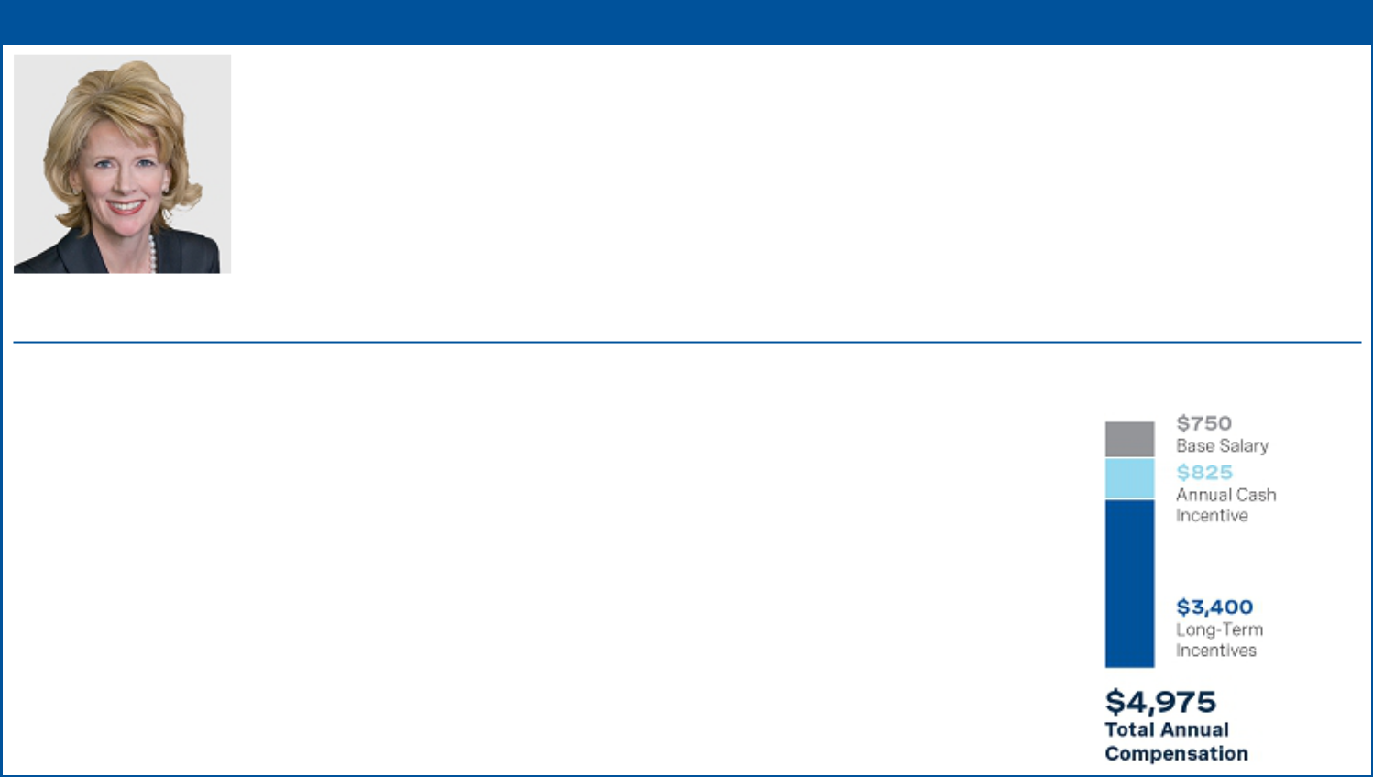

MARCIA E. BACKUS | Former Senior Vice President, General Counsel and Chief Compliance Officer

As part of her retirement from Occidental, Ms. Backus ceased being an executive officer as of October 3, 2022, stepped down from her role as Senior Vice President, General Counsel and Chief Compliance Officer of Occidental effective as of December 31, 2022 and terminated employment effective as of March 1, 2023. Ms. Backus has agreed to provide transition services to Occidental on a consulting basis through June 30, 2024.

Ms. Backus previously served as General Counsel since 2013, Senior Vice President since 2014 and Chief Compliance Officer since 2015. Ms. Backus was responsible for overseeing Occidental’s legal and compliance departments.

Tenure. Ms. Backus joined Occidental in 2013.

Performance Assessment. In assessing Ms. Backus’ performance, the Compensation Committee considered her leadership and management of her areas of responsibility, as well as her support for Occidental’s overall strategic business goals and performance objectives. Ms. Backus’ efforts included her instrumental involvement in the company’s successful balance sheet improvement efforts through repurchases of $3 billion of common equity and repaying over $ 10.5 billion in debt. Ms. Backus also demonstrated superior performance in handling litigation matters, developed and implemented proven litigation strategies and achieved
successful outcomes.

COMPENSATION DECISIONS 2022 TARGET COMPENSATION

($) in Thousands
Base salary: Effective February 21, 2022, Mr. Backus’s salary was increased by $20,000 to $750,000, which the Compensation Committee determined was appropriate in light of her 2021 performance and scope of responsibilities.

Annual Cash Incentive: Ms. Backus’s target ACI award opportunity was set at $ 825,000, an increase of $25,000 from 2021. Based on a review of Ms. Backus’s individual performance, the Compensation Committee approved an ACI payout of 170% of target, consistent with the 170% payout for the company performance portion.

Long-Term Incentives: The target grant date value of Ms. Backus’s long-term incentive award package for 2022 was $3,400,000, an approximate 13% increase from 2021, which the Compensation Committee determined was appropriate in light of her 2021 performance and scope of responsibilities. For information regarding how the Compensation Committee determines individual long-term incentive award amounts, see “Elements of the 2022 Compensation Program – Long-Term Incentive Award Program” beginning on page 48.

In connection with her transition to a consulting role, Occidental entered into a Transition Services and Separation Agreement with Ms. Backus pursuant to which she is entitled to certain payments and acceleration of time-based equity awards. See “Potential Payments upon Termination or Change in Control – Payments to Former Officer” beginning on page 74 for a more detailed description of the agreement.

58

Table of Contents

Compensation Discussion and Analysis

Additional Compensation Policies and Practices

Stock Ownership Guidelines

Occidental’s stock ownership guidelines are intended to more closely align the interests of the NEOs with those of the company’s shareholders. The ownership guidelines range from two-to-six times the officer’s annual base salary, based on position, as illustrated below:

Position | Multiple of Base Salary
Chief Executive Officer | 6
Chief Financial Officer | 4
Senior Vice Presidents | 3
Vice Presidents | 2

An officer who does not meet the minimum ownership guidelines may not sell any shares of Occidental common stock until he or she meets the ownership guidelines and would continue to meet the ownership guidelines following any such sale. Unvested performance-based stock awards, unvested performance-based stock units and unexercised stock options do not count toward satisfaction of the stock ownership guidelines. Officers subject to the guidelines are expected to comply within five years from the later of the effective date of the guidelines or the date the individual is named to a participating position.

Equity Grant Practices

The Compensation Committee made equity grants pursuant to the long-term incentive program at its regularly scheduled February 2022 meeting. The grant date fair value of each of the CROCE and RSU awards was based on the closing price of Occidental’s common stock on the NYSE on the day the Compensation Committee granted the awards, and the grant date fair value of the TSR award also incorporates the estimated payout percentage of the award as of the grant date. The fair value of the NQSO awards is estimated using a Black Scholes model. As specifically authorized by the terms of the 2015 LTIP, the Board, upon the recommendation of the Compensation Committee, has delegated to Ms. Hollub the authority to grant equity awards in certain circumstances to new employees and to grant equity awards to Occidental’s employees who are not executive officers within specified limits.

Potential Recoupment of Compensation Due to Misconduct

Occidental may recoup certain compensation from executive officers in the event of misconduct pursuant to the terms of Occidental’s Code of Business Conduct, the terms of the ACI awards and the 2015 LTIP. Occidental’s Code of Business Conduct prohibits any officer, employee or director from violating or circumventing any law of the United States or a foreign country or engaging in unethical conduct during the course of his or her employment. The Audit Committee oversees compliance with the Code of Business Conduct and has put in place procedures, including a compliance hotline, to encourage prompt reporting of violations or suspected violations of the Code of Business Conduct, without fear of retaliation. In general, misconduct may have several consequences, including:

- Disciplinary action, which may include termination, referral for criminal prosecution and reimbursement to Occidental or others for any losses or damages resulting from the violation.
- Forfeiture of stock awards, in whole or in part, in the case of an employee’s termination for cause.

- Forfeiture or reduction of the ACI award for violations of the Code of Business Conduct or related policies.

In addition, the 2015 LTIP includes a provision that gives Occidental the contractual right to recoup awards (i) where a participant has breached Occidental’s Business Code of Conduct by violating applicable law or company policy or engaging in unethical conduct or (ii) pursuant to a policy to be adopted by Occidental to comply with Section 954 of the Dodd-Frank Wall Street Reform and Consumer Protection Act, which will generally require recoupment of incentive-based compensation if Occidental is required to prepare an accounting restatement due to material noncompliance with any financial reporting requirement.

2023 PROXY STATEMENT
59

Table of Contents

Compensation Discussion and Analysis

Risk Assessment of Compensation Policies and Practices

Although the majority of the executive compensation program is performance-based, the Compensation Committee believes Occidental’s compensation programs do not encourage unnecessary or excessive risk-taking. In reaching its conclusion, the Compensation Committee reviewed the findings of a risk-taking analysis performed by its independent compensation consultant, Meridian. The Compensation Committee concurred with Meridian’s finding that Occidental’s compensation programs include multiple features that appropriately mitigate excessive risk-taking and that the compensation programs do not encourage excessive risk-taking. With respect to the executive compensation program, the compensation features that are indicative of appropriate risk-taking include:

- Diversified Performance Metrics. The ACI award and long-term incentive awards consider multiple performance criteria, rather than a single metric.

- Balanced Pay Mix. The total compensation opportunity features an effective balance between short- and long-term compensation components.

- Capped Awards. Performance-based stock awards and the ACI award are capped as a percentage of the targeted award and payout of the TSR award is capped at target if Occidental’s absolute TSR is negative over the performance period.

- Stock Ownership Guidelines and Holding Periods. Meaningful stock ownership guidelines and holding requirements for executives encourage a long-term perspective and require holding stock for extended periods.

- Clawback Provisions. The ACI award and long-term incentive awards are subject to clawback provisions beyond legal requirements, including forfeiture and recoupment provisions of awards in the event of violations of Occidental’s Code of Business Conduct.

- Anti-Hedging Provisions. Occidental’s executive officers, directors and other employees are prohibited from purchasing financial instruments (including prepaid variable forward contracts, equity swaps, collars and exchange funds) or otherwise engaging in transactions that are designed to, or have the effect of, hedging or offsetting any decrease in the market value of Occidental’s securities.

Compensation Committee Report

The Compensation Committee has reviewed and discussed with management the preceding Compensation Discussion and Analysis section for the year ended December 31, 2022. Based on these reviews and discussions, the Compensation Committee recommended to the Board of Directors that the Compensation Discussion and Analysis be included in the proxy statement for the 2023 Annual Meeting of Shareholders.

Respectfully submitted,

THE EXECUTIVE COMPENSATION COMMITTEE

Jack B. Moore (Chair)
William R. Klesse
Avedick B. Poladian

60

Table of Contents

Executive Compensation Tables

Summary Compensation

SUMMARY COMPENSATION TABLE

 |  |  |  |  |  |  |  |  |  |  |  | Nonqualified
Name and |  |  |  |  |  |  | Stock |  | Option | Non-Equity |  | Deferred |  | All Other
Principal |  | Year |  | Salary | Bonus⁽¹⁾ |  | Stock |  | Option | Incentive Plan |  | Compensation |  | All Other |  | Total
Position |  | Year |  | Salary |  |  | Awards⁽²⁾ | Awards⁽³⁾ |  | Compensation⁽⁴⁾ |  | Earnings⁽⁵⁾ |  | Compensation⁽⁶⁾
Vicki Hollub | 2022 |  | $ | 1,258,082 | $ | 312,000 | $7,312,830 | $ | 2,437,542 | $ | 3,003,000 | $ | 96,545 | $549,511 | $ | 14,969,510
President and Chief Executive Officer
President and Chief Executive Officer | 2021 |  | $ | 1,000,000 | $ | — | $5,512,829 | $ | 1,837,511 | $ | 2,400,000 | $ | — | $318,199 | $ | 11,068,539
 | 2020 |  | $ | 616,966 | $ | — | $9,650,069 | $ | 2,625,002 | $ | 1,012,500 | $ | — | $260,914 | $ | 14,165,451
Robert L. Peterson | 2022 |  | $ | 701,616 | $ | 84,000 | $2,400,147 | $ | 800,032 | $ | 1,106,000 | $ | 46,113 | $271,909 | $ | 5,409,817
Senior Vice President and Chief
Senior Vice President and Chief | 2021 |  | $ | 650,000 | $ | — | $2,100,135 | $ | 700,003 | $ | 1,040,000 | $ | — | $170,980 | $ | 4,661,118
Financial Officer
 | 2020 |  | $ | 511,644 | $ | — | $2,854,296 | $ | — | $ | 300,000 | $ | — | $246,764 | $ | 3,912,704
Peter. J. Bennett | 2022 |  | $ | 605,110 | $ | 72,000 | $1,500,120 | $ | 500,008 | $ | 948,000 | $ | 37,054 | $226,325 | $ | 3,888,617
Vice President and President, ORCM,
Commercial Development
Kenneth Dillon | 2022 |  | $ | 705,110 | $ | 99,000 | $2,625,184 | $ | 875,020 | $ | 1,303,500 | $ | 59,048 | $295,601 | $ | 5,962,463
Kenneth Dillon Senior Vice President
Kenneth Dillon Senior Vice President | 2021 |  | $ | 675,000 | $ | — | $2,212,632 | $ | 737,503 | $ | 1,280,000 | $ | — | $169,936 | $ | 5,075,071
and President, Int’l Oil and Gas Ops
 | 2020 |  | $ | 461,438 | $ | — | $2,212,565 | $ | 737,501 | $ | 400,000 | $ | — | $261,594 | $ | 4,073,098
Richard A. Jackson | 2022 |  | $ | 701,616 | $ | 84,000 | $2,400,147 | $ | 800,032 | $ | 1,106,000 | $ | 40,166 | $251,981 | $ | 5,383,942
Senior Vice President and President,
Senior Vice President and President, | 2021 |  | $ | 650,000 | $ | — | $2,100,135 | $ | 700,003 | $ | 1,040,000 | $ | — | $163,523 | $ | 4,653,661
ORCM, Operations
Marcia E. Backus | 2022 |  | $ | 747,205 | $ | 99,000 | $ 3,978,113 | $ | 2,640,872 | $ | 1,303,500 | $ | 46,903 | $305,596 | $ | 9,121,189
Former Senior Vice President, General
Former Senior Vice President, General | 2021 |  | $ | 730,000 | $ | — | $2,250,167 | $ | 750,007 | $ | 1,280,000 | $ | — | $195,313 | $ | 5,205,487
Counsel and Chief Compliance
Officer(7) | 2020 |  | $ | 571,562 | $ | — | $2,689,817 | $ | 750,002 | $ | 400,000 | $ | — | $285,678 | $ | 4,697,059

- For 2022, amounts shown represent the portion of the earned ACI awards that relate to the Compensation Committee’s adjustment for key strategic accomplishments. The remainder of the final, earned ACI awards for 2022 are reported under “Non-Equity Incentive Plan Compensation.” For more information regarding the 2022 ACI award, see “Compensation Discussion and Analysis— Elements of the 2022 Compensation Program—Annual Cash Incentive” beginning on page 46.

- For 2022, amounts shown represent the aggregate grant date fair value of the CROCE, RSU and TSR long-term incentive awards granted to the NEOs. The grant date fair value of each of the CROCE and RSU awards equals the target number of stock units granted multiplied by Occidental’s closing stock price on the grant date. The grant date fair value of the TSR award is calculated based on a Monte-Carlo valuation on the date of grant, determined under Financial Accounting Standards Board Accounting Standard Codification Topic 718 (FASB ASC 718). See Note 15 to the Consolidated Financial Statements in Occidental’s Annual Report on Form 10-K regarding assumptions underlying the valuation of the TSR award. The maximum values of the annual 2022 TSR award as of the grant date for Ms. Hollub, Mr. Peterson, Mr. Bennett, Mr. Dillon, Mr. Jackson and Ms. Backus were approximately $3.4 million, $1.1 million, $0.7 million, $1.2 million, $1.1 million and $1.2 million, respectively. The maximum values of the annual 2022 CROCE award as of the grant date for Ms. Hollub, Mr. Peterson, Mr. Bennett, Mr. Dillon, Mr. Jackson and Ms. Backus were approximately $4.9 million, $1.6 million, $1.0 million, $1.8 million, $1.6 million and $1.7 million, respectively. The RSU award has no above-target payout scenario. For more information, see “Compensation Discussion and Analysis—Elements of the 2022 Compensation Program—Total Shareholder Return (TSR) Award,” “—Cash Return on Capital Employed (CROCE) Award,” “— Restricted Stock Unit (RSU) Award” on pages 49-50.

- For 2022, amounts shown represent NQSO awards granted to the NEOs. The grant date fair value of each of the NQSO awards represents the FASB ASC 718 value calculated using a Black-Scholes model on the date of grant of $23.39 per share of common stock underlying the award. See Note 15 to the Consolidated Financial Statements in Occidental’s Annual Report on Form 10-K regarding assumptions underlying the valuation of the NQSO awards. The NQSO awards vest ratably over three years with one-third vesting on each of February 28, 2023, 2024 and 2025, subject to continued employment. For more information, see “Compensation Discussion and Analysis—Elements of the 2022 Compensation Program—Non-Qualified Stock Option (NQSO) Award” on page 50.

- Amounts shown represent the final, earned ACI award less the portion of such awards that relates to the Compensation Committee’s adjustment for key strategic accomplishments. For more information regarding the 2022 ACI award, see “Compensation Discussion and Analysis—Elements of the 2022 Compensation Program—Annual Cash Incentive” beginning on page 46.

- Amounts shown represent the amount of any above-market earnings on nonqualified deferred compensation for the NEOs. For more information on nonqualified deferred compensation, see “Executive Compensation Tables–Nonqualified Deferred Compensation” on page 69.

2023 PROXY STATEMENT
61

Table of Contents

Executive Compensation Tables

- The following table shows “All Other Compensation” amounts for 2022 for the NEOs. In accordance with SEC rules, benefits that are generally available to all full-time salaried U.S. dollar employees, such as medical, dental, life insurance, health savings and flexible spending accounts, are not shown.

 | V. Hollub |  | R. Peterson |  | P. Bennett |  | K. Dillon |  | R. Jackson |  | M. Backus
Savings Plan^{(a)} | $ | 21,350 | $ | 21,350 | $ | 21,350 | $ | 21,350 | $ | 21,350 | $ | 21,350
SRP II^{(b)} | $ | 500,852 | $ | 230,631 | $ | 204,975 | $ | 260,176 | $ | 230,631 | $ | 268,362
Personal Benefits | $ | 27,309^{(c)} | $ | 19,928^{(d)} | $ | — | $ | 14,075^{(e)} | $ | — | $ | 15,884^{(e)}
Total | $ | 549,511 | $ | 271,909 | $ | 226,325 | $ | 295,601 | $ | 251,981 | $ | 305,596

  - Occidental’s contribution to the Occidental Petroleum Corporation Savings Plan (Savings Plan), a defined contribution 401(k) plan, as described on page 50.

  - Occidental’s contribution to the Supplemental Retirement Plan II (SRP II), a nonqualified, defined contribution retirement plan, as described on pages 68-69.

  - Financial and tax planning, excess liability insurance premiums, annual physical and personal use of corporate aircraft. The aggregate incremental cost, if any, of travel by the NEO’s spouse when accompanying the NEO also is included.

  - Financial and tax planning, excess liability insurance premiums and club dues.

  - Financial and tax planning and excess liability insurance premiums.

- As part of her retirement from Occidental, Marcia E. Backus ceased being an executive officer as of October 3, 2022, stepped down from her role as Senior Vice President, General Counsel and Chief Compliance Officer of Occidental effective as of December 31, 2022 and terminated employment effective as of March 1, 2023. The “Stock Awards” and “Option Awards” values reported for Ms. Backus also include the incremental accounting value associated with accelerated vesting of her outstanding time-based equity awards, which vested as of her separation date, and continued vesting of outstanding performance-based equity awards, for which the Company waived her continued service requirement, in each case in connection with her separation pursuant to the terms of her Transition Services and Separation Agreement. For more information, see the Grants of Plan-Based Awards table below and footnote 6 as well as “Executive Compensation Tables–Payments to Former Officer” on page 74.

62

Table of Contents

Executive Compensation Tables

Grants of Plan-Based Awards

The table below shows the plan-based awards granted by the Compensation Committee to the NEOs in 2022. For a summary of the key terms of the awards granted pursuant to the 2022 long-term incentive award program, see “Elements of the 2022 Compensation Program–Long-Term Incentive Award Program” beginning on page 48. For the actual amounts earned under the ACI award, see the “Non-Equity Incentive Plan Compensation” column of the Summary Compensation Table on page 61.

GRANTS OF PLAN-BASED AWARDS

 |  | Estimated Possible Payouts |  |  |  |  | Estimated Future Payouts |  |  |  | All Other | All Other |  |  | Grant
 |  | Under Non-Equity Incentive |  |  |  |  | Under Equity Incentive |  |  |  | Stock | Option |  | Date Fair
 |  |  | Plan Awards⁽¹⁾ |  |  |  |  | Plan Awards |  |  | Awards: | Awards: |  |  | Value of
Name/ |  |  |  |  |  |  |  |  |  |  | # of | # of | Exercise | Stock and
Name/ | Grant | Threshold |  | Target | Maximum |  | Threshold | Target # | Maximum |  | Shares of | Securities | Price of |  | Option
Type of | Grant | Threshold |  |  |  |  |  |  |  |  | Stock or | Underlying | Options |  | Awards
Award | Date | $ |  | $ | $ |  | # Shares | Shares | # Shares |  | Units | Options | ($) |  | ($)
V. Hollub
ACI |  | $— | $1,950,000 |  | $3,900,000
CROCE⁽²⁾ | 02/11/2022 |  |  |  |  |  | 14,179 | 56,713 | 113,426 |  |  |  |  | $ | 2,437,525
_{RSU}(3) | 02/11/2022 |  |  |  |  |  |  |  |  |  | 56,713 |  |  | $ | 2,437,525
TSR⁽⁴⁾ | 02/11/2022 |  |  |  |  |  | 9,795 | 39,180 | 78,360 |  |  |  |  | $ | 2,437,780
NQSO⁽⁵⁾ | 02/11/2022 |  |  |  |  |  |  |  |  |  |  | 104,213 | $42.98 | $ | 2,437,542
R. Peterson
ACI |  | $— | $ | 700,000 | $1,400,000
CROCE⁽²⁾ | 02/11/2022 |  |  |  |  |  | 4,654 | 18,614 | 37,228 |  |  |  |  | $ | 800,030
RSU⁽³⁾ | 02/11/2022 |  |  |  |  |  |  |  |  |  | 18,614 |  |  | $ | 800,030
_{TSR}(4) | 02/11/2022 |  |  |  |  |  | 3,215 | 12,859 | 25,718 |  |  |  |  | $ | 800,087
NQSO⁽⁵⁾ | 02/11/2022 |  |  |  |  |  |  |  |  |  |  | 34,204 | $42.98 | $ | 800,032
P. Bennett
ACI |  | $— | $ | 600,000 | $1,200,000
CROCE⁽²⁾ | 02/11/2022 |  |  |  |  |  | 2,909 | 11,634 | 23,268 |  |  |  |  | $ | 500,029
RSU⁽³⁾ | 02/11/2022 |  |  |  |  |  |  |  |  |  | 11,634 |  |  | $ | 500,029
TSR⁽⁴⁾ | 02/11/2022 |  |  |  |  |  | 2,010 | 8,037 | 16,074 |  |  |  |  | $ | 500,062
NQSO⁽⁵⁾ | 02/11/2022 |  |  |  |  |  |  |  |  |  |  | 21,377 | $42.98 | $ | 500,008
K. Dillon
ACI |  | $— | $ | 825,000 | $1,650,000
CROCE⁽²⁾ | 02/11/2022 |  |  |  |  |  | 5,090 | 20,359 | 40,718 |  |  |  |  | $ | 875,030
RSU⁽³⁾ | 02/11/2022 |  |  |  |  |  |  |  |  |  | 20,359 |  |  | $ | 875,030
TSR⁽⁴⁾ | 02/11/2022 |  |  |  |  |  | 3,517 | 14,065 | 28,130 |  |  |  |  | $ | 875,124
NQSO⁽⁵⁾ | 02/11/2022 |  |  |  |  |  |  |  |  |  |  | 37,410 | $42.98 | $ | 875,020
R. Jackson
ACI |  | $— | $ | 700,000 | $1,400,000
CROCE⁽²⁾ | 02/11/2022 |  |  |  |  |  | 4,654 | 18,614 | 37,228 |  |  |  |  | $ | 800,030
_{RSU}(3) | 02/11/2022 |  |  |  |  |  |  |  |  |  | 18,614 |  |  | $ | 800,030
TSR⁽⁴⁾ | 02/11/2022 |  |  |  |  |  | 3,215 | 12,859 | 25,718 |  |  |  |  | $ | 800,087
NQSO⁽⁵⁾ | 02/11/2022 |  |  |  |  |  |  |  |  |  |  | 34,204 | $42.98 | $ | 800,032

2023 PROXY STATEMENT
63

Table of Contents

Executive Compensation Tables

 |  |  | Estimated Possible Payouts |  |  |  |  | Estimated Future Payouts |  |  |  | All Other | All Other |  | Grant
 |  |  | Under Non-Equity Incentive |  |  |  |  | Under Equity Incentive |  |  |  | Stock | Option |  | Date Fair
 |  |  |  | Plan Awards⁽¹⁾ |  |  |  |  | Plan Awards |  |  | Awards: | Awards: |  | Value of
Name/ |  |  |  |  |  |  |  |  |  |  |  | # of | # of | Exercise | Stock and
Name/ | Grant | Threshold |  | Target |  | Maximum |  | Threshold | Target # | Maximum |  | Shares of | Securities | Price of | Option
Type of | Grant |  |  | Target |  |  |  |  |  |  |  | Stock or | Underlying | Options | Awards
Award | Date | $ |  | $ |  | $ |  | # Shares | Shares | # Shares |  | Units | Options | ($) | ($)
M. Backus
ACI
ACI |  |  | $ — | $825,000 | $ | 1,650,000
CROCE⁽²⁾
CROCE⁽²⁾ | 02/11/2022 |  |  |  |  |  |  | 4,945 | 19,777 | 39,554 |  |  |  |  | $850,015
_{RSU}(3) | 02/11/2022 |  |  |  |  |  |  |  |  |  |  | 19,777 |  |  | $850,015
TSR⁽⁴⁾ | 02/11/2022 |  |  |  |  |  |  | 3,416 | 13,663 | 27,326 |  |  |  |  | $850,112
NQSO⁽⁵⁾ | 02/11/2022 |  |  |  |  |  |  |  |  |  |  |  | 36,341 | $42.98 | $850,016
2022 RSU | 09/29/2022 |  |  |  |  |  |  |  |  |  |  | 13,172 |  |  | $818,113
Modification⁽⁶⁾ | 09/29/2022 |  |  |  |  |  |  |  |  |  |  | 13,172 |  |  | $818,113
2021 RSU | 09/29/2022 |  |  |  |  |  |  |  |  |  |  | 9,819 |  |  | $609,858
Modification⁽⁶⁾ | 09/29/2022 |  |  |  |  |  |  |  |  |  |  | 9,819 |  |  | $609,858
2022 NQSO | 09/29/2022 |  |  |  |  |  |  |  |  |  |  |  | 24,205 | $42.98 | $922,242
Modification⁽⁶⁾ | 09/29/2022 |  |  |  |  |  |  |  |  |  |  |  | 24,205 | $42.98 | $922,242
2021 NQSO | 09/29/2022 |  |  |  |  |  |  |  |  |  |  |  | 19,599 | $25.39 | $868,614
Modification⁽⁶⁾ | 09/29/2022 |  |  |  |  |  |  |  |  |  |  |  | 19,599 | $25.39 | $868,614

- Amounts shown reflect the possible payout range of the 2022 ACI award. For the actual amounts earned pursuant to the ACI award, see the “Non-Equity Incentive Plan Compensation” column of the Summary Compensation Table on page 61. For 2022, payout of the ACI award was based on Occidental’s performance with respect to certain key company performance metrics and the Compensation Committee’s assessment of each NEO’s individual performance. The ACI award is described further under “Compensation Discussion and Analysis—Elements of the 2022 Compensation Program—Annual Cash Incentive” beginning on page 46.

- The grant date fair value of the CROCE award is equal to the target number of PSUs originally granted multiplied by $42.98, the closing price of Occidental’s common stock on the grant date. Actual payout of the CROCE award may be zero or a range from 25% to 200% of the target number of PSUs granted based on Occidental’s CROCE at the end of the three-year performance period. For more information regarding the payout possibilities of the CROCE award, please see “Compensation Discussion and Analysis—Elements of the 2022 Compensation Program— Long-Term Incentive Award Program—Cash Return on Capital Employed (CROCE) Award” on page 50.

- The grant date fair value of the RSU award is equal to the number of RSUs granted multiplied by $42.98, the closing price of Occidental’s common stock on the grant date. The RSU award vests ratably over three years with one-third vesting on each of February 28, 2023, 2024 and 2025, subject to continued employment, and is payable in shares of common stock upon vesting. The vested shares are subject to a two-year holding period. The value of the RSU award at vesting will depend on the closing price of Occidental’s common stock on each vesting date. For more information regarding the RSU award, see “Compensation Discussion and Analysis—Elements of the 2022 Compensation Program—Long-Term Incentive Award Program—Restricted Stock Unit (RSU) Award” on page 50.

- The grant date fair value of the TSR award is based on a Monte Carlo simulation in accordance with FASB ASC 718. Actual payout of the TSR award may be zero or range from 25% to 200% of the target number of PSUs granted based on Occidental’s TSR at the end of the three-year performance period as compared to the TSR of the performance peer companies, and whether Occidental’s absolute TSR value for the performance period is positive. For more information regarding the payout possibilities of the TSR award, please see “Compensation Discussion and Analysis—Elements of the 2022 Compensation Program—Long-Term Incentive Award Program—Total Shareholder Return (TSR) Award” beginning on page 49.

- The grant date fair value of the NQSO award represents the FASB ASC 718 value calculated using a Black-Scholes model on the date of grant of $23.39 per share of common stock underlying the award. The NQSO award vests ratably over three years with one-third vesting on each of February 28, 2023, 2024 and 2025, subject to continued employment. For more information regarding the NQSO award, see “Compensation Discussion and Analysis—Elements of the 2022 Compensation Program—Non-Qualified Stock Option (NQSO) Award” on page 50.

- As described in footnote 6 of the Summary Compensation Table above, Occidental accelerated the vesting of Ms. Backus’ outstanding time-based equity awards and provided for continued vesting of her outstanding performance-based equity awards in connection with her separation and agreement to provide transition services pursuant to the terms of her Transition Services and Separation Agreement. These amounts represent the incremental fair value determined as of the date of the Transition Services and Separation Agreement in accordance with FASB ASC 718 calculated (i) using a Black-Scholes model on such date of $44.32 per share for NQSOs granted in 2021 and $38.10 per share for NQSOs granted in 2022 and (ii) the closing price of Occidental’s common stock on such date of $62.11 for the RSUs.

64

Table of Contents

Executive Compensation Tables

Outstanding Equity Awards

The table below sets forth the outstanding equity awards held by the NEOs as of December 31, 2022.

OUTSTANDING EQUITY AWARDS AT DECEMBER 31, 2022

 |  | Nonqualified Stock Options and |  |  |  |  |  |  | Stock Awards
 |  |  | Stock Appreciation Rights
 |  |  |  |  |  |  |  |  |  |  | Equity
 |  |  |  |  |  |  |  |  |  |  | Incentive
 |  |  |  |  |  |  |  |  |  |  | Plan
 |  |  |  |  |  |  |  |  |  |  | Awards:
 |  |  |  |  |  |  |  |  |  | Equity | Market or
 |  |  |  |  |  |  |  |  |  | Incentive | Payout
 |  |  |  |  |  |  |  |  | Market | Plan Awards: | Value
 |  |  |  |  |  |  | Number of |  | Market | Number of | of Unearned
 |  | Number of | Number of |  |  |  | Number of |  | Value of | Unearned | Shares,
 |  | Number of | Number of |  |  |  | Shares or | Shares or |  | Shares, Units | Units
 |  | Securities | Securities | Option |  |  | Units of |  | Units of | or Other | or Other
Name/ |  | Underlying | Underlying | Option | Option |  | Stock that | Stock that |  | Rights that | Rights that
Name/ | Grant | Unexercised | Unexercised | Exercise |  |  | Have Not |  | Have Not | Have | Have Not
Type of | Grant | Options (#) | Options (#) | Price⁽¹⁾ | Expiration |  | Vested |  | Vested | Not Vested | Vested
Award | Date | Exercisable | Unexercisable | ($) | Date |  | (#) |  | _{($)}(2) | (#) | _{($)}(2)
V. Hollub
NQSO⁽³⁾ | 02/14/20 | 399,540 | 199,769 | $40.03 | 2/14/2030
NQSO⁽³⁾ | 02/12/21 | 48,152 | 96,302 | $25.39 | 2/12/2031
NQSO⁽³⁾ | 02/11/22 |  | 104,213 | $42.98 | 2/11/2032
_{SAR}(3) | 02/14/20 | 171,231 | 85,615 | $40.03 | 2/14/2030
RSU⁽⁴⁾ | 02/14/20 |  |  |  |  |  | 21,033 | $ | 1,324,869
RSU⁽⁴⁾ | 02/14/20 |  |  |  |  |  | 20,282 | $ | 1,277,563
_{RSU}(4) | 02/12/21 |  |  |  |  |  | 48,248 | $ | 3,039,142
_{RSU}(4) | 02/11/22 |  |  |  |  |  | 56,713 | $ | 3,572,352
CROCE⁽⁵⁾ | 02/12/21 |  |  |  |  |  |  |  |  | 144,744 | $ 9,117,425
CROCE⁽⁵⁾ | 02/11/22 |  |  |  |  |  |  |  |  | 113,426 | $7,144,704
TSR⁽⁶⁾ | 02/12/21 |  |  |  |  |  |  |  |  | 99,988 | $6,298,244
_{TSR}(6) | 02/11/22 |  |  |  |  |  |  |  |  | 78,360 | $4,935,896
R. Peterson
NQSO⁽³⁾ | 02/12/21 | 18,344 | 36,686 | $25.39 | 2/12/2031
NQSO⁽³⁾ | 02/11/22 |  | 34,204 | $42.98 | 2/11/2032
RSU⁽⁴⁾ | 02/14/20 |  |  |  |  |  | 8,413 | $ | 529,935
_{RSU}(4) | 02/12/21 |  |  |  |  |  | 18,380 | $ | 1,157,756
RSU⁽⁴⁾ | 02/11/22 |  |  |  |  |  | 18,614 | $ | 1,172,496
CROCE⁽⁵⁾ | 02/12/21 |  |  |  |  |  |  |  |  | 55,140 | $3,473,269
CROCE⁽⁵⁾ | 02/11/22 |  |  |  |  |  |  |  |  | 37,228 | $2,344,992
TSR⁽⁶⁾ | 02/12/21 |  |  |  |  |  |  |  |  | 38,092 | $2,399,415
_{TSR}(6) | 02/11/22 |  |  |  |  |  |  |  |  | 25,718 | $1,619,977

2023 PROXY STATEMENT
65

Table of Contents

 |  |  |  |  |  |  |  |  |  | Executive Compensation Tables
 |  | Nonqualified Stock Options and |  |  |  |  |  |  |  | Stock Awards
 |  |  | Stock Appreciation Rights
 |  |  |  |  |  |  |  |  |  |  |  | Equity
 |  |  |  |  |  |  |  |  |  |  |  | Incentive
 |  |  |  |  |  |  |  |  |  |  |  | Plan
 |  |  |  |  |  |  |  |  |  |  |  | Awards:
 |  |  |  |  |  |  |  |  |  |  | Equity | Market or
 |  |  |  |  |  |  |  |  |  |  | Incentive | Payout
 |  |  |  |  |  |  |  |  |  | Market | Plan Awards: | Value
 |  |  |  |  |  |  |  | Number of |  | Market | Number of | of Unearned
 |  | Number of | Number of |  |  |  |  | Number of |  | Value of | Unearned | Shares,
 |  | Number of | Number of |  |  |  |  | Shares or | Shares or |  | Shares, Units | Units
 |  | Securities | Securities | Option |  |  |  | Units of |  | Units of | or Other | or Other
Name/ |  | Underlying | Underlying |  |  | Option |  | Stock that | Stock that |  | Rights that | Rights that
Name/ | Grant | Unexercised | Unexercised | Exercise |  |  |  | Have Not |  | Have Not | Have | Have Not
Type of | Grant | Options (#) | Options (#) | Price⁽¹⁾ |  | Expiration |  | Vested |  | Vested | Not Vested | Vested
Award | Date | Exercisable | Unexercisable |  | ($) | Date |  | (#) |  | _{($)}(2) | (#) | _{($)}(2)
P. Bennett
NQSO⁽³⁾ | 02/12/21 | 11,465 | 22,929 | $ | 25.39 | 2/12/2031
NQSO⁽³⁾ | 02/11/22 |  | 21,377 | $ | 42.98 | 2/11/2032
RSU⁽⁴⁾ | 02/14/20 |  |  |  |  |  |  | 7,011 | $ | 441,623
_{RSU}(4) | 02/12/21 |  |  |  |  |  |  | 11,488 | $ | 723,629
RSU⁽⁴⁾ | 02/11/22 |  |  |  |  |  |  | 11,634 | $ | 732,826
CROCE⁽⁵⁾ | 02/12/21 |  |  |  |  |  |  |  |  |  | 34,464 | $2,170,887
CROCE⁽⁵⁾ | 02/11/22 |  |  |  |  |  |  |  |  |  | 23,268 | $1,465,651
TSR⁽⁶⁾ | 02/12/21 |  |  |  |  |  |  |  |  |  | 23,808 | $1,499,666
TSR⁽⁶⁾ | 02/11/22 |  |  |  |  |  |  |  |  |  | 16,074 | $1,012,501
K. Dillon
NQSO⁽³⁾ | 02/14/20 | 160,360 | 80,179 | $ | 40.03 | 2/14/2030
NQSO⁽³⁾ | 02/12/21 | 19,326 | 38,652 | $ | 25.39 | 2/12/2031
NQSO⁽³⁾ | 02/11/22 |  | 37,410 | $ | 42.98 | 2/11/2032
RSU⁽⁴⁾ | 02/14/20 |  |  |  |  |  |  | 5,909 | $ | 372,208
RSU⁽⁴⁾ | 02/12/21 |  |  |  |  |  |  | 19,364 | $ | 1,219,738
RSU⁽⁴⁾ | 02/11/22 |  |  |  |  |  |  | 20,359 | $ | 1,282,413
CROCE⁽⁵⁾ | 02/12/21 |  |  |  |  |  |  |  |  |  | 58,094 | $3,659,341
CROCE⁽⁵⁾ | 02/11/22 |  |  |  |  |  |  |  |  |  | 40,718 | $2,564,827
TSR⁽⁶⁾ | 02/12/21 |  |  |  |  |  |  |  |  |  | 40,132 | $2,527,915
TSR⁽⁶⁾ | 02/11/22 |  |  |  |  |  |  |  |  |  | 28,130 | $1,771,909
R. Jackson
NQSO⁽³⁾ | 02/12/21 | 18,344 | 36,686 | $ | 25.39 | 2/12/2031
NQSO⁽³⁾ | 02/11/22 |  | 34,204 | $ | 42.98 | 2/11/2032
RSU⁽⁴⁾ | 02/14/20 |  |  |  |  |  |  | 8,814 | $ | 555,194
RSU⁽⁴⁾ | 02/12/21 |  |  |  |  |  |  | 18,380 | $ | 1,157,756
_{RSU}(4) | 02/11/22 |  |  |  |  |  |  | 18,614 | $ | 1,172,496
CROCE⁽⁵⁾ | 02/12/21 |  |  |  |  |  |  |  |  |  | 55,140 | $3,473,269
CROCE⁽⁵⁾ | 02/11/22 |  |  |  |  |  |  |  |  |  | 37,228 | $2,344,992
TSR⁽⁶⁾ | 02/12/21 |  |  |  |  |  |  |  |  |  | 38,092 | $2,399,415
TSR⁽⁶⁾ | 02/11/22 |  |  |  |  |  |  |  |  |  | 25,718 | $1,619,977

66

Table of Contents

 |  |  |  |  |  |  |  |  |  | Executive Compensation Tables
 |  |  | Nonqualified Stock Options and |  |  |  |  |  | Stock Awards
 |  |  | Stock Appreciation Rights
 |  |  |  |  |  |  |  |  |  |  | Equity
 |  |  |  |  |  |  |  |  |  |  | Incentive
 |  |  |  |  |  |  |  |  |  |  | Plan
 |  |  |  |  |  |  |  |  |  |  | Awards:
 |  |  |  |  |  |  |  |  |  | Equity | Market or
 |  |  |  |  |  |  |  |  |  | Incentive | Payout
 |  |  |  |  |  |  |  |  | Market | Plan Awards: | Value
 |  |  |  |  |  |  | Number of |  | Market | Number of | of Unearned
 |  | Number of | Number of |  |  |  | Number of |  | Value of | Unearned | Shares,
 |  | Number of | Number of |  |  |  | Shares or | Shares or |  | Shares, Units | Units
 |  | Securities | Securities | Option |  |  | Units of |  | Units of | or Other | or Other
Name/ |  | Underlying | Underlying | Option | Option |  | Stock that | Stock that |  | Rights that | Rights that
Name/ | Grant | Unexercised | Unexercised | Exercise |  |  | Have Not |  | Have Not | Have | Have Not
Type of | Grant | Options (#) | Options (#) | Price⁽¹⁾ | Expiration |  | Vested |  | Vested | Not Vested | Vested
Award | Date | Exercisable | Unexercisable | ($) | Date |  | (#) |  | ($)⁽²⁾ | (#) | ($)⁽²⁾
M. Backus
NQSO⁽³⁾ | 02/14/20 | 163,078 | 81,538 | $40.03 | 2/14/2030
NQSO⁽³⁾ | 02/12/21 | 19,654 | 39,307 | $25.39 | 2/12/2031
NQSO⁽³⁾ | 02/11/22 |  | 36,341 | $42.98 | 2/11/2032
_{RSU}(4) | 02/14/20 |  |  |  |  |  | 6,009 | $ | 378,507
RSU⁽⁴⁾ | 02/12/21 |  |  |  |  |  | 19,693 | $ | 1,240,462
RSU⁽⁴⁾ | 02/11/22 |  |  |  |  |  | 19,777 | $ | 1,245,753
CROCE⁽⁵⁾ | 02/12/21 |  |  |  |  |  |  |  |  | 59,080 | $3,721,449
CROCE⁽⁵⁾ | 02/11/22 |  |  |  |  |  |  |  |  | 39,554 | $2,491,506
_{TSR}(6) | 02/12/21 |  |  |  |  |  |  |  |  | 40,812 | $2,570,748
TSR⁽⁶⁾ | 02/11/22 |  |  |  |  |  |  |  |  | 27,326 | $1,721,265

- Anti-dilution adjustments were made to the exercise price and the number of shares of common stock underlying the 2020 NQSO and stock appreciation right (SAR) awards in connection with the warrant distribution on August 3, 2020.

- The dollar amounts shown represent the product of the number of shares or units shown in the column immediately to the left and $62.99, the closing price of Occidental’s common stock on the NYSE on December 30, 2022.

- The remaining unvested portion of each of the 2020 NQSO award and the 2020 SAR award vested on February 28, 2023. One-third of the 2021 NQSO award vested on February 28, 2023, and the remaining unvested portion will vest on February 28, 2024. One-third of the 2022 NQSO award vested on February 28, 2023, and the remaining unvested portion will vest ratably on February 28, 2024 and 2025. The closing price of Occidental’s common stock on the NYSE on December 30, 2022 ($62.99) was in excess of the strike price of the 2020, 2021 and 2022 NQSO awards and the grant price of the 2020 SAR award.

- The RSU awards vest ratably over a three-year period, subject to continued employment. The unvested portion of the RSU award granted in February 2020 vested on February 28, 2023; one-third of the RSU award granted in February 2021 vested on February 28, 2023 and the remaining unvested portion will vest on February 28, 2024; one-third of the RSU award granted in February 2022 vested on February 28, 2023 and the remaining unvested portion will vest ratably on February 28, 2024 and 2025.

- Pursuant to SEC rules, the values shown for the CROCE awards granted in 2021 and 2022 reflect a payout at the maximum level based on Occidental’s above-target performance through December 31, 2022.

- Pursuant to SEC rules, the values shown for the TSR awards granted in 2021 and 2022 reflect a payout at the maximum number of PSUs granted, based on the above-target performance of Occidental through December 31, 2022. The TSR awards vest based on the achievement of the applicable performance goal over the three-year performance period. The performance periods for the 2021 and 2022 TSR awards end on December 31, 2023 and December 31, 2024, respectively. The ultimate payout may be less or more than the amounts shown, with the possibility of no payout, depending on the outcome of the performance criteria and the value of Occidental’s common stock on the award certification date.

2023 PROXY STATEMENT
67

Table of Contents

Executive Compensation Tables

Stock Vested in 2022

The following table summarizes, for the NEOs, the stock awards vested during 2022. No NQSO or SAR awards were exercised by the NEOs in 2022.

PREVIOUSLY GRANTED STOCK AWARDS VESTED IN 2022

 | Stock Awards
 | Number |  | Value
 | of Shares |  | Value
 | Acquired |  | Realized
 | on Vesting | on Vesting
Name | (#) |  | ($)⁽¹⁾
V. Hollub | 295,656 | $ | 16,708,984
R. Peterson | 99,350 | $ | 4,628,168
P. Bennett | 80,554 | $ | 3,757,194
K. Dillon | 83,203 | $ | 4,700,497
R. Jackson | 86,753 | $ | 4,193,185
M. Backus | 83,866 | $ | 4,747,461

- Amounts shown represent the product of the number of shares vested and the closing price of Occidental’s common stock on the NYSE on either the award’s certification date, for performance-based awards, or the award’s vesting date, for time-vested awards. In each case, the number of shares acquired at vesting and the value realized at vesting do not include any reduction in vested shares or value realized associated with the cancellation of shares to satisfy tax withholding obligations.

Nonqualified Deferred Compensation

Supplemental Retirement Plan II

Employees whose participation in Occidental’s tax-qualified defined contribution plans is limited by applicable tax laws are eligible to participate in Occidental’s SRP II, which provides additional retirement benefits outside of those limitations.

Annual plan allocations for each participant restore the amounts that would have accrued for salary, ACI award amounts and bonus amounts, if any, under the qualified plans, but for the tax law limitations. Account balances are fully vested after three years of service and are payable following a separation from service, or upon the attainment of a specified age, as elected by the participant. Each of the NEOs is fully vested in his or her aggregate balance shown on page 69.

Interest on SRP II accounts is allocated daily to each participant’s account. The amount of interest earnings is calculated using a rate equal to the five-year U.S.

Treasury Note rate on the last business day of the processing month plus 2%, on a daily basis with monthly compounding.

Modified Deferred Compensation Plan

Under the MDCP, the maximum amount of an executive officer’s salary or ACI award payment that may be deferred for any one year is limited to $150,000. A participant’s overall plan balance must be less than $ 2 million at the end of any given year to enable a participant to defer compensation for the subsequent year. Deferred amounts earn interest at a rate equal to the five-year U.S. Treasury Note rate plus 2%.

The following table sets forth the 2022 contributions, earnings, withdrawals and balances under the SRP II and the MDCP, to the extent the NEOs participated in such plans. The footnotes provide information about other amounts that were reported as earned in the Summary Compensation Table on page 61 for 2022 and prior years.

68

Table of Contents

Executive Compensation Tables

NONQUALIFIED DEFERRED COMPENSATION

 |  |  |  |  |  |  | Aggregate
 |  | Executive | Occidental |  | Aggregate |  | Withdrawals/ |  | Aggregate
 |  | Contributions | Contributions |  | Earnings |  | Distributions |  | Balance at
Name | Plan | in 2022⁽¹⁾ | in 2022⁽²⁾ |  | in 2022⁽³⁾ |  | in 2022⁽⁴⁾ |  | 12/31/22⁽⁵⁾
V. Hollub | SRP II | $ — | $ | 500,852 | $ | 177,274 | $ | — | $ | 4,032,655
 | MDCP | $ — | $ | — | $ | 16,143 | $ | 21,794 | $ | 338,291
R. Peterson | SRP II | $ — | $ | 230,631 | $ | 86,517 | $ | — | $ | 1,965,457
 | MDCP | $ — | $ | — | $ | — | $ | — | $ | —
P. Bennett | SRP II | $ — | $ | 204,975 | $ | 63,573 | $ | — | $ | 1,458,881
 | MDCP | $ — | $ | — | $ | 24,837 | $ | — | $ | 540,571
K. Dillon | SRP II | $ — | $ | 260,176 | $ | 110,838 | $ | — | $ | 2,498,289
 | MDCP | $ — | $ | — | $ | — | $ | — | $ | —
R. Jackson | SRP II | $ — | $ | 230,631 | $ | 75,315 | $ | — | $ | 1,721,410
 | MDCP | $ — | $ | — | $ | — | $ | — | $ | —
M. Backus | SRP II | $ — | $ | 268,362 | $ | 87,944 | $ | — | $ | 2,005,435
 | MDCP | $ — | $ | — | $ | — | $ | — | $ | —

- No employee contributions to the SRP II are permitted, and none of the NEOs made contributions to the MDCP in 2022.

- Amounts represent Occidental’s 2022 contributions to the SRP II, which are reported under “All Other Compensation” in the Summary Compensation Table on page 61. Occidental did not make any contributions to the MDCP on behalf of any of the NEOs during 2022.

- Amounts include above-market earnings reported under “Nonqualified Deferred Compensation Earnings” in the Summary Compensation Table on page 61.

- The amount reported for Ms. Hollub represents a 2021 distribution from the MDCP paid in fiscal year 2022.

- The aggregate balance for each NEO who participates in the SRP II and/or the MDCP, as applicable, reflects the cumulative value, as of December 31, 2022, of the contributions to the NEO’s account, earnings on those contributions and any withdrawals or distributions since the NEO began participating in the plan. We previously reported Occidental contributions for the NEOs in the Summary Compensation Table for fiscal years prior to 2022 in the following aggregate amounts: Ms. Hollub – $2,467,220; Mr. Peterson – $341,932; Mr. Dillon – $391,280; Mr. Jackson – $143,223 and Ms. Backus – $1,324,162. Mr. Bennett was not an NEO prior to 2022.

Executive Severance and Change in Control

Occidental adopted the Severance Plan and the CIC Severance Plan (each as defined below) to allow Occidental’s executives to continue to exercise their judgment and perform their responsibilities without the potential for distraction that can arise from concerns regarding their personal circumstances. In reviewing each plan, the Compensation Committee consulted with its independent compensation consultant, Meridian, to develop market-based severance benefits that are competitive within the oil and gas industry and that reflect broader U.S. industry practices.

Receipt of any severance benefits is subject to the executive’s execution of a release of any claims against Occidental, as well as compliance with any restrictive covenants that the Compensation Committee determines in its discretion.

Executive Severance Plan

Occidental maintains the Occidental Petroleum Corporation Executive Severance Plan (the Severance Plan), which is applicable to Occidental’s executive officers. The Severance Plan provides severance benefits in the event that an eligible executive’s employment with Occidental and its subsidiaries is terminated other than for “cause” (as defined in the Severance Plan). The Severance Plan does not provide benefits upon a resignation by an executive for any reason. The severance benefits provided under the Severance Plan are as follows:

- Cash Severance. Cash severance equal to 1.5 times (or, in the case of Occidental’s Chief Executive Officer, 2.0 times) the sum of (A) the executive’s base salary and (B) the executive’s annual bonus. The executive’s base salary is the base salary in effect on the termination date, and the executive’s annual bonus is the target bonus for the year of termination.

- Pro-Rata Bonus. The pro-rata portion of the executive’s annual bonus for the year of termination, determined based on the target bonus.

2023 PROXY STATEMENT
69

Table of Contents

Executive Compensation Tables

- Welfare Benefits. Continued participation of the executive (and eligible dependents) in the basic life, medical and dental plans in which the executive participated immediately before the termination date at the same rates and levels that the executive participated prior to termination, in accordance with the terms of such plans, for two years following the termination date.

- Accelerated or Continued Vesting of Long-Term Incentive Awards. The service-based vesting condition applicable to any long-term incentive award would be deemed to be met with respect to a pro-rata portion of the award. If the award is also subject to performance-based vesting conditions, the pro-rata portion of such award would continue to be subject to the satisfaction of the applicable performance conditions. Any individual performance goals that are not based on objective financial performance criteria would be deemed earned at target performance.
- Outplacement. Outplacement services for up to nine months following the termination date.

The Severance Plan also includes a “net best after tax provision” such that if any of the executive’s payments under the Severance Plan or otherwise would be subject to “golden parachute” excise taxes under the Internal Revenue Code, the payments to the executive will be reduced in order to limit or avoid the “golden parachute” excise tax if and to the extent such reduction would produce an expected better after-tax result for the executive.

Change in Control Severance Plan

Occidental also maintains the Occidental Petroleum Corporation Executive Change in Control Severance Plan (the CIC Severance Plan), which provides enhanced severance benefits to Occidental’s executive officers upon qualifying terminations of employment within two years following a Change in Control (as defined in the CIC Severance Plan).

The CIC Severance Plan complements Occidental’s Executive Severance Plan, which provides severance benefits upon qualifying terminations before a Change in Control and after the two-year protection period following the Change in Control but does not provide for enhanced change in control protections.

Severance benefits are payable under the CIC Severance Plan if an eligible executive’s employment with Occidental and its subsidiaries is terminated within two years following a Change in Control either (A) by Occidental (other than for “cause” (as defined in the CIC Severance Plan)) or (B) by the executive for “good reason” (as defined in the CIC Severance Plan). The severance benefits provided under the CIC Severance Plan are as follows:

- Cash Severance. Cash severance equal to 2.00 times (or, in the case of Occidental’s Chief Executive Officer, 2.99 times) the sum of (A) the executive’s base salary (based on the highest base salary in effect at any time during the three-year period preceding the Change in Control or at any time on or after the Change in Control) and (B) the executive’s target annual bonus.

- Pro-Rata Bonus. The pro-rata portion of the executive’s annual bonus for the year of termination, determined based on the greater of (A) the executive’s target annual bonus and (B) the amount of such bonus that would have been due for the full year based on actual results for such year, had the executive remained employed through the payment date.

- Welfare Benefits. Continued participation of the executive (and eligible dependents) in the basic life, medical and dental plans in which the executive participated immediately before the termination date at the same rates and levels that the executive participated prior to termination, in accordance with the terms of such plans, for two years following the termination date.

- Accelerated Vesting of Long-Term Incentive Awards. Vesting of all outstanding long-term incentive awards with performance-based awards vesting at the greater of target performance and actual performance, except that any individual performance goals that are not based on objective financial performance criteria would be deemed earned at target performance.

- Outplacement. Outplacement services for up to nine months following the termination date.

Like the Severance Plan, the CIC Severance Plan also includes a “net best after tax provision.”

70

Table of Contents

Executive Compensation Tables

Potential Payments upon Termination or Change in Control

Payments and other benefits provided to NEOs in various termination circumstances or in connection with a change in control are subject to certain policies, plans and agreements. The material terms of these arrangements are summarized above and below. Except as described in this CD&A, Occidental does not have any other agreements or plans that will require compensation to be paid to NEOs in the event of a termination of employment or a change in control.

Golden Parachute Policy. Occidental’s Golden Parachute Policy provides that, subject to certain exceptions, Occidental will not grant Golden Parachute Benefits (as defined in the policy) to any senior executive that exceed 2.99 times his or her salary plus ACI pay, unless the grant of such benefits is approved by a vote of Occidental’s shareholders. The complete Golden Parachute Policy is available at www.oxy.com.

Outstanding Equity Awards. All outstanding awards held by our NEOs are subject to double-trigger vesting upon a “change in control” (as defined in the 2015 LTIP). Payout under each of the outstanding equity awards based on various termination circumstances or in connection with a change in control are described in more detail in the footnotes to the Potential Payments table on page 73.

Potential Payments

In the table that follows, payments and other benefits provided to the NEOs in connection with various termination and change in control situations are set out as if the conditions for payment had occurred and the applicable triggering events took place on December 30, 2022, when the closing price of Occidental’s common stock was $62.99. The amounts shown are in addition to the payments and benefits that are potentially available to all full-time salaried U.S. dollar payroll employees, such as amounts vested under the Savings Plan and other tax-qualified retirement plans, amounts vested under Occidental’s nonqualified deferred compensation plans, payment for accrued PTO up to a maximum accrual ceiling of 350 hours, and disability benefits, among others.

Actual amounts to be paid will depend on several factors, such as the date of each NEO’s separation from Occidental or the occurrence of a change in control event, Occidental’s ultimate achievement of performance goals underlying performance awards and the price of Occidental’s common stock when such awards are earned, if at all. The disclosures below do not take into consideration the effect of the Retirement Policy (because such policy became effective for our named executive officers on February 15, 2023) or any requirements under Section 409A of the Internal Revenue Code, which could affect, among other things, the timing of payments and distributions.

 |  |  |  |  |  |  |  |  | Change in
 | Retirement |  |  | Death or | Involuntary |  | Change in | Control and
Name/Type of Award⁽¹⁾ | with Occidental |  |  | Death or | Termination |  | Change in |  | Qualifying
Name/Type of Award⁽¹⁾ |  | Consent |  | Disability | without Cause⁽²⁾ |  | Control | Termination⁽³⁾
V. Hollub
RSU Awards⁽⁴⁾ | $ | 4,453,267 | $ | 4,453,267 | $ | 4,453,267 | $ — | $ | 9,213,925
CROCE Awards⁽⁵⁾ | $ | 11,496,936 | $ | 8,457,795 | $ | 8,457,795 | $ — | $ | 16,262,128
TSR Awards⁽⁶⁾ | $ | 7,942,159 | $ | 5,842,828 | $ | 5,842,828 | $ — | $ | 11,234,141
NQSOs⁽⁷⁾ | $ | 5,945,343 | $ | 10,292,954 | $ | 5,945,343 | $ — | $ | 10,292,954
SAR Award⁽⁸⁾ | $ | 1,647,977 | $ | 1,965,720 | $ | 1,647,977 | $ — | $ | 1,965,720
Cash Severance⁽⁹⁾ | $ | — | $ | — | $ | 6,500,000 | $ — | $ | 9,867,000
Pro-Rata Bonus⁽⁹⁾ | $ | 3,315,000 | $ | 3,315,000 | $ | 1,950,000 | $ — | $ | 3,315,000
Health & Welfare Benefits⁽⁹⁾ | $ | — | $ | — | $ | 38,322 | $ — | $ | 38,322
Outplacement⁽⁹⁾ | $ | — | $ | — | $ | 30,000 | $ — | $ | 30,000
Total | $ | 34,800,682 | $ | 34,327,564 | $ | 34,865,532 | $ — | $ | 62,219,190

2023 PROXY STATEMENT
71

Table of Contents

Executive Compensation Tables

 |  |  |  |  |  |  |  |  | Change in
 | Retirement |  |  | Death or | Involuntary |  | Change in | Control and
Name/Type of Award⁽¹⁾ | with Occidental |  |  | Death or | Termination |  | Change in |  | Qualifying
Name/Type of Award⁽¹⁾ |  | Consent |  | Disability | without Cause⁽²⁾ |  | Control | Termination⁽³⁾
R. Peterson
RSU Awards⁽⁴⁾ | $ | 1,256,965 | $ | 1,256,965 | $ | 1,256,965 | $ — | $ | 2,860,187
CROCE Awards⁽⁵⁾ | $ | 4,254,345 | $ | 3,096,589 | $ | 3,096,589 | $ — | $ | 5,818,260
TSR Awards⁽⁶⁾ | $ | 2,938,989 | $ | 2,139,268 | $ | 2,139,268 | $ — | $ | 4,019,392
NQSOs⁽⁷⁾ | $ | 769,308 | $ | 2,063,816 | $ | 769,308 | $ — | $ | 2,063,816
Cash Severance⁽⁹⁾ | $ | — | $ | — | $ | 2,115,000 | $ — | $ | 2,820,000
Pro-Rata Bonus⁽⁹⁾ | $ | 1,190,000 | $ | 1,190,000 | $ | 700,000 | $ — | $ | 1,190,000
Health & Welfare Benefits⁽⁹⁾ | $ | — | $ | — | $ | 56,073 | $ — | $ | 56,073
Outplacement⁽⁹⁾ | $ | — | $ | — | $ | 30,000 | $ — | $ | 30,000
Total | $ | 10,409,607 | $ | 9,746,638 | $ | 10,163,203 | $ — | $ | 18,857,728
P. Bennett
RSU Awards⁽⁴⁾ | $ | 878,270 | $ | 878,270 | $ | 878,270 | $ — | $ | 1,898,078
CROCE Awards⁽⁵⁾ | $ | 2,659,061 | $ | 1,935,432 | $ | 1,935,432 | $ — | $ | 3,636,539
TSR Awards⁽⁶⁾ | $ | 1,836,915 | $ | 1,337,027 | $ | 1,337,027 | $ — | $ | 2,512,167
NQSOs⁽⁷⁾ | $ | 480,851 | $ | 1,289,884 | $ | 480,851 | $ — | $ | 1,289,884
Cash Severance⁽⁹⁾ | $ | — | $ | — | $ | 1,815,000 | $ — | $ | 2,420,000
Pro-Rata Bonus⁽⁹⁾ | $ | 1,020,000 | $ | 1,020,000 | $ | 600,000 | $ — | $ | 1,020,000
Health & Welfare Benefits⁽⁹⁾ | $ | — | $ | — | $ | 34,547 | $ — | $ | 34,547
Outplacement⁽⁹⁾ | $ | — | $ | — | $ | 30,000 | $ — | $ | 30,000
Total | $ | 6,875,097 | $ | 6,460,613 | $ | 7,111,127 | $ — | $ | 12,841,215
K. Dillon
RSU Awards⁽⁴⁾ | $ | 1,181,440 | $ | 1,181,440 | $ | 1,181,440 | $ — | $ | 2,874,360
CROCE Awards⁽⁵⁾ | $ | 4,513,613 | $ | 3,293,874 | $ | 3,293,874 | $ — | $ | 6,224,168
TSR Awards⁽⁶⁾ | $ | 3,118,132 | $ | 2,275,578 | $ | 2,275,578 | $ — | $ | 4,299,823
NQSOs⁽⁷⁾ | $ | 2,361,585 | $ | 4,042,799 | $ | 2,361,585 | $ — | $ | 4,042,799
Cash Severance⁽⁹⁾ | $ | — | $ | — | $ | 2,302,500 | $ — | $ | 3,070,000
Pro-Rata Bonus⁽⁹⁾ | $ | 1,402,500 | $ | 1,402,500 | $ | 825,000 | $ — | $ | 1,402,500
Health & Welfare Benefits⁽⁹⁾ | $ | — | $ | — | $ | 35,094 | $ — | $ | 35,094
Outplacement⁽⁹⁾ | $ | — | $ | — | $ | 30,000 | $ — | $ | 30,000
Total | $ | 12,577,270 | $ | 12,196,191 | $ | 12,305,071 | $ — | $ | 21,978,744
R. Jackson
RSU Awards⁽⁴⁾ | $ | 1,278,193 | $ | 1,278,193 | $ | 1,278,193 | $ — | $ | 2,885,446
CROCE Awards⁽⁵⁾ | $ | 4,254,345 | $ | 3,096,589 | $ | 3,096,589 | $ — | $ | 5,818,260
TSR Awards⁽⁶⁾ | $ | 2,938,989 | $ | 2,139,268 | $ | 2,139,268 | $ — | $ | 4,019,392
NQSOs⁽⁷⁾ | $ | 769,308 | $ | 2,063,816 | $ | 769,308 | $ — | $ | 2,063,816
Cash Severance⁽⁹⁾ | $ | — | $ | — | $ | 2,115,000 | $ — | $ | 2,820,000
Pro-Rata Bonus⁽⁹⁾ | $ | 1,190,000 | $ | 1,190,000 | $ | 700,000 | $ — | $ | 1,190,000
Health & Welfare Benefits⁽⁹⁾ | $ | — | $ | — | $ | 50,698 | $ — | $ | 50,698
Outplacement⁽⁹⁾ | $ | — | $ | — | $ | 30,000 | $ — | $ | 30,000
Total | $ | 10,430,835 | $ | 9,767,866 | $ | 10,179,056 | $ — | $ | 18,877,612

72

Table of Contents

Executive Compensation Tables

 |  |  |  |  |  |  |  |  | Change in
 | Retirement |  |  | Death or | Involuntary |  | Change in | Control and
Name/Type of Award⁽¹⁾ | with Occidental |  |  | Death or | Termination |  | Change in |  | Qualifying
Name/Type of Award⁽¹⁾ |  | Consent |  | Disability | without Cause⁽²⁾ |  | Control | Termination⁽³⁾
M. Backus⁽⁹⁾
RSU Awards⁽⁴⁾ | $ | 1,185,157 | $ | 1,185,157 | $ | 1,185,157 | $ — | $ | 2,864,722
CROCE Awards⁽⁵⁾ | $ | 4,551,281 | $ | 3,310,882 | $ | 3,310,882 | $ — | $ | 6,212,956
TSR Awards⁽⁶⁾ | $ | 3,144,083 | $ | 2,287,167 | $ | 2,287,167 | $ — | $ | 4,292,013
NQSOs⁽⁷⁾ | $ | 2,392,076 | $ | 4,077,239 | $ | 2,392,076 | $ — | $ | 4,077,239
Cash Severance⁽⁹⁾ | $ | — | $ | — | $ | 2,362,500 | $ — | $ | 3,150,000
Pro-Rata Bonus⁽⁹⁾ | $ | 1,402,500 | $ | 1,402,500 | $ | 825,000 | $ — | $ | 1,402,500
Health & Welfare Benefits⁽⁹⁾ | $ | — | $ | — | $ | 19,708 | $ — | $ | 19,708
Outplacement⁽⁹⁾ | $ | — | $ | — | $ | 30,000 | $ — | $ | 30,000
Total | $ | 12,675,097 | $ | 12,262,945 | $ | 12,412,490 | $ — | $ | 22,049,138

- The treatment of outstanding equity awards in connection with each termination scenario specified in this table is summarized in the chart below, without taking into account the effect of the Retirement Policy, which applied to the NEOs beginning in February 2023:

 |  |  |  |  | Change in
 | Retirement | Death or | Involuntary | Change in | Control and
Type of Award | with Occidental | Death or | Termination | Change in | Qualifying
Type of Award | Consent | Disability | without Cause⁽²⁾ | Control | Termination⁽³⁾
RSU | Award vests on a pro-rata basis. | Award vests on a pro-rata basis. | Award vests on a pro-rata basis. | No effect. | Award vests in full.
CROCE, TSR | Award vests on a pro-rata basis, | Award vests on a pro-rata basis, | Award vests on a pro-rata basis, | Award is | Award vests at
 | subject to actual performance; if | subject to actual performance. | subject to actual performance. | converted into | greater of target
 | retirement occurs on or after the |  |  | restricted | level or actual
 | 12-month anniversary of the |  |  | shares at target | performance.
 | grant date, the award vests in |  |  | level, subject to
 | full, subject to actual |  |  | continued
 | performance. |  |  | service vesting.
NQSO, SAR | Award vests on a pro-rata basis. | Award vests in full. | Award vests on a pro-rata basis. | No effect. | Award vests in full.

- Applicable to involuntary terminations without cause as defined in the Severance Plan.

- A qualifying termination means a termination by Occidental other than for “cause” or a termination by the NEO for “good reason” (in each case, as defined in the CIC Severance Plan) within 24 months following the date of the “Change in Control” (as defined in the CIC Severance Plan).

- The dollar amount shown represents the value realized upon the vesting of the RSU awards upon the occurrence of the applicable potential payment event, which is equal to the product of Occidental’s year-end closing stock price and the number of shares that vest in accordance with the terms of the applicable award.

- The dollar amount shown represents the payout of the CROCE awards at maximum in connection with the grantee’s retirement, disability, death or termination without cause based on Occidental’s performance through December 31, 2022.

- In the case of the grantee’s retirement, disability, death or termination without cause, the dollar amount shown represents the value realized upon the vesting of the TSR awards, which is equal to the product of the year-end closing stock price and the number of shares that vest in accordance with the terms of the award. Shares that vest in connection with these termination scenarios remain subject to the attainment of the applicable performance goal, which has been estimated for purposes of this table based on the performance of Occidental as of December 31, 2022. In the case of a change in control and qualifying termination, the dollar amount shown represents payout of the TSR awards at maximum based on Occidental’s performance through December 31, 2022.

- The dollar amounts shown represents the payout of the 2020, 2021 and 2022 NQSO awards, as applicable, as Occidental’s closing stock price on December 30, 2022 was in excess of the strike price of each of the 2020, 2021 and 2022 NQSO awards.

- Payout of the SAR award is shown in the table as Occidental’s closing stock price on December 30, 2022 was in excess of the grant price of the SAR award.

- For more information, see “Executive Compensation Tables–Executive Severance and Change in Control” beginning on page 69.

- Ms. Backus terminated employment effective as of March 1, 2023 and transitioned to a consulting role to provide transition services. For more information on the payments and benefits she received in connection with her termination, see “Executive Compensation Tables–Payments to Former Officer” below.

2023 PROXY STATEMENT
73

Table of Contents

Executive Compensation Tables

Payments to Former Officer

As part of her retirement from Occidental, Marcia E. Backus ceased being an executive officer as of October 3, 2022 and stepped down from her role as Senior Vice President, General Counsel and Chief Compliance Officer of Occidental effective as of December 31, 2022. From January 1, 2023 through her retirement on March 1, 2023, Ms. Backus served as Occidental’s Executive Adviser - Legal. Following her retirement, Ms. Backus agreed to provide Occidental with transition services on a consulting basis through June 30, 2024. Having Ms. Backus serve as a consultant to Occidental and provide transition services relating to longstanding litigation matters is vital to Occidental because Ms. Backus has significant background and institutional knowledge regarding such litigation and related strategies. Her continued service will allow for a more seamless transition on these matters.

In connection with her transition, Ms. Backus and Occidental entered into a Transition Services and Separation Agreement pursuant to which Ms. Backus is entitled to a monthly payment of $131,250 from January 1, 2023 through June 30, 2024, and, effective as of her termination of employment on March 1, 2023, accelerated vesting of outstanding time-based equity awards and continued vesting of outstanding performance-based equity awards. See “Executive Compensation Tables– Grants of Plan-Based Awards” beginning on page 63 for more information on the modification to Ms. Backus’ outstanding awards in connection with her retirement from Occidental. All such payments and benefits are in compliance with Occidental’s Golden Parachute Policy and are intended to compensate Ms. Backus for the transition services she has agreed to provide Occidental through June 30, 2024 and her continued compliance with confidential information, non-solicitation and non-competition covenants under the Transition Services and Separation Agreement. Furthermore, the majority of Ms. Backus' outstanding equity awards subject to accelerated vesting were set to vest before June 30, 2024, the date on which she will stop providing transition services to Occidental. Ms. Backus is not expected to receive any annual bonus or equity compensation for Occidental’s 2023 and 2024 fiscal years.

74

Table of Contents

Pay Ratio

For 2022, the annual total compensation of the median compensated employee of Occidental was $187,168; the annual total compensation of Ms. Hollub for purposes of this pay ratio disclosure was $14,988,805; and the ratio of these amounts is approximately 80 to 1. This pay ratio is a reasonable estimate calculated in a manner consistent with SEC rules based on Occidental’s payroll records and the methodology described below.

Pay Ratio Methodology. To identify the “median employee” (as defined by SEC rules), as well as to determine the annual total compensation of the median employee, we used certain permitted assumptions, adjustments and estimates, as described further below. Because the SEC rules for identifying the median compensated employee and calculating the pay ratio based on that employee’s annual total compensation allow companies to adopt a variety of methodologies, to apply certain exclusions and to make reasonable estimates and assumptions that reflect their employee populations and compensation practices, the pay ratio reported by other companies may not be comparable to the pay ratio reported above, as other companies have different employee populations and compensation practices and may utilize different methodologies, exclusions, estimates and assumptions in calculating their own pay ratios.

As permitted by SEC rules, for the 2022 pay ratio reported above, we used the same median employee that we used for our 2020 and 2021 pay ratios, as we believe there have been no changes in our employee population or employee compensation arrangements during the last two fiscal years that would significantly impact our pay ratio disclosure.

Employee Population. We identified the median employee used for 2020, 2021 and 2022 from Occidental’s employee population as of October 1, 2020. After excluding 613 employees pursuant to the de minimis exemption (as described below), Occidental’s employee population consisted of 11,664 employees. Under the de minimis exemption, Occidental was permitted to exclude up to 5% of its total employees who are non-U.S. employees. Occidental relied on this exemption to exclude the employee populations of the following jurisdictions, which collectively accounted for less than 5% of Occidental’s total employee population of 12,277 as of October 1, 2020: Chile (105); Colombia (506); Côte d’Ivoire (1); and the Netherlands (1).

Compensation Measure to Identify Median Employee. To identify the median employee, we used the annual salary of each employee as of October 1, 2020, plus any annual bonus paid to each employee during 2020, each as reported in Occidental’s payroll systems.

Total Compensation in 2022. We calculated the median employee’s compensation for 2022 in accordance with the requirements of Item 402 of Regulation S-K, which is equal to the amount of the median employee’s compensation for 2022 that would have been reported in the Summary Compensation Table on page 62, plus Occidental’s contributions for the median employee’s non-discriminatory health and welfare benefits. With respect to the annual total compensation of Ms. Hollub, we used the amount reported in the “Total” column of the Summary Compensation Table on page 61, plus Occidental’s contributions for Ms. Hollub’s non-discriminatory health and welfare benefits.

2023 PROXY STATEMENT
75

Table of Contents

Pay vs. Performance

As required by Section 953(a) of the Dodd-Frank Wall Street Reform and Consumer Protection Act, and Item 402(v) of Regulation S-K, we are providing the following information about the relationship between executive compensation actually paid (as calculated in accordance with such rule) (CAP) and certain financial performance metrics of Occidental. For further information concerning Occidental’s pay for performance philosophy and how Occidental aligns executive compensation with performance, see “Compensation Discussion and Analysis–Compensation Program Emphasizes Performance” beginning on page 43.

 |  |  |  |  |  |  | Value of Initial Fixed $100
 |  |  |  | Average |  | Average | Investment Based On:
 | Summary |  |  | Summary | Compensation |  | Occidental |  | Peer Group
 | Compensation | Compensation |  | Compensation |  | Actually | Total |  | Total |  |  |  | Net
 | Table Total for | Actually Paid |  | Table Total for | Paid to Other |  | Shareholder |  | Shareholder |  |  | Income⁽⁷⁾ |  | CROCE⁽⁸⁾
Year | CEO⁽¹⁾ |  | to CEO⁽²⁾ | Other NEOs⁽³⁾ |  | NEOs⁽⁴⁾ | Return⁽⁵⁾ |  | Return⁽⁶⁾ |  |  | (millions) |  | (non-GAAP)
2022 | $14,969,510 | $ | 59,216,041 | $5,953,206 | $ | 15,703,810 | $ | 171 | $ 151 |  |  | $ | 13,304 | 36%
2021 | $ 11,068,539 | $ | 25,210,335 | $4,898,834 | $ | 7,786,898 | $ | 78 | $ | 97 |  | $ | 2,790 | 22%
2020 | $14,165,451 | $ | 7,782,684 | $4,697,945 | $ | 1,381,898 | $ | 46 | $ | 66 |  | $ | (13,533) | 9%

- The dollar amounts reported are the amounts of “Total” compensation reported in our Summary Compensation Table for our CEO, Vicki Hollub, during each year.

- The dollar amounts reported represent the amount of CAP, as computed in accordance with SEC rules for the CEO for each year. The dollar amounts do not reflect the actual amount of compensation earned by or paid to the CEO during the applicable year. In accordance with SEC rules, the following adjustments were made to total compensation to determine the compensation actually paid:

 | Reported Summary | Reported Value of |  | Equity Award
 | Compensation Table
Year | Total for CEO | Equity Awards^{(a)} |  | Adjustments^{(b)} |  | CAP to CEO
2022 | $14,969,510 | $ | 9,750,372 | $ | 53,996,903 | $ | 59,216,041
2021 | $ 11,068,539 | $ | 7,350,340 | $ | 21,492,136 | $ | 25,210,335
2020 | $14,165,451 | $ | 12,275,071 | $ | 5,892,304 | $ | 7,782,684

- The grant date fair value of equity awards represents the total of the amounts reported in the “Stock Awards” and “Option Awards” columns in the Summary Compensation Table for the applicable year.

- The equity award adjustments for each applicable year were calculated in accordance with FASB ASC 718, and the valuation assumptions used to calculate fair values did not materially differ from those disclosed at the time of grant. These adjustments include the addition (or subtraction, as applicable) of the following:

 |  |  |  |  | Year over Year |  | Fair Value at |  |  | Value of
 |  |  | Year over Year |  |  | Change in | the End of the |  | Dividends or
 |  |  |  | Change in | Fair Value of |  | Prior Year of |  | other Earnings
 |  |  | Fair Value of |  | Equity Awards |  | Equity Awards |  | Paid on Stock or
 | Year End Fair |  | Outstanding and |  |  | Granted in | that Failed to |  | Option Awards
 | Value of Equity |  | Unvested Equity |  | Prior Years that |  | Meet Vesting |  | not Otherwise |  | Total Equity
 | Awards Granted |  | Awards Granted |  | Vested in the |  | Conditions in the |  | Reflected in Fair |  |  | Award
Year | During the Year |  | in Prior Years |  |  | Year |  | Year |  | Value | Adjustments
2022 | $ | 18,773,421 | $ | 21,967,897 | $ | 12,615,629 | $ | — | $ | 639,957 | $ | 53,996,903
2021 | $ | 10,479,996 | $ | 9,102,171 | $ | 2,205,677 | $ | (434,543) | $ | 138,835 | $ | 21,492,136
2020 | $ | 6,596,252 | $ | (1,315,766) | $ | 787,250 | $ | (515,538) | $ | 340,106 | $ | 5,892,304

- The dollar amounts reported represent the average of the amounts reported for Occidental’s NEOs as a group (excluding our CEO) in the “Total” column of the Summary Compensation Table in each applicable year. The NEOs included for purposes of calculating the average amounts in each applicable year are as follows: (i) for 2022, Mr. Peterson, Mr. Bennett, Mr. Dillon, Mr. Jackson and Ms. Backus; (ii) for 2021, Mr. Peterson, Ms. Backus, Mr. Dillon and Mr. Jackson; and (iii) for 2020, Mr. Peterson, Ms. Backus, Mr. Dillon, Christopher O. Champion, Edward A. Lowe, Cedric W. Burgher and Oscar Brown.

76

Table of Contents

Pay vs. Performance

- The dollar amounts reported represent the average amount of “compensation actually paid” to the applicable NEOs, as computed in accordance with SEC rules. The dollar amounts do not reflect the actual average amount of compensation earned by or paid to such NEOs during the applicable year. In accordance with the SEC rules, the following adjustments were made to average total compensation for the NEOs for each year to determine the compensation actually paid:

 | Average | Average |  |  |  |  |  | Average
 | Reported Summary | Reported |  | Average | Average Reported |  | Compensation
 | Compensation Table | Value of | Equity Award |  | Change in Pension |  | Actually Paid
Year | Total for Other NEOs | Equity Awards^{(a)} | Adjustments^{(b)} |  | Value^{(c)} |  | to Other NEOs
2022 | $5,953,206 | $3,703,935 | $ | 13,454,539 | $ | — | $ | 15,703,810
2021 | $4,898,834 | $2,887,646 | $ | 5,775,710 | $ | — | $ | 7,786,898
2020 | $4,697,945 | $3,469,797 | $ | 163,959 | $ | (10,209) | $ | 1,381,898

- The grant date fair value of equity awards represents the average of the total of the amounts reported in the “Stock Awards” and “Option Awards” columns in the Summary Compensation Table for the applicable year.

- The equity award adjustments for each applicable year were calculated using valuation methodologies (x) to compute fair values that did not materially differ from those disclosed at the time of grant and (y) are accordance with FASB ASC 718. These adjustments include the addition (or subtraction, as applicable) of the following:

 |  |  |  |  |  |  |  |  |  |  |  | Average
 |  |  |  |  |  |  |  | Year over | Average Fair |  |  | Value of
 |  |  |  | Year over |  |  | Year Average |  | Value at the |  | Dividends
 |  |  | Year Average |  |  |  | Change in |  | End of the |  |  | or other
 |  |  | Change in |  | Fair Value as |  | Fair Value |  | Prior Year |  |  | Earnings
 |  |  | Fair Value of |  | of Vesting |  |  | of Equity |  | of Equity | Paid on Stock
 |  | Average | Outstanding |  | Date of Equity |  |  | Awards | Awards that |  | or Option |  |  | Total
 |  | Year End | and Unvested |  |  | Awards | Granted in |  |  | Failed to | Awards not |  |  | Average
 | Fair Value |  | Equity Awards |  | Granted and |  | Prior Years |  | Meet Vesting |  | Otherwise |  |  | Equity
 |  | of Equity | Granted in |  | Vested in the |  | that Vested in |  | Conditions in |  | Reflected in |  |  | Award
Year |  | Awards | Prior Years |  |  | Year |  | the Year |  | the Year | Fair Value |  | Adjustments
2022 | $ | 5,892,074 | $ | 5,260,035 | $ | — | $ | 2,157,005 | $ | — | $ | 145,425 | $ | 13,454,539
2021 | $ | 4,117,151 | $ | 1,475,558 | $ | — | $ | 278,367 | $ | (107,488) | $ | 12,122 | $ | 5,775,710
2020 | $ | 802,458 | $ | (762,128) | $ | 193,764 | $ | (69,720) | $ | (111,552) | $ | 111,137 | $ | 163,959

  - The average aggregate change in actuarial present value of all defined benefit pension plans reported in Summary Compensation Table total has been deducted ($16,391) and the average amount attributable to the service cost for the NEO for the year has been added ($6,183).

- Cumulative TSR is calculated by dividing the sum of the cumulative amount of dividends for the 1-, 2-, and 3-year periods beginning December 31, 2019 and running through each fiscal year end, assuming dividend reinvestment, and the difference between Occidental’s share price at the end and the beginning of the applicable measurement period by Occidental’s share price on December 31, 2019.

- Amounts reported in this column assume that dividends were reinvested on the day of issuance. The peer group used for this purpose for 2022 and 2021 is the performance peer group as described in “Compensation Discussion and Analysis–Participants in the Executive Compensation Decision-Making Process–Role of Peer Company Information” on pages 44-45 and “–Elements of the 2022 Compensation Program–2022 Long-Term Incentive Award Mix at Grant Date–Total Shareholder Return (TSR) Award” beginning on page 49. The peer group used for this purpose for 2020 is the performance peer group as described in the company’s 2021 proxy statement in “Compensation Discussion and Analysis–Participants in the Executive Compensation Decision-Making Process–Role of Peer Company Information” on pages 44-45 and “–Elements of the 2020 Compensation Program–Long-Term Incentive Award Program–Total Shareholder Return (TSR) Award” beginning on page 49.

- The dollar amounts reported represent the amount of net income reflected in Occidental’s audited financial statements for the applicable year.

- CROCE is defined by Occidental as cash flows from operating activities before changes in working capital plus any distributions from Western Midstream Partners, LP which are included in cash flows from investing activities divided by average total debt plus stockholders’ equity (average of the beginning and ending totals for the current period). Management believes that CROCE is useful to investors when comparing our profitability and the efficiency with which management has employed capital over time relative to other companies. CROCE is not considered to be an alternative to net income reported in accordance with GAAP.

Financial Performance Measures

As described in greater detail in “Compensation Discussion and Analysis” beginning on page 37, Occidental’s executive compensation program reflects a variable pay-for-performance philosophy. The metrics that Occidental uses for both our long-term and short-term incentive awards are selected based on an objective of incentivizing our NEOs to increase the value of our enterprise for our shareholders. The most important financial performance measures used by Occidental to link executive compensation actually paid to Occidental’s NEOs, for the most recently completed fiscal year, to Occidental’s performance are as follows:

- Cash Return on Capital Employed (CROCE) (Company-Selected Measure)

- Relative Total Shareholder Return (TSR)

- Total Spend per Barrel

2023 PROXY STATEMENT
77

Table of Contents

Pay vs. Performance

Analysis of the Information Presented in the Pay versus Performance Table

As described in more detail in the “Compensation Discussion and Analysis” beginning on page 37, Occidental’s executive compensation program reflects a variable pay-for-performance philosophy. While Occidental utilizes several performance measures to align executive compensation with company performance, all of those company measures are not presented in the Pay versus Performance table. Moreover, Occidental generally seeks to incentivize long-term performance, and therefore does not specifically align Occidental’s performance measures with compensation that is actually paid (as computed in accordance with SEC rules) for a particular year. In accordance with SEC rules, Occidental is providing the following descriptions of the relationships between information presented in the Pay versus Performance table.

Compensation Actually Paid and TSR
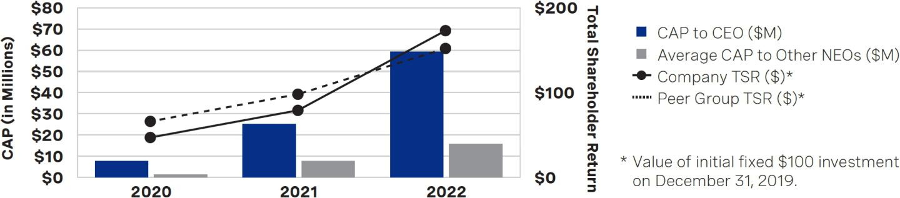

Compensation Actually Paid and Net Income
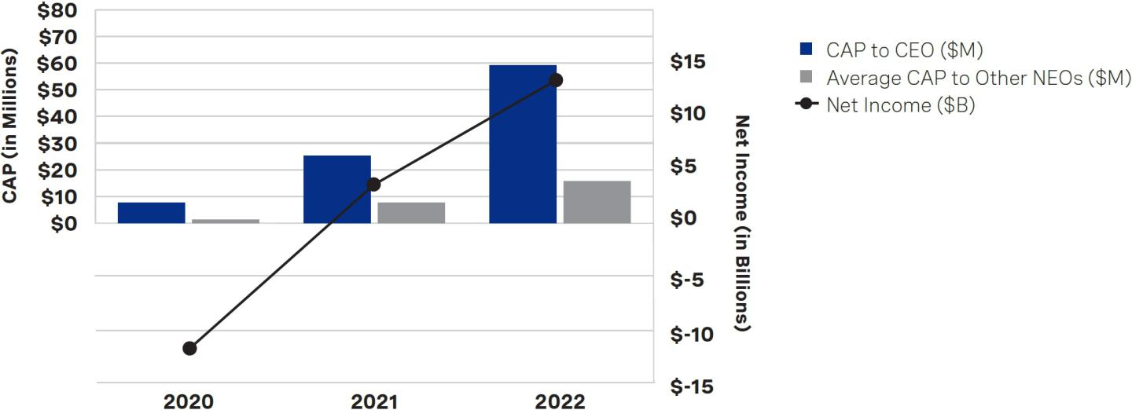

Compensation Actually Paid and CROCE
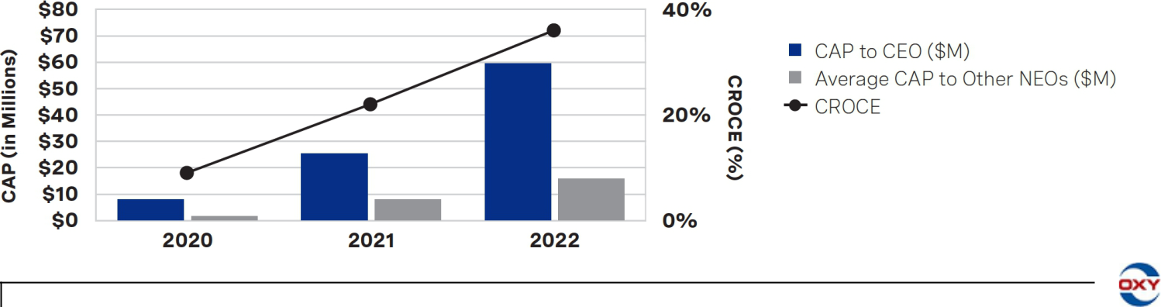

78

Table of Contents


RATIFICATION

OF SELECTION
OF KPMG AS
^{Proposal} OCCIDENTAL’S

INDEPENDENT

AUDITOR

Audit Related Matters

Independence of KPMG

THE BOARD OF

DIRECTORS
RECOMMENDS THAT YOU

VOTE “FOR” THE
RATIFICATION OF THE
SELECTION OF KPMG AS
OCCIDENTAL’S
INDEPENDENT AUDITOR.

The Audit Committee of the Board of Directors of Occidental oversees the appointment, compensation, performance and retention of the company’s independent registered public accounting firm that audits the consolidated financial statements of Occidental and its subsidiaries and internal control over financial reporting. The Audit Committee has selected KPMG LLP (KPMG) to continue to serve as Occidental’s independent registered public accounting firm for the year ending December 31, 2023. KPMG has audited Occidental’s financial statements since 2002. A member of that firm is expected to be present at the 2023 Annual Meeting, will have an opportunity to make a statement, if so desired, and is expected to be available to respond to appropriate questions.

The Audit Committee annually evaluates KPMG’s performance and independence in determining whether to retain KPMG or engage a different independent registered public accounting firm. Many factors contributed to the Audit Committee’s retention of KPMG as Occidental’s independent auditor, including:

Execution and quality of KPMG’s historical and recent audit plans

Quality of KPMG’s communications with the Audit Committee and management

Balance of KPMG’s experience and significant institutional knowledge with refreshment in light of mandatory audit partner rotation and other changes in team leadership

Strong quality control procedures of KPMG

KPMG’s independence from the company and management

Robust independence controls – internal, via the Audit Committee, and external, such as Public Company Accounting Oversight Board (PCAOB) and SEC oversight, PCAOB inspections, peer reviews, and PCAOB requirements for audit partner rotation

In accordance with applicable rules on partner rotation, KPMG’s lead partner for the company’s audit was changed in 2020, while KPMG’s engagement quality review partner for the audit was most recently changed in 2022. The Audit Committee is involved in considering the selection of KPMG’s primary engagement partner when there is rotation, which is at least every five years.

Audit and Non-Audit Services Pre-Approval Policy and Procedures

The Audit Committee must give prior approval to any management request for any amount or type of service (audit, audit-related and tax services or, to the extent permitted by law, non-audit services) Occidental’s independent auditor provides to Occidental. Additionally, the Audit Committee has delegated to the Audit Committee Chair full authority to approve any such request provided the Audit Committee Chair presents any approval so given to the Audit Committee at its next scheduled meeting. All audit and audit-related services rendered by KPMG in 2022 were pre-approved by the Audit Committee or the Audit Committee Chair before KPMG was engaged for such services. No services of any kind were approved pursuant to the de minimis exception for non-audit services set forth in Rule 2-01 of Regulation S-X.

2023 PROXY STATEMENT
79

Table of Contents

Proposal 4: Ratification of Selection of KPMG as Occidental’s Independent Auditor

Audit and Other Fees

KPMG was our independent auditor for the years ended December 31, 2022 and 2021. The audit fees billed and expected to be billed by KPMG for, and the fees billed by KPMG for all other services rendered during, the years ended December 31, 2022 and 2021, were as follows (in millions):

Services Provided |  | 2022 |  | 2021
Audit fees⁽¹⁾ | $ | 14.4 | $ | 13.1
Audit-related fees⁽²⁾ | $ | 0.1 | $ | 0.4
Tax fees⁽³⁾ | $ | 1.4 | $ | 0.5
All other fees⁽⁴⁾ | $ | 0.4 | $ | 0.4
Total | $ | 16.3 | $ | 14.4

- Audit fees include fees necessary to perform the annual audit and quarterly reviews in accordance with generally accepted auditing standards, annual attestation on internal control over financial reporting and services that generally only the independent auditor can reasonably provide, such as comfort letters, statutory audits, consents and assistance with, and review of, documents filed with the SEC.

- Audit-related fees in 2022 related to agreed-upon procedures, an attestation engagement related to our revolving credit facility and a pension plan audit. Audit-related fees in 2021 related to agreed-upon procedures, an attestation engagement related to our revolving credit facility, a pension plan audit and a subsidiary audit related to a disposition.
- Tax fees in 2022 primarily related to the issuance of a tax opinion on Occidental’s legal entity reorganization. Tax fees in 2021 related to tax advisory services.

- All other fees in 2022 and 2021 related to real-time system implementation assessment services.

Ratification of Selection of Independent Auditor

As a matter of good corporate governance, the Board of Directors of Occidental submits its Audit Committee’s annual selection of the independent auditor to our shareholders for ratification. A majority of the shares present or by proxy at the 2023 Annual Meeting and entitled to vote on this proposal must vote “FOR” the proposal to ratify the auditor selection. Abstentions have the same effect as votes “AGAINST” the proposal. Your broker may vote your shares on the proposal if you do not give your broker voting instructions, although we are aware that some brokers are choosing not to exercise this discretionary voting authority. As a result, we recommend you submit your vote as soon as possible. If the shareholders do not ratify the selection of KPMG, the Audit Committee will consider whether it is appropriate to select another independent auditor. Even if the shareholders ratify the selection of KPMG, the Audit Committee may select a different independent auditor at any time during the year if it determines that this would be in the best interests of Occidental and our shareholders. If KPMG should decline to act or otherwise become incapable of acting or if its retention is discontinued, the Audit Committee will select another independent auditor.

Report of the Audit Committee

The Audit Committee has reviewed and discussed Occidental’s audited financial statements for the year ended December 31, 2022, including management’s annual assessment of and report on Occidental’s internal control over financial reporting, with management and KPMG, Occidental’s independent auditor. In addition, the Audit Committee has discussed with KPMG the matters required to be discussed by the applicable standards of the PCAOB and the SEC. The Audit Committee received from KPMG written disclosures and the letter regarding its independence as required by the applicable requirements of the PCAOB. The Audit Committee has also considered whether the provision of non-audit services provided by KPMG to Occidental is compatible with maintaining their independence and has discussed with KPMG the firm’s independence. Based upon the reports and discussions described in this report, the Audit Committee recommended to the Board that the audited financial statements be included in Occidental’s Annual Report on Form 10-K for the year ended December 31, 2022, to be filed with the SEC.

Respectfully submitted,

THE AUDIT COMMITTEE

Robert M. Shearer (Chair)
Andrew Gould
Carlos M. Gutierrez

Avedick B. Poladian

80

Table of Contents


SHAREHOLDER

PROPOSAL
REQUESTING AN

Proposal INDEPENDENT

BOARD

CHAIRMAN POLICY

THE BOARD

OF DIRECTORS

RECOMMENDS A

VOTE “AGAINST”

THE SHAREHOLDER PROPOSAL, IF PROPERLY PRESENTED, FOR THE REASONS STATED ON PAGES 82-83.

Occidental has been advised that the following shareholder proposal may be introduced at the 2023 Annual Meeting. The Board of Directors disclaims any responsibility for the content of the proposal and for the statements made in support thereof, which, except for minor formatting changes, are presented in the form received from the shareholder proponent. The shareholder proposal is required to be voted on at the 2023 Annual Meeting only if it is properly presented.

John Chevedden (the proponent), 2215 Nelson Avenue, No. 205, Redondo Beach, California 90278, who reported owning 50 shares of Occidental’s common stock, submitted this proposal.

Proposal 5 – Independent Board Chairman


Shareholders request that the Board of Directors adopt an enduring policy, and amend the governing documents as necessary in order that 2 separate people hold the office of the Chairman and the office of the CEO as follows:

Whenever possible, the Chairman of the Board shall be an Independent Director.

The Board has the discretion to select a Temporary Chairman of the Board who is not an Independent Director to serve while the Board is seeking an Independent Chairman of the Board on an accelerated basis.

The Chairman shall not be a former employee of the company.

This policy could be phased in when there is a leadership transition.

The roles of Chairman and CEO are fundamentally different and should be held by 2 directors, a CEO and a Chairman who is completely independent of the CEO and our company. The job of the CEO is to manage the company. The job of the Chairman is to oversee the CEO and management.

Please vote yes:

Independent Board Chairman – Proposal 5

2023 PROXY STATEMENT
81

Table of Contents

Proposal 5: Shareholder Proposal Requesting an Independent Board Chairman Policy

THE BOARD OF DIRECTORS’ STATEMENT IN OPPOSITION

The Board of Directors recommends that shareholders vote AGAINST this shareholder proposal.

The Board of Directors recommends that shareholders vote AGAINST this proposal because the company’s amended and restated by-laws (the By-laws), as currently adopted, already require that the Board of Directors elect an independent director to be Chairman of the Board of Directors. This requirement has been in place at Occidental since May 2013. As a result of this and the additional reasons set forth below, the Board of Directors believes that this proposal is unnecessary, misdirected and not warranted for adoption at Occidental.

Independent Chairman is Already Required by Occidental’s By-laws

Article III, Section 13 of the By-laws states that “[t]he Board of Directors shall annually elect one of its Independent Directors (as defined in the Corporation’s Corporate Governance Policies adopted from time to time) to be Chairman of the Board of Directors.”

Occidental’s Corporate Governance Policies provide that to be considered “independent,” a director must be affirmatively determined by the Board, after receiving the recommendation of the Governance Committee and after due deliberation, to have no material relationship with the company other than as a director. In making this determination, the Board adheres to all of the specific tests for independence included in the New York Stock Exchange (NYSE) listing standards.

Jack B. Moore, the former President and Chief Executive Officer of Cameron International Corporation, was elected to the position of Independent Chairman of the Board of Directors in September 2022, following the passing of Stephen I. Chazen. Mr. Moore previously served as the Independent Vice Chairman of the Board from September 2019 until his election as Independent Chairman. Mr. Moore has never been employed by the company.

Mr. Chazen served as the President and Chief Executive Officer of Occidental from May 2011 to April 2016 and served as a member of the Board from May 2010 to May 2017. Following his departure from Occidental, Mr. Chazen founded Magnolia Oil & Gas Corporation, a publicly traded exploration and production company (Magnolia), and served as Magnolia’s President, Chief Executive Officer and Chairman. In 2020, Mr. Chazen rejoined Occidental’s Board. After carefully considering Mr. Chazen’s prior affiliation with Occidental, the Governance Committee reviewed and recommended, and the Board determined, that Mr. Chazen satisfied the NYSE independence requirements and had no material relationship with Occidental. Mr. Moore served as Independent Vice Chairman of the Board throughout Mr. Chazen’s tenure.

Moreover, as described on pages 25-26 of this proxy statement, the role and responsibilities of the Independent Chairman are robust, extensive and embody corporate governance “best practices.” The Independent Chairman chairs executive sessions of independent directors, assists in assuring compliance with the company’s Corporate Governance Policies and communicates to the CEO the views of the independent directors and the Board committees regarding objectives set for management by the Board, among other things.

Independent Vice Chairman or Other Independent Director Required to Serve in Independent Chairman’s Absence or Disability

While the proposal indicates that under the requested policy the Board would have the discretion to select a temporary Chairman who is not independent to serve while the Board seeks an independent Chairman, Occidental’s existing policies already require the continued independence of the Board’s leadership during a leadership transition. Under Article III, Section 13 of the By-laws, in the absence or disability of the Independent Chairman of the Board, the Independent Vice Chairman, if any, or other independent director as the Board may designate will exercise the powers and discharge the duties of the Independent Chairman.

82

Table of Contents

Proposal 5: Shareholder Proposal Requesting an Independent Board Chairman Policy

Imposing Arbitrary Restrictions on a Chairman’s Past Service with Occidental Inappropriately Undermines the Board’s Ability to Select an Independent Chairman Who Will Best Serve the Interests of the Company and its Shareholders

Lastly, the requested policy requires that “[t]he Chairman shall not be a former employee of the company”, which would preclude any director who has in the past served as an employee of the company in any capacity and for any duration from serving as Chairman, irrespective of the director’s independence status. The Board believes this restriction would arbitrarily and inappropriately eliminate qualified, independent directors from consideration as candidates for Independent Chairman. As explained above, Occidental’s governing documents specifically require that the Chairman and Vice Chairman satisfy specific independence requirements, and afford the Board flexibility to identify, from among the independent members of the Board, the Independent Chairman best suited to address the dynamic environment in which Occidental operates. By excluding any independent director who was previously employed by the company in any capacity, the proposal would inappropriately limit the Board’s ability to exercise its business judgment to determine the most effective leadership structure of the Board to serve the best interests of the company and its shareholders at any given time—including by selecting Chairmen who have not been employees of the company, like Mr. Moore who is currently the Independent Chairman.

For example, when Mr. Chazen was appointed as Independent Chair in March 2020 amidst the COVID-19 pandemic and turmoil in the energy markets, the Board believed that his deep knowledge of Occidental and decades of operational and financial leadership in the industry would add valuable insight as the company focused on managing the challenging macroeconomic environment. From Mr. Chazen’s appointment on March 18, 2020 through his passing on September 22, 2022, Occidental delivered over 500% in total shareholder returns. During this same period, the S&P 500 index delivered an approximate 63% total shareholder return. However, had the requested policy been in place at the time of his appointment, the Board would have been unable to appoint him as Independent Chairman, despite its determination that he was the independent director best suited to provide effective, independent leadership. The Board believes Occidental’s significant outperformance during Mr. Chazen’s tenure as Chairman underscores the importance of safeguarding the current flexibility afforded the Board to select the appropriate Independent Chairman.

* * * *

As described earlier in this proxy statement, Occidental has implemented, and is committed to continuing to have, strong corporate governance practices. In keeping with that commitment, the Independent Board Chairman policy that is already outlined in the By-laws and our Corporate Governance Policies provides for effective and independent Board oversight and leadership. Modifying the By-laws and our existing policies to also require that no former employee can serve as Independent Chairman despite satisfaction of the NYSE independence tests, among other things, would inappropriately constrain the Board’s ability to identify the Independent Chairman best suited to serve the interests of the company and its shareholders. For the aforementioned reasons, this proposal is unnecessary and not in the best interests of Occidental and its shareholders.

Accordingly, the Board of Directors recommends that you vote AGAINST this shareholder proposal.

2023 PROXY STATEMENT
83

Table of Contents

Security Ownership

Certain Beneficial Owners and Management

Based on a review of ownership reports filed with the SEC on or before March 10, 2023, the entities listed below are the only beneficial owners of greater than 5% of Occidental’s outstanding voting securities as of March 10, 2023, except as otherwise indicated in the notes to the table. This information may not be accurate or complete, and Occidental takes no responsibility for such information and makes no representation as to its accuracy or completeness as of the date hereof or any subsequent date. This information does not include changes in share ownership reported by the reporting person after the date of this table.

BENEFICIAL OWNERSHIP OF 5% SHAREHOLDERS

 | Total | Percent of |  |  | Sole | Shared
 | Number of | Percent of | Sole | Shared | Sole | Shared
Name and Address | Shares and | Outstanding | Sole | Shared | Investment | Investment
Name and Address | Warrants Owned | Common Stock⁽⁶⁾ | Voting Power | Voting Power | Power | Power
Warren E. Buffett and affiliated entities⁽¹⁾ | 284,012,289 | 28.92% | — | 284,012,289 | — | 284,012,289
3555 Farnam Street
Omaha, NE 68131
Dodge & Cox⁽²⁾ | 107,355,862 | 11.76% | 101,642,238 | — | 107,355,862 | —
555 California Street, 40th Floor
San Francisco, CA 94104
The Vanguard Group⁽³⁾ | 61,149,817 | 6.81% | — | 1,187,287 | 57,972,069 | 3,177,748
100 Vanguard Blvd.
Malvern, PA 19355
BlackRock, Inc.⁽⁴⁾ | 50,272,936 | 5.60% | 45,897,403 | — | 50,272,936 | —
55 East 52nd Street
New York, NY 10055
State Street Corporation⁽⁵⁾ | 48,735,391 | 5.43% | — | 45,233,612 | — | 48,710,750
1 Lincoln Street
Boston, MA 02111

- Pursuant to a Schedule 13G/A filed with the SEC on February 14, 2023, reporting beneficial ownership as of December 31, 2022, and a Form 4 subsequently filed with the SEC on March 7, 2023. According to the Schedule 13G/A filing, (i) Warren E. Buffett and Berkshire Hathaway Inc. (Berkshire) have shared voting power and shared investment power with regard to 278,210,498.81 common shares (194,351,650 common shares and 83,858,848.81 shares underlying the Berkshire Warrants (as such term is defined in the filing)); and (ii) National Indemnity Company has shared voting power and shared investment power with regard to 267,602,354.44 common shares (194,351,650 common shares and 73,250,704.44 shares underlying the Berkshire Warrants). Information about other entities deemed to share beneficial ownership of the shares, including their voting and investment power, is disclosed in the Schedule 13G/A filing. According to the Form 4 filed with the SEC on March 7, 2023, Warren E. Buffett and Berkshire acquired an additional 5,801,791 common shares through National Indemnity Company and, as of March 7, 2023, beneficially owned 200,153,441 common shares in the aggregate (not inclusive of the Berkshire Warrants).

- Pursuant to a Schedule 13G/A filed with the SEC on February 14, 2023, reporting beneficial ownership as of December 31, 2022. According to the filing, Dodge & Cox has sole voting power with regard to 101,642,238 securities (87,893,145 common shares and 13,749,093 warrants), sole investment power with regard to 107,355,862 securities (92,957,224 common shares and 14,398,638 warrants) and aggregate beneficial ownership of 107,355,862 securities (92,957,224 common shares and 14,398,638 warrants).
- Pursuant to a Schedule 13G/A filed with the SEC on February 9, 2023, reporting beneficial ownership as of December 31, 2022.

- Pursuant to a Schedule 13G/A filed with the SEC on February 8, 2023, reporting beneficial ownership as of December 31, 2022.

- Pursuant to a Schedule 13G/A filed with the SEC on February 7, 2023, reporting beneficial ownership as of December 31, 2022.

- Pursuant to SEC rules, the percentage of common stock beneficially owned by a shareholder includes shares that would be issued upon exercise of the warrants held by such shareholder but does not include the shares that may be issued upon exercise of warrants held by other shareholders.

84

Table of Contents

Security Ownership

The following table includes certain information regarding the beneficial ownership of Occidental common stock as of March 10, 2023, by each of Occidental’s named executive officers, directors, and all executive officers and directors as a group. The address for each person is c/o Occidental Petroleum Corporation, 5 Greenway Plaza, Suite 110, Houston, Texas 77046.

BENEFICIAL OWNERSHIP OF DIRECTORS AND EXECUTIVE OFFICERS

 |  | Options | Warrants | Total Shares | Percent of
 | Common | Exercisable | Exercisable | Total Shares | Outstanding
Name | Common | within | within | Beneficially | Common
Name | Stock⁽¹⁾ | 60 days | 60 Days | Owned | Stock⁽²⁾
Marcia E. Backus | 172,006 | 157,186 | 16,009 | 345,201
Vicky A. Bailey | 4,016 | — | — | 4,016
Peter J. Bennett | 74,932 | 30,056 | 9,694 | 114,682
Kenneth Dillon | 182,344 | 291,661 | 16,962 | 490,967
Andrew Gould | 30,295 | — | 2,351 | 32,646
Carlos M. Gutierrez | 48,997 | — | 7,832 | 56,829
Vicki Hollub | 519,500 | 987,196 | 50,033 | 1,556,729
Richard A. Jackson | 103,677 | 48,089 | 11,952 | 163,718
William R. Klesse | 176,984 | — | 29,760 | 206,744
Jack B. Moore | 50,832 | — | 4,799 | 55,631
Claire O’Neill | 724 | — | — | 724
Robert L. Peterson | 134,757 | 48,089 | 16,991 | 199,837
Avedick B. Poladian | 66,957 | — | 9,327 | 76,284
Ken Robinson | 549 | — | — | 549
Robert M. Shearer | 49,231 | — | 4,610 | 53,841
All executive officers and directors as a group (16 persons) | 1,481,668 | 1,470,355 | 165,864 | 3,117,887

- For executive officers, includes shares held through the Occidental Petroleum Corporation Savings Plan as of March 10, 2023. For non-employee directors, includes deferred stock units and/or common stock awards that are subject to restrictions on sale and transfer in the following amounts: Ms. Bailey – 4,016; Mr. Gould – 24,725; Mr. Gutierrez – 40,002; Mr. Klesse – 25,905; Mr. Moore
– 30,286; Ms. O’Neill – 724; Mr. Poladian – 41,618; Mr. Robinson – 549 and Mr. Shearer – 26,872.

- Less than 1%.

SECTION 16(A) REPORTS

Pursuant to Section 16(a) of the Securities Exchange Act of 1934 (as amended, the Exchange Act), Occidental’s executive officers, directors and any beneficial owner of more than 10 percent of any class of Occidental’s equity securities are required to file, with the SEC, reports of ownership and changes in ownership of Occidental common stock. Based solely on its review of the copies of the reports filed with the SEC and written representations that no additional reports were required, Occidental believes that, during 2022, all persons required to report timely filed all required reports.

2023 PROXY STATEMENT
85

Table of Contents

Questions and Answers About the Annual Meeting and Voting

1. WHY AM I RECEIVING THESE PROXY MATERIALS?

You are receiving these proxy materials because you held shares of Occidental’s common stock on March 10, 2023, the record date, which entitles you to notice of, and to vote at, Occidental’s 2023 Annual Meeting to be held on May 5, 2023, and at any adjournment or postponement thereof. The proxy materials include our Notice of Internet Availability, Notice of Annual Meeting of Shareholders, Proxy Statement and Annual Report on Form 10-K for the fiscal year ended December 31, 2022. The proxy materials also include the proxy card for the 2023 Annual Meeting. The proxy materials contain detailed information about the matters to be voted on at the 2023 Annual Meeting and provide information about Occidental to assist you in making an informed decision when voting your shares.

Occidental began furnishing the proxy materials to shareholders on March 23, 2023 and will bear all expenses in connection with this solicitation.

2. WHAT DOES IT MEAN IF I RECEIVE MORE THAN ONE PROXY CARD ON OR ABOUT THE SAME TIME?

It means that your shares are registered differently or are held in more than one account. In order to vote all of your shares, please sign, date and return each proxy card or, if you vote via the Internet or telephone, vote once for each proxy card you receive.

3. WHO IS ENTITLED TO VOTE AT THE MEETING?

Owners of our common stock as of the close of business on March 10, 2023, the record date, are entitled to vote at the 2023 Annual Meeting. The shares owned include shares you held on that date (i) directly in your name as the shareholder of record (registered shareholder) and (ii) in the name of a broker, bank or other holder of record where the shares were held for you as the beneficial owner (in street name). Each share of common stock is entitled to one vote on each matter. As of the record date, there were 898,115,138 shares of our common stock outstanding and entitled to vote. There are no other voting securities of Occidental entitled to vote at the 2023 Annual Meeting outstanding. A complete list of registered shareholders entitled to vote at the 2023 Annual Meeting will be open to the examination of any shareholder during normal business hours for 10 days prior to the 2023 Annual Meeting at Occidental’s headquarters and during the 2023 Annual Meeting at www.virtualshareholdermeeting.com/OXY2023, accessible using the 16-digit control number included on your Notice of Internet Availability, on your proxy card or in the voting instructions that accompanied your proxy materials.

4. HOW DO I VOTE MY SHARES?

If you are a shareholder of record as of the record date, you may vote by any of the following methods:

- Voting by Mail. If you choose to vote by mail, simply complete the enclosed proxy card, date and sign it, and return it in the postage-paid envelope provided. Your shares will be voted in accordance with the instructions on your proxy card.

- Voting by Internet. You may vote through the Internet by signing on to the website identified on your proxy card and following the procedures described on the website. Internet voting is available 24 hours a day, and the procedures are designed to authenticate votes cast by using a personal identification number located on your proxy card. The procedures permit you to give a proxy to vote your shares and to confirm that your instructions have been properly recorded. If you vote by Internet, you should not return your proxy card.

- Voting by Telephone. You may vote your shares by telephone by calling the toll-free telephone number provided on your proxy card. Telephone voting is available 24 hours a day, and the procedures are designed to authenticate votes cast by using a personal identification number located on your proxy card. The procedures permit you to give a proxy to vote your shares and to confirm that your instructions have been properly recorded. If you vote by telephone, you should not return your proxy card.

- Voting at the Meeting. The 2023 Annual Meeting will be held online. Please have your 16-digit control number on your Notice of Internet Availability, proxy card or in the voting instructions that accompanied your proxy materials to participate in the 2023 Annual Meeting by visiting www.virtualshareholdermeeting.com/OXY2023. You will be able to vote your shares electronically during the 2023 Annual Meeting (other than shares held through our employee benefit plans, which must be voted prior to the meeting).

If your shares are held in street name, your broker or other nominee has enclosed a proxy card for you to use to direct it how to vote your shares and may also provide additional voting instructions. Please instruct your broker or other nominee how to vote your shares using the form of proxy you received from it or otherwise in accordance with the voting instructions you receive.

86

Table of Contents

Questions and Answers About the Annual Meeting and Voting

Please return your completed proxy to your broker or other nominee or contact the person responsible for your account so that your vote can be counted. If your broker or other nominee permits you to provide voting instructions via the Internet or by telephone, you may vote that way as well.

Voting instructions relating to shares of our common stock held in the Occidental Petroleum Corporation Savings Plan and the Oxy Vinyls Savings Plan must be received no later than 11:59 p.m., Central Time, on the date that is two days prior to the 2023 Annual Meeting, so that the trustee of the plan (who votes the shares on behalf of plan participants) has adequate time to tabulate the voting instructions. Shares held in the Occidental Petroleum Corporation Savings Plan that are not voted or for which the trustee does not receive timely voting instructions will be voted by the trustee as directed by our Pension and Retirement Plan Administrative Committee, and shares held in the Oxy Vinyls Savings Plan that are not voted or for which the trustee does not receive timely voting instructions will be voted by the trustee as directed by the Oxy Vinyls Canada Company Retirement Committee.

5. CAN I REVOKE MY PROXY OR CHANGE MY VOTE?

Yes. You may revoke your proxy or change your vote before the 2023 Annual Meeting by filing a revocation with the Corporate Secretary of Occidental, by granting a new proxy bearing a later date (which automatically revokes the earlier proxy) whether made via the Internet, by telephone or by mail, or by attending the 2023 Annual Meeting virtually and voting online during the meeting.

If you hold your shares in street name, you may change your vote by contacting your broker or other nominee and following their instructions.

6. HOW WILL MY SHARES BE VOTED IF I SUBMIT A PROXY CARD BUT DO NOT SPECIFY HOW I WANT TO VOTE?

If you sign your proxy card and return it without marking voting instructions, your shares will be voted at the 2023 Annual Meeting:

- “FOR” the election of all director nominees (Proposal 1);

- “ONE YEAR” for Proposal 2;

- “FOR” Proposal 3;

- “FOR” Proposal 4;

- “AGAINST” Proposal 5; and

- in the discretion of the persons named as proxies on all other matters that may properly come before the 2023 Annual Meeting or any adjournment or postponement thereof.

7. HOW CAN I ATTEND THE 2023 ANNUAL MEETING?

We have decided to hold the 2023 Annual Meeting solely by means of virtual communications.

You may participate in the 2023 Annual Meeting only if you were a shareholder as of March 10, 2023, the record date, or if you hold a valid proxy. You will be able to participate in the 2023 Annual Meeting online and submit your questions during the meeting by visiting www.virtualshareholdermeeting.com/OXY2023. You also will be able to vote your shares electronically during the 2023 Annual Meeting (other than shares held through our employee benefit plans, which must be voted prior to the meeting).

To participate in the 2023 Annual Meeting, you will need the 16-digit control number included on your Notice of Internet Availability, on your proxy card or in the voting instructions that accompanied your proxy materials. If your shares are held in street name and your voting instruction form indicates that you may vote those shares through the http://www.proxyvote.com website, then you may access and participate in the 2023 Annual Meeting with the 16-digit access code indicated on that voting instruction form. Otherwise, shareholders who hold their shares in street name should contact their bank, broker or other nominee (preferably at least five days before the annual meeting) and obtain a “legal proxy” in order to be able to attend, participate in or vote at the 2023 Annual Meeting.

The 2023 Annual Meeting webcast will begin promptly at 9:00 a.m., Central Time. We encourage you to access the meeting prior to the start time. Online check-in will begin at 8:30 a.m., Central Time, and you should allow ample time for the check-in procedures.

8. WHAT IF I HAVE TECHNICAL DIFFICULTIES DURING CHECK-IN OR THE MEETING?

We will have technicians ready to assist you if you have any technical difficulties during check-in or the meeting. If you encounter any difficulties accessing the virtual meeting during the check-in or meeting time, please call the technical support number that will be posted on the virtual meeting log in page.

2023 PROXY STATEMENT
87

Table of Contents

Questions and Answers About the Annual Meeting and Voting

9. WHAT CONSTITUTES A QUORUM AT THE 2023 ANNUAL MEETING?

A majority of all outstanding shares entitled to vote at the 2023 Annual Meeting will constitute a quorum, which is the minimum number of shares that must be present or represented by proxy at the meeting to transact business. Abstentions and broker non-votes will be counted for purposes of determining whether a quorum is present.

10. WHAT IS THE VOTING REQUIREMENT TO APPROVE EACH OF THE PROPOSALS?

Proposal 1 will be subject to a majority voting standard because the By-laws provide that in an uncontested election, directors are elected by the majority of votes cast with respect to such director, meaning that the number of votes cast “FOR” a director must exceed the number of votes cast “AGAINST” that director. You may vote “FOR” or “AGAINST” or “ABSTAIN” when voting for each of the directors. Your broker may not vote your shares on this proposal unless you give voting instructions. Abstentions and broker non-votes have no effect on the vote.

Proposal 2 requires the affirmative vote of a majority of the shares present in person or by proxy at the 2023 Annual Meeting and entitled to vote on the subject matter. If none of the alternatives receives a majority vote, the frequency receiving the highest number of votes will be the frequency selected by shareholders. Abstentions have the same effect as votes cast “AGAINST” each of the frequency options of the proposal and broker non-votes, if any, have no effect on the vote.

Proposals 3, 4 and 5 require the affirmative vote of a majority of the shares present in person or by proxy at the 2023 Annual Meeting and entitled to vote on the subject matter. You may vote “FOR” or “AGAINST” or “ABSTAIN” when voting for each of these proposals. Abstentions will have the same effect as votes cast “AGAINST” each such proposal and broker non-votes, if any, have no effect on the vote.

11. WHAT HAPPENS IF I HOLD SHARES IN STREET NAME AND DO NOT SUBMIT VOTING INSTRUCTIONS? WHAT IS A BROKER NON-VOTE?

If your shares are held in street name, under NYSE rules, brokers are not permitted to vote on certain proposals and may not vote on any of the proposals unless you provide voting instructions. Therefore, unless you provide specific voting instructions, your shares may not be represented or voted at the meeting.

A broker non-vote occurs when a broker or other nominee holding shares for a beneficial owner does not vote on a particular proposal because the broker or nominee does not have discretionary voting power for that particular item (or has discretionary voting power but chooses not to exercise it) and has not received instructions from the beneficial owner. Under the NYSE rules that govern brokers who are voting with respect to shares held in street name, if brokers do not receive specific instructions, brokers may in some cases vote the shares in their discretion, but are not permitted to vote on certain proposals and may elect not to vote on any of the proposals unless you provide voting instructions.

- IS THE EFFECTIVENESS OF ANY OF THE PROPOSALS CONDITIONED ON THE APPROVAL OF ANOTHER PROPOSAL? None of the proposals recommended to be adopted by the Board are conditioned on the approval of another proposal.

- HOW CAN I ASK QUESTIONS DURING THE 2023 ANNUAL MEETING?

As part of the 2023 Annual Meeting, we will hold a live question and answer session, during which we intend, time permitting, to answer all written questions pertinent to Occidental and meeting matters that are submitted before or during the meeting in accordance with the 2023 Annual Meeting’s Rules of Conduct, which will be posted on the 2023 Annual Meeting website. Questions may be submitted the day of or during the 2023 Annual Meeting through www.virtualshareholdermeeting.com/ OXY2023. Answers to questions that are not addressed during the meeting are expected to be published on our Investor Relations website shortly after the meeting. Questions and answers may be grouped by topic and substantially similar questions will be grouped and answered once. We reserve the right to edit or reject questions we deem inappropriate.

- WHO SHOULD I CONTACT IF I HAVE ANY QUESTIONS OR NEED ASSISTANCE IN VOTING MY SHARES, OR IF I NEED ADDITIONAL COPIES OF THE PROXY MATERIALS?

If you have any questions, please contact Alliance Advisors, Occidental’s proxy solicitor, toll-free at 844-885-0175 or by email at oxy@allianceadvisors.com.

88

Table of Contents

General Information

This proxy statement is furnished in connection with the solicitation of proxies by the Board of Directors of Occidental Petroleum Corporation, a Delaware corporation, for use at the Annual Meeting of Shareholders on May 5, 2023, and at any adjournment or postponement of the meeting.

Information Available Online

Occidental’s Corporate Governance Policies and other governance policies, its Code of Business Conduct and the charters of the Board’s committees are available at www.oxy.com/investors/governance, or by writing to the Corporate Secretary’s office, Occidental Petroleum Corporation, 5 Greenway Plaza, Suite 110, Houston, Texas 77046.

Important Notice Regarding the Availability of Proxy Materials for the Shareholder Meeting to Be Held on May 5, 2023

This proxy statement and Occidental’s Annual Report on Form 10-K for the fiscal year ended December 31, 2022 are available without charge on Occidental’s website or by writing to the Corporate Secretary’s office at the address above. The Annual Report contains the consolidated financial statements of Occidental and its subsidiaries and the reports of KPMG LLP, Occidental’s independent auditor.

Householding of Proxy Materials

The SEC permits Occidental, with your permission, to send a single set of proxy materials to any household at which two or more shareholders reside if Occidental believes they are members of the same family. This rule is called “householding” and its purpose is to help reduce printing and mailing costs of proxy materials. To date, the company has not instituted this procedure, but may do so in the future.

A number of brokerage firms have instituted householding. If you and members of your household have multiple accounts holding shares of Occidental’s common stock, you may have received a householding notification from your broker. Please contact your broker directly if you have questions or wish to revoke your decision to household. These options are available to you at any time. If you receive a single set of proxy materials as a result of householding by your broker and you would like to receive separate copies of the Notice of Internet Availability, the Notice of Annual Meeting of Shareholders, Proxy Statement or Annual Report, you may submit a request to our Corporate Secretary at the address above, or by calling the Corporate Secretary’s office at 713-552-8654.

Voting Instructions and Information

Voting Rights

A Notice of Internet Availability or proxy card is being mailed beginning on March 23, 2023, to each shareholder of record as of the close of business on March 10, 2023, which is the record date for the determination of shareholders entitled to receive notice of, attend and vote at the 2023 Annual Meeting. As of the record date, Occidental had 898,115,138 shares of common stock outstanding. A majority of the outstanding shares of common stock must be represented at the 2023 Annual Meeting, in person or by proxy, to constitute a quorum and to transact business. Abstentions and broker non-votes will be counted for purposes of determining whether a quorum is present. You will have one vote for each share of Occidental’s common stock you own. You may vote online during the 2023 Annual Meeting or by proxy. Proxies may be submitted by telephone or by Internet at www.proxyvote.com as explained on the Notice of Internet Availability and, if you received a proxy card or voting information form, by marking, signing and returning the card in the envelope provided. Voting via the Internet is a valid proxy voting method under the laws of the state of Delaware, Occidental’s state of incorporation. You may not cumulate your votes.

2023 PROXY STATEMENT
89

Table of Contents

General Information

Pursuant to Occidental’s By-laws, a complete list of registered shareholders entitled to vote at the 2023 Annual Meeting will be open to the examination of any shareholder during normal business hours for 10 days prior to the 2023 Annual Meeting at Occidental’s headquarters and during the 2023 Annual Meeting at www.virtualshareholdermeeting.com/OXY2023, accessible using the 16-digit control number included on your Notice of Internet Availability, on your proxy card or in the voting instructions that accompanied your proxy materials.

Director Election Requirements

Pursuant to Occidental’s By-laws, in an uncontested election, directors are elected by the majority of votes cast with respect to such director, meaning that the number of votes cast “FOR” a director must exceed the number of votes cast “AGAINST” that director. Your broker may not vote your shares on this proposal unless you give voting instructions. Abstentions and broker non-votes, if any, have no effect on the vote. Any director who receives a greater number of votes “AGAINST” his or her election than votes “FOR” in an uncontested election must tender his or her resignation. Unless accepted earlier by the Board, such resignation will become effective on October 31st of the year of the election.

Voting of Proxies

The Board of Directors has designated Mses. Hollub and Clark, and each of them, with the full power of substitution, to vote shares represented by all properly executed proxies. The shares will be voted in accordance with the instructions specified on the proxy card. If no instructions are specified on the proxy card or if you indicate when voting on the Internet or by telephone that you wish to vote as recommended by the Board, the shares will be voted:

- “FOR” all director nominees (see page 14);

- “ONE YEAR” on the advisory vote on the frequency of future advisory votes to approve executive compensation (see page 35);

- “FOR” the advisory vote to approve named executive officer compensation (see page 36);

- “FOR” the ratification of the selection of KPMG as Occidental’s independent auditor (see page 79); and

- “AGAINST” the shareholder proposal requesting an Independent Board Chairman Policy (see page 81).

We are not aware of any matters to be presented at the 2023 Annual Meeting other than those described above. If any matters not described in this proxy statement are properly presented at the meeting, the proxies will use their own judgment to determine how to vote your shares. If the meeting is adjourned or postponed, the proxies can vote your shares at the adjournment or postponement as well.

Broker Votes

If your shares are held in street name, under NYSE rules, your broker is not permitted to vote on certain proposals and may not vote on any of the proposals unless you provide voting instructions. Therefore, unless you provide specific voting instructions, your shares may not be represented or voted at the meeting.

Confidential Voting Policy

All proxies, ballots and other voting materials are kept confidential, unless disclosure is required by applicable law or expressly requested by you, you include written comments on your proxy card or voting instruction form, or the proxy solicitation is contested. Occidental’s confidential voting policy is posted on Occidental’s website at www.oxy.com/investors/governance and also may be obtained by writing to the Corporate Secretary’s office, 5 Greenway Plaza, Suite 110, Houston, Texas 77046.

Voting Results

The voting results will be included in a Current Report on Form 8-K filed with the SEC and available through the SEC’s website or Occidental’s website at www.oxy.com, within four business days following the 2023 Annual Meeting, and may also be obtained by writing to the Corporate Secretary’s office at the address above.

90

Table of Contents

General Information

Solicitation Expenses

The expense of this solicitation will be paid by Occidental. Alliance Advisors has been retained to solicit proxies and to assist in the distribution of proxy materials for a fee estimated at $23,500 plus reimbursement of out-of-pocket expenses. Occidental also will reimburse banks, brokers, nominees and related fiduciaries for the expense of forwarding soliciting material to beneficial owners of its common stock. In addition, Occidental’s officers, directors and employees may solicit proxies but will receive no additional or special compensation for such work.

Shareholder Proposals for the 2024 Annual Meeting

Shareholders interested in submitting a proposal for inclusion in the proxy statement and proxy card relating to the 2024 Annual Meeting of Shareholders may do so by following the procedures in Rule 14a-8 under the Exchange Act. To be eligible for inclusion, shareholder proposals must be addressed to Occidental’s Corporate Secretary at Occidental Petroleum Corporation, 5 Greenway Plaza, Suite 110, Houston, Texas 77046, and be received no later than the close of business (5:00 p.m. Central Time) on November 24, 2023.

Under Occidental’s By-laws, shareholders must follow certain procedures to introduce an item of business at an annual meeting that is not included in the proxy materials. These procedures require that any such item of business must be submitted in writing to the Corporate Secretary at Occidental Petroleum Corporation, 5 Greenway Plaza, Suite 110, Houston, Texas 77046. Notice of the proposed item of business must be received no earlier than January 6, 2024 and no later than the close of business (5:00 p.m. Central Time) on February 5, 2024, and must include the information required by Occidental’s By-laws. However, if the 2024 Annual Meeting is more than 30 days before or after the anniversary of the date of the 2023 Annual Meeting, the notice must be received no later than the close of business on the tenth day following the day on which notice of the date of the 2024 Annual Meeting was mailed or public disclosure of the meeting date was made, whichever occurs first. A copy of the By-laws may be obtained by writing to the Corporate Secretary at the address listed above. The shareholder submitting the proposal or a representative of the shareholder must present the proposal in person at the meeting. The chairman of the meeting may refuse to allow the transaction of any item of business not presented in compliance with Occidental’s By-laws. In addition, the individuals named as proxies may have discretionary voting authority to vote against any such item of business.

Director Nominations for the 2024 Annual Meeting

Nominating Policy

It is the policy of the Governance Committee to consider nominees to the Board of Directors recommended by shareholders. Pursuant to the Nominating Policy, which is available at www.oxy.com/investors/governance/governance-policies/nominations-for-directors/, shareholder recommendations must be received by the Corporate Secretary of Occidental no earlier than January 6, 2024 and no later than February 5, 2024 to be considered by the Governance Committee. Each recommendation must include the following information:

- As to each person whom the shareholder proposes for election or re-election as a director:

  - The name, age, business address and residence address of the person;

  - The principal occupation or employment of the person;

  - The class or series and number of shares of capital stock of Occidental which are owned beneficially or of record by the person; and

  - Any other information relating to the person that is required to be disclosed in solicitations for proxies for election of directors pursuant to the rules and regulations of the SEC.

- As to the shareholder making the recommendation:

  - The name and address of record of such shareholder; and

  - The class or series and number of shares of common stock of Occidental which are beneficially owned by the shareholder.

2023 PROXY STATEMENT
91

Table of Contents

General Information

The shareholder’s recommendation must include the recommended person’s written consent to being named as a nominee and to serving as a director if elected.

In prior years, the Governance Committee has identified director candidates through the use of independent search firms, third-party recommendations, and the recommendations of directors and executive officers. The Governance Committee anticipates that, if a vacancy on the Board were to occur, it would use these sources as well as shareholder recommendations to identify candidates.

In deciding if a candidate recommended by a shareholder or identified by another source is qualified to be a nominee, it is the Governance Committee’s policy to consider:

- Whether the candidate is independent as defined in Occidental’s Corporate Governance Policies and as applied with respect to Occidental and the shareholder recommending the nominee, if applicable;

- Whether the candidate has the business experience, character, judgment, acumen and time to commit in order to make an ongoing positive contribution to the Board;

- Whether the candidate would contribute to the Board achieving a diverse and broadly inclusive membership; and

- Whether the candidate has the specialized knowledge or expertise, such as financial or audit experience, necessary to satisfy membership requirements for committees where specialized knowledge or expertise may be desirable.

If there is a vacancy and the Governance Committee believes that a recommended candidate has strong potential for Board service, the Governance Committee will arrange an interview with the candidate. Pursuant to its charter, the Governance Committee will not recommend any candidate to the Board who has not been interviewed by the Governance Committee.

In accordance with its charter, the Governance Committee annually reviews its performance and reports its findings to the Board. The Governance Committee also assists the Board in performing its self-evaluation, which includes an assessment of whether the Board has the necessary diversity of skills, backgrounds and experiences to meet Occidental’s ongoing needs.

Advance Notice Procedure to Nominate Candidates

Under Occidental’s By-laws, shareholders may nominate a person for election to the Board at an annual meeting by complying with the advance notice procedures in the By-laws and attending the annual meeting to make the necessary motion. For the 2024 Annual Meeting of Shareholders, the notice must be received no earlier than January 6, 2024 and no later than the close of business (5:00 p.m. Central Time) on February 5, 2024 and include the information required by Article III, Section 2 of the Bylaws. However, if the 2024 Annual Meeting is more than 30 days before or after the anniversary of the date of the 2023 Annual Meeting, the notice must be received by no later than the close of business on the tenth day following the day on which notice of the date of the 2024 Annual Meeting was mailed or such public disclosure was made, whichever occurs first. In addition to satisfying the deadlines in the advance notice provisions of our By-laws, a shareholder who intends to solicit proxies pursuant to Rule 14a-19 under the Exchange Act in support of nominees submitted under these advance notice provisions for the 2024 Annual Meeting must notify our Corporate Secretary in writing no later than March 6, 2024.

Proxy Access Procedure to Nominate Candidates

In 2015, with input from shareholders, the Board amended Occidental’s By-laws to permit a group of up to 20 shareholders, owning 3% or more of Occidental’s outstanding common stock continuously for at least three years to nominate and include in Occidental’s proxy materials directors constituting up to 20% of the Board, but not less than two directors, provided that the shareholder(s) and the nominee(s) meet the requirements in Article III, Section 15 of the By-laws. To be included in the 2024 proxy materials, director nominations pursuant to Article III, Section 15 must be received no earlier than October 25, 2023 and no later than the close of business (5:00 p.m. Central Time) on November 24, 2023.

92

Table of Contents

General Information

Forward-Looking Statements

This proxy statement contains “forward-looking statements” within the meaning of the “safe harbor” provisions of the Private Securities Litigation Reform Act of 1995, including but not limited to statements about Occidental’s expectations, beliefs, plans or forecasts. Forward-looking statements involve estimates, expectations, projections, goals, forecasts, assumptions, risks and uncertainties, many of which involve factors or circumstances that are beyond Occidental’s control. Actual results may differ from anticipated results, sometimes materially, and reported or expected results should not be considered an indication of future performance.

Factors that could cause actual results to differ and that may affect Occidental’s results of operations and financial position appear in Part I, Item 1A “Risk Factors” of Occidental’s Annual Report and in Occidental’s other filings with the SEC.

Because the factors referred to above could cause actual results or outcomes to differ materially from those expressed or implied in any forward-looking statements, you should not place undue reliance on any such forward-looking statements. Further, any forward-looking statement speaks only as of the date of this communication and, unless legally required, Occidental does not undertake any obligation to update any forward-looking statement, as a result of new information, future events or otherwise.

In addition, ESG-related statements are aspirational, are not guarantees or promises that related goals or targets may be met, and may be based on standards for measuring progress that are still developing, internal controls and processes that continue to evolve and assumptions that are subject to change in the future. In particular, there are multiple proposed or recently adopted changes to various GHG reporting regulations and protocols, including from the U.S. Environmental Protection Agency, the SEC, the GHG Protocol and certain countries and states, as well as for additional controls, fees or taxes on emissions. Given the potential significance of these changes for estimation and reporting, Occidental may update or modify our reported emissions and our current suite of GHG goals and targets to reflect new regulations and protocols, although we expect to retain our overarching net-zero goals and to continue to implement emissions reduction plans that we believe will complement our investments in DAC, CCUS and other low-carbon technologies and infrastructure.

Website references and references to other Occidental publications throughout this proxy statement are provided for convenience only, and the content on the referenced websites and in the referenced publications is not incorporated by reference into this proxy statement.

2023 PROXY STATEMENT
93

Table of Contents

ANNEX A

Reconciliations to GAAP

This proxy statement refers to cash return on capital employed (CROCE), return on capital employed (ROCE) and free cash flow, which are supplemental measures not calculated in accordance with generally accepted accounting principles in the United States (GAAP).

CROCE is defined by Occidental as cash flows from operating activities before changes in working capital plus any distributions from Western Midstream Partners, LP which are included in cash flows from investing activities divided by average total debt plus stockholders’ equity (average of the beginning and ending totals for the current period). Management believes that CROCE is useful to investors when comparing our profitability and the efficiency with which management has employed capital over time relative to other companies. CROCE is not considered to be an alternative to net income reported in accordance with GAAP.

CASH RETURN ON CAPITAL EMPLOYED (CROCE) (NON-GAAP)

$ in millions |  | 2022 |  |  |  | 2021
Cash flow from operating activities (GAAP) |  | $ 16,810
Plus: Changes in operating assets and liabilities and other operating, net |  | 1,325
Adjusted cash flow from operating activities (Non-GAAP) | A | $ 18,135
Debt, net at December 31, 2022 |  | $ 19,835
Total stockholder’s equity at December 31, 2022 |  | 30,085
Total debt and stockholder’s equity at December 31, 2022 |  | $ 49,920
Debt, net at December 31, 2021 |  |  |  |  |  | $ 29,617
Total stockholder’s equity at December 31, 2021 |  |  |  |  |  | 20,327
Total debt and stockholder’s equity at December 31, 2021 |  |  |  |  |  | $ 49,944
Average capital employed (Non-GAAP) | B | $ 49,932
CROCE (Non-GAAP) | A/B | 36.3%

ROCE is defined by Occidental as net income before interest expense and tax effect on interest expense divided by average total debt plus stockholders’ equity (average of the beginning and ending totals for the current period). Management believes that ROCE is useful to investors when comparing our profitability and the efficiency with which management has employed capital over time relative to other companies. ROCE is not considered to be an alternative to net income reported in accordance with GAAP.

RETURN ON CAPITAL EMPLOYED (ROCE) (NON-GAAP)

$ in millions |  |  | 2022 |  |  |  |  | 2021
Net Income (GAAP) |  | $ | 13,304
Interest Expense |  |  | 1,030
Tax effect on interest expense |  |  | (216)
Net income before interest expense (Non-GAAP) | A | $ | 14,118
Current maturities on long-term debt |  | $ | 165
Long-term debt, net at December 31, 2022 |  |  | 19,670
Total stockholder’s equity at December 31, 2022 |  |  | 30,085
Total debt and stockholder’s equity at December 31, 2022 |  | $ | 49,920
Current maturities on long-term debt at December 31, 2021 |  |  | $ |  |  |  |  | 186
Long-term debt, net at December 31, 2021 |  |  |  |  |  |  |  | 29,431
Total equity at December 31, 2021 |  |  |  |  |  |  |  | 20,327
Total debt and stockholder’s equity at December 31, 2021 |  |  | $ |  |  |  |  | 49,944
Average capital employed (Non-GAAP) | B | $ | 49,932
ROCE (Non-GAAP) | A/B |  | 28%
94

Table of Contents

ANNEX A

Operating cash flow before working capital and free cash flow are non-GAAP measures. Occidental defines operating cash flow before working capital as operating cash from continuing operations less working capital and free cash flow as operating cash flow before working capital less capital expenditures. These non-GAAP measures are not meant to disassociate those items from management’s performance, but rather are meant to provide useful information to investors interested in comparing Occidental’s performance between periods. Reported operating cash flow from continuing operations is considered representative of management’s performance over the long term, and operating cash flow before working capital and free cash flow are not considered to be alternatives to reported operating cash flow in accordance with GAAP.

FREE CASH FLOW (NON-GAAP)

$ in millions |  | 2022
Operating cash flow from continuing operations (GAAP) | $ | 16,810
Plus: Working capital and other, net |  | 1,325
Operating cash flow from continuing operations before working capital (Non-GAAP) | $ | 18,135
Less: Capital Expenditures (GAAP) |  | (4,497)
Free Cash Flow (Non-GAAP) | $ | 13,638

2023 PROXY STATEMENT
95

Table of Contents
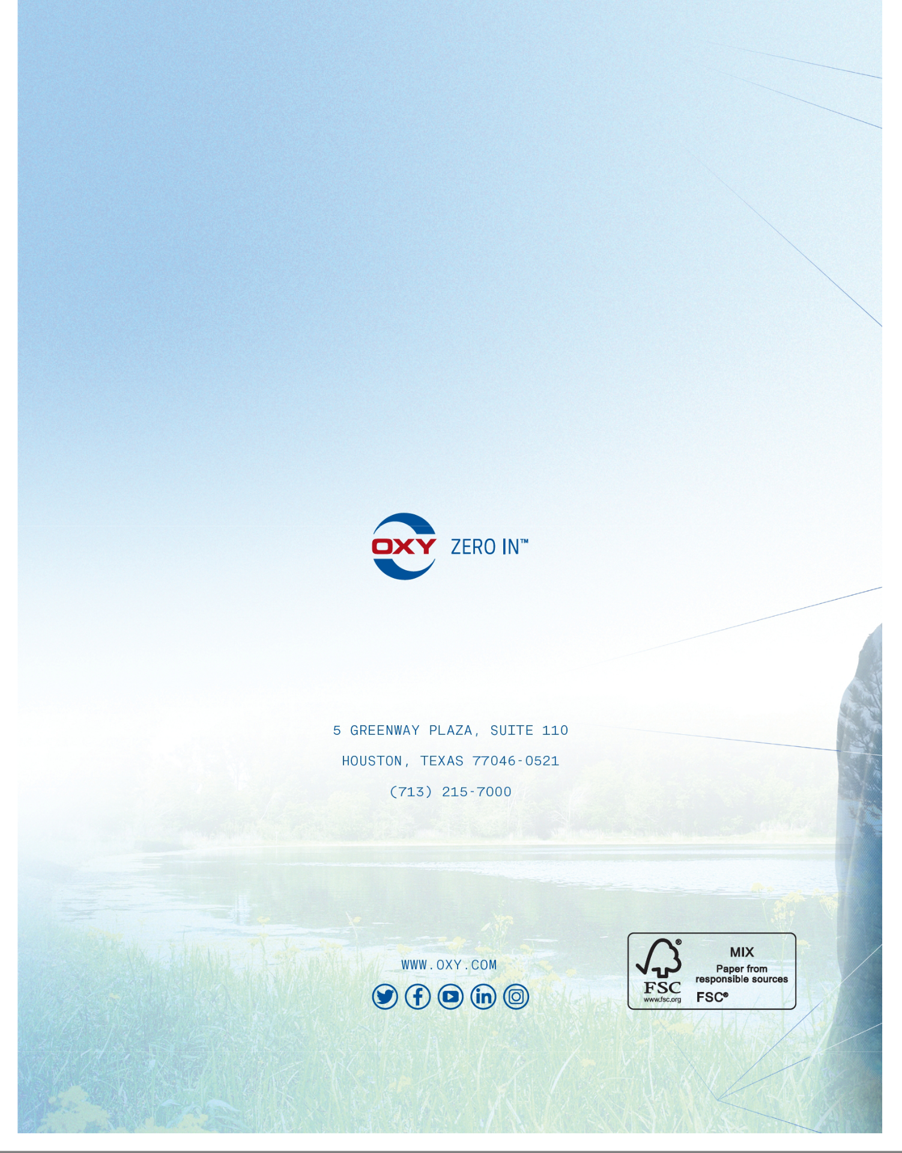

Table of Contents
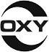

5 GREENWAY PLAZA, SUITE 110

HOUSTON, TX 77046

VOTE BY INTERNET

Before The Meeting - Go to www.proxyvote.com or scan the QR Barcode above

Use the Internet to transmit your voting instructions and for electronic delivery of information until 11:59 p.m. Eastern Time on May 4, 2023 and, for participants of the Occidental Petroleum Corporation Savings Plan and the Retirement Savings Program for employees of Oxy Vinyls Canada Co., until 11:59 p.m. Eastern Time on May 2, 2023. Have your proxy card in hand when you access the website and follow the instructions to obtain your records and to create an electronic voting instruction form.

During The Meeting - Go to www.virtualshareholdermeeting.com/OXY2023

You may attend the meeting via the Internet and vote during the meeting. Have the sixteen-digit control number that is printed in the box marked by the arrow available and follow the instructions.

VOTE BY PHONE - 1-800-690-6903
Use any touch-tone telephone to transmit your voting instructions until 11:59 p.m. Eastern Time on May 4, 2023 and, for participants of the Occidental Petroleum Corporation Savings Plan and the Retirement Savings Program for employees of Oxy Vinyls Canada Co., until 11:59 p.m. Eastern Time on May 2, 2023. Have your proxy card in hand when you call and then follow the instructions.

VOTE BY MAIL
Mark, sign and date your proxy card and return it in the postage-paid envelope we have provided or return it to Vote Processing, c/o Broadridge, 51 Mercedes Way, Edgewood, NY 11717.

ELECTRONIC DELIVERY OF FUTURE PROXY MATERIALS
If you would like to reduce the costs incurred by Occidental in mailing proxy materials, you can consent to receiving all future proxy statements, proxy cards and annual reports electronically via e-mail or the Internet. To sign up for electronic delivery, please follow the instructions above to vote using the Internet and, when prompted, indicate that you agree to receive or access proxy materials electronically in future years.

TO VOTE, MARK BLOCKS BELOW IN BLUE OR BLACK INK AS FOLLOWS:
D99515-P86980 | KEEP THIS PORTION FOR YOUR RECORDS
 | DETACH AND RETURN THIS PORTION ONLY
THIS PROXY CARD IS VALID ONLY WHEN SIGNED AND DATED.


OCCIDENTAL PETROLEUM CORPORATION

This proxy is solicited on behalf of the Board of Directors of Occidental Petroleum Corporation.

The Board of Directors recommends a vote “FOR” each nominee listed in Proposal 1.

- Election of Directors

Nominees: |  | For | Against | Abstain
1a. | Vicky A. Bailey | ☐ | ☐ | ☐
1b. | Andrew Gould | ☐ | ☐ | ☐
1c. | Carlos M. Gutierrez | ☐ | ☐ | ☐
1d. | Vicki Hollub | ☐ | ☐ | ☐
1e. | William R. Klesse | ☐ | ☐ | ☐
1f. | Jack B. Moore | ☐ | ☐ | ☐
1g. | Claire O’Neill | ☐ | ☐ | ☐
1h. | Avedick B. Poladian | ☐ | ☐ | ☐
1i. | Ken Robinson | ☐ | ☐ | ☐
1j. | Robert M. Shearer | ☐ | ☐ | ☐

The Board of Directors recommends a vote of |  | One | Two | Three | Abstain
every “ONE YEAR” for Proposal 2. |  | Year | Years | Years | Abstain
2. Advisory | Vote on the Frequency of Future | ☐ | ☐ | ☐ | ☐
Advisory | Votes to Approve Named Executive
Officer Compensation

The Board of Directors recommends a vote “FOR” |  | For | Against | Abstain
Proposals 3 and 4.
3. | Advisory Vote to Approve Named Executive Officer | ☐ | ☐ | ☐
 | Compensation
4. | Ratification of Selection of KPMG as Occidental’s | ☐ | ☐ | ☐
 | Independent Auditor

The Board of Directors recommends a vote “AGAINST” For Against Abstain Proposal 5.

5. Shareholder Proposal Requesting an Independent Board ☐ ☐ ☐

Chairman Policy

THIS PROXY, WHEN PROPERLY EXECUTED, WILL BE VOTED AS DIRECTED OR, IF NO

DIRECTION IS GIVEN, WILL BE VOTED AS THE BOARD OF DIRECTORS RECOMMENDS.

Please sign exactly as your name(s) appear(s) on the proxy. If the shares are held in joint tenancy, all persons should sign. Trustees, administrators, etc. should include their title and authority. Corporations should provide the full name of the corporation and the title of the authorized officer signing the proxy.

Signature [PLEASE SIGN WITHIN BOX] Date Signature (Joint Owners) Date

Table of Contents

Important Notice Regarding the Availability of Proxy Materials for the Annual Meeting:

The Notice and 2023 Proxy Statement and 2022 Annual Report are available at www.proxyvote.com.

D99516-P86980


OCCIDENTAL PETROLEUM CORPORATION

ANNUAL MEETING OF SHAREHOLDERS
Friday, May 5, 2023 at 9:00 a.m. Central Time

www.virtualshareholdermeeting.com/OXY2023

proxy card

VICKI HOLLUB and NICOLE E. CLARK, and each of them, with full power of substitution, are hereby authorized to represent and to vote the shares of the undersigned in OCCIDENTAL PETROLEUM CORPORATION (“Occidental”) as directed on the reverse side of this proxy card and, in their discretion, on all other matters which may properly come before the Annual Meeting of Shareholders to be held on May 5, 2023, and at any adjournment or postponement thereof (including, if applicable, on any matter which the Board of Directors did not know would be presented at the Annual Meeting of Shareholders by a reasonable time before the proxy solicitation was made), as if the undersigned were present and voting at the meeting.

The shares represented by this proxy will be voted as directed on the reverse side of this proxy card. Where no direction is given, such shares will be voted in accordance with the recommendation of the Board of Directors to the extent permitted by law; therefore, if no direction is made, this proxy will be voted FOR the election of each director nominee listed in Proposal 1; every ONE YEAR for Proposal 2; FOR Proposals 3 and 4; AGAINST Proposal 5; and, in the proxies’ discretion, in accordance with the recommendation of the Board of Directors, on any other matters coming before the meeting or any adjournment or postponement thereof. In the event any of the nominees named on the reverse side of this proxy card is unavailable for election or unable to serve, the shares represented by this proxy may be voted for a substitute nominee selected by the Board of Directors.

Your proxy will be kept confidential in accordance with the confidential voting policy described in the Proxy Statement and available on Occidental’s website.

Continued and to be signed on reverse side

Table of Contents

5 GREENWAY PLAZA, SUITE 110

HOUSTON, TX 77046

VOTE BY INTERNET - www.proxyvote.com or scan the QR Barcode above
Use the Internet to transmit your voting instructions and for electronic delivery of information until 11:59 p.m. Eastern Time on May 2, 2023. Have your voting instruction card in hand when you access the website and follow the instructions to obtain your records and to create an electronic voting instruction form.

VOTE BY PHONE - 1-800-690-6903
Use any touch-tone telephone to transmit your voting instructions until 11:59 p.m. Eastern Time on May 2, 2023. Have your voting instruction card in hand when you call and then follow the instructions.

VOTE BY MAIL
Mark, sign and date your voting instruction card and return it in the postage-paid envelope we have provided or return it to Vote Processing, c/o Broadridge, 51 Mercedes Way, Edgewood, NY 11717.

ELECTRONIC DELIVERY OF FUTURE PROXY MATERIALS
If you would like to reduce the costs incurred by Occidental in mailing proxy materials, you can consent to receiving all future proxy statements, voting instruction cards and annual reports electronically via e-mail or the Internet. To sign up for electronic delivery, please follow the instructions above to vote using the Internet and, when prompted, indicate that you agree to receive or access proxy materials electronically in future years.

TO VOTE, MARK BLOCKS BELOW IN BLUE OR BLACK INK AS FOLLOWS:
D99517-Z84384 | KEEP THIS PORTION FOR YOUR RECORDS
 | DETACH AND RETURN THIS PORTION ONLY
THIS PROXY CARD IS VALID ONLY WHEN SIGNED AND DATED.


OCCIDENTAL PETROLEUM CORPORATION

This proxy is solicited on behalf of the Board of Directors of Occidental Petroleum Corporation.

The Board of Directors recommends a vote “FOR” each nominee listed in Proposal 1.

- Election of Directors

Nominees: |  | For | Against | Abstain
1a. | Vicky A. Bailey | ☐ | ☐ | ☐
1b. | Andrew Gould | ☐ | ☐ | ☐
1c. | Carlos M. Gutierrez | ☐ | ☐ | ☐
1d. | Vicki Hollub | ☐ | ☐ | ☐
1e. | William R. Klesse | ☐ | ☐ | ☐
1f. | Jack B. Moore | ☐ | ☐ | ☐
1g. | Claire O’Neill | ☐ | ☐ | ☐
1h. | Avedick B. Poladian | ☐ | ☐ | ☐
1i. | Ken Robinson | ☐ | ☐ | ☐
1j. | Robert M. Shearer | ☐ | ☐ | ☐

The Board of Directors recommends a vote of |  | One | Two | Three | Abstain
every “ONE YEAR” for Proposal 2. |  | Year | Years | Years | Abstain
2. Advisory | Vote on the Frequency of Future | ☐ | ☐ | ☐ | ☐
Advisory | Votes to Approve Named Executive
Officer Compensation

The Board of Directors recommends a vote “FOR” |  | For | Against | Abstain
Proposals 3 and 4.
3. | Advisory Vote to Approve Named Executive Officer | ☐ | ☐ | ☐
 | Compensation
4. | Ratification of Selection of KPMG as Occidental’s | ☐ | ☐ | ☐
 | Independent Auditor

The Board of Directors recommends a vote “AGAINST” For Against Abstain Proposal 5.

5. Shareholder Proposal Requesting an Independent Board ☐ ☐ ☐

Chairman Policy

THIS PROXY, WHEN PROPERLY EXECUTED, WILL BE VOTED AS DIRECTED OR, IF NO

DIRECTION IS GIVEN, WILL BE VOTED AS THE BOARD OF DIRECTORS RECOMMENDS.

THE RESULTS OF THE VOTING WILL BE HELD IN STRICT CONFIDENCE BY THE

TRUSTEE.

Please sign exactly as your name(s) appear(s) on the proxy. If the shares are held in joint tenancy, all persons should sign. Trustees, administrators, etc. should include their title and authority. Corporations should provide the full name of the corporation and the title of the authorized officer signing the proxy.

Signature [PLEASE SIGN WITHIN BOX] Date Signature (Joint Owners) Date

Table of Contents

Important Notice Regarding the Availability of Proxy Materials for the Annual Meeting:

The Notice and 2023 Proxy Statement and 2022 Annual Report are available at www.proxyvote.com.

D99518-Z84384


OCCIDENTAL PETROLEUM CORPORATION

ANNUAL MEETING OF SHAREHOLDERS
Friday, May 5, 2023 at 9:00 a.m. Central Time

www.virtualshareholdermeeting.com/OXY2023

voting instruction card

TO THE BANK OF NEW YORK MELLON,

TRUSTEE OF THE OCCIDENTAL PETROLEUM CORPORATION SAVINGS PLAN (THE “PLAN”):

I acknowledge receipt of the Notice of Annual Meeting of Shareholders of Occidental Petroleum Corporation (“Occidental”) to be held on May 5, 2023, and the Proxy Statement furnished in connection with the solicitation of proxies by Occidental’s Board of Directors. I understand that the Trustee will vote the shares which are held for my account pursuant to the Plan in the manner indicated on the reverse side of this card and, in your discretion, on all other matters which may properly come before such meeting and at any adjournment or postponement thereof (including, if applicable, on any matter which the Board of Directors did not know would be presented at the Annual Meeting of Shareholders by a reasonable time before the proxy solicitation was made).

My vote for the election of directors is indicated on the reverse side. Nominees are: Vicky A. Bailey, Andrew Gould, Carlos M. Gutierrez, Vicki Hollub, William R. Klesse, Jack B. Moore, Claire O’Neill, Avedick B. Poladian, Ken Robinson and Robert M. Shearer. In the event any of the foregoing nominees are unavailable for election or unable to serve, shares represented by this card may be voted for a substitute nominee selected by the Board of Directors.

I understand that in the event I do not return this card, or it is not received by May 2, 2023, any shares held for my account in the Plan will be voted by you, as Trustee, in accordance with the direction of the Plan’s Administrative Committee.

Continued and to be signed on reverse side

Table of Contents

5 GREENWAY PLAZA, SUITE 110

HOUSTON, TX 77046

VOTE BY INTERNET - www.proxyvote.com or scan the QR Barcode above
Use the Internet to transmit your voting instructions and for electronic delivery of information until 11:59 p.m. Eastern Time on May 2, 2023. Have your voting instruction card in hand when you access the website and follow the instructions to obtain your records and to create an electronic voting instruction form.

VOTE BY PHONE - 1-800-690-6903
Use any touch-tone telephone to transmit your voting instructions until 11:59 p.m. Eastern Time on May 2, 2023. Have your voting instruction card in hand when you call and then follow the instructions.

VOTE BY MAIL
Mark, sign and date your voting instruction card and return it in the postage-paid envelope we have provided or return it to Vote Processing, c/o Broadridge, 51 Mercedes Way, Edgewood, NY 11717.

ELECTRONIC DELIVERY OF FUTURE PROXY MATERIALS
If you would like to reduce the costs incurred by Occidental in mailing proxy materials, you can consent to receiving all future proxy statements, voting instruction cards and annual reports electronically via e-mail or the Internet. To sign up for electronic delivery, please follow the instructions above to vote using the Internet and, when prompted, indicate that you agree to receive or access proxy materials electronically in future years.

TO VOTE, MARK BLOCKS BELOW IN BLUE OR BLACK INK AS FOLLOWS:
D99519-Z84385 | KEEP THIS PORTION FOR YOUR RECORDS
 | DETACH AND RETURN THIS PORTION ONLY
THIS PROXY CARD IS VALID ONLY WHEN SIGNED AND DATED.

OCCIDENTAL PETROLEUM CORPORATION

This proxy is solicited on behalf of the Board of Directors of Occidental Petroleum Corporation.

The Board of Directors recommends a vote “FOR” each nominee listed in Proposal 1.

- Election of Directors

Nominees: |  | For | Against | Abstain
1a. | Vicky A. Bailey | ☐ | ☐ | ☐
1b. | Andrew Gould | ☐ | ☐ | ☐
1c. | Carlos M. Gutierrez | ☐ | ☐ | ☐
1d. | Vicki Hollub | ☐ | ☐ | ☐
1e. | William R. Klesse | ☐ | ☐ | ☐
1f. | Jack B. Moore | ☐ | ☐ | ☐
1g. | Claire O’Neill | ☐ | ☐ | ☐
1h. | Avedick B. Poladian | ☐ | ☐ | ☐
1i. | Ken Robinson | ☐ | ☐ | ☐
1j. | Robert M. Shearer | ☐ | ☐ | ☐

The Board of Directors recommends a vote of |  | One | Two | Three | Abstain
every “ONE YEAR” for Proposal 2. |  | Year | Years | Years | Abstain
2. Advisory | Vote on the Frequency of Future | ☐ | ☐ | ☐ | ☐
Advisory | Votes to Approve Named Executive
Officer Compensation

The Board of Directors recommends a vote “FOR” |  | For | Against | Abstain
Proposals 3 and 4.
3. | Advisory Vote to Approve Named Executive Officer | ☐ | ☐ | ☐
 | Compensation
4. | Ratification of Selection of KPMG as Occidental’s | ☐ | ☐ | ☐
 | Independent Auditor

The Board of Directors recommends a vote “AGAINST” For Against Abstain Proposal 5.

5. Shareholder Proposal Requesting an Independent Board ☐ ☐ ☐

Chairman Policy

THIS PROXY, WHEN PROPERLY EXECUTED, WILL BE VOTED AS DIRECTED OR, IF NO

DIRECTION IS GIVEN, WILL BE VOTED AS THE BOARD OF DIRECTORS RECOMMENDS.

Please sign exactly as your name(s) appear(s) on the proxy. If the shares are held in joint tenancy, all persons should sign. Trustees, administrators, etc. should include their title and authority. Corporations should provide the full name of the corporation and the title of the authorized officer signing the proxy.

Signature [PLEASE SIGN WITHIN BOX] Date Signature (Joint Owners) Date

Table of Contents

Important Notice Regarding the Availability of Proxy Materials for the Annual Meeting:

The Notice and 2023 Proxy Statement and 2022 Annual Report are available at www.proxyvote.com.

D99520-Z84385


OCCIDENTAL PETROLEUM CORPORATION

ANNUAL MEETING OF SHAREHOLDERS
Friday, May 5, 2023 at 9:00 a.m. Central Time

www.virtualshareholdermeeting.com/OXY2023

voting instruction card

TO THE TRUSTEE OF THE RETIREMENT SAVINGS PROGRAM

FOR EMPLOYEES OF OXY VINYLS CANADA CO. (THE “PROGRAM”):

I acknowledge receipt of the Notice of Annual Meeting of Shareholders of Occidental Petroleum Corporation (“Occidental”) to be held on May 5, 2023, and the Proxy Statement furnished in connection with the solicitation of proxies by Occidental’s Board of Directors. You are directed to vote the shares which are held for my account pursuant to the Program in the manner indicated on the reverse side of this card and, in your discretion, on all other matters which may properly come before such meeting and at any adjournment or postponement thereof (including, if applicable, on any matter which the Board of Directors did not know would be presented at the Annual Meeting of Shareholders by a reasonable time before the proxy solicitation was made).

My vote for the election of directors is indicated on the reverse side. Nominees are: Vicky A. Bailey, Andrew Gould, Carlos M. Gutierrez, Vicki Hollub, William R. Klesse, Jack B. Moore, Claire O’Neill, Avedick B. Poladian, Ken Robinson and Robert M. Shearer. In the event any of the foregoing nominees are unavailable for election or unable to serve, shares represented by this card may be voted for a substitute nominee selected by the Board of Directors.

I understand that in the event I do not return this card, or it is not received by May 2, 2023, any shares held for my account in the Program will be voted by you in accordance with the direction of the Program’s Retirement Committee.

Continued and to be signed on reverse side

