UNITED STATES

SECURITIES AND EXCHANGE COMMISSION
Washington, D.C. 20549

SCHEDULE 14A

Proxy Statement Pursuant to Section 14(a) of
the Securities Exchange Act of 1934

Filed by the Registrant ☒

Filed by a Party other than the Registrant ☐

Check the appropriate box:
- Preliminary Proxy Statement

- Confidential, for Use of the Commission Only (as permitted by Rule 14a-6(e)(2))

- Definitive Proxy Statement

- Definitive Additional Materials

- Soliciting Material under Rule 14a-12

OCCIDENTAL PETROLEUM

CORPORATION

(Name of Registrant as Specified In Its Charter)

(Name of Person(s) Filing Proxy Statement, if other than the Registrant)

Payment of Filing Fee (Check the appropriate box):

- No fee required.

- Fee computed on table below per Exchange Act Rules 14a-6(i)(1) and 0-11.

  - Title of each class of securities to which transaction applies:

  - Aggregate number of securities to which transaction applies:

  - Per unit price or other underlying value of transaction computed pursuant to Exchange Act Rule 0-11 (set forth the amount on which the filing fee is calculated and state how it was determined):

  - Proposed maximum aggregate value of transaction:

  - Total fee paid:

- Fee paid previously with preliminary materials.

- Check box if any part of the fee is offset as provided by Exchange Act Rule 0-11(a)(2) and identify the filing for which the offsetting fee was paid previously. Identify the previous filing by registration statement number, or the Form or Schedule and the date of its filing.

  - Amount Previously Paid:

  - Form, Schedule or Registration Statement No.:

  - Filing Party:

  - Date Filed:

Attached as Exhibit 1 is the text of the website that is being maintained at https://www.voteforoccidental.com/en/home in connection with the opposition of Occidental Petroleum Corporation to the solicitation of requests by Carl C. Icahn and certain of his affiliated groups and entities.

Forward Looking Statements

This communication contains “forward-looking statements” within the meaning of the “safe harbor” provisions of the Private Securities Litigation Reform Act of 1995, including but not limited to statements about Occidental’s expectations, beliefs, plans or forecasts. Forward-looking statements involve estimates, expectations, projections, goals, forecasts, assumptions, risks and uncertainties, many of which involve factors or circumstances that are beyond Occidental’s control. Actual results may differ from anticipated results, sometimes materially, and reported or expected results should not be considered an indication of future performance.

Factors that could cause actual results to differ and that may affect Occidental’s results of operations and financial position appear in Part I, Item 1A “Risk Factors” of Occidental’s Annual Report on Form 10-K for the year ended December 31, 2018, and in Occidental’s other filings with the U.S. Securities and Exchange Commission (“SEC”). Additional factors related to the proposed transaction between Occidental and Anadarko Petroleum Corporation (“Anadarko”) appear in the definitive proxy statement/prospectus that is a part of Occidental’s registration statement on Form S-4, as amended, which was declared effective by the SEC on July 11, 2019 in connection with the proposed transaction between Occidental and Anadarko.

Because the factors referred to above could cause actual results or outcomes to differ materially from those expressed or implied in any forward-looking statements, you should not place undue reliance on any such forward-looking statements. Further, any forward-looking statement speaks only as of the date of this communication and, unless legally required, Occidental does not undertake any obligation to update any forward-looking statement, as a result of new information, future events or otherwise.

Additional Information and Where to Find It

Occidental has filed with the SEC a definitive consent revocation solicitation statement on Schedule 14A and has mailed such definitive consent revocation solicitation statement to shareholders of Occidental. This communication is not a substitute for any consent revocation solicitation statement or other document that Occidental has filed or may file with the SEC in connection with any solicitation by Occidental.

INVESTORS AND SECURITY HOLDERS ARE URGED TO READ THE CONSENT REVOCATION SOLICITATION STATEMENT (INCLUDING ANY AMENDMENTS OR SUPPLEMENTS THERETO) FILED BY OCCIDENTAL AND ANY OTHER RELEVANT DOCUMENTS FILED WITH THE SEC CAREFULLY AND IN THEIR ENTIRETY BECAUSE THEY CONTAIN OR WILL CONTAIN IMPORTANT INFORMATION ABOUT ANY SOLICITATION. Investors and security holders may obtain copies of these documents and other documents filed with the SEC by Occidental free of charge through the website maintained by the SEC at www.sec.gov. Copies of the documents filed by Occidental are also available free of charge by accessing Occidental’s website at www.oxy.com.

Participants

Occidental, its directors and executive officers and other members of management and employees will be participants in the solicitation of proxies with respect to a solicitation by Occidental. Information about Occidental’s executive officers and directors, and its ownership of Occidental by security holdings or otherwise, is available in Occidental’s Annual Report on Form 10-K for the year ended December 31, 2018, which was filed with the SEC on February 21, 2019, in its proxy statement for the 2019 Annual Meeting which was filed with the SEC on March 28, 2019 and in its Form 8-K which was filed with the SEC on July 15, 2019. To the extent holdings of Occidental securities have changed since the amounts printed in the proxy statement for the 2019 Annual Meeting, such changes have been or will be reflected on Statements of Change in Ownership on Form 4 filed with the SEC. These documents are available free of charge at the SEC’s website at www.sec.gov.

Exhibit 1

OXY Disclaimer Forward Looking Statements This website contains “forward-looking statements” within the meaning of the “safe harbor” provisions of the Private Securities Litigation Reform Act of 1995, including but not limited to statements about Occidental Petroleum Corporation’s (“Occidental”) expectations, beliefs, plans or forecasts. Forward-looking statements involve estimates, expectations, projections, goals, forecasts, assumptions, risks and uncertainties, many of which involve factors or circumstances that are beyond Occidental’s control. Actual results may differ from anticipated results, sometimes materially, and reported or expected results should not be considered an indication of future performance. Factors that could cause actual results to differ and that may affect Occidental’s results of operations and financial position appear in Part I, Item 1A “Risk Factors” of Occidental’s Annual Report on Form 10-K for the year ended December 31, 2018, and in Occidental’s other filings with the U.S. Securities and Exchange Commission (“SEC”). Additional factors related to the proposed transaction between Occidental and Anadarko Petroleum Corporation (“Anadarko”) appear in the definitive proxy statement/prospectus that is a part of Occidental’s registration statement on Form S-4, as amended (the “Registration Statement”), which was declared effective by the SEC on July 11, 2019, in connection with the proposed transaction between Occidental and Anadarko. Because the factors referred to above could cause actual results or outcomes to differ materially from those expressed or implied in any forward-looking statements, you should not place undue reliance on any such forward-looking statements. Further, any forward-looking statement speaks only as of the date of the relevant communication on this website and, unless legally required, Occidental does not undertake any obligation to update any forward-looking statement, as a result of new information, future events or otherwise. Additional Information and Where to Find it In connection with the proposed transaction with Anadarko, Occidental has filed with the SEC the Registration Statement, containing a prospectus of Occidental that also constitutes a proxy statement of Anadarko. Anadarko mailed a definitive proxy statement/prospectus to stockholders of Anadarko. In connection with the consent solicitation by Carl C. Icahn and certain related parties, Occidental has also filed with the SEC a consent revocation solicitation statement on Schedule 14A and mailed such consent revocation solicitation statement to stockholders of Occidental. This website and the communications herein are not a substitute for the proxy statement/prospectus or Registration Statement or other document Occidental and/or Anadarko has filed or may file with the SEC in connection with the proposed transaction between Occidental and Anadarko or a substitute for any consent revocation solicitation statement or other document that Occidental has filed or may file with the SEC in connection with any solicitation by Occidental.

INVESTORS AND SECURITY HOLDERS ARE URGED TO READ THE PROXY STATEMENT/PROSPECTUS, THE REGISTRATION STATEMENT, THE CONSENT REVOCATION SOLICITATION STATEMENT (INCLUDING, IN EACH CASE, ANY AMENDMENTS OR SUPPLEMENTS THERETO) FILED BY OCCIDENTAL AND ANY OTHER RELEVANT DOCUMENTS FILED WITH THE SEC CAREFULLY AND IN THEIR ENTIRETY BECAUSE THEY CONTAIN OR WILL CONTAIN IMPORTANT INFORMATION ABOUT OCCIDENTAL, ANADARKO, THE PROPOSED TRANSACTION AND ANY SOLICITATION. Investors and security holders may obtain copies of these documents and other documents filed with the SEC by Occidental and Anadarko free of charge through the website maintained by the SEC at www.sec.gov. Copies of the documents filed by Occidental and Anadarko are also available free of charge by accessing their websites at www.oxy.com and www.anadarko.com, respectively. Participants Occidental, Anadarko and their directors and executive officers and other members of management and employees may be deemed to be participants in the solicitation of proxies in respect of the proposed transaction between Occidental and Anadarko. In addition, Occidental, its directors and executive officers and other members of management and employees may be deemed to be participants in the solicitation of proxies with respect to a solicitation by Occidental. Information about Occidental’s executive officers and directors is available in Occidental’s Annual Report on Form 10-K for the year ended December 31, 2018, which was filed with the SEC on February 21, 2019, in its proxy statement for the 2019 Annual Meeting which was filed with the SEC on March 28, 2019 and in its Form 8-K which was filed with the SEC on July 15, 2019. To the extent holdings of Occidental securities have changed since the amounts printed in the proxy statement for the 2019 Annual Meeting, such changes have been or will be reflected on Statements of Change in Ownership on Form 4 filed with the SEC. Information about Anadarko’s executive officers and directors is available in Anadarko’s Annual Report on Form 10-K for the year ended December 31, 2018, which was filed with the SEC on February 14, 2019, and in its proxy statement for the 2019 Annual Meeting which was filed with the SEC on March 29, 2019. Additional information regarding the interests of such potential participants is included in the Registration Statement, proxy statement/prospectus and is or will be included in other relevant documents filed with the SEC. These documents are or will be available free of charge from the sources indicated above. I Agree I do not Ag
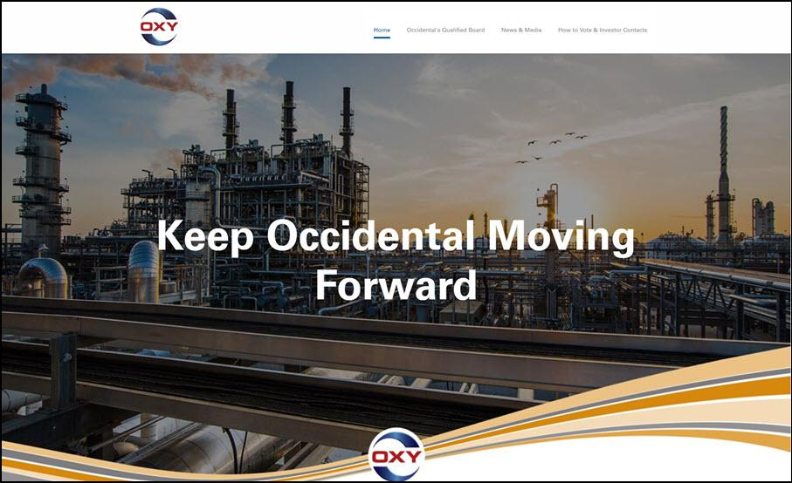

OXY Occidental’s Qualified Board News & Media How to Vote & Investor Contacts Keep Occidental Moving Forward OXY

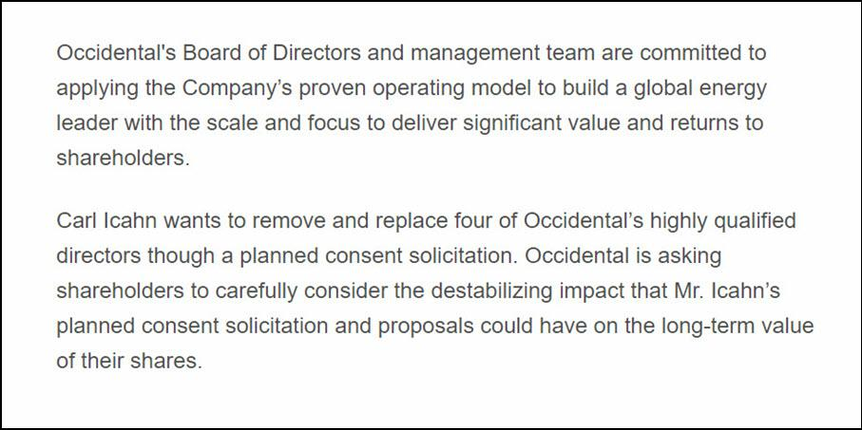

Occidental's Board of Directors and management team are committed to applying the Company’s proven operating model to build a global energy leader with the scale and focus to deliver significant value and returns to shareholders. Carl Icahn wants to remove and replace four of Occidental’s highly qualified directors though a planned consent solicitation. Occidental is asking shareholders to carefully consider the destabilizing impact that Mr. Icahn’s planned consent solicitation and proposals could have on the long-term value of their shares.

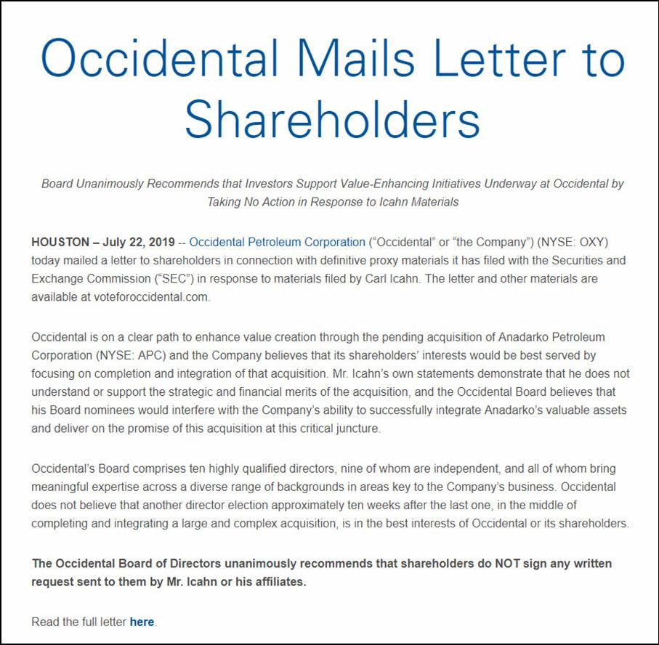

Occidental Mails Letter to Shareholders Board Unanimously Recommends that Investors Support Value-Enhancing Initiatives Underway at Occidental by Taking No Action in Response to Icahn Materials HOUSTON – July 22, 2019 -- Occidental Petroleum Corporation (“Occidental” or “the Company”) (NYSE: OXY) today mailed a letter to shareholders in connection with definitive proxy materials it has filed with the Securities and Exchange Commission (“SEC”) in response to materials filed by Carl Icahn. The letter and other materials are available at voteforoccidental.com. Occidental is on a clear path to enhance value creation through the pending acquisition of Anadarko Petroleum Corporation (NYSE: APC) and the Company believes that its shareholders’ interests would be best served by focusing on completion and integration of that acquisition. Mr. Icahn’s own statements demonstrate that he does not understand or support the strategic and financial merits of the acquisition, and the Occidental Board believes that his Board nominees would interfere with the Company’s ability to successfully integrate Anadarko’s valuable assets and deliver on the promise of this acquisition at this critical juncture. Occidental’s Board comprises ten highly qualified directors, nine of whom are independent, and all of whom bring meaningful expertise across a diverse range of backgrounds in areas key to the Company’s business. Occidental does not believe that another director election approximately ten weeks after the last one, in the middle of completing and integrating a large and complex acquisition, is in the best interests of Occidental or its shareholders. The Occidental Board of Directors unanimously recommends that shareholders do NOT sign any written request sent to them by Mr. Icahn or his affiliates. Read the full letter here.

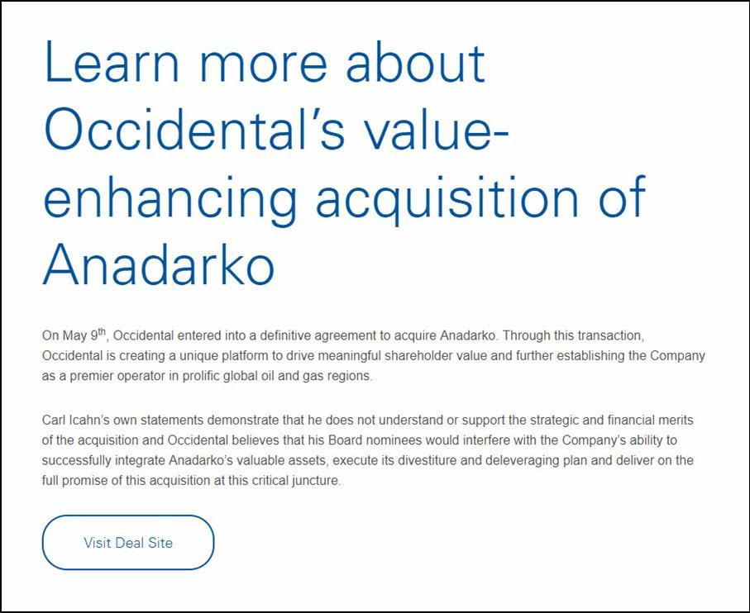

Learn more about Occidental’s value-enhancing acquisition of Anadarko On May 9th, Occidental entered into a definitive agreement to acquire Anadarko. Through this transaction, Occidental is creating a unique platform to drive meaningful shareholder value and further establishing the Company as a premier operator in prolific global oil and gas regions. Carl Icahn’s own statements demonstrate that he does not understand or support the strategic and financial merits of the acquisition and Occidental believes that his Board nominees would interfere with the Company’s ability to successfully integrate Anadarko’s valuable assets, execute its divestiture and deleveraging plan and deliver on the full promise of this acquisition at this critical juncture. Visit Deal Site

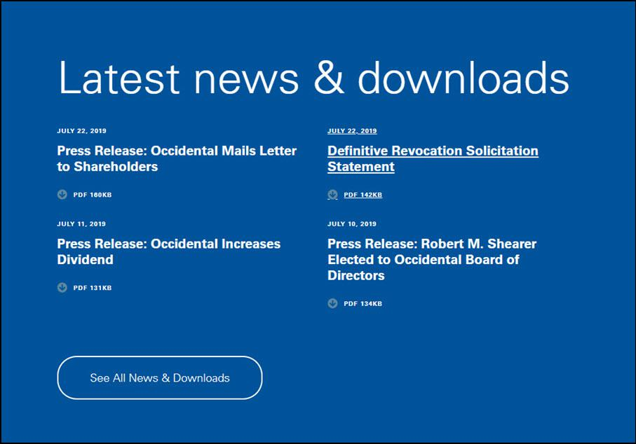

Latest news & downloads JULY 22, 2019 Press Release: Occidental Mails Letter to Shareholders Press Release: Occidental Mails Letter to Shareholders PDF 160KB JULY 22, 2019 Definitive Revocation Solicitation Statement Definitive Revocation Solicitation Statement PDF 142KB JULY 11, 2019 Press Release: Occidental Increases Dividend Press Release: Occidental Increases Dividend PDF 131KB JULY 10, 2019 Press Release: Robert M. Shearer Elected to Occidental Board of Directors Press Release: Robert M. Shearer Elected to Occidental Board of Directors PDF 134KB See All News & Downloads

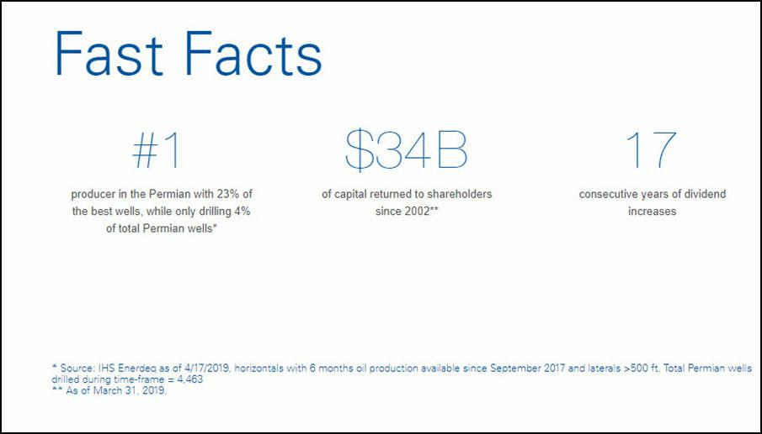

Fast Facts #1 producer in the Permian with 23% of the best wells, while only drilling 4% of total Permian wells* $34B of capital returned to shareholders since 2002** 17 consecutive years of dividend increases * Source: IHS Enerdeq as of 4/17/2019, horizontals with 6 months oil production available since September 2017 and laterals >500 ft. Total Permian wells drilled during time-frame = 4,463 ** As of March 31, 2019.

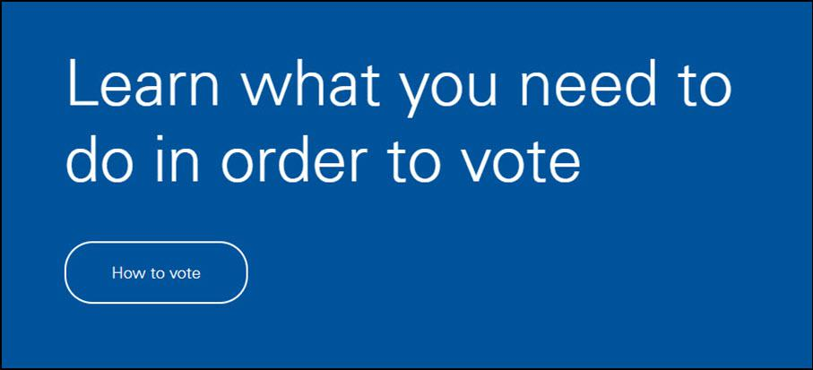

Learn what you need to do in order to vote How to vote

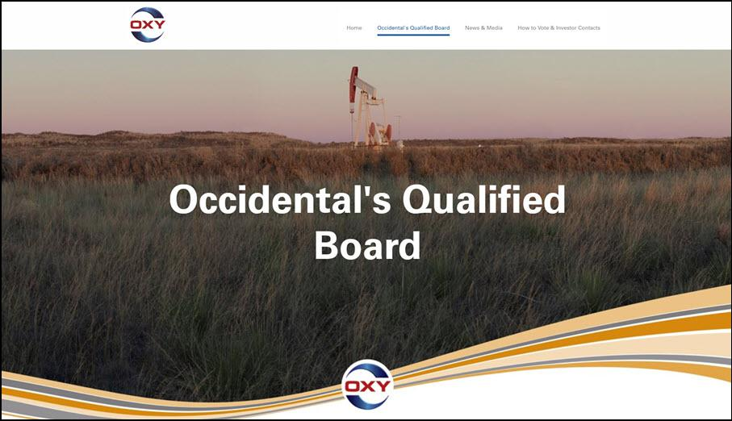

OXY Occidental’s Qualified Board News & Media How to Vote & Investor Contacts Occidental’s Qualified Board OXY

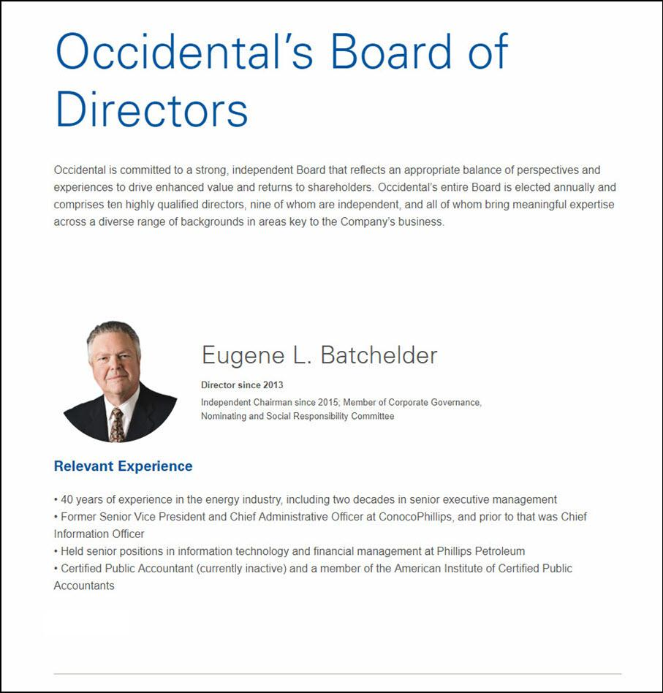

Occidental’s Board of Directors Occidental is committed to a strong, independent Board that reflects an appropriate balance of perspectives and experiences to drive enhanced value and returns to shareholders. Occidental’s entire Board is elected annually and comprises ten highly qualified directors, nine of whom are independent, and all of whom bring meaningful expertise across a diverse range of backgrounds in areas key to the Company’s business. Eugene L. Batchelder Director since 2013 Independent Chairman since 2015; Member of Corporate Governance, Nominating and Social Responsibility Committee Relevant Experience 40 years of experience in the energy industry, including two decades in senior executive management Former Senior Vice President and Chief Administrative Officer at ConocoPhillips, and prior to that was Chief Information Officer Held senior positions in information technology and financial management at Phillips Petroleum Certified Public Accountant (currently inactive) and a member of the American Institute of Certified Public Accountants

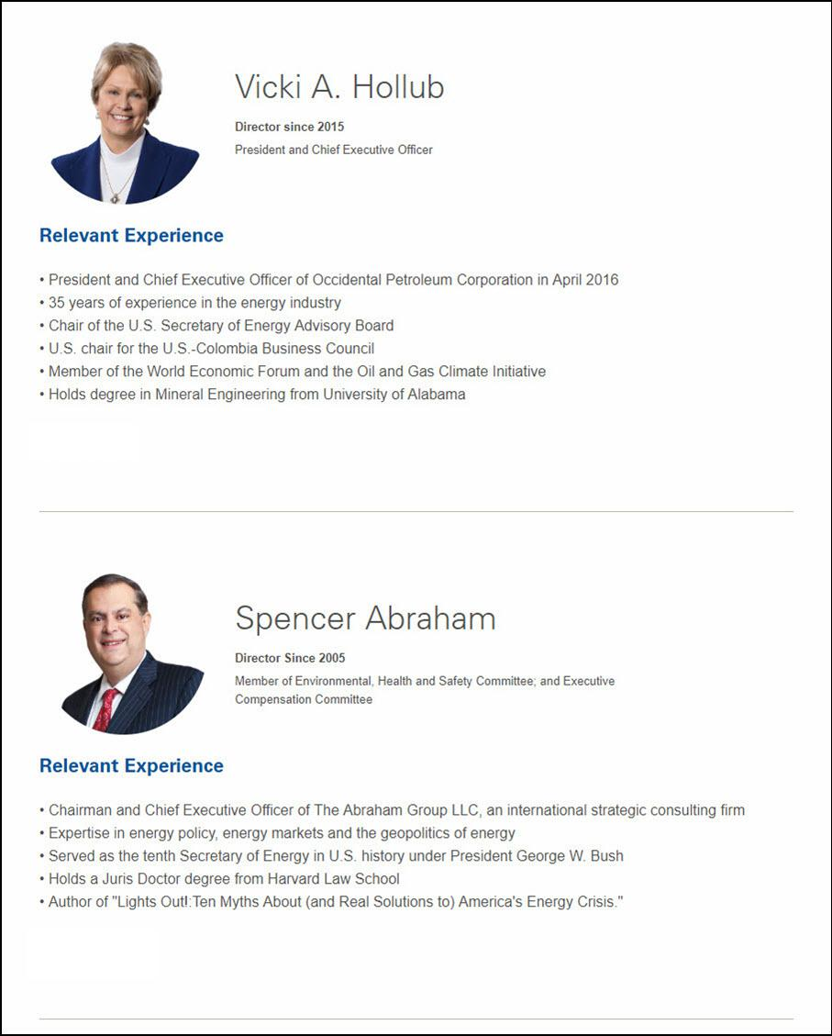

Vicki A. Hollub Director since 2015 President and Chief Executive Officer Relevant Experience President and Chief Executive Officer of Occidental Petroleum Corporation in April 2016 35 years of experience in the energy industry Chair of the U.S. Secretary of Energy Advisory Board U.S. chair for the U.S.-Colombia Business Council Member of the World Economic Forum and the Oil and Gas Climate Initiative Holds degree in Mineral Engineering from University of Alabama Spencer Abraham Director Since 2005 Member of Environmental, Health and Safety Committee; and Executive Compensation Committee Relevant Experience Chairman and Chief Executive Officer of The Abraham Group LLC, an international strategic consulting firm Expertise in energy policy, energy markets and the geopolitics of energy Served as the tenth Secretary of Energy in U.S. history under President George W. Bush Holds a Juris Doctor degree from Harvard Law School Author of "Lights Out!:Ten Myths About (and Real Solutions to) America's Energy Crisis."

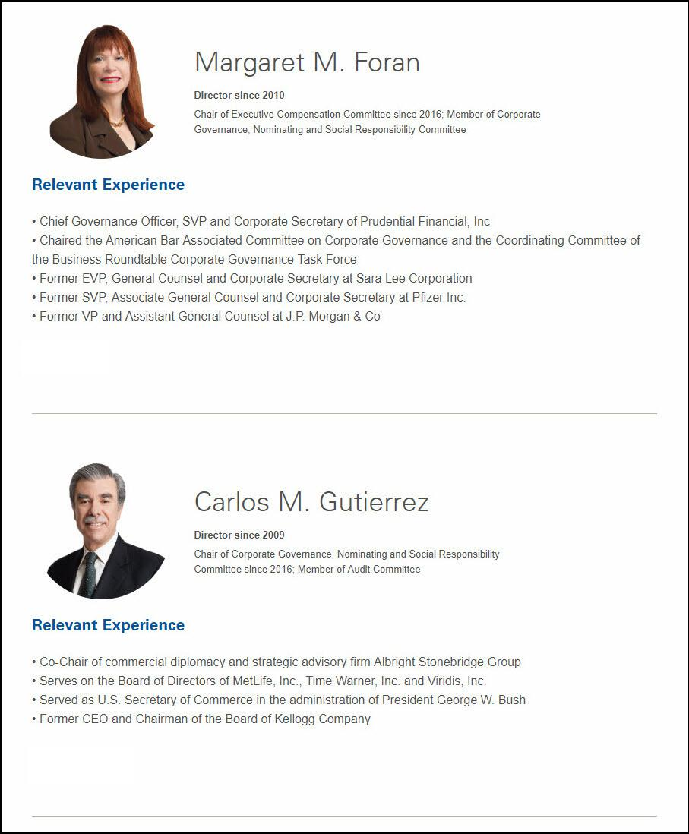

Margaret M. Foran Director since 2010 Chair of Executive Compensation Committee since 2016; Member of Corporate Governance, Nominating and Social Responsibility Committee Relevant Experience Chief Governance Officer, SVP and Corporate Secretary of Prudential Financial, Inc Chaired the American Bar Associated Committee on Corporate Governance and the Coordinating Committee of the Business Roundtable Corporate Governance Task Force Former EVP, General Counsel and Corporate Secretary at Sara Lee Corporation Former SVP, Associate General Counsel and Corporate Secretary at Pfizer Inc. Former VP and Assistant General Counsel at J.P. Morgan & Co Carlos M. Gutierrez Director since 2009 Chair of Corporate Governance, Nominating and Social Responsibility Committee since 2016; Member of Audit Committee Relevant Experience Co-Chair of commercial diplomacy and strategic advisory firm Albright Stonebridge Group Serves on the Board of Directors of MetLife, Inc., Time Warner, Inc. and Viridis, Inc. Served as U.S. Secretary of Commerce in the administration of President George W. Bush Former CEO and Chairman of the Board of Kellogg Company

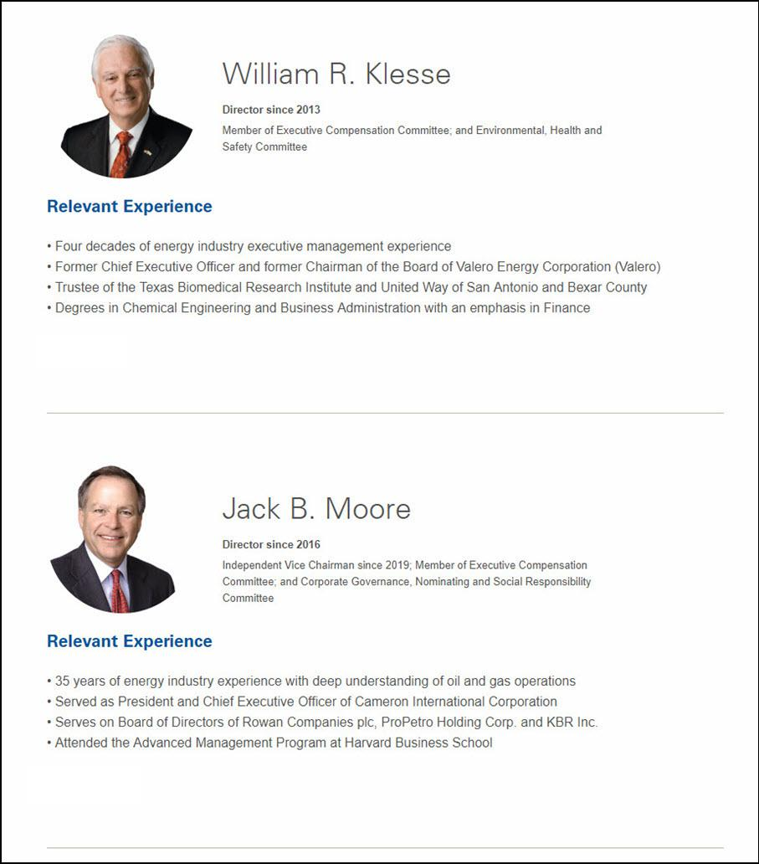

William R. Klesse Director since 2013 Member of Executive Compensation Committee; and Environmental, Health and Safety Committee Relevant Experience Four decades of energy industry executive management experience Former Chief Executive Officer and former Chairman of the Board of Valero Energy Corporation (Valero) Trustee of the Texas Biomedical Research Institute and United Way of San Antonio and Bexar County Degrees in Chemical Engineering and Business Administration with an emphasis in Finance Jack B. Moore Director since 2016 Independent Vice Chairman since 2019; Member of Executive Compensation Committee; and Corporate Governance, Nominating and Social Responsibility Committee Relevant Experience 35 years of energy industry experience with deep understanding of oil and gas operations Served as President and Chief Executive Officer of Cameron International Corporation Serves on Board of Directors of Rowan Companies plc, ProPetro Holding Corp. and KBR Inc. Attended the Advanced Management Program at Harvard Business School

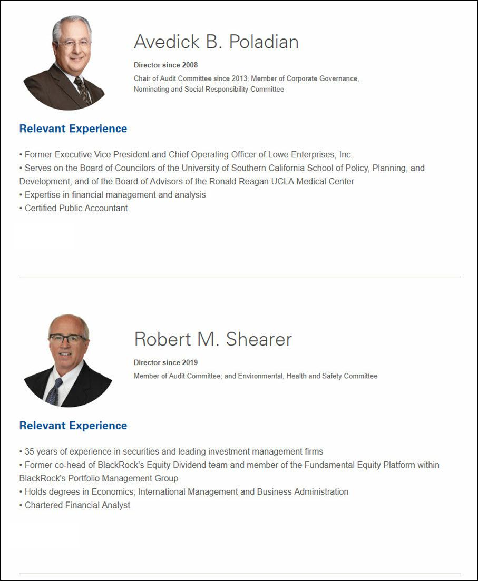

Avedick B. Poladian Director since 2008 Chair of Audit Committee since 2013; Member of Corporate Governance, Nominating and Social Responsibility Committee Relevant Experience Former Executive Vice President and Chief Operating Officer of Lowe Enterprises, Inc. Serves on the Board of Councilors of the University of Southern California School of Policy, Planning, and Development, and of the Board of Advisors of the Ronald Reagan UCLA Medical Center Expertise in financial management and analysis Certified Public Accountant Robert M. Shearer Director since 2019 Member of Audit Committee; and Environmental, Health and Safety Committee Relevant Experience 35 years of experience in securities and leading investment management firms Former co-head of BlackRock’s Equity Dividend team and member of the Fundamental Equity Platform within BlackRock's Portfolio Management Group Holds degrees in Economics, International Management and Business Administration Chartered Financial Analyst

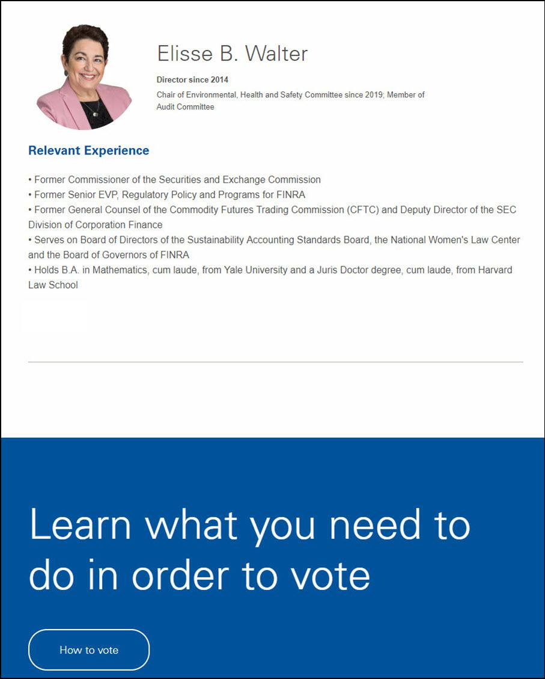

Elisse B. Walter Director since 2014 Chair of Environmental, Health and Safety Committee since 2019; Member of Audit Committee Relevant Experience Former Commissioner of the Securities and Exchange Commission Former Senior EVP, Regulatory Policy and Programs for FINRA Former General Counsel of the Commodity Futures Trading Commission (CFTC) and Deputy Director of the SEC Division of Corporation Finance Serves on Board of Directors of the Sustainability Accounting Standards Board, the National Women's Law Center and the Board of Governors of FINRA Holds B.A. in Mathematics, cum laude, from Yale University and a Juris Doctor degree, cum laude, from Harvard Law School Learn what you need to do in order to vote How to vote

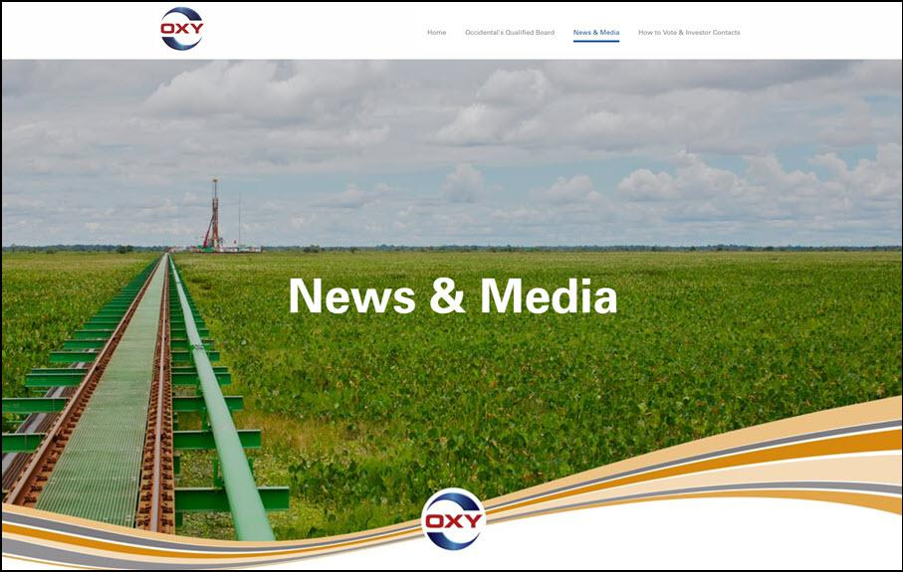

OXY Occidental’s Qualified Board News & Media How to Vote & Investor Contacts News & Media OXY

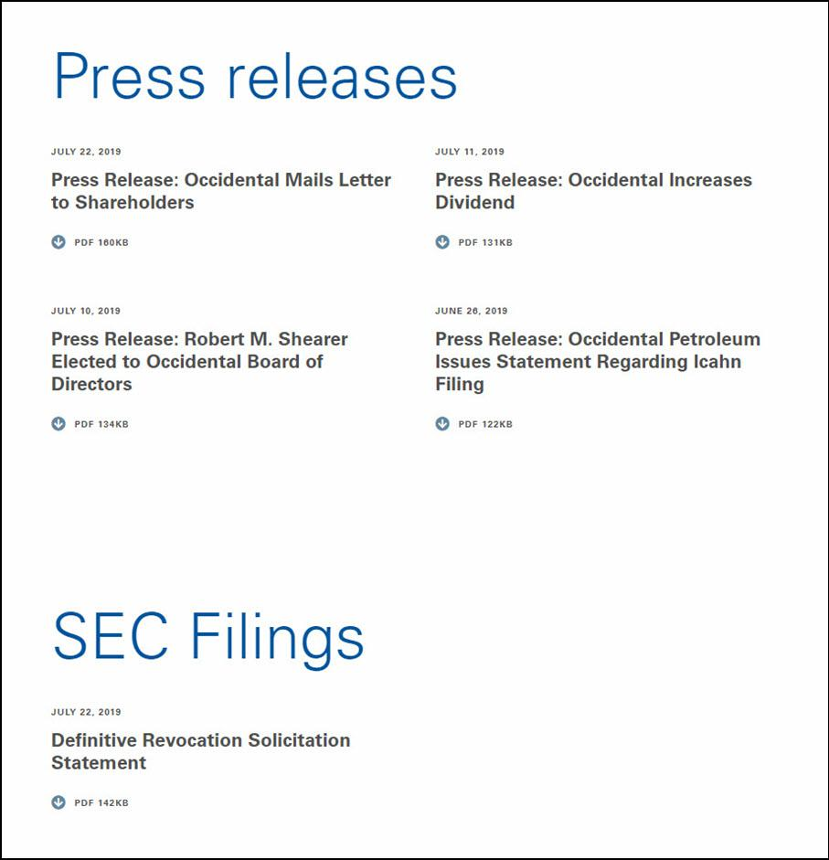

Press releases JULY 22, 2019 Press Release: Occidental Mails Letter to Shareholders Press Release: Occidental Mails Letter to Shareholders PDF 160KB JULY 11, 2019 Press Release: Occidental Increases Dividend Press Release: Occidental Increases Dividend PDF 131KB JULY 10, 2019 Press Release: Robert M. Shearer Elected to Occidental Board of Directors Press Release: Robert M. Shearer Elected to Occidental Board of Directors PDF 134KB JUNE 26, 2019 Press Release: Occidental Petroleum Issues Statement Regarding Icahn Filing Press Release: Occidental Petroleum Issues Statement Regarding Icahn Filing PDF 122KB SEC Filings JULY 22, 2019 Definitive Revocation Solicitation Statement Definitive Revocation Solicitation Statement PDF 142KB

Learn what you need to do in order to vote How to vote

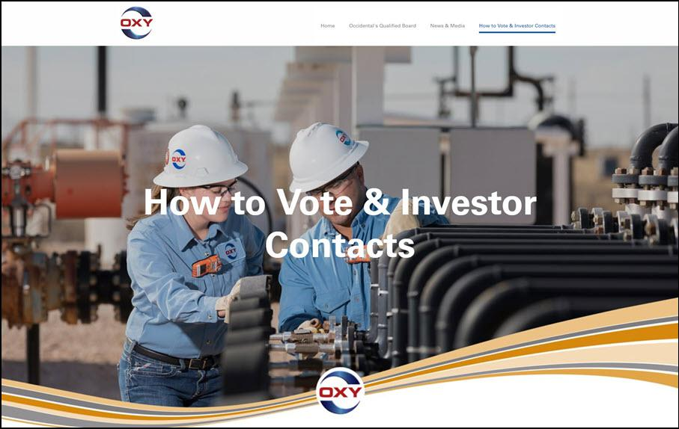

OXY Occidental’s Qualified Board News & Media How to Vote & Investor Contacts How to Vote & Investor Contacts OXY

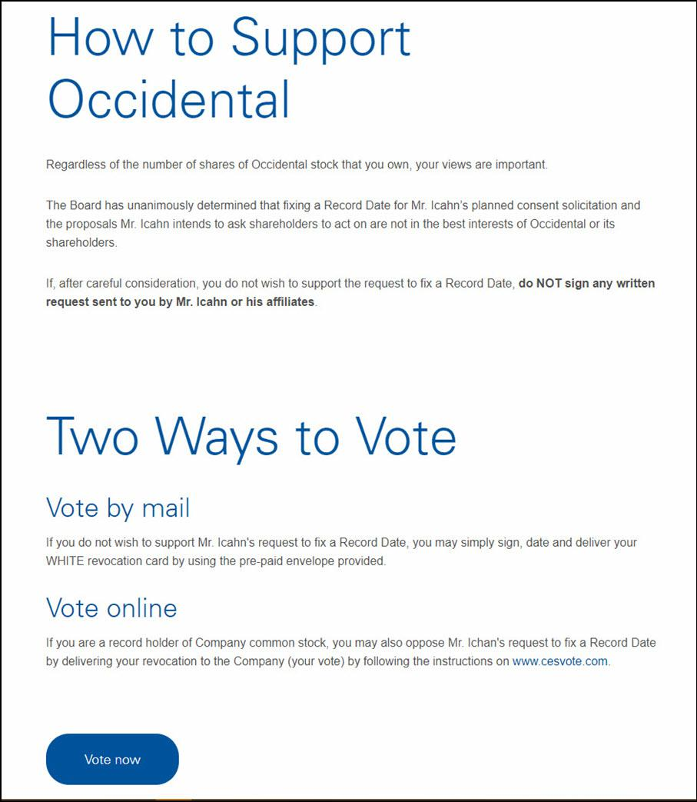

How to Support Occidental Regardless of the number of shares of Occidental stock that you own, your views are important. The Board has unanimously determined that fixing a Record Date for Mr. Icahn’s planned consent solicitation and the proposals Mr. Icahn intends to ask shareholders to act on are not in the best interests of Occidental or its shareholders. If, after careful consideration, you do not wish to support the request to fix a Record Date, do NOT sign any written request sent to you by Mr. Icahn or his affiliates. Two Ways to Vote by mail If you do not wish to support Mr. Icahn's request to fix a Record Date, you may simply sign, date and deliver your WHITE revocation card by using the pre-paid envelope provided. Vote online If you are a record holder of Company common stock, you may also oppose Mr. Ichan's request to fix a Record Date by delivering your revocation to the Company (your vote) by following the instructions on www.cesvote.com. Vote now

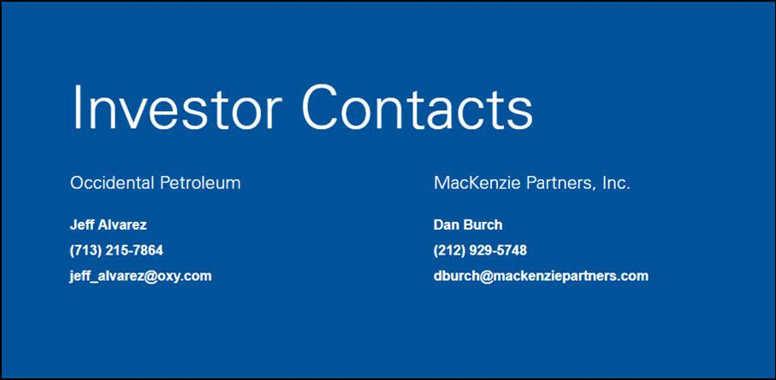

Investor Contacts Occidental Petroleum Jeff Alvarez (713) 215-7864 jeff_alvarez@oxy.com MacKenzie Partners, Inc. Dan Burch (212) 929-5748 dburch@mackenziepartners.com

