SEC Form 3
FORM 3 | UNITED STATES SECURITIES AND EXCHANGE COMMISSION  Washington, D.C. 20549  INITIAL STATEMENT OF BENEFICIAL OWNERSHIP OF SECURITIES  Filed pursuant to Section 16(a) of the Securities Exchange Act of 1934  or Section 30(h) of the Investment Company Act of 1940
  OMB APPROVAL
  OMB Number: | 3235-0104
  Estimated average burden
  hours per response: | 0.5
1. Name and Address of Reporting Person*  (Street) | 2. Date of Event Requiring Statement (Month/Day/Year)  08/01/2026 | 3. Issuer Name and Ticker or Trading Symbol  OCCIDENTAL PETROLEUM CORP /DE/ [ OXY ]  Foreign Trading Symbol
  POLLACK BRAD
  (Last) | (First) | (Middle)
  OCCIDENTAL PETROLEUM CORPORATION
  5 GREENWAY PLAZA, SUITE 110
  HOUSTON | TX | 77046
  (City) | (State) | (Zip)
 |  | 4. Relationship of Reporting Person(s) to Issuer  (Check all applicable) | 5. If Amendment, Date of Original Filed (Month/Day/Year)
   | Director |  | 10% Owner
   | Officer (give title below) |  | Other (specify below)
  SVP & General Counsel
6. Individual or Joint/Group Filing (Check Applicable Line)
Form filed by One Reporting Person
Form filed by More than One Reporting Person

Table I - Non-Derivative Securities Beneficially Owned
1. Title of Security (Instr. 4) | 2. Amount of Securities Beneficially Owned (Instr. 4) | 3. Ownership Form: Direct (D) or Indirect (I) (Instr. 5) | 4. Nature of Indirect Beneficial Ownership (Instr. 5)
Common Stock | 16,376 | D
Common Stock | 2,425(1) | I | By OPC Savings Plan
Table II - Derivative Securities Beneficially Owned
(e.g., puts, calls, warrants, options, convertible securities)
1. Title of Derivative Security (Instr. 4) | 2. Date Exercisable and Expiration Date (Month/Day/Year) |  | 3. Title and Amount of Securities Underlying Derivative Security (Instr. 4) |  | 4. Conversion or Exercise Price of Derivative Security | 5. Ownership Form: Direct (D) or Indirect (I) (Instr. 5) | 6. Nature of Indirect Beneficial Ownership (Instr. 5)
1. Title of Derivative Security (Instr. 4) | Date Exercisable | Expiration Date | Title | Amount or Number of Shares | 4. Conversion or Exercise Price of Derivative Security | 5. Ownership Form: Direct (D) or Indirect (I) (Instr. 5) | 6. Nature of Indirect Beneficial Ownership (Instr. 5)
Explanation of Responses:
1. Based on a plan statement dated July 31, 2026.
Remarks:
Exhibit List Exhibit 24 - Power of Attorney
 | /s/ Brittany A. Smith, Attorney-in-Fact for Brad Pollack | 08/04/2026
 | ** Signature of Reporting Person | Date
Reminder: Report on a separate line for each class of securities beneficially owned directly or indirectly.
* If the form is filed by more than one reporting person, see Instruction 5 (b)(v).
** Intentional misstatements or omissions of facts constitute Federal Criminal Violations See 18 U.S.C. 1001 and 15 U.S.C. 78ff(a).
Note: File three copies of this Form, one of which must be manually signed. If space is insufficient, see Instruction 6 for procedure.
Persons who respond to the collection of information contained in this form are not required to respond unless the form displays a currently valid OMB Number.
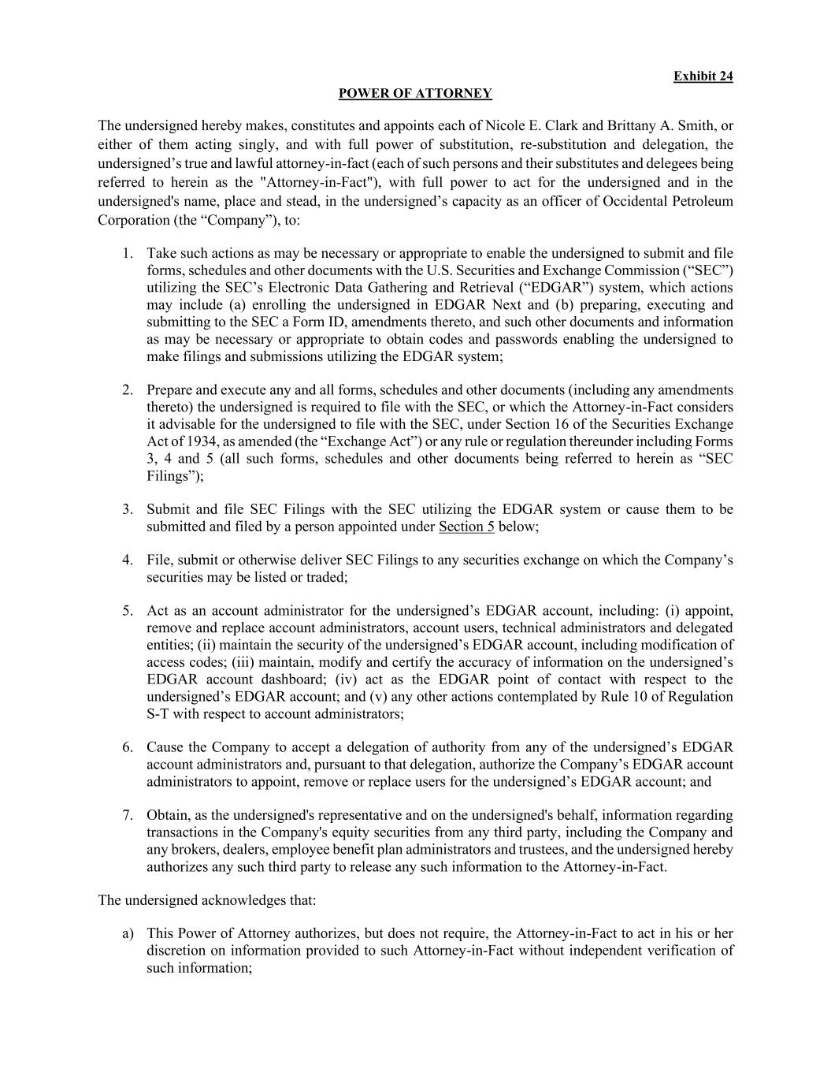
Exhibit 24 POWER OF ATTORNEY The undersigned hereby makes, constitutes and appoints each of Nicole E. Clark and Brittany A. Smith, or either of them acting singly, and with full power of substitution, re-substitution and delegation, the undersigned’s true and lawful attorney-in-fact (each of such persons and their substitutes and delegees being referred to herein as the "Attorney-in-Fact"), with full power to act for the undersigned and in the undersigned's name, place and stead, in the undersigned’s capacity as an officer of Occidental Petroleum Corporation (the “Company”), to: 1. Take such actions as may be necessary or appropriate to enable the undersigned to submit and file forms, schedules and other documents with the U.S. Securities and Exchange Commission (“SEC”) utilizing the SEC’s Electronic Data Gathering and Retrieval (“EDGAR”) system, which actions may include (a) enrolling the undersigned in EDGAR Next and (b) preparing, executing and submitting to the SEC a Form ID, amendments thereto, and such other documents and information as may be necessary or appropriate to obtain codes and passwords enabling the undersigned to make filings and submissions utilizing the EDGAR system; 2. Prepare and execute any and all forms, schedules and other documents (including any amendments thereto) the undersigned is required to file with the SEC, or which the Attorney-in-Fact considers it advisable for the undersigned to file with the SEC, under Section 16 of the Securities Exchange Act of 1934, as amended (the “Exchange Act”) or any rule or regulation thereunder including Forms 3, 4 and 5 (all such forms, schedules and other documents being referred to herein as “SEC Filings”); 3. Submit and file SEC Filings with the SEC utilizing the EDGAR system or cause them to be submitted and filed by a person appointed under Section 5 below; 4. File, submit or otherwise deliver SEC Filings to any securities exchange on which the Company’s securities may be listed or traded; 5. Act as an account administrator for the undersigned’s EDGAR account, including: (i) appoint, remove and replace account administrators, account users, technical administrators and delegated entities; (ii) maintain the security of the undersigned’s EDGAR account, including modification of access codes; (iii) maintain, modify and certify the accuracy of information on the undersigned’s EDGAR account dashboard; (iv) act as the EDGAR point of contact with respect to the undersigned’s EDGAR account; and (v) any other actions contemplated by Rule 10 of Regulation S-T with respect to account administrators; 6. Cause the Company to accept a delegation of authority from any of the undersigned’s EDGAR account administrators and, pursuant to that delegation, authorize the Company’s EDGAR account administrators to appoint, remove or replace users for the undersigned’s EDGAR account; and 7. Obtain, as the undersigned's representative and on the undersigned's behalf, information regarding transactions in the Company's equity securities from any third party, including the Company and any brokers, dealers, employee benefit plan administrators and trustees, and the undersigned hereby authorizes any such third party to release any such information to the Attorney-in-Fact. The undersigned acknowledges that: a) This Power of Attorney authorizes, but does not require, the Attorney-in-Fact to act in his or her discretion on information provided to such Attorney-in-Fact without independent verification of such information;

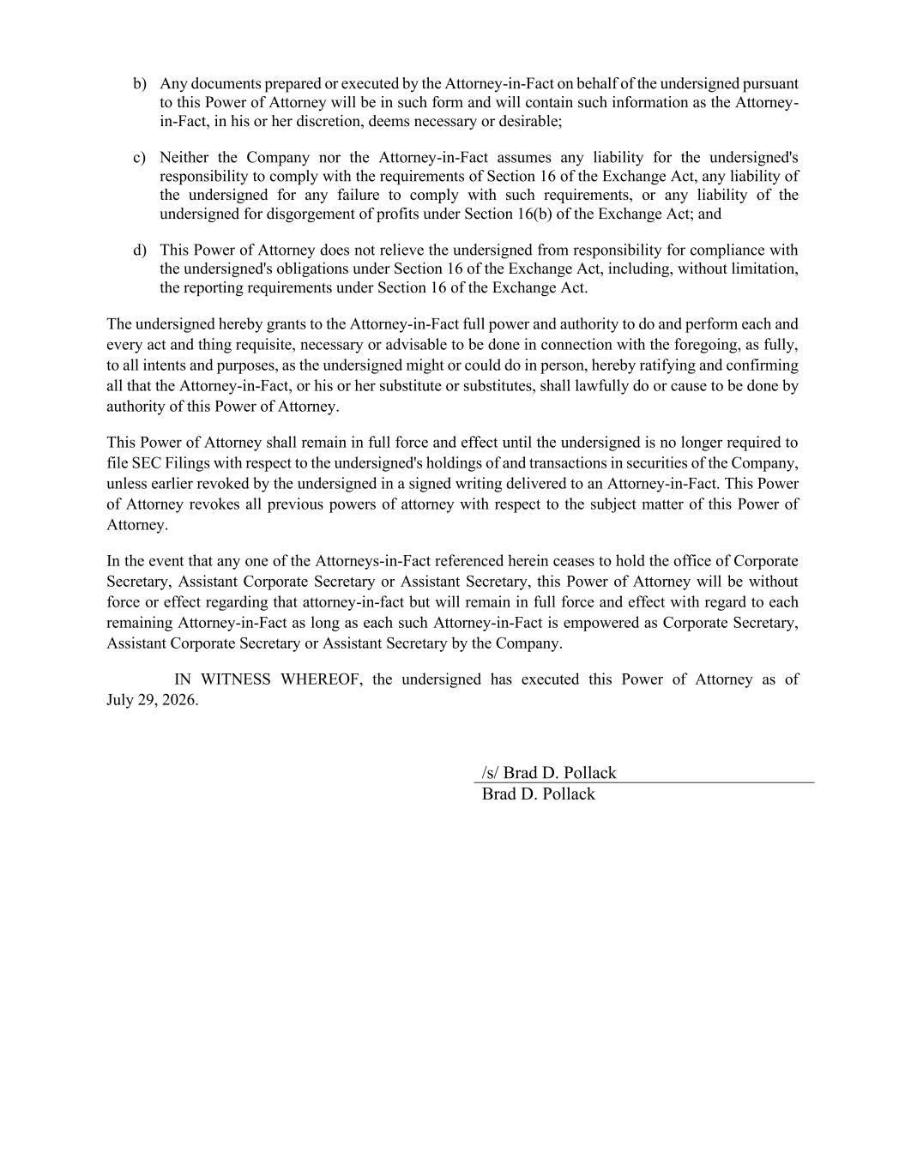
b) Any documents prepared or executed by the Attorney-in-Fact on behalf of the undersigned pursuant to this Power of Attorney will be in such form and will contain such information as the Attorney- in-Fact, in his or her discretion, deems necessary or desirable; c) Neither the Company nor the Attorney-in-Fact assumes any liability for the undersigned's responsibility to comply with the requirements of Section 16 of the Exchange Act, any liability of the undersigned for any failure to comply with such requirements, or any liability of the undersigned for disgorgement of profits under Section 16(b) of the Exchange Act; and d) This Power of Attorney does not relieve the undersigned from responsibility for compliance with the undersigned's obligations under Section 16 of the Exchange Act, including, without limitation, the reporting requirements under Section 16 of the Exchange Act. The undersigned hereby grants to the Attorney-in-Fact full power and authority to do and perform each and every act and thing requisite, necessary or advisable to be done in connection with the foregoing, as fully, to all intents and purposes, as the undersigned might or could do in person, hereby ratifying and confirming all that the Attorney-in-Fact, or his or her substitute or substitutes, shall lawfully do or cause to be done by authority of this Power of Attorney. This Power of Attorney shall remain in full force and effect until the undersigned is no longer required to file SEC Filings with respect to the undersigned's holdings of and transactions in securities of the Company, unless earlier revoked by the undersigned in a signed writing delivered to an Attorney-in-Fact. This Power of Attorney revokes all previous powers of attorney with respect to the subject matter of this Power of Attorney. In the event that any one of the Attorneys-in-Fact referenced herein ceases to hold the office of Corporate Secretary, Assistant Corporate Secretary or Assistant Secretary, this Power of Attorney will be without force or effect regarding that attorney-in-fact but will remain in full force and effect with regard to each remaining Attorney-in-Fact as long as each such Attorney-in-Fact is empowered as Corporate Secretary, Assistant Corporate Secretary or Assistant Secretary by the Company. IN WITNESS WHEREOF, the undersigned has executed this Power of Attorney as of July 29, 2026. /s/ Brad D. Pollack Brad D. Pollack

